**FORM I GEOGRAPHY**

**INTRODUCTION TO GEOGRAPHY**

**The meaning of Geography**

* Scientific study of the earth as a home of man.
* Study of interrelationship on natural and human phenomena on the earth’s surface.

**Environment**

* The surroundings
* All external conditions surrounding an organism which has influence over its behaviour.

Environment can be divided into two:

* 1. **The Physical Environment**
* Natural physical conditions of weather, climate, vegetation, animals, soil, landforms and drainage.
  1. **The Human Environment**
* Human activities such as farming, forestry, mining, tourism, settlement, transportation, trade and industry.

**Branches of Geography**

* + 1. **Physical Geography**
* Deals with the study of natural physical environment of human kind.

The areas covered include:

* 1. Geology-study of the origin, structure and composition of the earth. It includes study of rocks.
  2. Geomorphology- the study of internal and external land forming processes and landforms.
  3. Climatology- the study of climate and weather
  4. Pedology- the study of soils
  5. Biogeography - the study of soils, vegetation and animals.
  6. Hydrology- the study of water bodies
  7. Spatial geography-study of space

**2. Human and Economic Geography**

-Study of people and their activities on the earth’s surface.

The areas covered include:

1. Mining
2. Forestry
3. Agriculture
4. Fishing
5. Wildlife and tourism
6. Industry
7. Energy etc.
   * + 1. **Practical Geography**

-A smaller branch which equips the learner with practical skills that enhance their understanding and interpretation of human and physical geographical information.

The areas are:

1. Statistical methods
2. Map work
3. Field work
4. Photograph work

**Importance of Studying Geography**

1. Facilitates good relationship among nations by studying geography of other regions of the world.
2. It’s a career subject in that it enables one to go for advanced studies in specialised fields e.g. geography teachers, meteorology, surveying etc.
3. Enables us to appreciate other people’s way of life by learning economic activities of different communities within our country and other parts of the world.
4. Enables us to conserve our environment when we learn negative and positive effects of human activities on the environment.
5. Enables us to conserve our resources when we learn wise use of resources in conservation and management of resources e.g. wildlife, forests, energy, etc.
6. Inculcates in us virtues of cooperation and patience as we work in groups.
7. Makes us to appreciate manual work as we are involved in practical geography which may lead to self employment.
8. Promotion of industry such as tourism by guiding tourists to places of interest by using maps, calculations of distances etc.

**Relationship between Geography and Other Subjects**

1. **Mathematics-**mathematical techniques are used in drawing graphs and pie charts and mathematical formulae are used in geography to calculate distances, areas, population density, population densities, etc.
2. **History-**history uses geographical tools like maps, charts and graphs to show where past events took place e.g. the movement of people in the past.
3. **Biology**-Geography explains the distribution of organisms and factors influencing their distribution on the earth’s surface.
4. **Physics-**geography uses physics principles and formulae to calculate and describe aspects such as magnetic field, gravity, vibrations of the earth etc.
5. **Chemistry-**geography applies chemistry in studying chemical composition and chemical changes which take place in soils and rocks.
6. **Agriculture-**geography studies farming systems, their distribution and factors affecting farming activities.
7. **Meteorology**-geography uses meteorological information in the study of weather and in classifying climatic regions and mapping them.
8. **Geology-**geography studies rocks.

**The Earth and the Solar System**

Solar system is the group of heavenly bodies comprising the sun and the nine planets.

**The origin of the Solar System**

**Theories**

A theory is a set of reasoned ideas intended to explain facts or events

1. **Passing Star Theory**

* A star with a greater gravitational pull passed near the sun
* It attracted large quantities of gaseous materials from the sun
* The materials split, cooled and condensed to form planets
* The planets were set in orbit by the passing star

**Weaknesses**

* Doesn’t explain the origin of the sun and star.
* Minimal chance of a star approaching another
* Materials would disperse than condense

1. **Collision Theory**

* Star with greater gravitational pull passed near the sun
* It attracted large quantities of gaseous materials
* The materials split into portions
* Large portions collided with smaller ones and swept them to form planets.

The weaknesses are the same as the passing star’s Theory.

1. **Nebula Clod Theory**

* There was a slowly rotating cloud of dust and gas called Nebula
* It cooled and began to contact
* Rotation speed increased and successive rings of gaseous materials were formed.
* The rings condensed to form planets
* The central gaseous material remained as the sun

**Evidence**

* Rotation and revolution of planets in anticlockwise direction

**Weakness**

The origin of nebular is not explained.

1. **Supernova/explosion Theory**

* There was a violent explosion of a star.
* A cloud of dust (nebular) remained from the star.
* There was fast movement of the cloud due to the force of explosion.
* Rotation speed increased due to gravitational attraction
* The cloud flattened into a disc.
* The matter began to accumulate towards the centre to form a proto-sun which later began to shine.
* The rest of the cloud collapsed to form planets.

**Weaknesses**

* Doesn’t explain the origin of the star
* Doesn’t explain the cause of explosion

**Composition of the Solar System**

**1. The Sun**

It’s the centre of the universe.

**Characteristics**

* It’s a star.

A **star** is a heavenly possessing its own light which it transmits.

**Nebula/galaxy** is a cluster of stars.

The earth is in a galaxy called **The Milky Way.**

* It’s made of very hot gases mainly hydrogen (70%) and helium (30%).
* Has a diameter of 1392000km.
* Surrounded by a layer of gas which has boiled from its surface which is called **corona**.
* Rotates on its own axis in anticlockwise direction.
* Has gravitational pull which holds all the planets in orbit around it.

An **orbit** is a path which a planet or a satellite follows around a star or a planet.

* Temperature at its centre is 15m◦c and at the surface is 5500◦c.
* Radiates solar energy which is very important for all forms of life on the earth.

**2. The Planets**

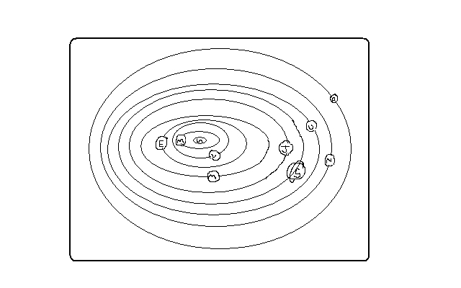

Planets are large spherical celestial/heavenly bodies in space.

There are 9 planets in our solar system.

**Characteristics**

* Spherical in shape
* Don’t have their own light but reflect it from the sun.
* Revolve around the sun in anticlockwise direction.
* Have their own force of gravity
* Only one is known to support life.

The following are the planets arranged in order from the one nearest to the sun.

**Mercury**

* Nearest from the sun
* Its 58m km from the sun
* Has no satellites
* Takes approximately 88 earth days to revolve around the sun

**Venus**

* 2nd planet from the sun
* It’s 108m km from the sun
* One of the brightest planets
* Can be seen clearly with naked eyes
* Takes approximately 225 earth days to revolve around the sun
* Slightly smaller than the earth
* Has no satellites
* Together with the earth they are called twin planets due to having many similarities

**Earth**

* The 3rd planet from the sun
* The earth and the heavenly bodies make the universe
* The only planet that supports life
* The home of man
* Approximately 149m km from the sun
* Takes 365 ¼ days to revolve around the sun
* Has one satellite, the moon

**Mars**

* Also called The Red Planet because when it’s observed through a telescope it appears reddish.
* The 4th from the sun
* Slightly smaller than the earth
* Approximately 228m km from the sun
* Takes 687 earth days to revolve around the sun
* Between Mass and Jupiter there are small celestial bodies called planetoids.
* Has no satellite.

**Jupiter**

* 5th planet from the sun
* Approximately 778m km from the sun
* Largest in the universe
* Rotates on its own axis at very fast speed
* Has flattened poles due to its fast speed of rotation
* Has very thick layers of ice on its surface
* takes 12 earth years to revolve around the sun
* Has 16 satellites

**Saturn**

* 6th planet from the sun
* Second largest planet
* Approximately 1427m km from the sun
* Takes 29 ½ earth years to revolve around the sun
* Has a ring around it
* Has 18 satellites

**Uranus**

* 7th planet from the sun
* About 4 times bigger than the earth
* Approximately 2870m km from the sun
* Also rotates very fast
* Also has flattened poles due to fast speed of rotation
* It appears greenish foe being surrounded by methane gas
* Has 8 satellites
* Takes 84 earth years to revolve around the sun

**Neptune**

* One of the farthest from the sun
* 8th planet from the sun
* Approximately 4497m km from the sun
* Has 8 satellites
* Takes 165 earth years to revolve around the sun
* Very similar in size, colour and character with Uranus

**Pluto**

* 9th planet from the earth
* Farthest from the sun
* The smallest
* 1/6 the size of the earth
* Approximately 5900m km from the sun
* Takes 248 earth years to revolve around the sun
* Has one satellite
* Very little is known about it

**Other Celestial Bodies**

**Natural Satellites**

* Any natural heavenly body that orbits around a planet e.g. moon for earth, tritan for Saturn and Triton for Neptune.

**Asteroids/Planetoids**

* Also called minor planets.
* Are small fragments of rocks left going around the sun when the solar system was formed
* Found between Mass and Jupiter
* Are 1500 in number
* They sometimes collide with each other and planets due to Jupiter’s gravitational pull causing them to move in erratic orbits.

**Comets**

* Heavenly bodies which appear to have a head and a long tail
* Made of ice, dust and frozen gas
* The head is made of many particles of dust, rock and frozen gases.
* Their tail is made of gases and points away from the sun.
* Move around the sun in extremely long and oval orbits
* Their orbits cross the earth’s orbits e.g. Halley’s Comet which appears after every 76 years.

**Meteoroid**

* Small heavenly body which strays from its orbit in the solar system and enters the earth’s atmosphere at very high speed.

**Meteor**

* A meteoroid which is burning out due to friction after entering the earth’s atmosphere.

**Meteorite**

* Remains of a meteoroid which have reached the earth’s surface or incompletely burnt up meteoroid.
* When they fall they sink into the ground forming craters
* They are rich in iron

**The Moon**

* A natural satellite
* Receives its light from the sun and reflects it onto the earth.
* It revolves around the earth
* Takes 29.5 days to complete one revolution around the earth
* Its orbit is almost circular
* As it revolves around the sun it appears in various shapes ranging from crescent/new moon, half moon, gibbons moon and full moon.
* Has gravitational pull which causes the rising and falling of the ocean level
* As the moon orbits around the earth it creates an event called eclipse.

**Eclipse**

-Phenomenon occurring when the rays of the sun are blocked from reaching the earth or the moon.

**Solar/Sun Eclipse**

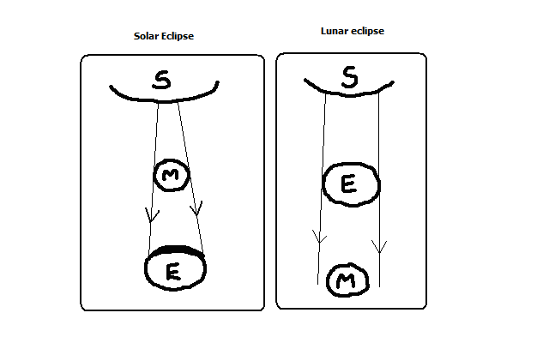

* The moon comes between the earth and the sun
* The moon’s shadow is cast on the earth
* The sun appears to be covered by darkness

**Lunar/moon Eclipse**

* The earth comes between the moon and the sun
* The earth’s shadow is cast on the moon
* The moon appears to be covered by darkness

**The Origin of the earth**

* A star with a greater gravitational pull passed near the sun
* It attracted large quantities of gaseous materials from the sun
* The materials split, cooled and condensed
* Heavier materials collected at the centre to form the core
* Less dense materials collected around the core to form the mantle
* The lightest materials formed the crust

**The shape of the earth**

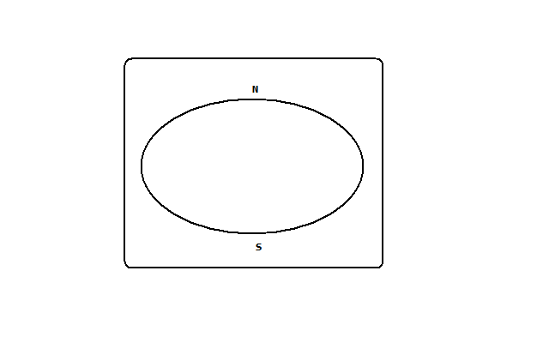

The shape of the earth is called geoid/ovoid/oblate spheroid due to being an imperfect sphere by being wide at the equator and flat at the poles.

**Proofs/Evidence That the Earth Is Spherical**

1. If one moves towards the east in a straight line he will end up where he started.
2. Satellite photographs taken from space show that the earth is like a sphere.
3. Places in the east see the sun earlier than those in the west.
4. When a ship is approaching the smoke is seen first, then the mast and finally the whole ship.
5. All the planets are spherical so the earth being one of them is also spherical.
6. During the moon eclipse the earth casts a spherical shadow on the moon.
7. The earth’s horizon appears curved when observed from a very high point like a tower.

**The size of the earth**

* Equatorial diameter-12756km
* Equatorial circumference-40085km
* Polar diameter-39995km
* Surface area of the earth-510×106 km2
* Water surface-73%.

**The Movement of the Earth**

There are 2 movements of the earth namely:

1. Rotation of the earth on its axis
2. Revolution of the earth around the sun

**Rotation of the Earth**

-Movement of the earth on its own axis (imaginary line through the centre from N pole to S pole.

* Rotates through 360◦.
* Takes 24 hours (day) to complete 1 rotation.
* Rotates in an anticlockwise direction (west to east).

**Effects of Rotation of the Earth**

1. Creates day and night because at any one time one side of the earth faces the sun (day) and the other remains in darkness (night).
2. Causes deflection of winds and ocean currents in the N hemisphere to the left and in the S hemisphere to the right.
3. It causes rising and falling of ocean tides.
4. Causes time difference between longitudes.

* Takes one hour to go through 15◦.
* 4 min to go through 1◦.

**Calculation of Local Time**

-The time recorded in places within the same longitude.

A longitude is an imaginary line running from N to S which shows how far E or W a place is from the prime meridian.

Greenwich Meridian (0◦) longitude is the point of reference when calculating time.

Time is gained towards the E and lost towards the W.

**Examples**

1. Suppose the time at GWM is 12 noon what is the local time at Watamu 40◦E?

Time gained=40×4=160min=2 hours 40min

Local time at Watamu is 12.00+2.40=14.40-1200=2.40pm.

1. At Dar-es-Salaam 40◦E time is 12pm what is the time at Ecuador 40◦E?

40◦+20◦=60◦

60×4=240min=4hours

Ecuador is behind in time =12.00-4=8 am.

If the places are on the same side subtract the degrees to get the difference and add or subtract from the reference time depending on which side the place is.

**Calculation of Longitude**

What is the longitude of place x whose local time is 8 am when local time at GWM is noon?

Time difference =12.00-8=4 hours

Degrees=4×15=60◦

Since x is behind in time its then 60◦W.

**Standard Time and Zones**

* Standard time is time recorded by countries within the same time zone.
* Standard time was come up with due to confusion resulting from time changing at every longitude.
* The world has 24 time zones.

**The International Date Line**

It’s the 180◦ longitude.

**Effects of Crossing It**

* One gains time when he crosses it from W to E and has to adjust the clock ahead by 24 hours.
* One loses time when he crosses it from E to W and has to adjust the clock backwards by 24 hours.

**Revolution of the Earth**

* Movement of the earth in its orbit around the sun.
* It’s in anticlockwise direction.
* The orbit of the earth’s revolution is elliptical.
* Takes 365 ¼ days in a year or 366 days in a leap year (every 4 years).
* The sun moves from the tropic of cancer to the equator and then towards tropic of Capricorn and back to the tropic of cancer.
* 21st march and 23rd September are called **equinoxes** becausethe length of day and night is equal. The sun is vertically overhead at noon at the equator.
* 21st June is called **summer solstice** because its summer in the N hemisphere. The sun is vertically overhead at noon at the tropic of cancer.
* 22nd December is called **winter** **solstice** because its winter in the S. hemisphere. The sun is vertically overhead at noon at noon at the tropic of Capricorn.
* Solstice is the period of maximum tilting of the earth towards the sun.

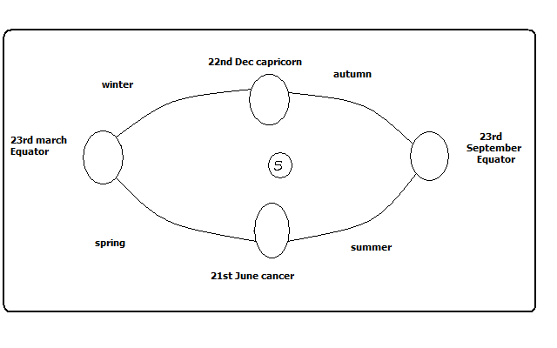

**Effects of the Revolution of the earth**

1. Causes the four seasons summer, autumn, winter and spring due to the movement of overhead sun causing changes in the heat belt.
2. Causes variation of day and night’s lengths due to the earth’s axis being inclined to the path of revolution at an angle of 60◦.
   * Equinoxes have equal lengths of day and night.
   * Summers have longer days and shorter nights.
   * Winters have longer nights and shorter days.

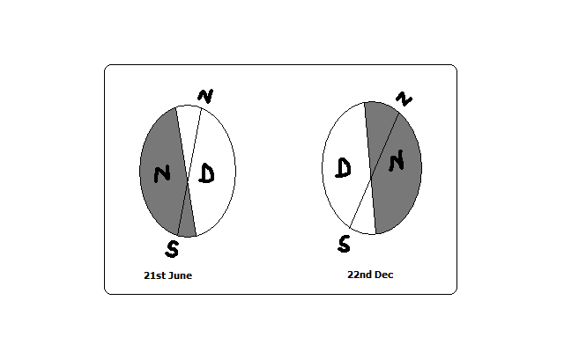

1. Causes changes in the altitude of the midday sun due to the earth’s orbit being elliptical.

* Highest altitude during equinox
* Lowest altitude during solstices

1. Causes lunar eclipse due to revolution bringing the earth in line with the sun and the moon.

**The Structure of the Earth**

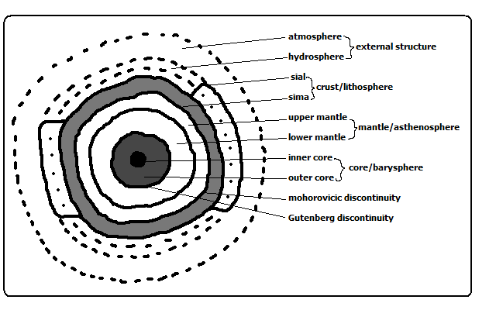

**Internal Structure of the Earth**

The evidence used to study the earth’s interior are

1. mining
2. drilling
3. quarrying/excavation

**A. Crust/Lithosphere**

* Outermost layer of the earth
* Made of soils and other loose deposits of sand
* The dominant rocks are granites.
* Extends 0-50km
* Has 2 layers

**1. Sial**

* Also called continental crust
* Made of light coloured rocks
* Called sial because it’s made up of **si**lica and **al**uminium.

**2. Sima**

* Also called oceanic crust
* Mainly made of basaltic rocks which are brittle.
* Called sima because it is made of **si**lica **ma**gnesium and iron.

**Mohorovicic Discontinuity (Moho)**

* A definite zone of discontinuity between the crust and the mantle.
* Was discovered by Dr. Andrija Mohorovicic in 1909.

**B. The Mantle/Asthenosphere**

* Layer lying between the crust and the core
* Made of iron and magnesium
* Has two layers

1. **Upper mantle**

* Rocks are more elastic than those of sima.
* Temperature is about 1000◦c.

1. **lower mantle**

* Rocks are like very viscous liquid.
* Temperature ranges between 1000◦c to 3000◦c.

**Why the Interior of Earth Is Very Hot**

1. Due radio-active decay causing most of the heating.
2. Due to great pressure as a result of overlying crustal materials.
3. The original heat resulting from slow cooling of the materials which were pulled off the sun

**Gutenberg Discontinuity**

* A definite zone of discontinuity between mantle and core.

**C. Core/barysphere/Centrosphere**

* The innermost/central layer of the earth.
* Has 2 layers

**Outer Core**

* Composed of very dense rocks
* Made up of nickel and iron
* Temperatures are up to 3700◦c.

**Inner Core**

* A solid mass of mainly iron
* Temperatures are estimated to be 4500◦c to 5000◦c.

**External Structure of the Earth**

* 1. **The Atmosphere**
* Layer of gases surrounding the earth.
* The earth revolves with it because its held onto it by gravity
* It’s about 330km thick.

**Composition of the Atmosphere**

* 1. Gases-exist as a mixture
  2. Smoke particles
  3. Dust particles
  4. Water vapour

**The structure of the Atmosphere**

It’s divided into 4 layers/zones namely:

1. **Troposphere**

-Lowest layer of the atmosphere

-Contains 90% of water vapour

-Rainfall is got from it

-Temperature decreases with increase in altitude (lapse rate)

-Air is turbulent due to mixing of air

-Contains dust particles

-There is a zone of transition between troposphere and stratosphere called **tropopause**.

1. **Stratosphere/ozonosphere**

-Layer lying next to troposphere

-Has layers

-Lower isothermal layer in which temperature is constant

-Upper layer of temperature inversion in which temperature increases with increasing altitude

-Has ozone layer which absorbs harmful ultraviolet radiation.

-Air is calm so it’s used by passenger jets

-Limited amounts of water vapour

-There is a zone of transition between stratosphere and mesosphere called **stratopause**.

1. **Mesosphere**

-Middle layer of the atmosphere.

-Temperature decreases with increasing altitude.

-There is a zone of transition between mesosphere and thermosphere called mesopause which is an inversion layer.

1. **Thermosphere/ionosphere**

* High radiation is present.
* The pressure is very low.
* Gases and molecules in this layer exist as ions due to high radiation.
* Has no definite top but merges gradually into the outermost part of the atmosphere called exosphere.
* Exosphere consists of rare gases like hydrogen and helium.
* Beyond the atmosphere there is the outer space.
* Outer space is the universe beyond the atmosphere in which other planets and stars exist.

**Significance of Atmosphere**

1. Animals and plants breathe in from it oxygen for respiration.
2. Plants use carbon dioxide from it for photosynthesis.
3. Water vapour in the atmosphere condenses to form clouds which give us rain.
4. Ozone layer in the stratosphere shields us from ultraviolet radiation which may cause cancers.
5. Carbon dioxide and methane in the atmosphere cause global warming through the green house effect.

**b) The Hydrosphere**

* Part of the earth’s surface covered by water masses e.g. oceans, seas, lakes, rivers and even underground water.
* It comprises 73% of the earth’s surface area.
* The atmosphere and hydrosphere are related in that atmospheric gases penetrate to the ocean depth in solution form.
* The lower atmosphere, hydrosphere and the upper part of the earth’s crust are called biosphere meaning the sphere of the earth in which organic life exists.

**WEATHER**

**-**Daily atmospheric conditions of a place at a particular time.

**Elements of Weather**

1. Temperature
2. Humidity precipitation
3. Precipitation
4. Atmospheric pressure
5. Wind
6. Sunshine
7. Cloud cover

**A Weather Station**

**-**A place where observation, measuring and recording of weather elements is done

**Factors to Be Taken Into Account When Sitting a Weather Station**

1. An open place where there is little obstruction of weather elements.
2. Accessible place so that recording can be done easily.
3. A fairly level or gently sloping ground (5◦) so that it’s easy to position weather instruments.
4. The place should provide a wide view of the surrounding landscape and the sky.
5. The site should be free from flooding.
6. The place should have security.

**Instruments for Measuring Elements of Weather**

1. Thermometer-temperature
2. Hygrometer-humidity
3. Rain gauge-rainfall
4. Barometer-air pressure
5. Sunshine recorder-sunshine duration and intensity
6. Wind vane –wind direction
7. Anemometer-wind speed
8. Evaporimeter-rate and amount of evaporation.

**The Stevenson Screen**

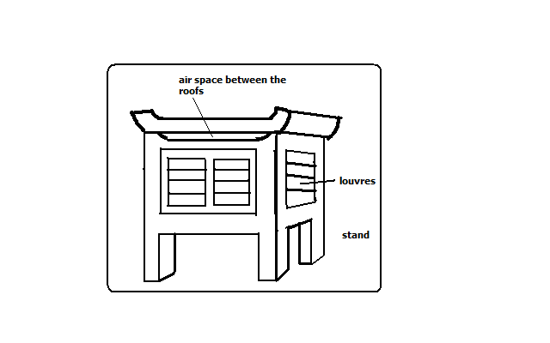

-A white wooden box mounted on 4 legs used to house thermometers and hygrometers.

The instruments which are found in it are:

1. Maximum thermometer
2. minimum thermometer
3. Six’s thermometer
4. hygrometer-wet bulb and dry bulb thermometer

**Importance**

1. Provide shade conditions for accurate temperature recording.
2. Ensure safety of thermometers because they are delicate.

**Qualifications Which Make Stevenson Screen Suitable For Its Work**

1. Painted white for little absorption of solar heat energy.
2. Made of wood which is a bad conductor of heat.
3. Well ventilated to allow easier flow of air inside it.
4. Raised to prevent contact with terrestrial radiation.
5. Has double roof which acts as an insulator to prevent direct heating from the sun.

**Recording and Calculating Weather Conditions**

**Temperature**

-Degree of hotness of an object or a place.

It’s measured using 3 types of thermometers namely:

1. Maximum thermometer
2. Minimum thermometer
3. Six’s thermometer

**Maximum Thermometer**

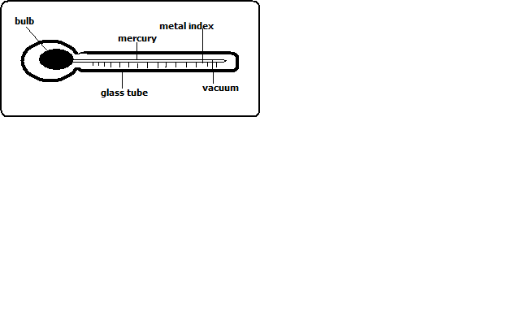

It’s used to measure the highest temperature reached in a day.

It uses mercury.

**How It’s Used/Works**

* Temperature rises causing mercury to expand.
* Mercury pushes the index up.
* When temperature falls mercury contracts.
* The maximum temperature is read from the scale at the lower end of the index.
* Thermometer is reset by shaking it to force mercury back into the bulb.

**Minimum Thermometer**

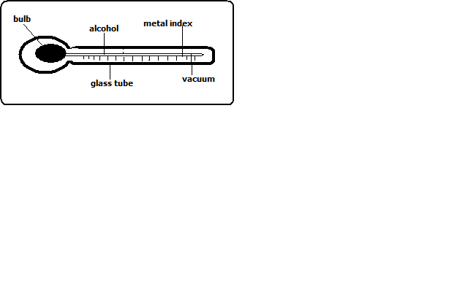

It’s used to record the lowest temperature reached in a day.

It uses alcohol.

**How it’s Used/Works**

* Temperature falls causing alcohol to contract.
* Alcohol pulls the index down.
* When temperature rises alcohol expands and rises in the tube.
* The index remains where it was pulled.
* Minimum temperature reading is obtained from the scale at the lower end of the index.

**Calculating Temperature**

* 1. **Diurnal/daily Temperature range**

**-**Difference between the maximum and minimum temperature for any one day.

* 1. **Mean Daily Temperature**

**-**Average of the maximum and the minimum daily temperatures.

* 1. **Mean Monthly temperature**

-Sum of mean daily temperatures in a month divided by the number of days in that month.

* 1. **Mean Monthly minimum Temperature**

**-**Sum of daily minimum temperatures divided by the number of days in that month.

* 1. **Mean Monthly Maximum Temperature**

-Sum of daily maximum temperatures divided by the number of days in that month.

* 1. **Mean Annual Temperature**

-Sum of mean monthly temperatures divided by 12.

* 1. **Mean Annual Temperature Range**

**-**Difference between the highest and the lowest mean monthly temperatures in a year.

* 1. ◦k=◦c+273
  2. ◦F=(◦c×1.8)+32 derive the rest from the formulas.

**Rainfall**

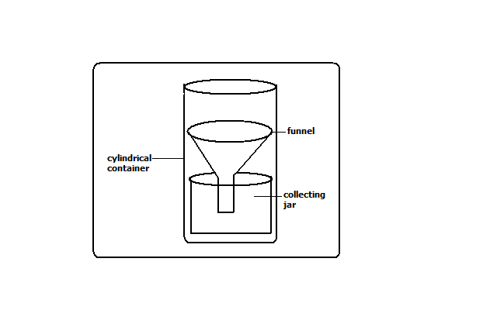

Rain gauge is the instrument used to measure the amount of rainfall in a day.

It should be made of impermeable material which can’t absorb water.

**How It’s Used/Works**

* It’s taken to an open space to prevent water from dropping into the funnel.
* Its sunk into the ground to prevent evaporation
* The funnel top is left 30cm above the ground to prevent splashes of water and run off.
* After 24 hours water is emptied into the measuring cylinder.
* The reading of the amount of rainfall is got from the measuring cylinder in millimetres.
* The figure represents the millimetres of water falling on each square millimetre of the ground.
* It could be used to measure snow fall by melting it before the readings are gotten.

**Calculating Rainfall**

* 1. **Monthly Rainfall Total**

**-**Sum of rainfall recorded in a month.

* 1. **Annual Rainfall Total**

-Sum of monthly rainfall totals for 12 months.

* 1. **Mean Monthly Rainfall**

-Sum of rainfall totals for a particular month over several years divided by the number of the years of observation.

* 1. **Mean Annual Rainfall**

-Sum of mean monthly rainfall for 12 months of the year.

**Sunshine**

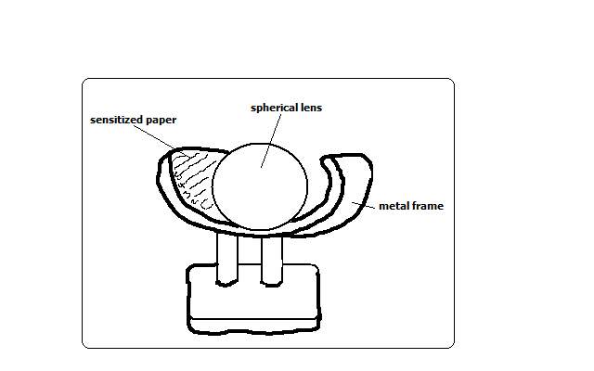

Duration of sunshine is measured using Campbell stokes sunshine recorder.

**How It Works**

* Spherical lens focuses light on sensitized paper.
* The paper burns when the sun is shining.
* The total hours of sunshine is got by adding all the burnt sections from calibrations on the side of sensitized paper.
* The sensitized paper is changed every day.

**Humidity**

Humidity is the condition of atmosphere with reference to its water content.

It’s measured with hygrometer or psychrometer which consists of wet and dry bulb thermometers kept in Stevenson screen.

Dry bulb thermometer is a thermometer covered with muslin bag immersed in water while dry bulb thermometer has no muslin.

**How It Works**

* When air is dry there is a lot of evaporation from the muslin.
* Evaporation cools the bulb of thermometer resulting in a low temperature reading.
* When humidity is high there is little evaporation from the muslin.
* The wet bulb thermometer is cooled at a slower rate and both thermometers show almost the same temperature reading.
* The difference in readings between the two thermometers is used to determine relative humidity.

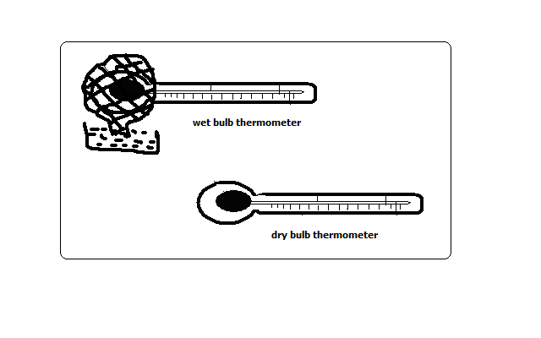

**Interpretation of Hygrometer Readings**

* When the 2 readings are the same, relative humidity is 100% i.e. the air is saturated.
* If the difference is small, humidity is high.
* If the difference is big, humidity is very low.

**Calculating Humidity**

**Absolute Humidity**

-Actual amount of water vapour a given volume of air can hold. It’s expressed in g/m3.

**Specific Humidity**

-Mass of water vapour in a given mass of air. It’s expressed in g/km.

**Relative Humidity**

-Ratio between the absolute humidity and the maximum amount of water the air can hold expressed in a percentage.

R.H.=A.H/Maximum amount of water the air can hold at the same temperature.

Example

* If the air at 20◦c contains 10g/m3 and given air can hold a maximum of 20g/m3.calculate the relative humidity.

10×100/20=50%

**Wind**

**Direction**

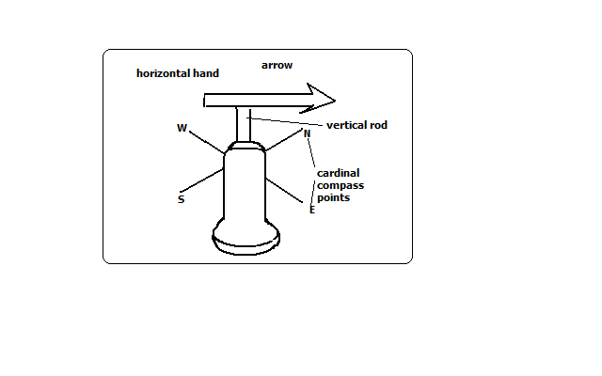

Wind direction is determined using wind vane.

**How It Works**

* As the wind blows the arrow swings.
* The arrow points in the opposite direction of the wind flow.
* The direction is read from the cardinal compass points.
* The arrow will point in the direction from which the wind is blowing.
* For instance if it points S the wind is blowing from S towards N.

**Wind Sock**

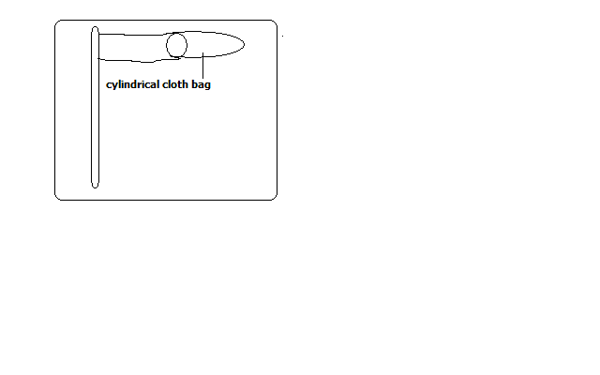

-Used to indicate the general direction of wind flow.

-Not kept in a weather station because it doesn’t give the accurate direction of wind flow.

-Seen near airstrips for the benefit of pilots.

**How it Works**

* When wind blows the bas stretches out in the direction that the wind is blowing.

**Wind speed/Velocity**

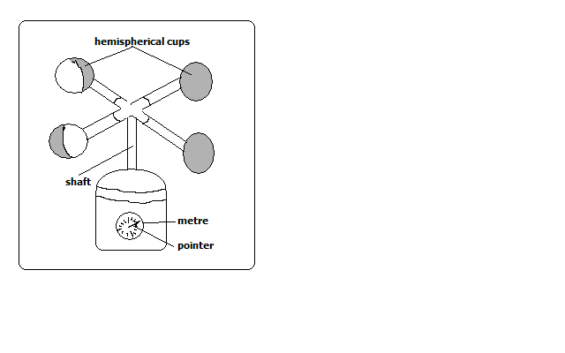

**-**Measured using anemometer.

**How It Works**

* When wind blows hemispherical cups rotate.
* The number of rotations is obtained from the metre on the lower part of the anemometer.
* The units for measuring wind are called knots.

**Atmospheric Pressure**

**-**The force exerted by gases in the atmosphere on some area or body on the earth’s surface.

-Measured using barometers of three types namely mercury, aneroid and Fortin Barometers.

**Mercury Barometer**

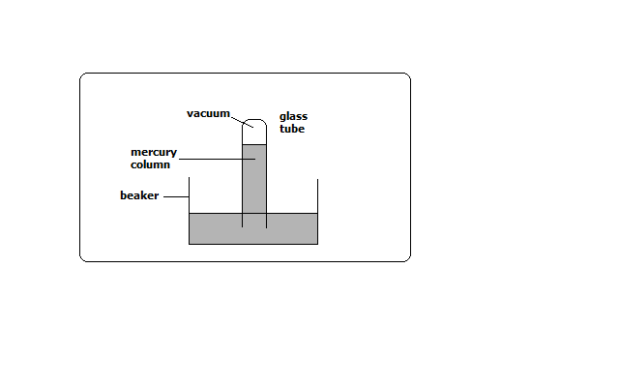

**How It Works**

* Air exerts pressure on the mercury in the beaker.
* The height of mercury in the tube is proportional to the atmospheric pressure.
* The readings are taken in mmHg.
* Its 760mmHg at sea level

**Advantage**

Quite accurate

**Disadvantage**

1. Cumbersome to carry around.
2. Can be damaged quite easily while being carried around.

**Aneroid Barometer**

**-**Measures changes in atmospheric pressure.

**How It Works**

* Has air tight compartment (vacuum).
* Compartment expands when pressure decreases.
* It collapses when pressure increases.
* The movement is transmitted by lever to a pointer on a dial.
* The readings are in kg/cm3.

**Evaporation**

The rate and amount of evaporation is measured using piche and tank evaporimeters.

**Piche Evaporimeter**

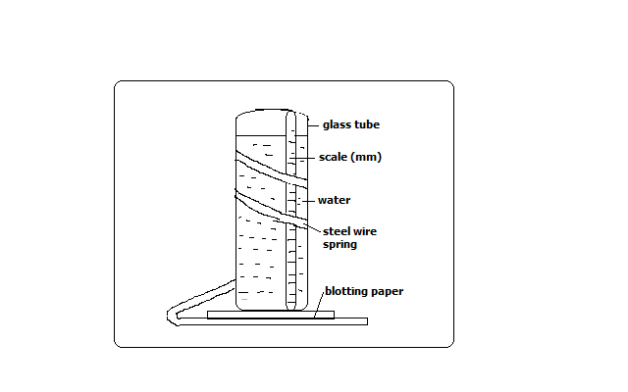

* When there is a lot of sunshine water evaporates from the blotting paper.
* The level of water in the glass tube reduces.
* The rate and amount of evaporation is got by looking at the scale on the outside of the glass tube.
* The units are in mm.

**Tank Evaporimeter**

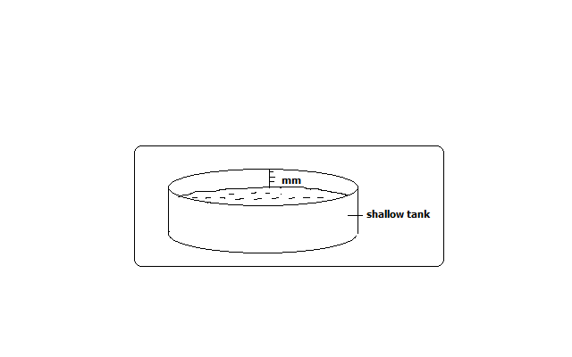

**How It Works**

* The tank with water is put in the open.
* Water evaporates when there is a lot of sunshine.
* Water in the tank reduces.
* The rate and amount of evaporation is got from calibrations in the inner side of the tank in mm.

**Cloud Cover**

The amount of cloud cover is observed using eyes.

It’s given in oktas**.**

Okta=approximately 1/8 of sky is covered with clouds.

**Weather Forecasting**

-Prediction of the conditions of the atmosphere for a given place for a certain period.

**Methods of Weather Forecasting**

**Traditional Methods**

-Prediction of weather based on traditional beliefs and facts.

* Plants shedding leaves indicates period of drought.
* Safari ants indicate it will rain.
* Migration of butterflies also indicates it will rain.
* Croaking of frogs during dry season indicate its going to rain.
* Flowering of certain plants indicates the onset of rainfall.
* Changes in the intensity of sunshine indicate its going to rain.

**Modern Methods**

**-**Prediction of weather using modern instruments and new technology of collecting, transmitting, processing and analysing weather data.

**Instruments Used**

1. **Satellites-**electronic devices which orbit the earth which collect and transmit weather data which is interpreted by computers.
2. **Radar**-an instrument used to see cloud formation.
3. **Sensors/radiosodes-**instrument fixed on a balloon used to measure atmospheric pressure, temperature and humidity.
4. **Computers-**electronic device used to store, analyse and display weather information.

**Significance/Importance of Weather Forecasting**

1. Helps us to be aware of natural calamities related to weather before they occur so as to take precautionary measures.
2. Guiding tourists on when to visit national parks.
3. Helps farmers to plan their activities such as planting, harvesting, etc.
4. Ensures air and water transport is carried out safely.
5. Helps sporting people to plan their training and competition schedules.
6. Helps people to plan many other activities such as mining, electricity generation, holiday events, etc.
7. Helps fishing communities to plan their activities.

**Factors Hindering Weather Forecasting**

1. Lack of skilled man power due to limited training facilities.
2. Lack of modern equipment leading to wrong forecasts.
3. Natural calamities such as storms and earthquakes.
4. Extreme weather conditions which may damage or displace instruments.
5. Use of faulty instruments.
6. Human error.
7. Poor sitting of instruments.

**Factors Influencing Weather**

**Temperature**

**Factors influencing temperature**

1. **Altitude**

**-**Height above sea level.

* Temperature decreases with increase in height due to air at higher altitude being thinner and hence there is less particles e.g. gases, dust, smoke and water vapour to store heat so its rapidly lost to the outer space.

1. **Latitude**

-Distance from the equator.

Temperature decreases with increase in latitude.

* Places neat equator experience high temperature due to the rays of the sun travelling a shorter distance facing less interference from atmospheric conditions hence more solar energy reaches the earth’s surface. Also the rays of the sun strike the earth at right angles hence solar energy is concentrated over a small area.
* At higher latitudes the rays of the sun travel a longer distance facing more interference from atmospheric conditions hence less solar energy reaches the earth’s surface. Also the rays of the sun strike the earth at an acute angle hence solar energy is spread over a large area.

1. **Aspect**

-Direction of slope.

* At higher latitudes slopes facing the equator have higher temperature because they face the sun while those facing the poles have lower temperature have lower temperature because they face away from the sun.

1. **Winds**

**-**Transfer heat from one place to another.

* When they blow from cool areas they take the cooling effect to the areas they blow over and when they blow from warm areas they take warming influence to the places they blow over.

1. **Distance from a Large Water Body**

* Areas near a large water body experience lower temperature during the hot season and higher temperature during the cool season due to sea breezes, warm and cold ocean currents and wind blowing over water which could be either warmer or cooler than the adjacent land.

1. **Cloud Cover**

* Clouds reduce the amount of solar energy reaching the surface by absorbing, scattering and reflecting solar radiation.
* When there are clear skies during the day the temperature is higher due to the earth receiving maximum solar insolation.
* During clear nights there are very low temperatures due to a lot of terrestrial radiation being lost to the outer space.
* Cloudy nights on the other hand are warmer due to clouds radiating to the earth heat absorbed during the day.
* **Length of Day**
* The longer the period of solar insolation the greater the quantity of radiation a place receives and hence the more the heat that will be generated by the earth and vice versa.

1. **Solar Altitude**

* At equinox when the earth is farthest from the sun the temperature on the earth is lower due to less solar radiation reaching the earth’s surface due to travelling a longer distance and hence facing great interference from atmospheric conditions.
* At solstices the earth receives more solar energy due to travelling a shorter distance and hence facing less interference from atmospheric conditions.

1. **Solar Input**

* Sometimes the sun gives out more heat due to reactions being violent causing temperature on the earth to be higher.
* When it gives out less heat the temperature on the earth is lower.

1. **Surface Conditions**

* Light surfaces e.g. smooth surfaces reflect sunlight and hence less solar energy reaches the earth’s surface.
* Dark and irregular surfaces such as with vegetation absorb more heat leading to higher surface temperatures.

**Humidity**

**Factors Influencing Humidity**

1. **Temperature**

* Places with high temperature experience high humidity due to high evaporation and air having high capacity to hold moisture.
* Places with low temperature have low humidity due to low evaporation and air having low capacity to hold moisture.

1. **Source of Moisture**

* Areas near water bodies e.g. Kisumu and Mombasa experience high humidity due to evaporation of water from the water body.
* Places near thick vegetation also have high humidity due to evapotranspiration.
* Areas far away from water bodies such as the middle of deserts have low humidity.
* Areas receiving heavy rainfall also have high humidity.

1. **Air Pressure**

* There is high humidity at low altitudes because high pressure compresses air warming it increasing its capacity to hold moisture and also causes high evaporation.
* There is low pressure at high altitudes because air expands and cools thus reducing its capacity to hold moisture.

1. **Latitude**

* Low latitudes experience high humidity due to high temperatures resulting into high rates of evaporation and air having high capacity to hold moisture.
* High latitudes experience low humidity due to low temperatures resulting into low rates of evaporation and air having low capacity to hold moisture.

**Significance of Humidity/Moisture**

1. Affects rain formation in such as way that places with high humidity are likely to experience higher rainfall than those with low humidity.
2. Regulates the heat loss from the earth’s surface by absorbing terrestrial radiation (process in which the earth gives off heat into the atmosphere).
3. It affects sensible temperature in that the higher the humidity the more we experience sensible temperature.

**Precipitation**

-The forms in which the earth’s surface receives moisture.

1. **Snow**

Solid precipitation formed when tiny water droplets freeze and form ice crystals.

The crystals may fuse to form flakes.

1. **Sleet**

-Precipitation which is a mixture of rain and snow.

1. **Hail**

Roughly spherical lumps of ice formed when super cooled cloud droplets mould themselves around ice crystals before cooling. It destroys crops life and house roofs.

1. **Dew**

-Precipitation consisting of water droplets formed on cold surfaces at night e.g. iron roofs and glass blades.

**How It’s Formed**

* In a clear night there is a high ground radiation.
* Temperature of the earth’s surface fall below dew point (temperature at which air being cooled becomes saturated).
* Excess water condenses on cold surfaces.

1. **rain**

-Precipitation consisting of water drops/droplets formed when tiny water droplets merge around particles of matter and become heavy and fall down to the earth.

**Condensation**

Turning of water vapour into tiny water droplets as cooling continues below dew point.

The droplets join to form clouds.

**Causes of Condensation**

1. **Adiabatic cooling-**cooling of moist air as it rises vertically.
2. **Orographic cooling**-cooling of moist air as it climbs a hill or mountain.
3. **Frontal cooling**-cooling of warm air mass when it blows towards a cold air mass.
4. **Advection cooling**-cooling as a result of moist air moving over a cool land or sea.

**How Condensation Takes Place/Cloud Formation**

* Moist air rises to the condensation level (altitude where temperature is below dew point.
* It’s cooled below dew point.
* Tiny water droplets condense around tiny particles such as dust, smoke particles and pollen grains and salt particles (condensation nuclei).
* The droplets merge and eventually become bigger and fall as rain.
* If moisture rises to an altitude where temperature is below 0◦c the condensed water droplets freeze forming ice particles or super cooled water (water which has remained in a liquid state at temperatures below freezing point due to lack of sufficient condensation nuclei.
* Super cooled cloud droplets may mould themselves around ice crystals before freezing to form hail.

**Types of rainfall**

* 1. **Relief/Orographic/Mountain rainfall**

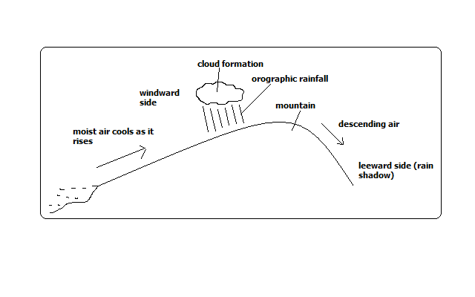

Rain experienced on the windward slopes of mountains or hills formed when moist air is forced to rise over a mountain or a hill.

**How it Forms**

* Moist air is forced to rise over a hill or mountain.
* The temperature and air pressure decreases making it to expand.
* Air cools due to decreased temperature and decreased pressure causing it to expand.
* Moisture condenses forming tiny water droplets (clouds).
* The tiny water droplets in clouds merge and become too heavy to be suspended in air and fall as rain.
* Air proceeds to the leeward side with low moisture content.
* Since its heavier due to being cool it descends over that side and gets warmed making it to hold onto the little moisture it had causing that side to receive low rainfall (rain shadow).
  1. **Convectional Rainfall**

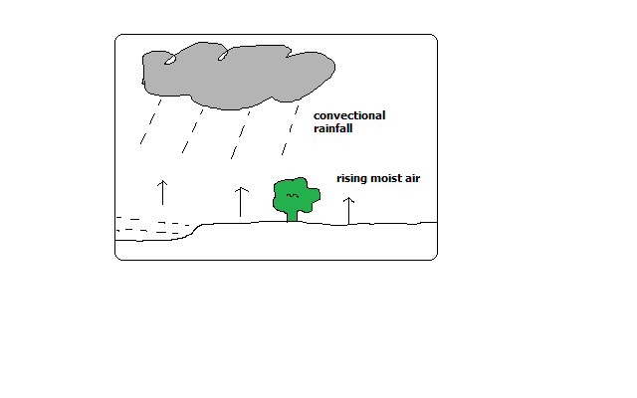

Type of rainfall common near large water bodies formed as a result of convective rising and cooling of moist air.

It’s accompanied by thunderstorms.

**How it forms**

* Ground or water body is heated causing evaporation.
* There is convective rising and cooling of moist air.
* Condensation takes place forming tiny water droplets (clouds).
* The droplets merge and fall as rain.
* The cooled dry air descends to the surface where its heated and its capacity to hold moisture is increased.
* The process is repeated.
  1. **Frontal/Cyclonic Rainfall**

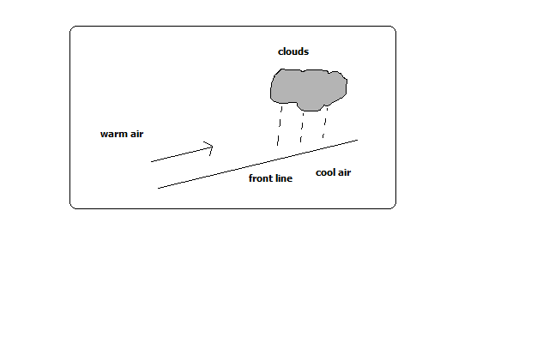

Type of rainfall common in mid-latitudes formed when warm air blows towards a cold area or when warm air mass meets with a cold air mass.

It’s accompanied by cyclones (violent winds).

**How it Forms**

* Warm moist air mass meets with a cold air mass.
* The warm air is forced to rise as it’s less dense.
* It cools as it rises at the line of contact with cold air.
* The moisture condenses forming clouds resulting in frontal rain.

**Factors Influencing Rainfall Types and Amounts**

* 1. **Relief/Topography**

Relief features such as mountains and hills results in the rising and cooling of moist winds to form relief rainfall.

* 1. **Aspect**

Windward slopes which are on the path of rain bearing winds receive heavier rainfall than leeward slopes which face away.

* 1. **Forests and Water Bodies**

Areas near forests and large water bodies experience higher rainfall and more often due to high rate of evaporation.

* 1. **air pressure**

High pressure areas receive low rainfall than low pressure areas due to pushing of air masses from high pressure to low pressure. The high pressure areas have descending dry air.

* 1. **air masses**

When warm and cold air masses meet frontal rainfall is formed.

* 1. **Ocean Currents**
* It influences rainfall whereby coasts washed by warm ocean currents experience heavy rainfall when moist onshore winds are warmed by the current and made to hold on to moisture which they release on reaching the land.
* The coasts washed by cold ocean currents on the other hand experience low rainfall as a result of moist winds being cooled and moisture in them condensed resulting in rain falling over the ocean thereby bringing little or no rain to the coastal areas. This is the cause of western margin deserts e.g. Kalahari and Namib deserts.

**Atmospheric pressure**

**Factors Influencing Atmospheric Pressure**

* 1. **Altitude**
* Pressure decreases with increase in altitude because the column of air becomes shorter hence it exerts less weight.
  1. **Temperature**
* When air is heated it expands and exerts pressure over a large area resulting in reduced pressure.
* When it’s cooled it contracts and exerts pressure over a small area resulting in increased pressure.
  1. **Rotation of the earth**
* Rotation pushes air masses from poles towards the equator causing air to spread out and occupy more space causing it to expand making pressure to decrease.
* When air from the equator moves towards the poles it occupies less space causing it to contract resulting into high pressure.

**Mist and Fog**

Mist and fog are a mass of tiny water droplets suspended in the lower layers of the atmosphere.

Fog is denser than mist i.e. has more moisture.

Both hinder visibility although fog reduces visibility to less than a kilometre.

When fog mixes with smoke it’s called smog.

**How They Form**

* Moist air cools below dew point.
* Condensation takes place.
* The resultant water droplets remain suspended in the air.

**Types of Fog**

* 1. **Radiation Fog**
* Type formed when moist air is cooled below dew point as a result of intense radiation on the ground at night.
  1. **Advection Fog**
* Type formed when moist air from the sea moves horizontally over a cold surface e.g. snow covered ground.
  1. **Orographic/Hill/Upslope Fog**
* Type formed when moist air is cooled after climbing a hill or mountain.
  1. **Evaporation Fog**
* Type formed when water vapour is added to cold air that is already near saturation causing excess water vapour to condense and form fog.
  1. **Frontal Fog**
* Type formed when warm moist air is cooled from below as it rises over a cold air mass.
  1. **Steam Fog**
* **Type formed when moist air passes over the surface of a much warmer fresh water body.**
* The warm water is cooled from above and condensing water vapour forms fog. It appears to be steaming.
  1. **Ice Fog**
* Type formed when water vapour is converted directly into ice crystals when temperatures are below freezing point.

**Clouds**

-Are a mass of tiny droplets or ice particles formed when water vapour condenses.

**Three Cloud Forms**

1. **Cirroform**

-Thin and wispy clouds composed of ice crystals.

1. **Stratiform**

-Appear as greyish sheets covering most of the sky and are rarely broken into units.

1. **Cumuliform**

-Are massive rounded with a flat base and limited horizontal extent and billow upwards to great heights.

**Basic Cloud Types**

1. **Stratus Clouds**

-Are found in layers, are flat in shape and resemble fog.

1. **Nimbus Clouds**

-are dark at the base and sometimes white at the sides and cause rain and thunderstorms.

1. **Cirro-cumulus**

-Are white clouds consisting of white ice crystals.

1. **Nimbostratus**

-A rain cloud which is dark grey and spreads over the sky in low uniform layers.

1. **Cumulus Clouds**

-Clouds with a flat horizontal base, massive, rounded and less horizontal extent.

1. **Alto cumulus**

-High clouds composed of ice crystals which indicate fair weather.

**World distribution of Pressure Zones and the Planetary wind System/World Prevailing Winds**

**The Equatorial Low pressure Zone (ITCZ-low)**

* Found between 23 ½ ◦N and 23 ◦N
* Experiences high temperatures.
* A zone of low pressure and doldrums (light and intermediate winds).
* Zone where S.E and N.E Trade Winds converge.
* Associated with convectional rain and thunderstorms.
* Migrates to the N and with the apparent movement of the overhead sun.

**The Sub-tropical High Pressure Zone**

* Found within 30◦N and 30◦S.
* A zone of high pressure.
* A region of calm descending air.
* Source of Trade Winds and Westeries.
* Zone of divergence of T. Winds and Westeries.

**The Temperate Low Pressure Zone**

* Found within 60◦N and 60◦S.
* A low pressure zone.
* Zone of convergence of westeries and polar easteries.

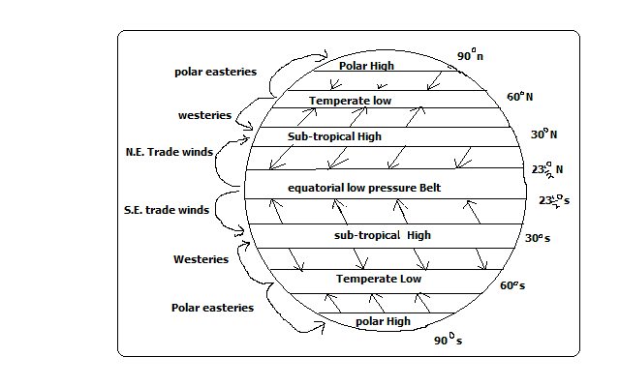

**The Polar High Pressure Zone**

* Found over the poles 90◦N and 90◦S.
* A high pressure Zone.
* Zone of descending calm air of low temperature.
* Source of polar easteries.

**The Worlds Prevailing Winds**

These are the major winds blowing over the earth frequently and consistently and which influence the world weather.

1. **Trade Winds**

* Blow from sub-tropical high pressure zone and blow to the equatorial low pressure belt.

1. **Westeries**

* Originate from sub-tropical high pressure zone and blow to the temperate low pressure belt.

1. **The Polar Easteries**

* Originate from polar high pressure zone and blow to temperate low pressure zone.

**Monsoon Winds**

* Seasonal winds which reverse in the direction of flow.
* They blow towards the land during summer (onshore) and from the land during winter (off shore).
* Bring heavy rains when onshore which can cause severe flooding.
* Well developed in the Indian Sun-continent, china, Japan and S.E Asia.

**Air Masses**

-Distinct large parcels of air moving in one direction

-Originate from areas of uniform weather and topography from where they derive their characteristics e.g. flat areas, forests, deserts, and snow covered areas.

**Characteristics of Air Masses**

* A large volume of air.
* Covers an extensive area.
* Has uniform temperature and humidity.
* Distinct from the surrounding air.
* Retains its characteristics when it moves away.

**Types of air Masses**

* 1. **Equatorial Air Mass**
* Originate from equatorial oceans.
* It’s hot and unstable.
  1. **Sub-tropical Air Mass**
* Forms near sub-tropical high pressure belt.
  1. **Polar Air Mass**
* Forms near the poles or temperate low pressure zone.
* It’s cool.
  1. **Arctic and Antarctic air Masses**
* Forms over the ice sheets of Greenland and Antarctica respectively.
  1. **Effect of air masses on Weather**
* When warm moist air mass and cool air mass meet cyclonic rainfall is formed e.g. tropical maritime and polar maritime.
* Cool air masses take cooling effect to the areas they move to e.g. polar continental.
* If they are warm they take warming influence to the area they move to e.g. tropical continental.

**Pressure Systems in the World**

* 1. **Cyclone**

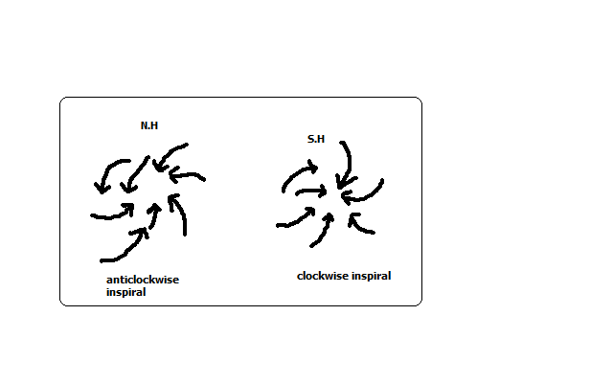

* It’s a low pressure system characterised by low pressure at the centre and increases outwards.
* Starts in areas where air ascends from the ground to the atmosphere and descends at high altitude.
* It’s of two types. Tropical cyclones e.g. hurricane, typhoon and willy willies and depressions which are characterised by temperate latitudes.
* The movement of wind is anticlockwise in the N. hemisphere and clockwise in the S. hemisphere.
  1. **Anticyclone**
* A high pressure system characterised by high pressure at the centre and decreases outwards.

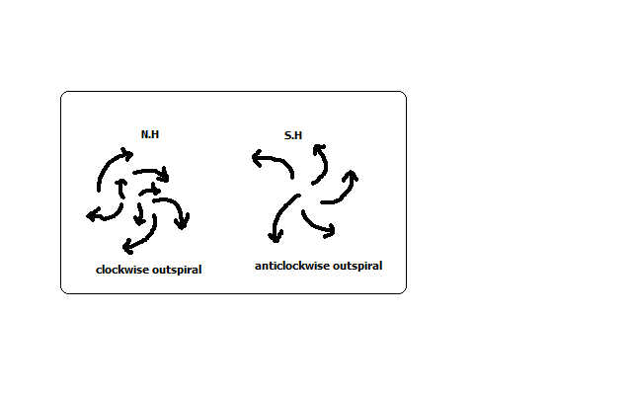

* It starts in areas where air is descending from the atmosphere onto the ground and then blows outwards on the ground.
* The movement of wind is clockwise in the N. hemisphere and anticlockwise in the S. hemisphere.

**Local Winds**

**-**Which occur regularly for a short period of time affecting a limited area.

-Modify the weather of the area they blow to.

**1. Sea Breeze**

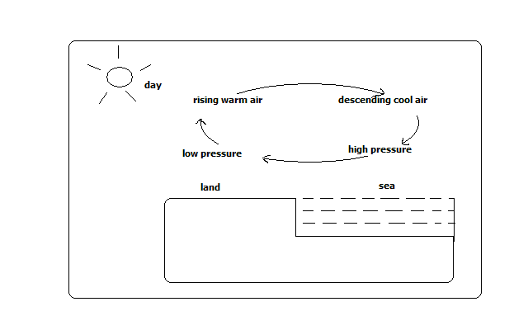

**-**A light and gentle wind which blows from the sea to the adjacent land.

**How it Forms**

* During the day land is heated faster than the sea.
* Air over the land is warmed and rises.
* Air from the sea moves to the land to replace the rising air.
* The rising air from the land cools and descends over the sea at high altitude.
* Circulation continues until the pressure difference is reversed at night.

**Effects on weather**

It takes cooling effect on land on a hot afternoon.

**2. Land Breeze**

-A light and gentle wind which blows from land to the sea during the night.

**How it Forms**

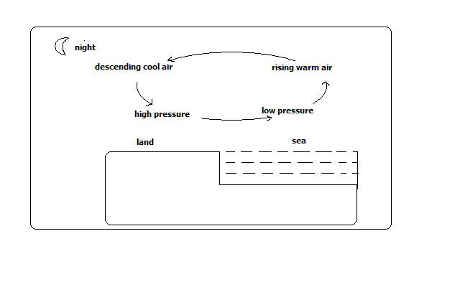

* At night land loses heat faster than the sea.
* Air over the sea is warmed and rises.
* Air from the land moves to the sea to replace the rising air.
* Rising air from the sea descends over land at high altitude.
* Circulation continues until pressure difference is reversed during the day.

**Effects on weather**

It causes early morning showers through moisture brought towards land at high altitude.

* 1. **Anabatic winds (Valley Breeze)**

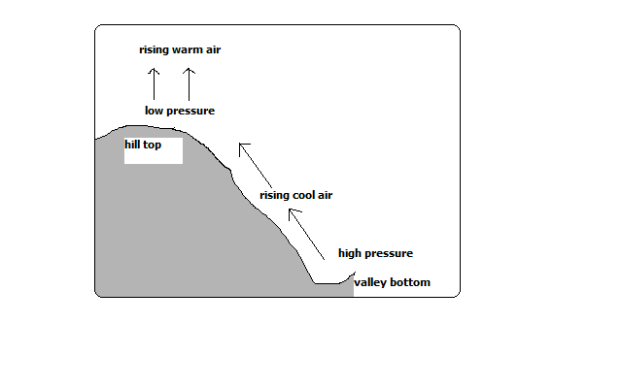

-Cool local winds which blow from the valley to the hill tops during summer afternoons.

**How it Forms**

* During the day hill tops are heated more than valley bottoms.
* Air over the hill tops is warmed and rises.
* Cool air over the valley move up to the hill to replace the rising air.

**Effect on weather**

-Cause afternoon showers on hilly grounds.

* 1. **Katabatic/Descending Winds**

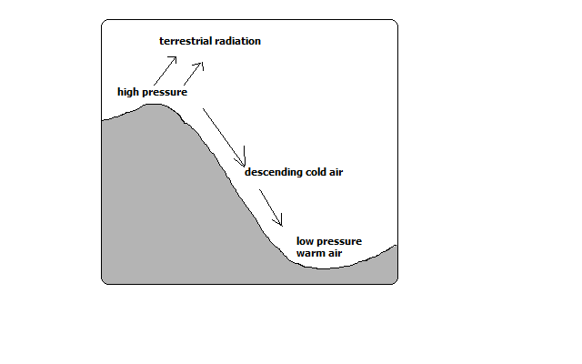

-Cold local winds which blow from hill tops to the valley during the night.

* During the night hill tops lose heat faster than the valley.
* Air over the valley is warmed and rises.
* Cool air over the hill tops move to the valley by gravity to replace the rising air.

**Effect on Weather**

**-**Takes chilly conditions on valley bottoms.

* 1. **Harmattan Winds**

-N.E winds which originate from Sahara and blow across W. Africa between November and March taking dry conditions there.

* 1. **Fohn Winds (Alps)**

-Local cold winds which slide down the leeward side of the mountain at high speed and are warmed producing a temperature rise.

Due to the high speed and temperature they are associated with wild fires.

They are known as Chinook in Rocky Mountains, Santa Anas in California and Mistral in France.

**Factors influencing Wind Flow (Speed and direction)**

1. **Pressure Gradient**

If the pressure difference between high and low pressure areas is high the winds blow at high speed (strong) but if it’s low they blow at high speed (are gentle).

1. **distance between Places of High and Low Pressure**

If the high and low pressure areas are near each other winds blow at high speed but if distant from each other winds blow at low speed.

1. **Rotation of the earth**

Rotation of the earth deflects winds to the right in the N. hemisphere and to the left in the S. hemisphere.

1. **Frictional Force**

If the surface of the earth is rugged or has obstacles such as hills, mountains, valleys or vegetation the wind is blocked causing speed reduction and its direction of flow is also changed.

**STATISTICS**

**Statistics**-numerical figures collected systematically and arranged for a particular purpose.

**Statistical** **data**-information presented inform of numbers e.g.

1. No. of students in a school
2. Mean daily temperature of a place
3. Amount of milk produced daily from a farm
4. Amount of money earned from exports annually.

**Statistical** **methods**-techniques of collecting, recording, analysing, presenting and interpreting statistical data.

**Significance of Statistics**

-Illustrates relationship between 2 or more varying quantities e.g. beans production and acreage under cultivation.

-Summarises geographical information which saves time and space.

-Makes comparison between components e.g. province with the highest number of people.

-Prediction of future trends of weather and climate.

-Prediction of natural disasters e.g. droughts and floods.

-Planning for provision of social amenities e.g. hospitals and schools.

**Types of Statistical Data**

**Primary Data**

-First hand or original information from the field e.g.

-Mean daily temperature from a weather station

-Enumeration/census

**Secondary/Derived Data**

-2nd hand information available in stored sources compiled by other researchers e.g.

* Textbooks
* Reference books
* Maps
* Video/audio tapes
* Textbooks
* Newspapers
* Magazines
* Census reports
* Slides
* Census reports

**Nature of Statistical Data**

* 1. **Discrete Data**

**-**Which is given in whole numbers e.g.

16 elephants

1093 tonnes of wheat

* 1. **Continuous Data**

-Facts and figures which can take any value e.g.

* Fractions e.g.23 ¼
* Decimals e.g. 6.20 mm
* Values within range e.g. 0-30◦c
  1. **Grouped Data**

-Which is non precise/exact but values range in groups e.g.

|  |  |
| --- | --- |
| Age group | Number of boys |
| 15-19 | 32 |
| 20-24 | 8 |

**Sources of Statistical Data**

1. **Primary Sources**

-People or places which have 1st hand or original information.

The information can be collected by observation, measuring, counting, photographing etc.

**Advantages**

* + Give first hand information
  + The information can’t be got from other sources

1. **Secondary sources**

-Materials in which information collected by others was stored e.g. text books, reference books, etc.

**Methods of Collecting Data (statistical Techniques)**

1. **Observation**

-Use of eyes to observe features or weather then information is recorded immediately e.g. cloud cover, rocks, soil, land forms, vegetation, etc.

**Advantages**

-Gives 1st hand information which is reliable.

-Relevant material to the study is collected.

-Time saving since one doesn’t have to look for data in many places.

**Disadvantages**

1. Data on past activities isn’t available.
2. May be hindered by weather conditions e.g. mist and dust storms.
3. Ineffective for people with visual disabilities.
4. Tiresome and expensive as it involves a lot of travelling because physical presence is required.
5. **interviewing**

-Gathering information from people by direct discussions then answers are recorded. It may be face to face or on a telephone. A questionnaire prepared in advance is used.

**Guidelines**

-One should be polite

-Warm and friendly

-Respondents/ interviewees should be assured information is confidential.

-Respondent should not be interrupted when answering questions.

-They should not be given clues but answers should come from them.

**Advantages**

-Reliable first hand information is collected.

-Interviewer can seek clarification in case of ambiguity of answers.

-Can be used on illiterate.

-Interviewer can gauge the accuracy of responses.

**Disadvantages**

1. Time consuming since one person can be handled at a time.
2. Expensive and tiresome as extensive travelling is required to meet the respondents.
3. May encounter language barrier if the respondent doesn’t speak the same language as the interviewer.
4. A respondent may lie, exaggerate or distort facts leading to collection of wrong information.
5. **Administering questionnaires**

-Set of systematically structured questions printed on paper used on interviews or sent to respondents to fill answers.

**Types**

* **Open-ended questionnaire**-in which respondent is given a chance to express his views. The disadvantage is that different answers are given which are difficult to analyse.
* **Closed-ended (rigid) questionnaire-**in which respondents are given answers to choose from.

**Characteristics of a good questionnaire**

* Short
* Uses simple language
* Systematically arranged from simple to difficult
* Clear questions
* Doesn’t touch on respondent’s privacy

**Advantages**

1. Comparisons can be made since questions are similar.
2. First hand information which is relevant to current trends and situation is collected.
3. Saves money on travelling as physical presence isn’t required.
4. Saves time as all respondents are handled at the same time.
5. A lot of information can be collected.

**Disadvantages**

1. Difficult analysis due to different answers.
2. Some questionnaires may be sent back while blank by lazy respondents.
3. Can’t be used on illiterate respondents.
4. Some respondents may write wrong information.
5. **Content analysis**

-Technique of collecting data from secondary sources.

This is by reading, watching films, viewing photographs and listening to get what is relevant.

**Advantages**

1. Easy to get data if analysed.
2. Cheap as there isn’t extensive travelling
3. Saves time as all information is in one place.
4. Possible to get old data

**Disadvantages**

1. Difficult to verify accuracy of data
2. Data may be irrelevant to current trends
3. Up to date data may not be readily available
4. **Measuring**

-Determining distances, areas, height or depth using instruments and recording.

-Distance can be estimated by pacing or taking steps of equal and unknown length.

1. **Collecting Samples**

-Getting a small part e.g. of soil, rock or vegetation to represent the whole to be used to carry out tests in the laboratory.

1. **Counting/census taking**

-Arithmetical counting and recording.

1. **Photographing**

-Capturing on film or video and still photographs.

1. **Digging**

**-**Using tools such as hoe pick axe, spade or soil auger to get samples of soil and rocks.

1. **Feeling and touching**

-Using fingers to feel the surfaces of soils and rocks to get their textures.

1. **sampling**

-Examining by taking a sample -a part representing the whole (population).

**Types of Sampling**

1. **Random Sampling**

**-**Selection of members of a group haphazardly where every item has an equal chance of being selected e.g. to select 5 students to go for a tour from a class:

* Class members write their names on pieces of paper
* They are folded and put in a basket
* The basket is shaken and fives papers are taken out

1. **Systematic Sampling**

-Selection of members of a sample from an evenly distributed phenomena at regular intervals e.g. after every 10 items/members.

1. **Stratified sampling**

-Selection of members of a sample by breaking the population into homogenous groups e.g. to select 6 students to go for a tour:

* Break the class into boys and girls
* Select 3 student from each group by random or systematic sampling
* Combine units from each group to form the required sample.

1. **Cluster Sampling**

-Selection of sample by dividing the sample into clusters with similar characteristics then a sample is taken from each cluster and representative choices from each cluster are combined to form a sample e.g. to sample the housing cost an estate is chosen to represent each group and representative choices are chosen from each estate and combined to form a sample.

**Advantages**

1. It’s less expensive
2. It saves time
3. It avoids bias

**Disadvantages**

1. A poor selected sample can lead to misleading information
2. Systematic sampling to an evenly distributed population

**Experimentation**

–Conducting a test or investigation to provide evidence for or against a theory e.g. to determine the chemical composition of rocks and soils.

**Advantages**

1. First hand data is obtained
2. Gives accurate results if properly conducted.
3. It can lead to further discoveries

**Disadvantages**

1. May be expensive as it involves use of expensive equipment.
2. May be time consuming
3. Use of defective instruments may lead to inaccurate results
4. Improper handling of equipment and chemicals may lead to accidents

**Methods of Recording Data**

-Methods off storing information to avoid losing it.

1. **Note Taking**

**-**Writing in a note book what is being observed, answers during interviews and then notes are compiled in school or office when writing report.

1. **Filling In Questionnaires**

-Filling answers in questionnaires which are responses from a respondent by an interviewer or respondent himself which he/she then sends back.

1. **Tallying**

-Making 4 vertical or slanting strokes and the 5th across the 4 to record data obtained by counting or measuring similar items.

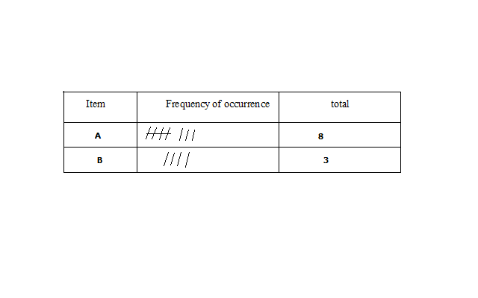

1. **Tabulation**

-Drawing of tables and filling in data systematically e.g. weather recording sheets.

|  |  |  |  |  |  |  |  |  |  |  |  |  |
| --- | --- | --- | --- | --- | --- | --- | --- | --- | --- | --- | --- | --- |
| Month | J | F | M | A | M | J | J | A | S | O | N | D |
| Temp(◦c) | 24 | 24 | 23 | 22 | 19 | 17 | 17 | 18 | 19 | 20 | 22 | 23 |
| Rainfall(mm) | 109 | 122 | 130 | 76 | 52 | 34 | 28 | 38 | 70 | 108 | 121 | 120 |

1. **Field Sketching**

**-**Summarising information observed in the field by making a rough drawing of landscape and labelling the essential information.

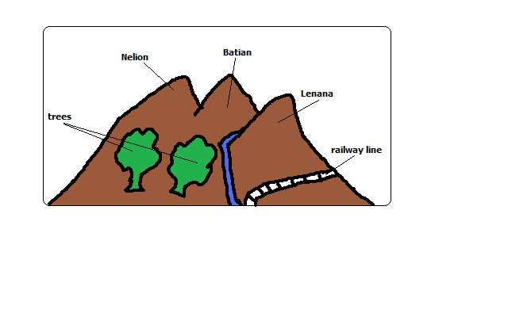

1. **Mapping/Drawing Maps**

**-**Drawing of a rough map of an area of study and labelling in words or symbols accompanied by key.

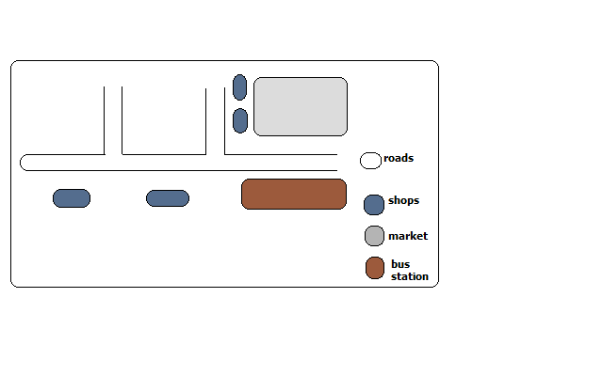

1. **Tape Recording**

**-**Recording image of an object or landscape on a film which is processed to get a photograph then the photographs are labelled to avoid mix up during storage.

1. **Labelling samples**

-Recording conversations during interviews on audio tapes using a tape recorder.

-Permission should be got from the respondent to record his/her responses.

**Advantages**

* It’s used if responses are too many to be recorded on a note book.
* It allows smooth flow of discussion as asking respondents to repeat answers would irritate them.

**Analysis of Data**

**-Examining the numerical figures in detail.**

**Techniques of analysing Data**

1. **Calculation of Percentages**

-If in the study of a farm 10 hectares are devoted to coffee, what is the % of the area under coffee?

**10/100×10%**

The table below shows the number of tourists who visited Kenya from various parts of the world in 2006.

|  |  |  |
| --- | --- | --- |
| Place of Origin | No. of tourists per year | |
| 2005 | 2006 |
| Europe  Africa  Asia | 942000  120000  97000 | 965000  154000  128000 |
| Total | 1159000 | 1247000 |

1. Calculate percentage increase of tourists from Africa between 2005 and 2006.
2. **Measures of Central Tendency**

**-**Outstanding general characteristics of the data.

* 1. **Arithmetic Mean**

-The average

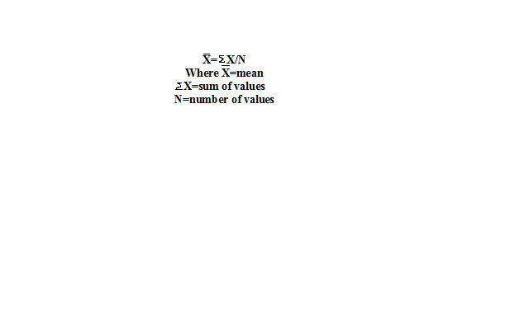

**Advantages**

* Easy to calculate for a small data
* Summarises data using a single digit
* Easy to understand and interpret

**Disadvantages**

* Difficult to calculate for grouped data
* Affected by extreme values
  1. **Median**

**-**The middle value in a set of data arranged in order.

M= (N+1)/2

* 1. 20, 50, 90, 100, 150, 180, 200, 220, 240, 300, 360.
  2. 20, 50, 90, 100, 150, 180, 200, 220, 240, 300.

**Advantages**

* Easy to calculate in a small data set
* Easy to understand as it’s the value at the middle

**Disadvantages**

* Difficult to calculate in a large data set
* Doesn’t show data distribution

1. **Calculation of Ranges**

-Difference between the largest and smallest values. Calculate the range of for the data above.

* 1. **Mode**

-Most frequently recurring value in a set of data.

10, 2, 5, 9, 10, 11, 20, 15, 18, 10.

The mode is 10.

**Advantages**

* Easy to find as no calculation is involved
* Easy to understand

**Disadvantage**

* Rarely used as a measure of central tendency

**Statistical Presentation of Data**

**FIELD WORK**

**-**Scientific study of geography using the environment as a laboratory or source of information.

**Types of Field Work**

1. **Field Excursion**

-Visiting an area near or far from the school to see geographical phenomena then note down and discuss later in class.

**Aim**

* 1. Reinforce what has been learnt in class
  2. Gain more geographical knowledge
  3. Identify and appreciate geographical features
  4. Identify problems of geographical interest

1. **Field Research**

-Systematic problem solving done by experts in which scientific methods of collecting, recording and analysing data are used.

1. **Field Study**

-Study conducted within a neighbourhood in which one theme is pursued e.g. ‘A study of a local farm’.

**Importance of Field Work**

1. Reinforces what has been learnt in class.
2. Enables one to gain more geographical knowledge.
3. It breaks the monotony of classroom work.
4. It provides learner with practical skills of collecting, recording and analysing data and report writing.
5. Gives students an opportunity to go out and practise what they have learnt in class.
6. Enables students to familiarise themselves with the environment and develop a positive attitude towards it.
7. Enables students to develop a positive attitude towards manual work.
8. Promotes development of virtues like cooperation by working in groups.

**Field Work Procedure (Steps Followed)**

1. **Identification of Topic/Theme**

-Reason why you want to carry out field study e.g. ‘A study of rocks around the school’

1. **Identification of the Area of Study**

-Determining the area to be used for study.

-Should be chosen carefully to ensure that the field study is successful.

**Conditions It Should Meet**

1. Should contain sufficient information
2. Should be within a convenience distance to reduce expenses
3. **Statement of Objectives**

-Stating aims of carrying the field study.

-Act as guidelines to activities to be undertaken during field work.

They should be simple, brief, testable and achievable. E.g. for the topic ‘A study of a local farm’ objectives could be stated as follows:

* To **find out** methods of farming in a local farm
* To **identify** the cattle breeds in the farm
* To **investigate** the problems facing the farm.

1. **Formulation of Hypotheses**

**-**Assumptions set before field work whose validity or acceptance is to be proved.

**Types of Hypotheses**

* **Null Hypothesis (Ho)**

-One stated in negative form e.g. ‘There is no relationship between rainfall and crop yield’.

* **Alternative/Substantive hypothesis (H1)**

-One stated positively e.g. ‘most foodstuffs sold in the neighbourhood don’t come from the immediate neighbourhood’.

Quantitative words should be used e.g. more, most, majority. It should not be obvious.

1. **Preparation of the Field Study**

It involves:

1. **Seek Permission from Relevant Authorities**

**-**Seeking permission from school and authority in the area you are visiting.

It is important to:

* To avoid being denied permission to enter there
* Enables individuals to set early the suitable date and time of visit
* Helps to arrange for a guide to conduct you around

1. **Conduct Reconnaissance (Pre-Visit)**

**-**A familiarisation tour of the intended area of study.

It is important to:

* To determine appropriate routes to be taken
* Enables to get documents from officials
* Helps one to identify the appropriate methods of data collection
* Helps to identify appropriate equipment to be used

1. **Hold Discussion In Class**

-Looking through formulated objectives and hypotheses.

It’s important to:

* Determine their suitability
* Make adjustments
* Decide upon data recording methods

1. **Preparation of a Questionnaire**

-Important where the interviewer is not able to be with respondents for a long time.

1. **Dividing Into Groups**

* To ease congestion in the area of study
* To create order during field work
* To reduce fatigue among participants
* To help participants collect data within the time given

1. **Preparation for Documents**

* Topographical maps to show the routes you will follow
* Tables for filling in information
* Permission documents

1. **Reading Through Relevant Books**

-Reading about the topic and the area of study

Important in that it helps participants to know:

* The kind of data they need to collect
* The techniques to be employed in the field.

1. **Preparation of a Work Schedule**

**-**A timetable to be followed on the day of field study.

It is important to:

* Indicate the specific time when each activity should take place
* Reduce time wastage by ensuring proper time management
* Ensure all important areas are covered and none is forgotten
* Provide an estimate of total time required for study

1. **Selection of Important Tools and Equipment**

-Tape measure and rulers for measuring, pencils for drawing sketch maps, notebooks for writing notes, polythene bag for sorting and carrying samples, cameras for taking photographs, geological hammer getting rock samples and hoe for digging to get soil samples, etc.

1. **Carrying Out the Field Study**

-Setting off to go to the area of study to look for data where techniques of collecting and recording data are applied.

**Follow Up Activities**

-After data is collected and recorded it’s summarised in the following ways:

* Discussing the findings in class giving reports through group leaders
* Writing reports in essay form
* Calculation of percentages, means, medians and modes
* Laboratory testing of samples
* Presentation of data using methods such as graphs, pie charts, etc.

**Problems Encountered in Field work**

1. **Language Barrier**

-Inability to communicate due to the interviewer and the respondent not sharing the same language or respondents may be illiterate and thus unable to fill questionnaire. The problems are:

* Data may not be collected
* Illiterate people may give wrong answers while attempting questionnaires
* An interpreter may have to be engages who would be paid which would raise costs.
* Answers may be distorted by the interpreter

1. **Hostility**

Those being approached to give answers may become harsh due to feeling that their time is being wasted which would cause the field study to be unsuccessful.

1. **Dishonest Respondents**

-Respondents giving wrong information due to suspicion fear of shame or superstition.

1. **Bad Weather**

-Raining heavily making it impossible to proceed with data collection and difficulty in movement.

-Becoming very hot making participants uncomfortable and thus unable to proceed with data collection smoothly.

-Becoming misty or foggy causing invisibility problems.

1. **Accidents in the Field**

One may fall and get injured when walking on rugged areas.

Injuries may result when using tools to get samples by cutting using pangas or knives and digging using hoes.

1. **Attacks by Wild Animals**

-Participants may encounter wild animals when carrying out the study in bushy areas e.g. snakes which may bite them, rhinos which may charge at them, etc.

1. **Inaccessibility**

**-**physical barriers such as swamps, rivers without bridges, steep slopes and thick vegetation may hinder participants from reaching areas with vital information.

**MINERALS AND ROCKS**

**Minerals**

-Inorganic substances occurring naturally at or below the earth’s surface.

**Characteristics of Minerals**

1. Different degrees of hardness e.g. some are very hard e.g. diamond while others are very soft e.g. talc.
2. Some have atoms arranged in an orderly manner to form crystals e.g. quartz form a 6- sided prism.
3. Varying number of elements e.g. gold has one (Av) while quartz has 2 (SiO2).
4. Different abilities to allow light to pass through e.g. some are transparent, opaque or translucent.
5. Specific colours e.g. gold is shiny yellow while copper is brown.
6. Have specific surface appearance (lustre) when they reflect light i.e. metallic (shiny) or non-metallic (glass like).
7. Definite chemical composition or constant ratio of elements e.g. quartz has one atom of silicon and two atoms of oxygen.
8. Tendency to break along certain lines or cleavage) e.g. flint has cleavage like that of glass.
9. Different densities e.g. some are very heavy e.g. lead while others are light e.g. silicate minerals.
10. Some minerals conduct electricity while others don’t e.g. copper conducts while diamond doesn’t.
11. Some can be pressed into different shapes while others can’t e.g. copper is malleable while flint isn’t.

**Types of Minerals**

**Metallic minerals**

**-Ferrous Minerals-**limonite, magnetite, siderite and haematite.

**-Non-ferrous Minerals**-copper, aluminium, gold, lead, etc.

**-Non-metallic Minerals-**graphite, diamond, asbestos, coal, etc.

**-Energy minerals-**petroleum, coal and uranium.

**Rocks**

**-**A consolidated material composed of grains of one or more minerals.

**Classification of Rocks**

1. **Igneous Rocks**

-Rocks formed when molten material from the earth’s interior cools and solidifies on or beneath the earth’s surface.

**Types of Igneous Rocks**

* 1. **Intrusive Igneous Rocks**

-Rocks formed when magma cools and solidifies below the earth’s surface e.g. granite, diorite, gabbro, peridotite.

-Have coarse texture as a result of slow cooling giving minerals more time to form large crystals.

-Are classified further into two:

(i) Hypabyssal rocks- intrusive igneous rocks which are near the earth’s surface.

(ii) Plutonic rocks-intrusive igneous rocks which are deep below the surface.

* 1. **Extrusive Igneous Rocks**

**-**Rocks formed when lava solidifies on the earth’s surface.

-Have fine texture due to fast cooling giving minerals less time to collect together to form larger crystals.

They are of two types namely:

1. **Volcanic Ejecta**

-Extrusive igneous rocks formed in the following ways:

* When ash and lava ejected from underground as they fall on the earth’s surface e.g. pumice.
* When dust and ash ejected settle on the ground and get compressed to form a rock e.g. tuff.

1. **Lava Flows**

-Extrusive igneous rocks formed when basic lava flows over a considerable distance then cools and solidifies e.g. basalt and obsidian.

1. **Sedimentary Rocks**

-Rocks formed when particles of other rocks are laid down and compressed into layers or when plant and animal remains are buried and compressed and compacted.

* When they are laid down a layer is formed.
* As deposition continues additional layers are formed which compress the lower layers into a hard mass.

**Types of Sedimentary Rocks**

* 1. **Mechanically Formed Sedimentary Rocks**

-Sedimentary rocks formed when weathered igneous or metamorphic rocks are deposited and compacted e.g. sandstone and shale.

* 1. **Organically formed Sedimentary Rocks**

-Sedimentary rocks formed when animal and plant or animal remains are buried, compressed and compacted.

**Classification of Organically Formed Sedimentary Rocks**

**(i) Calcareous rocks**-rich in calcium carbonate e.g. chalk and limestone.

Coral rocks are formed from remains of sea polyps which extract lime from the sea, build shells for protection, attach themselves to each other and rocks to live in colonies, then die and shells to form coral rocks.

**(ii) Ferruginous Rocks-**rich in iron e.g. ironstone.

**(iii) Siliceous Rocks**-rich in silica e.g. diatomite.

**(iv) Carbonaceous Rocks**-rich in carbon e.g. coal.

* 1. **Chemically formed Sedimentary Rocks**

-Sedimentary rocks formed when materials dissolved in water chemically react forming new substances then water evaporated leaving layers of those salts.

**Classification of Chemically Formed Sedimentary Rocks**

**(i) Carbonates** e.g. trona and dolomite

**(ii) Sulphates-**sulphate compounds

**(iii) Chlorides** e.g. halite

**(iv)** **Silicates** e.g. flint

**(v) Iron stones** e.g. haematite and limonite.

1. **Metamorphic Rocks**

-Rocks which have changed their physical appearance and chemical properties as a result of subjection to great heat and pressure e.g.

* Gneiss from granite
* Slate from clay
* Marble from limestone
* Quartzite from sandstones

**Distribution of Major Rocks in Kenya**

**Eastern Kenya region**

* The major rocks are metamorphic rocks e.g. marble in parts of Machakos and schist and gneiss in parts of Kitui.
* Volcanic rocks in Yatta plateau and Kapiti plans.
* Sedimentary rocks e.g. limestone rocks used in Bamburi for cement manufacturing.

**Coastal Region**

* Major rocks are sedimentary rocks e.g. limestone used in Bamburi for cement manufacture.
* There are volcanic rocks in Tsavo rich in ground water resources.

**Northern and N.E Region**

* Dominated by sedimentary sands.
* There are volcanic rocks in Mt. Marsabit and around Rift Valley.

**Rift Valley and Kenya Highlands**

* Dominated by volcanic rocks
* There are metamorphic rocks which have resulted from changing of igneous rocks.

**L. Victoria Basin**

* Granite and gneiss dominate Western Kenya where they form high rocky hills called granitic tors common in Kisii, Maragoli and Bunyore areas.
* Sedimentary rocks deposited by rivers e.g. Nyando, Nzoia, Yala and Sondu.

**Significance of Rocks**

1. Rocks weather to form soil which is important in agriculture.
2. Form aquifers which store ground water which forms springs which form rivers and wells which provide water for domestic and industrial use.
3. Some rocks are sources of building materials e.g. igneous rocks are used to make ballast and limestone rocks are used as building blocks and raw material in cement manufacturing.
4. Phosphate and nitrate rocks are used to make fertiliser used in agriculture.
5. Granitic tors of W. Kenya and high volcanic peaks such as those of Mt. Kenya are a tourist attraction which brings foreign exchange.
6. Pumice is used as a scrubbing stone.
7. A rock such as coal is used as fuel for heating, smelting of iron and thermal electricity generation.
8. Source of minerals e.g. oil and coal is associated with sedimentary rocks.

**MINING**

-Process of extracting valuable minerals from the earth’s surface.

**Formations in Which Minerals Occur**

1. **Veins and Lodes**

-Occurrence of minerals in crevices, cracks or faults in igneous rocks.

* They are said to occur in **veins if they** occur there in small quantities.
* Said to occur in lodes if they occur there in large quantities e.g. zinc, copper and silver.

1. **Reefs**

-Veins and lodes which are exposed on the surface.

1. **Seams/Layers/Beds**

-Occurrence of minerals as sedimentary or as a result of compression of accumulated organic or inorganic material e.g. coal and halite.

1. **Alluvial Deposits**

-Occurrence of minerals while mixed with materials such as sand, gravel, silt, etc.

These were minerals which were detached from the veins by weathering and carried away by streams and rivers and got deposited e.g. gold, diamond and platinum.

1. **Weathering Products**

-Minerals formed by deep weathering of rocks then leaching carried minerals from the top to lower layers where they accumulated e.g. aluminium, nickel, iron and manganese.

1. **Oil pools/Wells**

-Occurrence of minerals in pools or wells in sedimentary rocks e.g. petroleum and natural gas.

**Conditions Necessary for Formation of Petroleum**

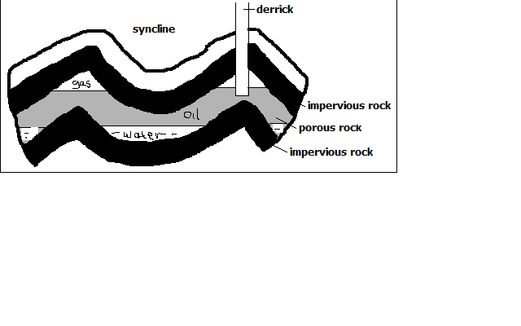

1. Presence of fossils or organic remains
2. Presence of sedimentary rocks for burying organic remains.
3. Presence of pressure to compress organic remains to cook the oil and natural gas out of organic matter.
4. Presence of a porous reservoir rock to store and transmit petroleum to the oil pools e.g. limestone and sandstone.
5. Presence of a trap like a syncline to hold petroleum in a reservoir to prevent its escape.
6. Presence of impermeable rocks below the trap or syncline to prevent petroleum from percolating further underground.

**Factors Influencing Exploitation of Minerals**

1. **Value of Mineral**

Minerals of high value will be mined even if they occur in small quantities because one sold it will be possible to offset mining costs and make a profit and vice versa.

1. **Quality of Ore**

Mining can be done if the mineral deposits have high mineral content because they are economical to work on but deposits with low mineral content are rarely worked on except if the mineral in them is rare e.g. uranium.

1. **Size of Deposit**

Minerals which aren’t of high value have to occur in large quantities for them to be mined so that it will be a possible to recover mining costs and make a profit.

1. **Capital**

Lack of capital causes developing countries not to exploit minerals and leave it to international companies because a lot of money is needed for exploration, infrastructure, salaries, energy etc e.g. titanium mining at Kwale is being done by Tiomin company from Canada.

1. **Method of Mining**

A mineral requiring open cast mining will be mined even if the mineral deposit is large but one requiring underground mining will be extracted if its in large deposit or if its of high value or rare.

1. **Transport costs**

Minerals occurring in remote areas far from the markets are not likely to be exploited if the transport system is poorly developed since mineral ore is heavy and bulky and transporting it by road and railway is expensive.

1. **Market for the Mineral**

Mining can be done if the mineral is in demand and if the prices are reasonable so that mining costs are offset and a profit is realised.

1. **Political Influence**

Mineral deposits at the borders of two countries may not be exploited as a dispute may arise concerning whom mine it e.g. dispute between Iraq and Kuwait over Rumaila should oil field.

1. **Labour**

Exploitation of some minerals require skilled workers and if they lack it may not be done as is the case in developing countries because expatriates have to be engaged and are very expensive to pay which may reduces the profits accruing from mining.

**Methods of Mining**

1. **Open Cast Mining**

-Method of extracting minerals which are near the earth’s surface.

**Types**

* 1. **Stripping**

-Stripping off of the unwanted material lying on top of the mineral deposit and then digging to remove the mineral bearing rock if it’s soft or if it’s hard explosives may be used to loosen it and then huge power shovels are employed to dig up the mineral deposits.

* 1. **Hill-slope Boring**

-Using boring instruments known as augers to drill out mineral deposit and bring it to the surface.

1. **underground Mining**

-Method employed when the mineral lies very deep below the surface and the overburden is too thick to be removed by mechanical means.

**Types**

* 1. **Shaft Method**

-Method employed when the mineral bearing rock doesn’t out crop.

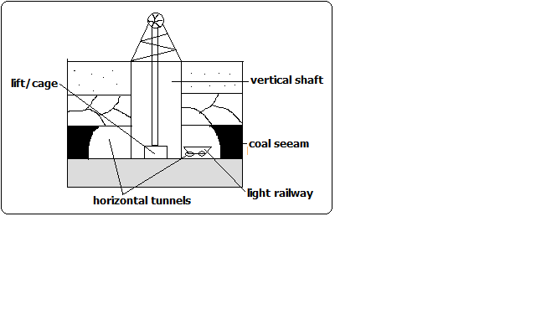

**How it’s carried Out**

* Vertical shafts are sunk into the earth’s crust to reach the layer with the mineral.
* Horizontal tunnels are dug from the vertical shaft to reach the mineral.
* Props are erected to support the roof to prevent it from collapsing.
* The mineral bearing rock is blasted loose by explosives.
* The deposit is transported on light rail or conveyor belt to the bottom of the shaft.
* It is then brought to the surface in a crane or a lift called cage.
  1. **Drift/Adit Mining**

-Method employed when the mineral deposit can be reached from the valley sides.

* Horizontal tunnels (adits) are constructed from the side of the hill.
* Railway line is constructed into the mine to bring out the mineral e.g. mining of copper at Kilembe in Uganda.
  1. **Solution Method**

-Method used in mining soluble minerals such as sulphur, salt, potash, etc.

* Superheated water is ejected into salt deposits.
* The mineral dissolves or melts.
* The solution is then pumped into the surface.
  1. **Drilling**

**-**Method employed in exploitation of petroleum.

* Wells (oil derricks) are drilled.
* Oil and natural gas are brought to the surface under their own pressure or by pumping.

1. **Alluvial/Placer Mining**

-Method used to extract minerals occurring in alluvial deposits e.g. gold, tin, diamonds and platinum.

**Types**

* + 1. **Panning**

It involves:

* Digging a mixture of sand, gravel and mineral from the river bed.
* Putting it in a pan and rotating the pan while tilted.
* The lighter sand or gravel is washed on the side leaving the heavier mineral at the bottom of the pan e.g. gold mining in Migori and R. Morun Beds in W. Pokot.
  + 1. **Dredging**
* A dredger scoops water logged alluvium from the bed of a lake.
* The alluvium is passed over sloping channels with series of traps.
* Wastes are washed away and denser materials are left at the bottom of the trap e.g. mining of soda ash at L. Magadi.
  + 1. **Hydraulic Mining**

-Method used when alluvial deposit occurs on a valley side.

* A powerful jet of water is directed at the deposit.
* Gravel and mineral collect at the valley because of the great pressure.
* The mineral grains are recovered and washed out.
  + 1. **Sub-marine Mining**

-Method employed in extracting minerals in alluvial deposits lying deep down the ocean floor.

* A sub-marine dredger goes down the ocean floor.
* It scoops mineral deposit and rises to the surface.
* The alluvium is passed over sloping channels with series of traps.
* Wastes are washed away and denser materials are left at the bottom of the trap.

**Significance of Minerals/Mining in Kenya**

1. Kenya earns foreign exchange from exportation of minerals which is used to import goods and services and fund development projects.
2. Mining is a source of employment to people such as those who work in mines, in cement factories, in transport sector, etc.
3. Mining has led to development of industries by providing raw materials used in those industries e.g. limestone used in cement factories, coal used in iron and steel industries, soda ash used in glass industry, etc.
4. Mining has led to development of transport system to make mining areas accessible e.g. Magadi soda mine is connected to the main Mombasa-Nairobi railway line.
5. Mining has led to development of settlements e.g. Magadi town which originated from the mining of soda ash.
6. Mining is a source of market for goods and services e.g. there are shops and markets, banking and insurance services offered to people working in mines and related industries.
7. Has led to development of social amenities by providing social facilities such as housing, health, electricity, water and education alongside infrastructure.

**Distribution of Minerals in E. Africa**

**-Phosphates** used in the manufacture of fertiliser-Tororo in Uganda and Majingu Hill in Tanzania.

**-Limestone** used in cement manufacturing-Hima in N.W Uganda, Tanga in Tanzania, Athi River and Bamburi in Kenya.

**-Fluorspar** a source of fluorine used in chemical industries-Kerio Valley in Kenya.

**-Common salt** used for consumption-Kilifi and Magadi in Kenya and L. Kitwe in Uganda.

**-Diatomite** used in making insulators –Kariandusi near Gilgil and Gicheru in Nyandarua.

**-Stones** in Machakos, Mutonga and Mbeere.

**-Carbon dioxide** used in making dry ice and in beer and soft drinks industry- Esagari in Baringo and Kagwe in Kiambu.

**-Diamond** used to make ornaments, glass cutters and drills-Mwadui in Tanzania.

**-Titanium** used in the manufacture of insulators for aircraft- Kwale district.

**-Gemstones** near Voi and Mwatate.

**-Soapstone** used for sculpture-Tabaka in Kisii.

**-Copper** used to make electrical wires and coins-Kilembe in Uganda.

**-Gold** used to make medals and jewellery and as a basis of world currency-Musoma in Tanzania, Kakamega and Migori in Kenya.

**-Coal** used in smelting of iron and generation of thermal electricity**-**in Ruvuma River Basin and Kivira Songwe in Tanzania.

**Problems Facing Mining Industry in Kenya**

1. Inadequate capital making Kenya not to benefit from mineral resources because mining is left to multinational companies who pocket all the money to recover mining cost.
2. Areas where mineral deposits are inaccessible due to poor transport and infrastructure which makes prospecting and mining difficult.
3. Insufficient skilled personnel causing dependence on expatriates who are expensive to pay which reduces profits accruing from mining.
4. Most of mining is controlled by foreign companies so most of the mineral revenue ends up to them as salaries and dividends.
5. Occurrence of minerals in very small deposits which are not economically viable.
6. Lack of power supply especially in remote areas with minerals.
7. Land use conflicts which affect mining e.g. in Kwale between Tiomin and the local people due to inadequate compensation.

**Effect of mining on the Environment**

1. Renders land useless for other economic activities such as agriculture (dereliction) due to open pits left on land and heaps of rock waste litter dumped on land.
2. Pollutes the environment e.g. atmospheric pollution from dust and smoke from tractors and trucks, water pollution from spilling of oil from offshore oil drilling and soil pollution from chemicals and explosives used in mining.
3. Leads to loss of bio-diversity due to destruction vegetation which also destroys habitats of various animals leading to their destruction also.
4. Causes soil degradation e.g. by loosening the soil which makes it vulnerable to agents of erosion like wind and water, tractors and trucks compact the soil making water infiltration difficult and chemicals used interfering with soil chemical composition making it unsuitable for agriculture.
5. Causes mass wasting when explosives and heavy equipment used in mining shake the ground making weathered materials to move faster down slope under the influence of gravity.

**Trona mining on L. Magadi**

**Location**

-L.Magadi is 120km S.W of Nairobi on the floor of the Great Rift Valley.

**Occurrence**

-Trona deposits occur as a solution of sodium salts the main ones being sodium sequicarbonate and sodium chloride.

**Mode of Formation**

* Rain water dissolves soda salts in volcanic rocks.
* The solution percolates through the rocks and soil and gets beneath the basin.
* The accumulated solution is heated by the hot rocks beneath.
* Pressure builds up and the heated solution is pushed to the surface.
* It comes out of the ground inform of hot springs below or on the sides of the lake.
* Due to high temperature water evaporates leaving behind crystals of trona.

**Extraction and Processing**

* A dredger scoops trona out of the lake.
* It crushes it into smaller pieces and separates it from rock debris.
* The material is mixed with water to form slurry and transported to factory on the lake’s shore.
* In the factory the slurry is mixed with water to wash out impurities such as mud and salt and dried.
* It is sent to desiccators and heated to remove moisture and hydrogen to form soda ash.
* Soda ash is cooled and ground into powder and sieved.
* It’s packed into paper bags, weighed and transported to the market.

**Uses of Soda ash**

**Used in the:**

* 1. Glass industry in the manufacture of glasses and bottles.
  2. Manufacture of soaps and detergents.
  3. Softening water in paper making.
  4. In textile industry.
  5. In oil refining.

**Benefits to the Economy**

1. Has led to growth of Magadi town ship.
2. Has led to development of social amenities such as hospitals and schools and water from Oloibortoto River which has benefited the local people.
3. Has led to development of infrastructure e.g. railway line from Konza to L. Magadi.
4. The Magadi Soda Company employs many Kenyans including the nomadic Maasai.
5. Exports of soda ash earn Kenya a substantial amount of foreign exchange.

**Problems**

1. Stiff competition from developed countries with large soda deposits e.g. U.S.A and Israel.
2. Low value of salt is insufficient to meet its production cost.
3. High labour costs due to incentives given so that workers agree to work in the hostile environment of L. Magadi.

**Gold in S. Africa**

Gold occurs as small grains in a hard rock.

It’s mined by shaft mining since its bearing rocks are deep below the surface.

The main mining area is the Witwatersrand and others are Ogendaalrus and lydenburg.

**Processing**

* Ore is crushed to a fine powdery dust.
* Mixed with water until it is fluid mud.
* Cyanide is added to dissolve gold.
* The fluid is runoff with gold dissolved leaving behind waste salts.
* Zinc dust is added to filter gold for solidification.
* Gold sinks as it is denser.
* Gold is smelted and cast into ingots.

**Significance to the Economy of S. Africa**

1. Earns the country foreign exchange used for paying foreign debts.
2. Offers employment to many people raising their living standards.
3. Has led to widespread urbanisation contributing to formation of Witwatersrand conurbation.
4. Has formed a broad market for other industries e.g. engineering, foot wear, electrical and construction industries.
5. Has led to improvement of infrastructure and social amenities e.g. roads, schools, hospitals, etc.
6. Led to development of agriculture.

**Problems Facing Gold mining**

1. Expensive to mine for lying deeply.
2. Large capital is required to start mines.
3. Complication of mining by folds and faults in the crust.
4. Low gold content in the ore.
5. Problem of removal of underground water.
6. Lack of adequate supply of fresh water on the surface in mining areas.
7. Accidents resulting from collapsing of mine roofs.

**Diamond Mining in S. Africa**

Diamond is the hardest known substance.

-Mined in Kimberly, Bloemfontein and Alexander Bay.

-Mined by underground mining or alluvial mining.

**Processing**

* Diamond bearing Kimberlite is crushed
* Crushed rock is mixed with water
* Diamond sinks to the bottom as it’s denser
* Water and less dense residue are drained off
* Remaining material is put on heavily greased trays and washed
* Diamond repels water so it sticks to grease while remnants are drained off
* Diamonds are then sorted out and graded into gem diamonds and industrial type (for cutting purposes).

**Contribution to the Economy**

1. Provides employment to thousands of people
2. Earns the country substantial foreign exchange
3. Has led to growth of urban centres e.g. Pretoria and Kimberly.
4. Has contributed to development of infrastructure

**Problems Facing Diamond Mining**

1. Fluctuation in the world market prices
2. High cost of mining and processing diamond
3. depletion of mines
4. Low mineral in the ore making mining expensive
5. labour competition with other sectors e.g. manufacturing and gold mining

**Petroleum in the Middle East**

Oil is a thick black sticky liquid called crude oil

* It was formed from small creatures that lived in shallow lagoons about 100-200m ago.
* Decaying remains of those creatures mixed with mud at the bottom as sediments
* The sediments piled on each other and slowly transformed into sedimentary rocks
* Gradually the remains were converted into oil and gas.

Major oil producers in the Middle East are Saudi Arabia with the largest reserves, Iraq, Kuwait and United Arab Emirates.

Middle East accounts for 64% of world oil reserves.

There are several giant oil fields in Ghawar in Saudi Arabia and Kirkuk in Iraq.

**Processing**

Crude oil is processed by refining using a technique called fractional distillation.

The process takes place near as possible to the market as it’s cheaper to transport crude oil than the different refined products.

It’s processed into secondary products such as petrol, paraffin, lubricating oils, dyes, fertilisers and plastics.

* Impurities are removed from the crude oil
* Crude oil is heated before entering fluctionating column
* It’s turned into vapour or gas
* Different ingredients turn back to liquid at different temperatures.
* Ingredients gradually cool, condense and collect in various trays and allowed to overflow until they reach an outlet.

**Contribution to the Economies**

1. Arab’s investments overseas have increased due to oil reserves.
2. High income per capita due to oil profits.
3. Has led to development of cities e.g. Tripoli in Libya.
4. Investment of oil money in other sectors e.g. power stations, cement factories and exploitation of other minerals.
5. Earns the countries substantial foreign exchange
6. Increased political and military power.
7. Artesian water is made available for domestic and irrigation purposes e.g. in Libya.
8. Oil companies help in fixing down the sand dunes and planting trees in the deserts.

**FORM 2 GEOGRAPHY**

**INTERNAL LAND FORMING/ENDOGENETIC PROCESSES**

**-**Processes operating in the interior of the earth resulting in the formation of natural physical features or landforms.

They are caused by earth movements.

Examples of these processes are folding, faulting and Vulcanicity.

Formation of land forms by internal land forming processes is determined by:

* Nature and age of earth materials
* Type of movement involved
* Intensity and scale of movement involved

**Crustal Earth Movements**

**-**Displacement of the earth’s crustal rocks.

They are brought about by tectonic forces which originate and operate in the interior of the earth e.g. tensional forces (which operate along horizontal plane moving away from each other), compressional forces (which operate along horizontal plane moving towards each other), shear forces (which move past each other with unequal strength) and gravitational forces (which attracts things to the earth’s centre).

Earth movements are of 2 types:

1. Horizontal/lateral/orogenic movements
2. Vertical/epeirogenic movements

**Horizontal Earth Movements**

-Movements which act along a horizontal plane within crustal rocks.

They are caused by tensional and compressional and shear forces.

**Effects**

They cause:

* Strain and stretching of crustal rocks due to stretching caused by tensional forces which cause formation of cracks or faults.
* Squeezing and shortening of crustal by compressional forces rocks which cause them which also cause formation of faults.
* Crustal rocks to shear by slipping past each other or by dividing into layers which is caused by shear forces.

**Results of Horizontal Earth Movements**

**-**results in the formation of the following features:

1. Faults
2. Rift valleys
3. fold mountains
4. Escarpments
5. Basins
6. Tilt blocks
7. Block mountains

**Vertical Earth Movements**

-Movements which occur along the earth’s radius or towards the earth’s surface or towards its centre.

**Effects**

**Causes:**

* Subsiding/sinking/downwarping or pulling of crustal rocks downwards.
* Uplifting/upwarping or pushing of crustal rocks upwards
* Tilting of crustal rocks or shearing in vertical direction due to greater uplift on one side.

**Results of Vertical Earth Movements**

1. Raised cliffs
2. Tilt blocks
3. Rift valleys
4. Fault scarps/escarpments
5. Plateaus
6. basins

**Causes of Earth Movements**

1. Magma movement within the earth’s crust.
2. Gravitational force
3. Convectional currents in the mantle
4. Isostatic adjustment

**Magma Movement within the Earth’s Crust**

* + When magma moves with force pushing crustal rocks horizontally or vertically.
  + When magma moves from reservoir and leaves empty spaces onto which crustal rocks are pulled inwards.

**Gravitational Force**

-When the attractive force of the earth pulls crustal rocks into empty spaces left after magma escaping from the reservoir.

**Convectional Currents within Mantle**

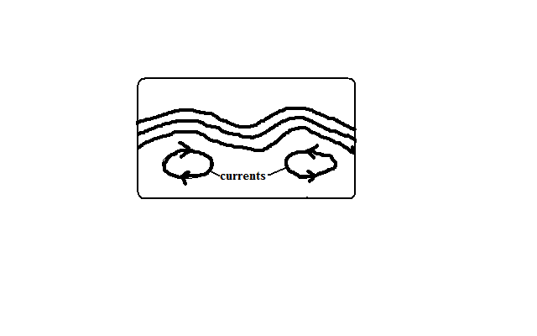

-When convectional currents in magma in mantle drug crustal rocks by friction.

Horizontal movement of currents cause horizontal movements while vertical cause vertical movements.

**Isostatic Adjustment**

-Rising of continental masses to restore the upset state of balance between sial and sima layers.

-Isostacy is the state of balance between sial and sima layers.

It can be disturbed by erosion on continents and melting of continental ice sheets.

The reduced weight causes continental masses to rise.

**Theories Explaining the Earths Movements**

A theory is reasoned ideas intended to explain facts or ideas.

There are 2 theories which explain the earth’s movements namely the Continental Drift Theory and the Plate tectonics theory.

**i)Theory of Continental Drift**

Its proponent was A. Wegener.

It explains the origin of 6 continents.

It states:

* The earth was a single sialic land mass called **Pangaea** surrounded by a huge ocean called **Panthalasa** whose floor was a mass of sima.
* Pangaea broke into two parts called **Laurasia** (N. Hemisphere) which lay around equator and **Gondwanaland** (S. Hemisphere) which lay around south pole which were separated by a narrow ocean called **Tethys** (the present Mediterranean Sea).
* Laurasia broke into Laurentian Shield and Fennoscandia (Europe, Asia and N. America) and moved northwards to their present positions.
* Gondwanaland broke into Africa, Australia, S. America and Antarctica and India subcontinent.
* Africa and India drifted northwards.

**Evidences Supporting the Theory**

* 1. Fitting of western coast of Africa and S. America into a jigsaw.
  2. Discovery of coal 40◦N and 55◦N which was formed by burying of tropical vegetation.
  3. Considerable displacement of rocks along some faults e.g. along the Great Glen Fault of Scotland.
  4. Cape and Buenos Aires folds resemble one another by having east west trend.
  5. Red sea shores show evidence of having undergone lateral displacement an indication that it was formed by movement of the earth’s crust.
  6. Evidence of ancient Glaciation to the south of equator in Africa in Madagascar and India where there is presence of ancient glacial deposits suggesting these areas were once around South Pole.

**ii)Plate Tectonics Theory**

It states that:

* The earth’s crust is made of blocks called plates.

**7 Large Ones**

* 1. Eurasian plate
  2. Australian plate
  3. Africa plate
  4. Antarctic plate
  5. N. American plate
  6. S. American plate
  7. Pacific plate

**Smaller Ones**

1. Indian
2. Arabian
3. Caribbean
4. Cocos
5. Somali plates
6. Juan de Fuca
7. Nazca
8. Philippine
9. Scotia

* These plates are two types : tectonic plates:
  1. Oceanic plates which form major areas of the ocean floor including coastal lowland.
  2. Continental plates which form the bulk of the continental land mass.
* The plates float on molten mantle layer called **Asthenosphere.**
* The plates move relative to each other due to convectional currents in the mantle.
* They move away from each other forming **extension** or **constructive** **boundary** called so because magma fills the space between.

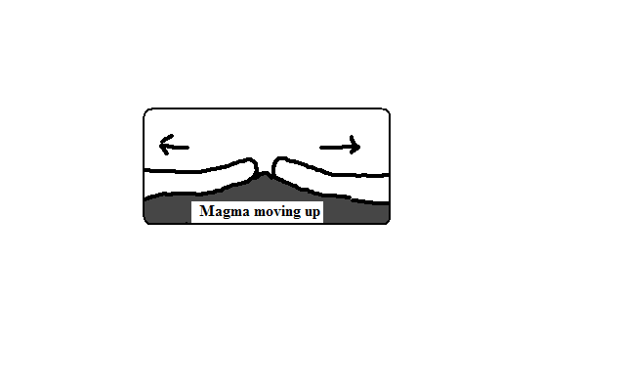

* They move towards each other forming **compressional** or **destructive** **boundary** called so because materials between are crushed. The movements of those two types of plates have the following effects:
  1. **When two oceanic plates meet**

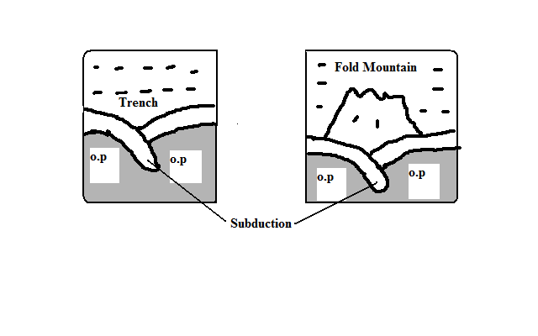

* There is subduction and the ocean floor is pulled inwards forming a trench e.g. Java Trench .**Subduction** is the passing of edge of one plate beneath the edge of another.
* Sediments on the sea floor in the region of subduction are compressed to form Fold Mountains.
  1. **When an oceanic plate meets a continental plate** the edge of the oceanic plate slides beneath the continental plate in a movement called subduction.
* Sediments on the sea floor in the region of subduction are compressed to form Fold Mountains.
* Fold Mountains are also formed at the edge of the continent when the sial layer is compressed.
* The edge of the oceanic plate bends into the mantle forming a trench.

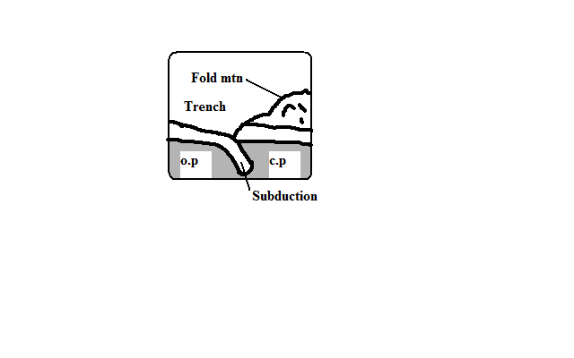

* 1. **When two continental plates collide** the sial layer is folded into mountains.

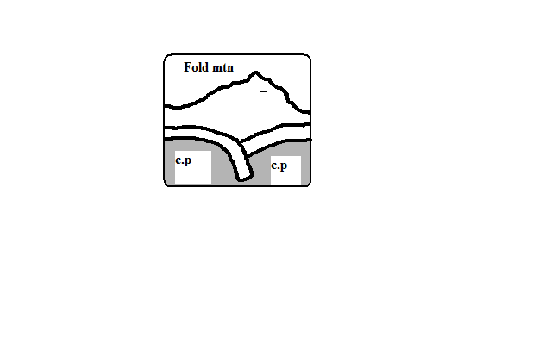

* They move past each other forming **transform** or **conservative** **boundary** called so because there is neither construction nor destruction which occurs where the plates are separated by a major fault.

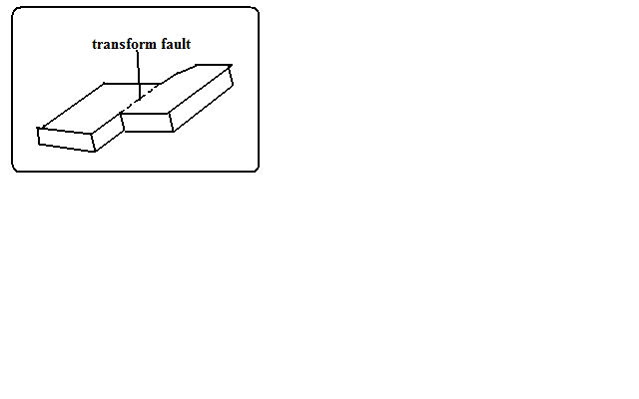

**Significance of Plate Movements**

1. Are sources of earthquakes and Vulcanicity.
2. Causes formation of land forms such as Fold Mountains and ocean trenches.
3. Spectacular landscapes formed are a tourist attraction.
4. Eruption of magma can result in formation of valuable minerals.

**FOLDING**

-Process in which crustal rocks are distorted by compressional forces by being caused to bend upwards and downwards.

-It occurs on fairly young sedimentary rocks.

**Parts of a Fold**

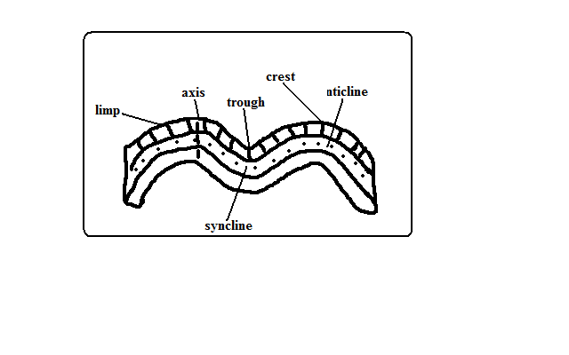

1. Anticlines (upfolds)-parts of the earth’s surface which bend upwards when folding occurs.
2. Synclines (down folds)-Parts of the earth’s surface which bend downwards when folding occurs.
3. Crest-upper most part of Anticline.
4. Trough-lowest part of a syncline
5. Limp-rock layers sloping on both sides of a fold
6. Axis-imaginary line drawn vertically through the centre of the anticline.

**Types of Folds**

**1. Simple Symmetrical Folds**

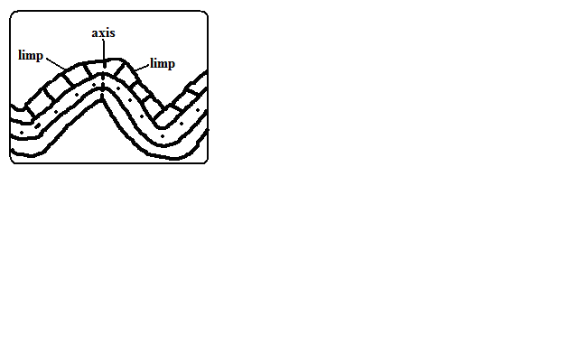

-Which are symmetrical about the anticline.

-Formed by 2 compressional forces of equal magnitude.

**2. Asymmetrical Folds**

**-**Which are asymmetrical about the anticlines axis or in which one limp is steeper than the other.

-Formed by two compressional forces of unequal magnitude in which one is stronger than the other.

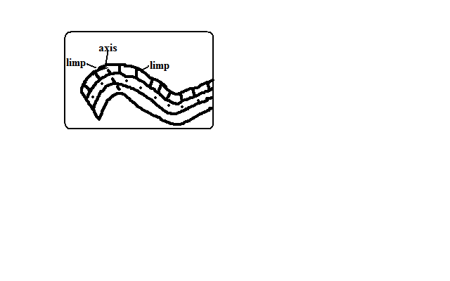

**3.Over Folds**

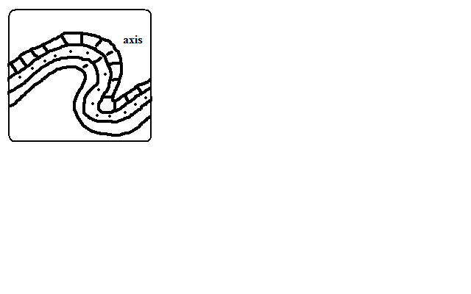

-In which anticline of one fold is pushed over the limp of the other.

**4. Isoclinal Folds**

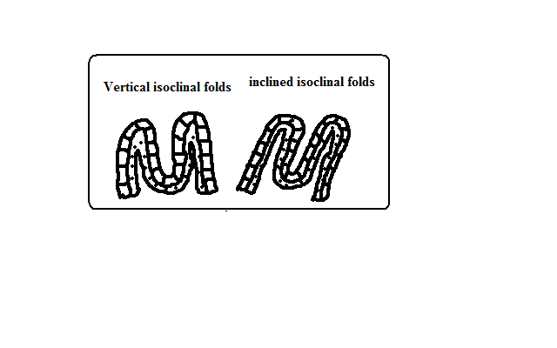

-Which are packed closely together and with limps almost parallel to each other.

-Vertical Isoclinal folds are formed by compressional forces of equal magnitude while inclined Isoclinal folds are formed by forces of unequal magnitude.

**5. Recumbent Folds**

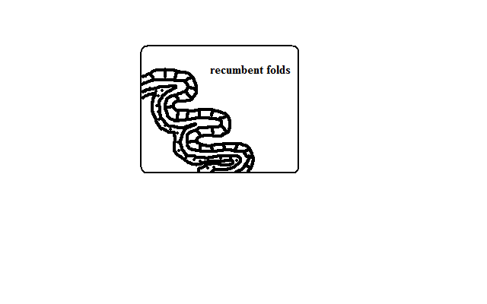

-Which lie in a horizontal manner.

-Formed by two compressional forces one of which is very strong.

**6. Nappe/Overthrust Fold**



- In which one limp is pushed over the other limp.

-The forces are very strong and they cause a fracture/fault to develop.

**7Anticlinorium and Synclinorium Complex**

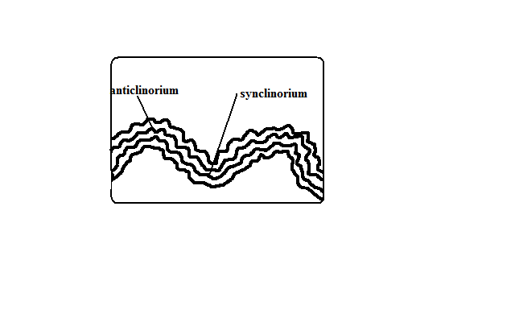

-Folds characterised by minor upfolds and minor downfolds.

* Land is first subjected to weak compressional forces resulting into minor folds.
* Later the land is subjected to much greater compressional forces resulting into new upfolds with minor folds (Anticlinorium) and new down folds with minor folds (Synclinorium).

**Resultant Features Due To Folding**

**1. Fold Mountains and Their Distribution**

-Worlds highest and most impressive mountains and the most conspicuous feature of folding.

* Himalayas-Asia
* Everest-Nepal-Tibet border-highest point.
* Andes-Peru in S. America
* Alps-South Central Europe
* Rockies-W.N. America
* Atlas-N.W. Africa.
* Appalachian-E.N. America

**Theories of Origin of Fold Mountains**

**1. Contraction Theory**

During the earth’s formation surface rocks cooled faster and wrinkled to form Fold Mountains.

**2. Convectional Currents Theory**

* Horizontal convectional currents in the mantle exerted frictional pull on crustal rocks.
* Continental crusts were pulled towards each other.
* Sediments between them were squeezed into folds.

**3. Continental Drift Theory**

* During break of Gondwanaland India drifted northwards and collided with Eurasia.
* Sediments between were squeezed to form fold mountains e.g. Himalayas and Everest.

**4. Plate Tectonics Theory**

* When an oceanic plate meets another or it meets a continental plate the sediments under the sea are compressed to form Fold Mountains.
* When two continental plates meet the sial layer is compressed to form fold mountains

-E.g. Alps was formed when Africa plate pushed against the rigid European plate.

**2. Escarpments**

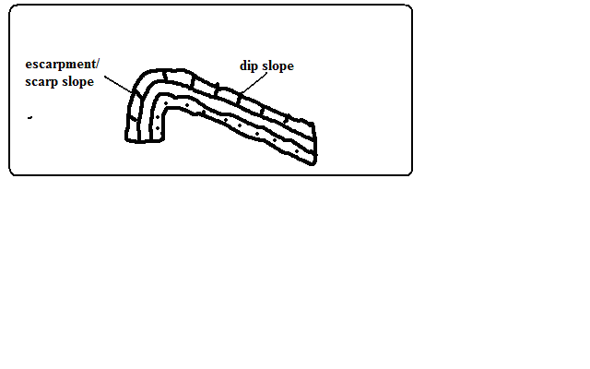

-A relatively continuous line of steep slopes facing the same direction.

Formed one compressional force causes folding resulting in one steep limp of the anticline which forms the escarpment.

**3. Depressions**

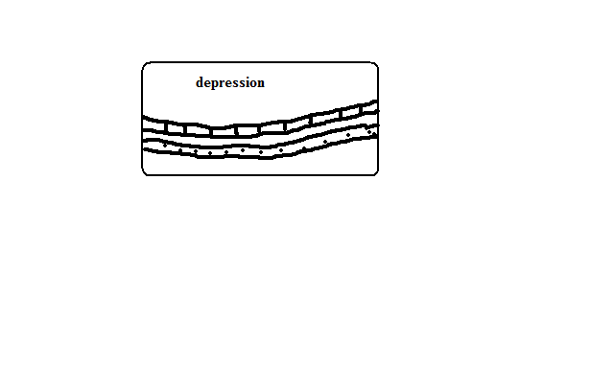

Formed when not very strong forces cause folding causing some parts of the earth’s surface to form synclines forming basins.

**4. Ridges and Valleys**

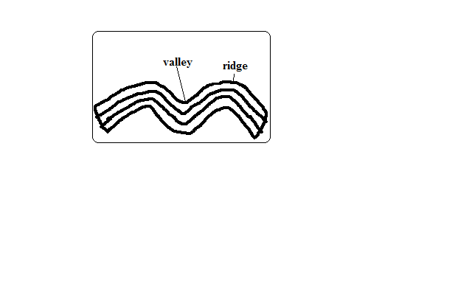

When folding occurs anticlines form uplands/ridges/hills while synclines form valleys.

**5. Rolling Plains**

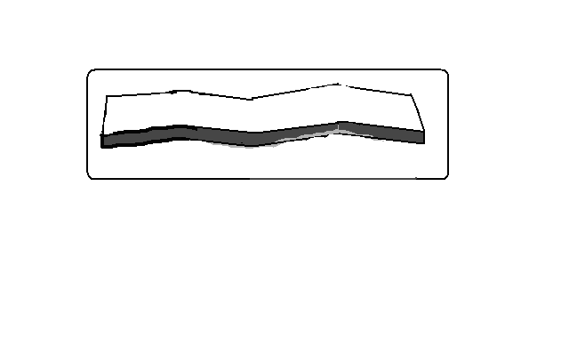

**-**Plains which appear to rise and roll.

-Formed when plains are acted upon by weak compressional forces resulting into gently sloping anticlines and very wide synclines.

**6. Inter-montane Plateaus**

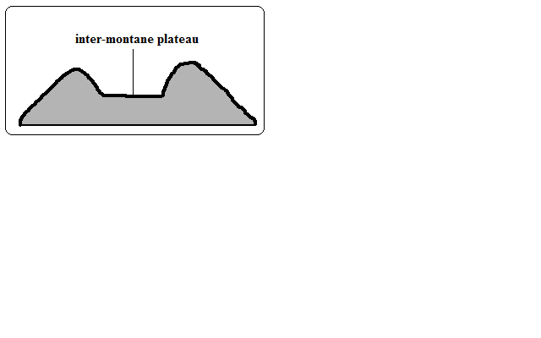

-A high fairly level land between mountains.

-Formed when rocks at the edges of a region become intensely folded and the middle parts resist folding resulting into mountains which enclose a high fairly level land.

**7. Inter-montane basins**

-Formed when some parts of inter-montane plateau sink more to form basins.

**Significance of Folding**

**To Human Activities/Economic significance**

**Positive/advantages**

1. Fold Mountains are a tourist attraction which brings foreign exchange.
2. Fold Mountains are water catchment areas and sources of rivers.
3. Some fold mountains have valuable mineral deposits such as coal and petroleum.
4. Fold Mountains act as protective barriers during war.
5. Some fold mountains on the path of rain bearing rainfall influence rainfall causing the windward slopes to receive heavier rainfall.
6. Folding can lead to formation of valuable minerals due to metamorphism.
7. Folding brings valuable minerals to the surface making them easily available.

**Negative/disadvantages**

1. Fold Mountains on the path of rain winds cause the leeward slopes to receive less rainfall.
2. Fold Mountains discourage settlement due to cold temperatures and rugged terrain
3. Folding can lead to burying of minerals.
4. Fold Mountains are a barrier to road and railway where there are no passes and where there are passes they may be covered by snow. Orographic fog hinders pilot’s visibility.

**To Physical Environment**

* 1. Folding can result in submerged coastal zones which are used as harbours.
  2. Can lead to metamorphism of rocks changing their original state and making them more resistant to erosion.
  3. Depressions formed by folding turn into wet land important for water purification.
  4. Folding leads to faulting and magma may escape through faults leading to Vulcanicity and earth quakes.

**FAULTING**

Faulting is the cracking/fracturing of the brittle crustal rocks due to tectonic forces.

Faults are fractures or cracks that develop in the crust.

* When tensional forces cause crustal rocks to stretch and fracture at the region of maximum tension.
* When compressional causes squeezing of crustal rocks to fracture at the areas where they are intensely squeezed.
* When vertical movements exert pressure on rocks leading to fracturing.
* When shear forces cause crustal rocks to tear.

**Parts of a Fault**

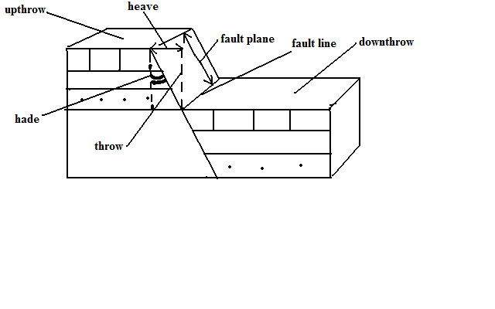

* 1. Upthrow-part of the land displaced upwards.
  2. Down-throw-part of the land displaced downwards.
  3. Throw-vertical displacement.
  4. Heave-horizontal displacement
  5. Hade-inclination of fault to vertical plane
  6. Fault line-fault path
  7. Fault plane-separation of land created by the fault

**Types of Faults**

**Normal Faults**

Type formed by tensional forces in which one block slides downwards in relation to the other.

* Rocks are subjected to tensional forces

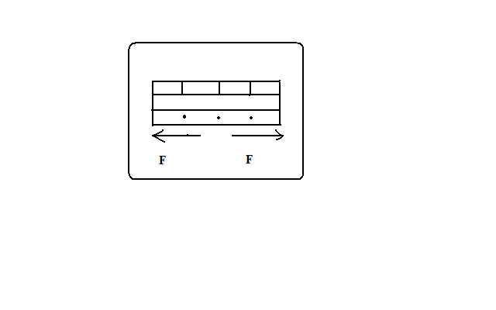

* A normal fault develops

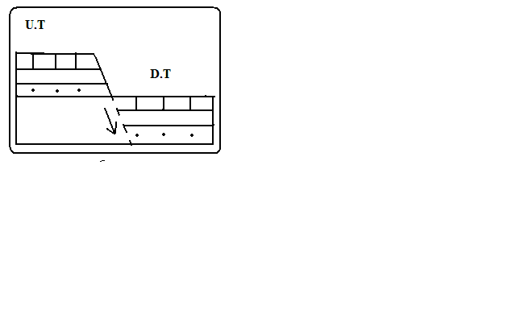

* One block slides downwards.

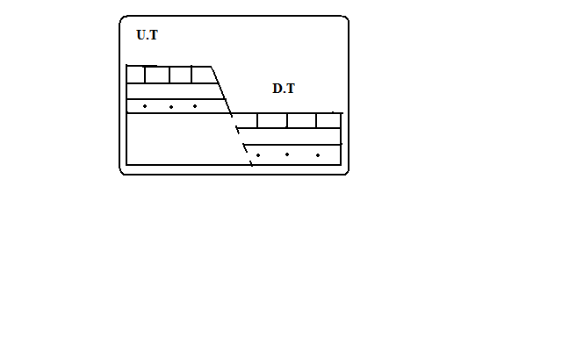

**Reverse Fault**

Type formed by compressional forces in which one block of land is pushed upwards in relation to the other.

* Rocks are subjected to compressional forces.

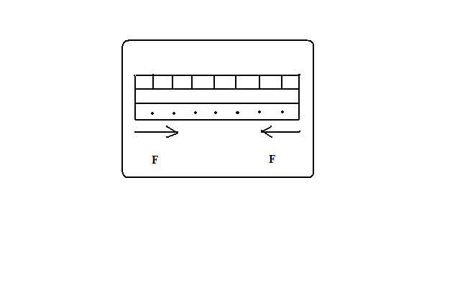

* A reverse fault develops.

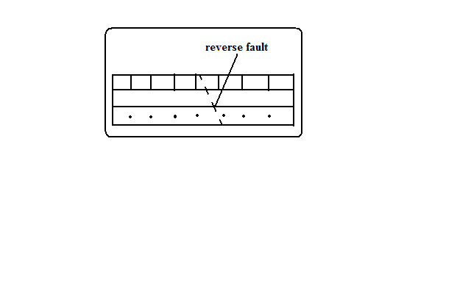

* One block is pushed over the other.

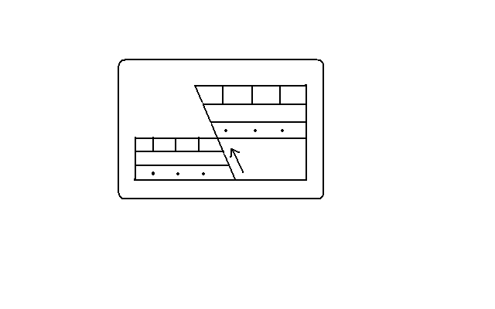

**Shear/Tear Fault**



Type formed by shear forces in which adjacent blocks of land slide past one another. If a shear fault occurs between continents it’s called a **Transform fault** e.g. San Andrean fault of California and great glen fault of Scotland.

**Thrust Faults**

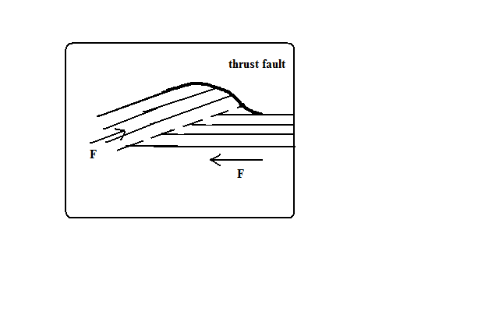

Typeformed when very strong compressional forces cause almost horizontal faults to develop and one block of land is pushed over the other.

**Anticlinal fault**

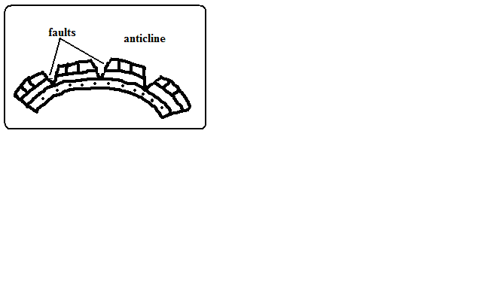

Typeformed when anticlines are compressed further and cracks form on the crest.

**Features Resulting From Faulting**

**Fault Scarp/Escarpment**

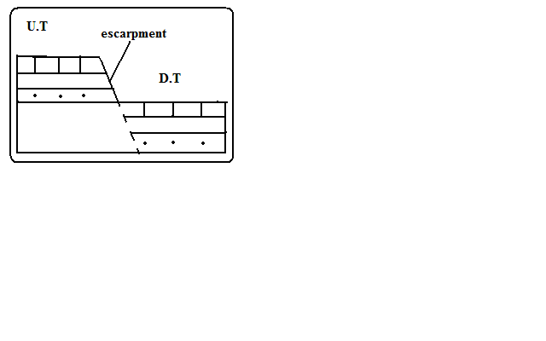

Steep line of slopes formed by vertical movement of earth along a fault e.g. Mau, Nguruman, Nyandarua and Nandi.

-Are exposed parts of a fault plane.

It may be formed due to normal faulting or reverse faulting when overhanging blocks are eroded.

**Fault Steps**

-Landresembling the staircase or steps of a house with a series of fault scarps at different levels.

* Parallel vertical faults develop.
* Land between the faults is unequally displaced downwards.
* A series of fault scarps at different levels is formed.

-E.g. Keiyo escarpment and at Kijabe.

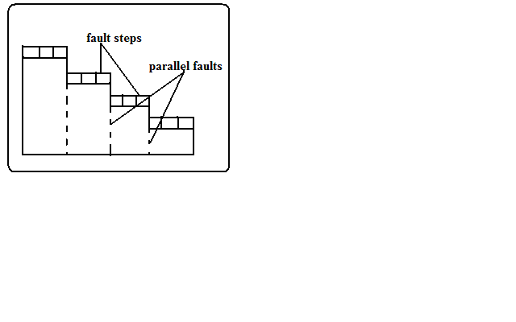

**Fault Blocks/Block/Horst Mountains**

Blocksof land raised above the surrounding land.

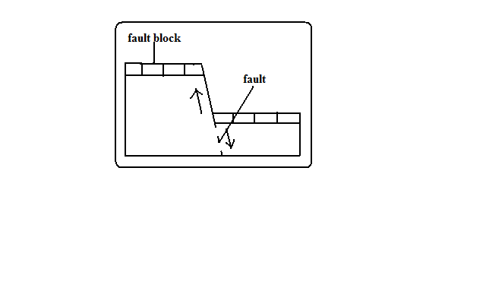

* Where tectonic forces cause faulting and land on one side of the fault get raised or sink along the fault planes.

Examples of fault blocks are Aberdare/Nyandarua ranges, Mau escarpment and Nandi Hills.

2.

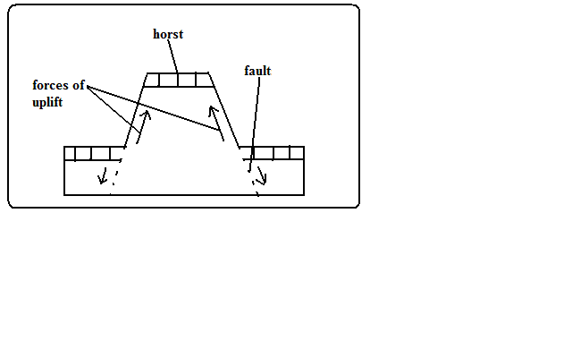

* Where Blocksof land bordered by normal faults which are almost parallel to each other sink leaving the middle block standing.

Examples of horsts are Ruwenzori of W. Uganda and Usambara and Pare mountains of Tanzania.

**Tilt Blocks**

-Fault blocks which are inclined on one side.

* Occurs when the fault block, horst or fault steps have greater uplift on one side and as a result they are not flat at the top but tilted. The resultant features are tilted fault blocks, tilted horst and tilt fault steps which form ridges and fault guided valleys.

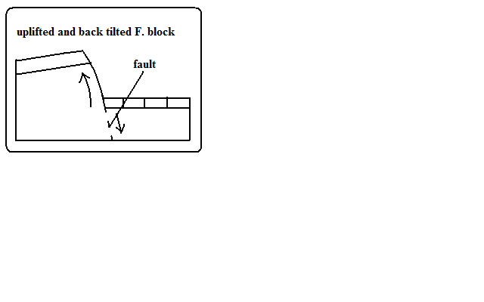

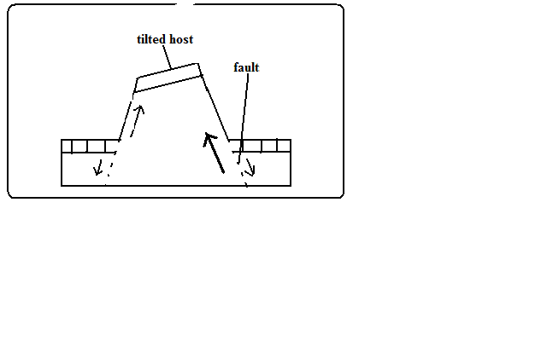

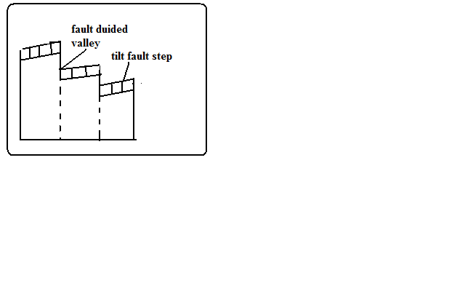

**Rift Valley**

-Along narrow trough with steep escarpments on both sides.

**Theories of Formation**

**Tensional Theory**

* Rocks are subjected to tensional forces.



* Normal faults which are almost parallel develop.

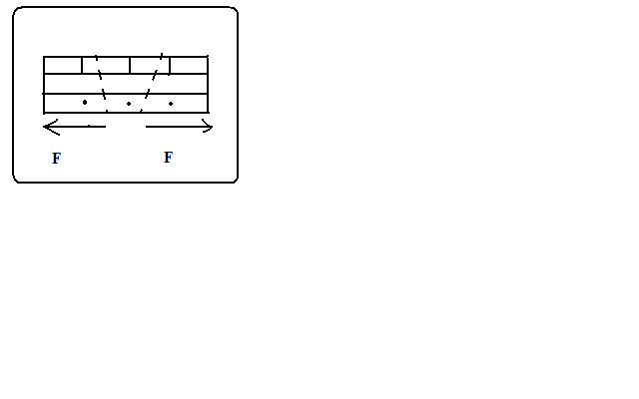

* One block slides downwards forming the rift valley.

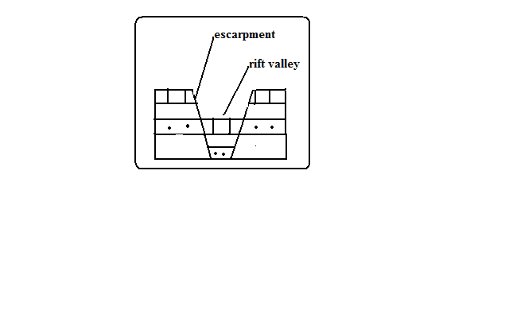

**Compressional Theory**

* Rocks are subjected to compressional forces.



* Reverse fault which are almost parallel develop.

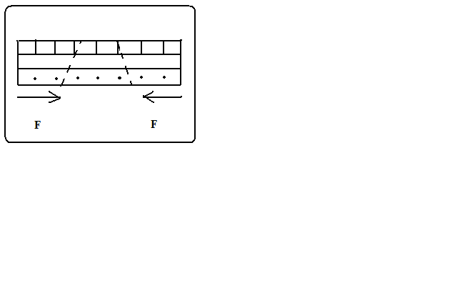

* The side blocks are pushed over the middle block.

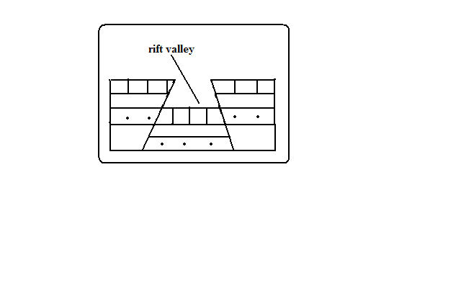

* Overhanging blocks are worn out by denudation to form escarpments



**Anticlinal Theory**

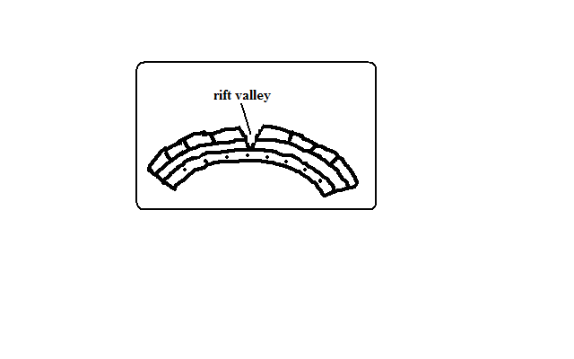

Suggests the rift valley was formed by Anticlinal arching.

* Upward forces pushed sedimentary rock strata upwards.
* The rock layers bent into a big arch.
* A gaping/huge crack developed at the crest of the arch due to tension forming the rift valley.

**The Great Rift Valley/The Great E.A Rift Valley**

**-**The world’s biggest rift valley.

It starts in Syria and ends in Mozambique.

It’s divided into 4 parts.

1. Ethiopian Rift system-starts from Afar in Ethiopia to the Kenyan border around L. Stephanie.
2. Gregory Rift system-Starts from the northern border of Kenya with Ethiopia to Tanzania. It has a small N.E-S.W branches:
   * Kano Rift valley in Kenya
   * L. Eyasi Rift Valley in Tanzania
3. Western Rift valley-Starts at Sudan border to south of L. Rukwa. Features which are here are Ruwenzori Mountain and Lakes Albert, Edward, Kivu, Tanganyika and Rukwa.
4. Malawi Rift valley-a continuation of Gregory Rift system to Zambezi River in Mozambique. It has a small N.E-S.W branch called Luangwa valley.

**The Gregory Rift Valley**

-Named after a geologist called Gregory J.W who carried out extensive studies in this area.

It’s where the Rift Valley features are more pronounced.

**Features associated with it**

* Fault blocks**-**Aberdare range, Mau, Nandi and Cherangani hills.
* Step faults-Kijabe and Tambach
* Tilt blocks-Aberdare range uplifted and tilted eastwards and Mau escarpment uplifted and tilted westwards.
* Lava flows and volcanic cones e.g. Menengai and Ngorongoro crater.
* Rift Valley lakes formed when unequal sinking created faults which were later filled with water. The lakes are deep and elongated. Examples are Lakes Naivasha, Nakuru, Elementaita, Baringo, Bogoria, Ol Bolossat and Turkana. Most of the lakes are salty with exception of L. Naivasha which has fresh water.

**Why Most Rift Valley Lakes Are Salty**

1. Lack of outlets to drain away salts contained in them.
2. Lack of enough water to dilute salinity due to little rainfall and lack of rivers flowing in them.
3. High rates of evaporation causing increased accumulation of salts.
4. Lake’s water being in contact with rocks with mineral salts which it directly dissolves.
5. Washing into the lake of mineral rich soils by surface runoff.

**Why L. Naivasha Has Fresh Water**

1. It has underground drainage to the Indian Ocean.
2. There is inflow of fresh water from rivers and rain.
3. The latest volcanic eruption covered the bed rock with lava.

**Major Faulted Areas of the World**

1. The Great Rift Valley from Syria to Mozambique.
2. Northern England and the Great Glen Fault of Scotland.
3. The Central Massif of Europe.
4. The middle Rhine Rift Valley region.

**Significance of Faulting**

**To Human Activities**

1. Rift valley lakes are important for fishing, irrigation and domestic use.
2. The Rift Valley and associated features are a tourist attraction which earns foreign exchange.
3. Hot springs and geysers formed during faulting can be harnessed for geothermal power.
4. Block Mountains are water catchment areas and sources of rivers due to the heavy rainfall they receive on the windward side.
5. Faulting results in the exposure of minerals such as diatomite in Gilgil and Fluorspar in Kerio Valley.
6. Fault scarps may expose underground water resulting in the formation of scarp springs.
7. Unequal subsidence caused by faulting may cause formation of depressions which may form lakes which useful for fishing, transport and mining e.g. L. Naivasha.

**Negative**

* 1. Faulting disrupts transport and communication by disjointing land.
  2. Faulting may lead to loss of life and property by causing land to sink.
  3. Faulting may cause a river to disappear or change its course and flow along the fault line.
  4. Steep scarp slopes formed by faulting are prone to soil erosion.
  5. Faulting has given rise to semi-desert conditions in some areas when Block Mountains on the path of rain winds cause leeward sides to receive little rainfall.

**VULCANICITY**

-Process in which solid, liquid or gaseous materials are forced out of the interior of the earth into the earth’s crust or onto the earth’s surface.

These materials are magma, lava, gases, dust, ash and cinder.

**Causes of Vulcanicity**

* Magma under high temperature and pressure moving through lines of weakness or faults.
* When tectonic plates move away from each other and boundaries give way to magma.
* Underground water coming into contact with hot materials hence changing into gaseous form.

There are 2 types of Vulcanicity:

**Extrusive Vulcanicity (volcanic)**: in which materials intrude crustal rocks and don’t reach the earth’s surface. **Magma** is the molten material while it’s underground.

**Intrusive Vulcanicity (plutonic):** in which materials reach the earth’s surface. **Lava** is the molten material after it reaches the surface.

There are two types of lava and magma, acidic and basic. Acidic lava is viscous and solidifies quickly and doesn’t spread far but accumulates around the vent. Basic lava is more fluid or less viscous and takes longer before cooling and spreads for great distances before doing so. Other materials emitted are **gases**, **ashes, dust and cinder.** The solid materials are called **pyroclasts**. Materials come out through a **hole/vent (vent eruption)** or **crack/fissure (fissure eruption)**.

**Features Resulting From Vulcanicity**

-Divided into intrusive and extrusive features or landforms.

**Intrusive/Plutonic Features**

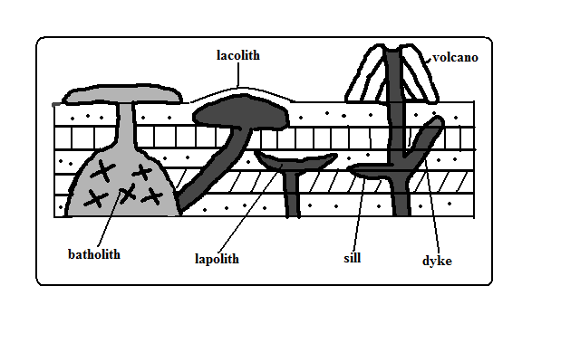

-Features formed by intrusive Vulcanicity when materials intrude the earth’s crust.

**Sill**

**-**An igneous intrusion which lies along a bending plane of rock strata.

-Formed when magma forces its way between rock layers then cools and solidifies.

-It forms ridge like escarpments when exposed by erosion e.g. Fouta Djalon highland of Guinea and 3 sisters of S. Africa.

**Dyke**

-A wall-like igneous intrusion which lies across the bedding plane of rock strata.

-Formed when magma intrudes cracks or faults cutting across bedding planes of rocks then cools and solidifies.

-Can be vertical or inclined.

When exposed it forms ridges e.g. Kaap Valley in Transvaal S. Africa and Jos Plateau in Nigeria.

**Laccolith**

-Amushroom-shaped igneous intrusion lying between bending planes of a country rock.

-Formed when viscous magma pushes its way through a vent and accumulates around the vent before reaching the earth’s surface pushing the overlying rock into a dome shape.

-It’s so high that land is turned into mountains e.g. El Koub Hill in Algeria, Henry Mountains in Utah U.S.A and Fonjay Massif in Madagascar.

**Batholiths**

-Largest igneous intrusion formed underground formed when very hot magma intrudes bedding planes of rocks and replaces or metamorphoses it e.g. Chaila Massif in Gabon, Ikhonga-Murwe in Kakamega and the largest is in British Columbia.

**Lopolith**

-a large saucer shaped igneous intrusion formed when viscous magma intrudes into bedding planes of a country rock. They form shallow depressions on the earth’s surface of the earth e.g. Bushveld complex in S. Africa and Duluth Gabbro mass in U.S.A.

**Phacolith**

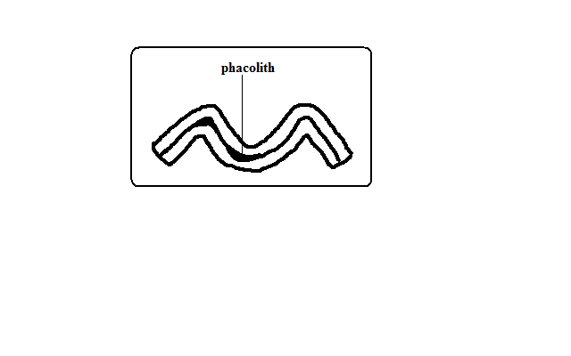

**-**A lens shaped igneous intrusion which forms in the crest or trough of an anticline e.g. Corndon Hill in England.

**Extrusive/Volcanic Features**

-Formed when magma reaches the earth’s surface through vents or fissures.

**Volcanoes**

A volcano is a cone shaped hill formed when volcanic materials flow out and accumulate around a vent. Volcanoes are classified into three groups:

1. Active volcano- which is known to have erupted in recent times e.g. OL Donyo Lengai in Tanzania and Mt. Cameroon, and Mauna Loa in Hawaii.
2. Dormant volcano-not known to have erupted in the recent past but show signs of volcanic activity such as presence of hot springs, geysers and fumaroles e.g. Mt. Kilimanjaro, Longonot and Menengai.
3. Extinct volcano-which has not shown signs of possible future eruptions e.g. Mountains Kenya and Elgon.

**Types of Volcanoes**

**Acidic Lava Domes**

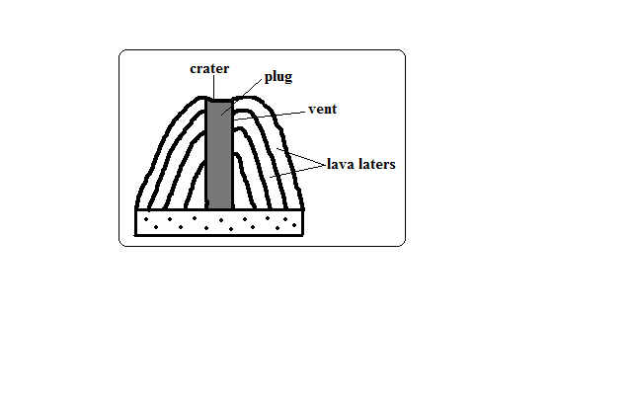

**-**A steep dome shaped volcanic hill made of acidic lava.

* Viscous lava flows out through a vent.
* It accumulates around the vent because it’s viscous.
* Eruptions occur later and lava flows out covering the layers below.
* A steep sided dome shaped mound of volcano is formed e.g. Itasy Massif of Madagascar, Mt. Kenya and Kilimanjaro.

**Characteristics**

1. Its dome-shaped
2. Has steep slopes
3. Made of acidic lava
4. Has lava layers
5. Has steep slopes
6. Has a narrow base

**Basic Lava Domes/Shield Volcanoes**

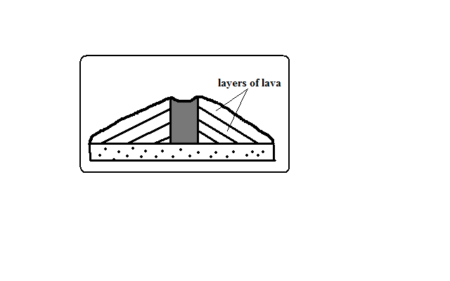

**-**A low lying volcanic hill made of basic lava.

* Basic magma flows out to the surface through a vent.
* The lava flows far before solidifying because its fluid.
* Eruptions occur later and lava spreads over the old lava.
* A shield shaped mound of volcano is formed e.g. Canary Islands, Cape Verde and Sao Tome which are volcanic Islands in the Indian Ocean.

**Characteristics**

1. Dome/shield shaped
2. Has gentle slopes
3. Made of basic lava
4. Has lava layers
5. Has a broad base

**Ash and Cinder Cones**

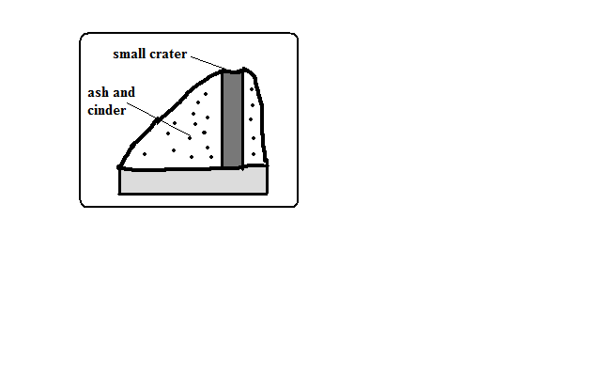

A volcano built from ash and cinder or small fragments of lava.

* Violent vent eruption occurs.
* Ash and pyroclasts are emitted and thrown high.
* Some materials fall and settle around the vent forming a hill.
* Light materials are blown by wind to the leeward side e.g. Chyulu Hills, Teleki and Likaiyu near L. Turkana.

**Characteristics**

1. Made of pyroclasts
2. Asymmetrical about the axis
3. Cone shaped
4. Has smooth slopes
5. Has steep windward slope and gentle leeward slope

**Composite /Complex/Stratified Volcanoes**

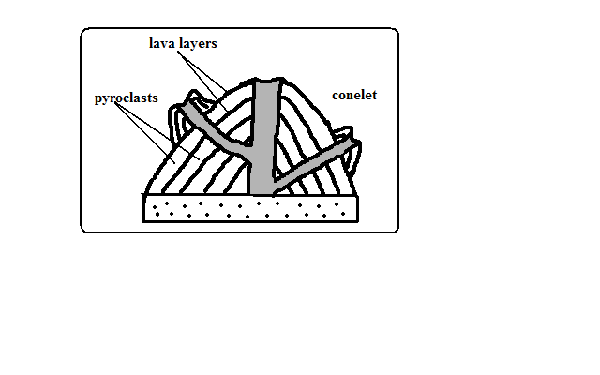

A volcano made of alternating layers of lava and pyroclasts and conelets.

* The first eruption throws out pyroclasts.
* Then viscous lava flows out and solidifies on them.
* Eruption occurs later blowing the rocks sealing the vent.
* The pieces of rock settle on earlier solidified lava.
* Another mass of lava flows out and spreads over pyroclasts and solidifies.
* The process is repeated causing the volcano to build upwards
* The conelets are formed when magma is unable to overcome the plug and finds its way through weak lines at the sides and then pyroclasts and lava accumulate around the side vent e.g. Mountains Kenya, Longonot, Elgon and Kilimanjaro.

**Characteristics**

1. Cone shaped
2. Stratified (made of alternating layers of lava and pyroclasts.
3. It has conelets (parasitic cones).
4. It has steep slopes.
5. Made of acidic lava

**Plug Dome/volcano/Spine**

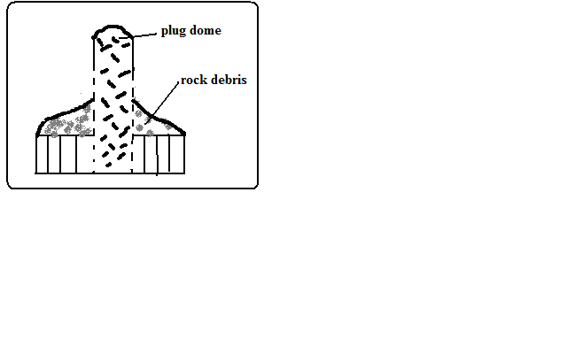

-A column of very viscous lava which sticks above the ground.

* A column of very viscous magma flows out of the ground.
* It cools and hardens rapidly as it rises vertically.
* Pieces of rock break from the plug and accumulate on the sides e.g. Mont Pelee in West Indies, Hyrax and Fischer’s Tower at Hells gate in Naivasha and Devils Tower in U.S.A.

**Characteristics**

1. Made of very viscous lava.
2. It is dome shaped like a mushroom germinating out of the ground.
3. Has debris on its sides.
4. Has very steep sides
5. Cylindrical in shape
6. Disintegrates fast due to rocks undergoing rapid cooling.

**Volcanic Plug**

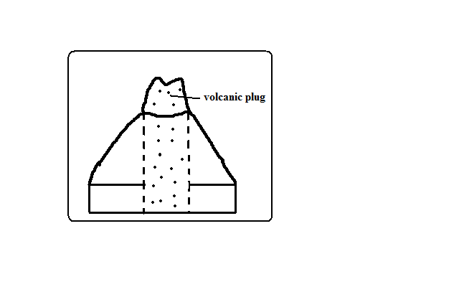

-Stump of rock formed when magma which solidified inside a vent (plug) is exposed by denudation.

* A volcano is first formed.
* Lava on the sides of the volcano is eroded fast due to cooling fast.
* The lava in the vent which is hard due to slow cooling is exposed forming a stump of rock e.g. Peaks of Mt. Kenya, Rangwa Hill and Tororo Rock.

**Characteristics**

1. It resembles a stump of a tree.
2. Its dome shaped.
3. Very steep at the top and less steep at the bottom
4. Made of hard/resistant rock

**Lava Plains and Plateaus**

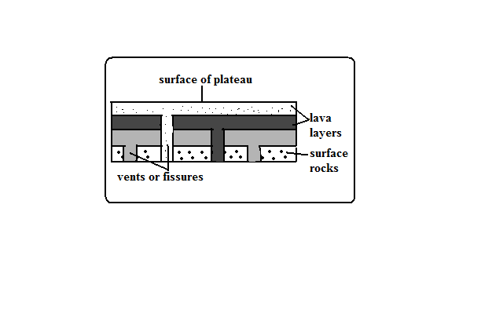

Lava plain: fairly level lowland below 500m above sea level covered by thin lava layers.

Lava plateau: fairly level highland/upland above 500m above sea level covered by thick layers.

-Formed by fissure eruption.

* Magma of low viscosity comes out of the ground through a fissure.
* It flows for a long distance before cooling and solidifying filling depressions and valleys forming a plain.
* Eruption occurs later and lava flows out through lines of weakness on crustal rock and solidified lava.
* The new lava spreads on top of the old lava forming a new layer.
* The process is repeated and a plateau is formed e.g. Mwea, Nandi and Laikipia Plains and Yatta and Uasin Gishu Plateaus.

**Craters**

**-**A funnel shaped depression found on top of a volcano.

**Modes of Formation**

**Cooling and Contraction of Magma**

* Eruption occurs and a volcano is formed.
* Magma in the vent cools and contracts.
* It withdraws into the vent leaving a depression at the vents mouth e.g. Ngorongoro and Menengai craters.
* Rain water or water from melting snow may collect into craters to form crater lakes e.g. L. Paradise on Mt. Marsabit, L. Magadi on Ngorongoro Crater and L. Chala on Kenyan Tanzanian border.

**Explosion**

* Gases underground expand due to heat from magma.
* They force their way out through a weak line in the crustal rocks.
* An explosion occurs leaving a hole in the ground called a **ring crater** e.g. Ghama and Dobot craters in Tanzania and Hora craters inEthiopia.
* Water from underground or rivers may accumulate into ring craters to form lakes called **maars** e.g. Lakes Katwe and Nyungu in Uganda.

**Falling of a Meteorite**

* A meteorite falls on the earth’s surface.
* It sinks into the rocks leaving a depression.
* Water may collect into the depression forming a lake e.g. L. Bosumtwi in Ghana.

**Calderas/Basal Wreck**

**-**A very large basin-shaped depression on the summit of a volcano.

**Modes of Formation**

**Violent Explosion**

* Gases and water heated by magma expand.
* They force their way through a vent.
* The rocks at the top of the volcano are blown off forming a large depression e.g. Nyirarongo Caldera in DRC and Sabiro Caldera in Uganda.

**Block Subsidence/Cauldron**

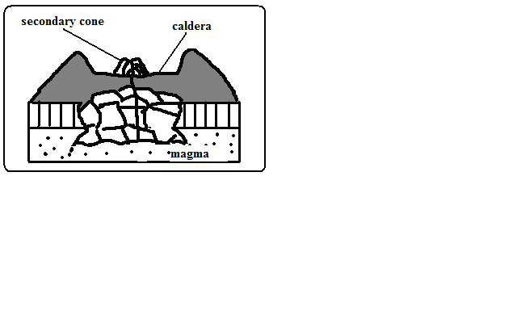

* Eruption occurs to form a volcano.
* An empty space (cauldron) is left in the magma reservoir in the mantle.
* The rocks forming the middle of volcano are pulled inwards by gravity.
* The middle of the volcano collapses forming a large depression at the top e.g. Menengai Caldera near Nakuru and Ngorongoro caldera which is the largest in E. Africa and 6th largest in the world.
* Water from rain or underground may fill calderas to form lakes e.g. L. Magadi in the Ngorongoro caldera and L. Ngozi in Tanzania.

**Outward Collapsing**

* Ash and pyroclasts volcano grows high.
* Materials on top exert pressure on those below.
* Materials at the base begin to spread outwards.
* The top of volcano collapses inwards forming a collapse caldera e.g. Napak Caldera in Uganda.

**-**A vent in a volcano which emits gases.

**Fumaroles**

The gases come from chemical reactions in crustal rocks when heated by magma or when minerals in rocks come into contact with hot air and steam underground.

They are of two types:

Mofette: fumarole which emits carbon dioxide.

Solfatara: fumarole which emits gases with sulphurous compounds.

**Hot Springs and Geysers**

Hot spring is a place where hot water is emitted from the ground quietly e.g. at the shores of Lakes Magadi and Bogoria.

A geyser is a jet of water and steam which are violently ejected from the ground e.g. at Olkaria and western shores of L. Bogoria.

**How They Are Formed**

* Percolating water is heated by hot rocks or magma.
* Some collect into chambers called sumps where it develops pressure causing it to be superheated super heated.
* The pressure forces the steam outwards towards the earths surface through holes and cracks in rocks.
* The steam comes out of the ground which reduces pressure in sumps causing the water to expand/boil and come to the surface.
* The steam comes out with a whistling sound accompanied by water forming a geyser.
* The escaping steam heats ground water in surrounding rock.
* The heated water may find its way to the surface where it quietly comes out of the ground forming a hot spring.

**Differences**

|  |  |
| --- | --- |
| Hot spring | Geyser |
| -Water comes out quietly.  -only water comes out.  -water may just be warm. | -Water and steam come out violently.  -water is accompanied by steam.  -water is very hot. |

**Pools of Boiling Water**

**-**Small area of still water which appears to be boiling.

* Actual heating of pool water by gases and steam causing the water to boil.
* Gases and steam coming out below the pool of water causing the pool to bubble and appear as if it’s boiling.

**World Distribution of Volcanoes**

1. Regions of faulting e.g. the Great Rift Valley of E. Africa.
2. Mid-Atlantic ocean ridge.
3. The western coast of America.
4. Zones of recent mountain building e.g. fold mountains of S.E Asia.

**Significance of Vulcanicity**

**Positive**

1. Volcanic rocks weather to form fertile agriculturally productive soils e.g. basalt.
2. Geysers are sources of geothermal electricity e.g. at Olkaria.
3. Hot springs water is pumped into houses for heating during winter e.g. Iceland.
4. Volcanic features are a tourist attraction e.g. hot springs, geysers and snow capped Mt. Kenya.
5. Igneous rocks e.g. phonolites are crushed to make ballast for building roads, bridges, etc.
6. Crater lakes are a source of fish e.g. L. Katwe in Uganda, sources of minerals e.g. L. Magadi and sources of water for domestic use.
7. Volcanic mountains are catchment areas, sources of rivers and habitats for wildlife.
8. Pumice a volcanic rock is used as a scrubbing stone.
9. Vulcanicity is useful for production of gases e.g. carbon dioxide used in soft drinks manufacture.

**Negative**

1. Volcanic eruptions cause of life and destruction of property e.g. sulphur dioxide, ash, cinder and lava may bury houses and farm land.
2. Volcanic mountains are barrier to transport and communication.
3. Volcanic mountains on the path of rain winds cause leeward slopes to receive little rainfall by preventing rain bearing winds from reaching there.
4. Volcanic eruptions cause environmental pollution from dust, ash and sulphur dioxide.

**EARTH QUAKES**

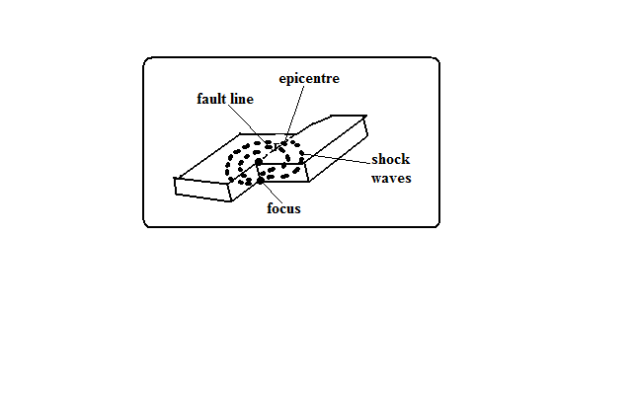

-Sudden and rapid movement of the earth’s crust.

-areas prone to them are called **seismic zones** and those not prone are called **aseismic zones**.

It’s caused by shock waves.

There are 3 types of earthquake waves namely:

1. Primary waves-which travel fastest and cause the rock particles to vibrate in a push and pull manner and can pass through gases, liquids and solids.

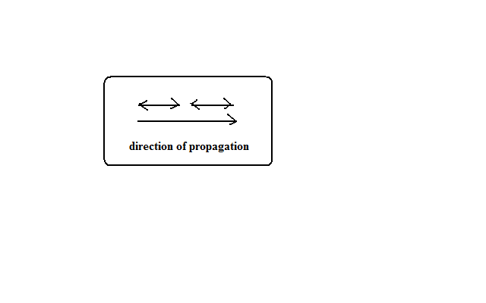

1. Secondary waves-which cause rock particles to vibrate at right angles to the direction of wave movement.

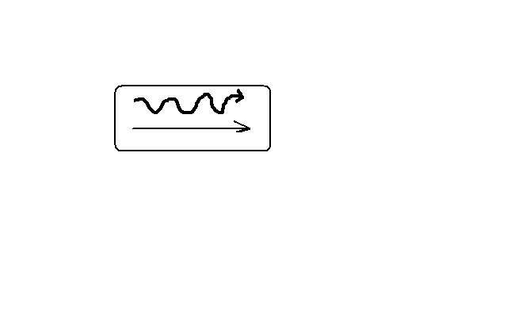

1. Surface longitudinal waves-which cause surface rocks to shake sometimes causing buildings to collapse.
   * 1. Rayleigh waves-Which cause surface rocks to move in elliptical orbits.

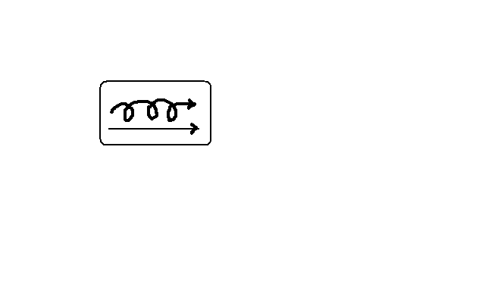

* + 1. Love waves-which cause rock particles to move in a horizontal manner at right angle to the direction of wave.

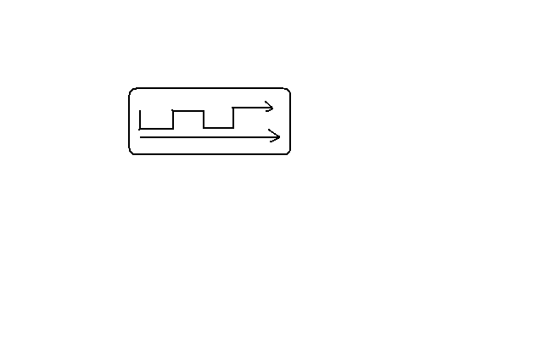

Earth quake originates from a point known as **seismic focus/origin**.

The part of the earth vertically above the seismic focus and where the shock waves are first experienced is called **epicentre**.

**Causes of Earthquakes**

**Natural Causes**

1. Tectonic movements e.g. movement of tectonic plates. They cause tectonic earthquakes.
2. Vulcanicity when magma movement displaces rocks suddenly shaking and shuttering them.
3. Gravitative force when crustal rocks collapse into cauldron due to gravity.
4. Energy release in the mantle when radioactivity takes place in mantle releasing explosive energy which sends shock waves outwards.
5. Isostatic adjustment when the continental masses rise to restore the upset state of balance between sial and sima layers.

**Human Causes**

1. Exploding nuclear bombs underground which causes shock waves which spread outwards and are felt in the neighbourhood.
2. When a train rolls on its rails causing the ground to vibrate.
3. Explosion of explosives used in mining and quarrying which cause vibrations to be felt in the neighbourhood.
4. When large reservoirs are constructed and the heavy weight of water reactivate dormant faults causing tremors.

**Measurement of Earthquakes**

Seismograph is a pendulum based instrument used to measure earthquakes.

It records seismic impulses on a graph-like record called seismogram mounted on it.

Earthquakes are measured by their intensity and magnitude.

**Intensity**

-Measure of how strong/hard the quake shakes the ground.

It’s seen from the effects the earthquake has on people, buildings and other structures.

It’s measured on the **Mercalli Scale** which uses a scale running from Roman i-xiii e.g.

* I- description -imperceptible
* V-rather strong-sleepers are awakened and there is swinging of objects.
* VIII-destructive-gaping cracks in walls some brought down.
* XII- major catastrophe-every building destroyed.

**Magnitude**

-Measure of amount of energy given off by an earthquake.

It’s measured on Ritcher Scale which ranges from 0-8.9.

Intensity values depend on how far a place is from epicentre.

The higher the scale the more severe the earthquake is.

* Intensity I-magnitude 2
* Intensity VIII-magnitude 6
* Intensity XII-magnitude 8.5.

**World Distribution of Earthquakes**

1. Within the zones of major faulting e.g. Rift Valley.
2. In areas of Vulcanicity e.g. Oldonyo Lengai in Tanzania.
3. Along boundaries of tectonic plates e.g. Japan, Philippines, East Indies and west coast of north and South America.

**Effects of Earthquakes**

1. Can cause loss of life and property when buildings collapse burying people.
2. Disrupt transport and communication by vertically and laterally displacing land which disconnects pipelines, electricity lines, roads and railways.
3. Causes landslides which also cause loss of life and property and disrupts communication.
4. Causes raising and lowering of the sea floor and the coastal regions.
5. Cause huge sea waves called Tsunami which may flood the neighbouring coastal areas.
6. Trigger folding, Vulcanicity and fires.
7. Give off a lot of explosive energy more than an atomic bomb.
8. Cause fear and panic.
9. Hinder settlement as it is restricted to aseismic areas.
10. Cause violent motions of the earth’s surface.

**MAP WORK**

Map - representation of the whole or part of the earth’s surface drawn to scale.

* Shows outline of objects on the ground
* Drawn as if the drawer was above the ground
* It shows details
* Most of the features are indicated by symbols.

Picture: image of a real object.

* Gives details in their visible shapes and sizes
* Can be inform of free hand, drawing, painting or a photograph
* Not drawn to scale

Plan: outline of something drawn to scale.

* Also drawn as if a person was directly above the ground
* It represents a very small place
* The scale is large to show details e.g. house plan
* Gives specific information

**Types of Maps**

Classified according to the purpose for which each map is drawn.

Topographical Maps: This shows selected natural physical features on a small portion of a country.

Atlas maps: this is a collection of maps in one volume.

Sketch maps: maps which are roughly drawn. A good sketch map should have the following characteristics:

1. neat and clear
2. title
3. frame
4. key
5. compass direction

**Uses of Maps**

1. Sketch maps are used to summarise information for easy reference.
2. Used for locating other countries.
3. Used for comparing sizes of countries.
4. For locating climatic regions of different parts of the world.
5. Give information on distribution of geographical phenomena e.g. vegetation on the earth’s surface.
6. Help travellers to find their way.
7. Used to calculate distance of a certain place.
8. Used to locate physical features like landforms.

**Marginal Information**

Information contained in the area surrounding the map.

1. Map name e.g. Yimbo.
2. Sheet title e.g. East Africa 1:50000 (Kenya).
3. grid system numbers
4. latitudes and longitudes
5. Compass direction with grid, true and magnetic north.
6. scales
7. key
8. publisher and copyright
9. Map identification
   * Map series
   * Sheet number or sheet index

**Map Scales**

A scale is a ratio of a distance on a map to a corresponding distance on the ground.

**Types of Scales**

-Statement scale –expressed in words e.g. 1cm represents 1km, 1cm to 1km.

-Representative Fraction (RF)-expressed as a fraction or ratio e.g. 1/200,000 or 1:200,000.

-Linear scale-shown by a line which is subdivided into smaller units.

**Conversion of Scales**

**Statement scale into RF**

**1cm rep 1km to RF**

Multiply the number of kilometres by 100,000 (1km=100,000cm) i.e. 1×100000=100,000.Statement scale is 1/100,000 or 1:100,000.

2cm rep 1km

Divide both sides by two to get 1cm rep ½ kilometres.

Multiply ½ by 100,000 to get 50,000.

RF is 1/50,000 or 1:50,000.

**RF to Statement Scale**

-Divide the denominator by 100,000.

-Write the scale in statement form.

**Linear Scale to Statement Scale**

* Measure a unit distance off a linear scale e.g.

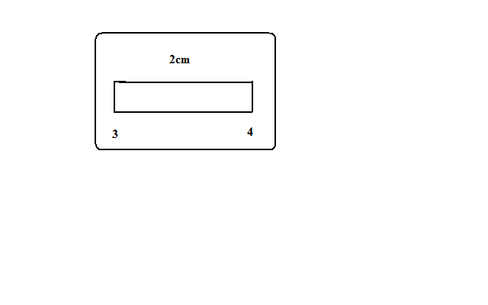

* The distance is 4-3=1km which is represented by 2cm.
* Use the methods in (1) and (2) above.

Q. Given that the ground distance is 200km while the distance on map is 20cm calculate the scale.

**Sizes of Scales**

1. Small scales- show a large area of land on a small size of paper. They show limited details e.g. 1:250,000, 1:500,000, 1:1,000,000.
2. Medium scales- used to represent a relatively smaller area on a given size of paper e.g. 1:50,000, 1:100,000, 1:125,000.
3. Large scales-used to represent a small area of land on a given piece of paper. They show a lot of details e.g. 1:2,500, 1:10,000, 1:25000

**Arranging Scales in Order**

Ascending Order-smallest to largest

Descending Order-largest to smallest

(1)1/500,000

(3)1:25,000

(4)1/10,000

(2)1cm rep 500m

**Uses of Scales**

1. Estimating distances on maps
2. Measuring distances accurately-use dividers and ruler, piece of string or thread for curved distances or straight edge of paper.

E.g. calculate actual distance of a line 8.5cm long on a map using the following scales.

(i) 2cm rep 1km

(ii) 1:100,000

1. Calculation of areas-no. of full grid squares+ number of ½grid squares/2 or use of rectangles (l×b) or triangles (½ b×h).

**Direction**

-Course upon which something is pointing to.

**Methods of Showing Direction**

**Traditional Methods**

**1. Use of Stars**

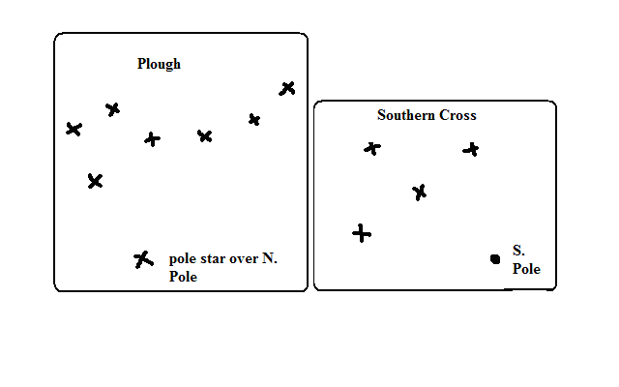

-E.g. use of groups of stars called plough to find northern direction by locating the pole star and use of Southern Cross by using the brightest star which is over South Pole to find northern direction.

**2. Use of Shadows**

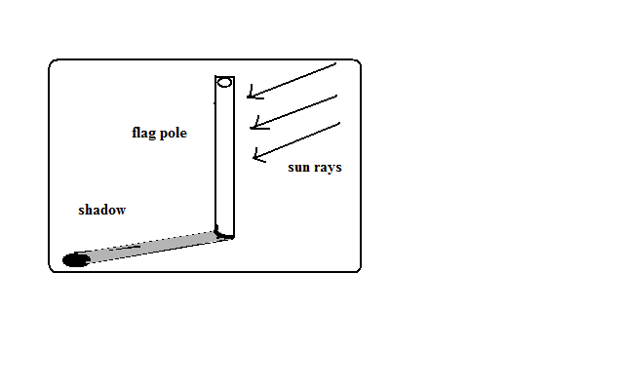

-E.g. morning, shadow of flag pole cast to your left you are facing north, etc.

**3. Land Marks**

-Using conspicuous features such as hills, buildings even roads to get direction.

**Modern Methods**

* 1. **Land Marks**
  2. **Compass Direction.**

-Use of magnetic compass which has a needle which always points north.

It has 16 cardinal points and 4 are basic.

**Bearing**

**-**Expression of direction in degrees of an angle.

It’s measured from north in a clockwise direction.

**Calculation of Bearing**

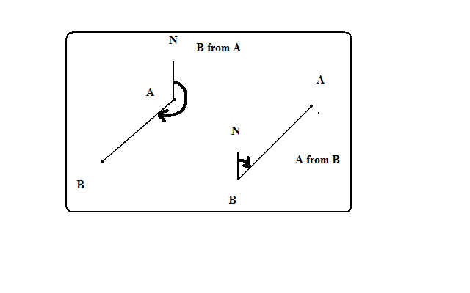

Draw N-S line through observation point.

Join the two points. If it’s a feature the line should end at the centre of that feature.

Using a protractor measure the angle between the N-S line and the line joining the 2 points in a clockwise direction.

Bearing is expressed in degrees, minutes and seconds. 1◦=60’(min), 1 min=60” (sec)

The degrees are always expressed in 3 figures e.g. 030◦

**Types of Norths**

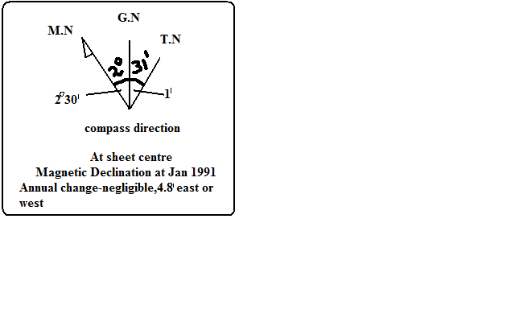

**1. True North**

-Position on the globe where all longitudes meet or the direction of N. Pole.

**2. Grid North**

-Point where Eastings meet at the N. Pole.

**3. Magnetic North**

-Point which the magnetic needle rests when left to swing freely.

**Types of Bearing**

**1. Grid Bearing**

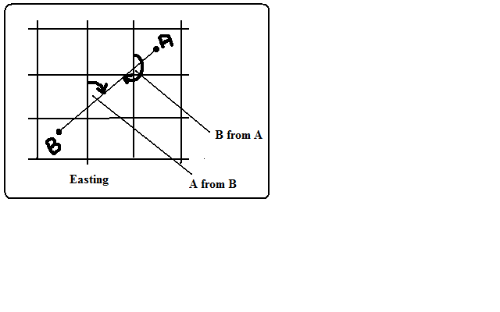

-Bearing calculated from Grid North.

* Join the two points on the topographical map using a line.
* Measure the angle where the Eastings intersect the line joining the two points e.g. **030◦.**

**2. True Bearing**

**-**Bearing calculated from True North. Its calculated when the type of bearing isn’t specified.

-E.g. from our compass diagram true bearing will be 30◦-1’=**29◦59’**

**3. Magnetic Bearing**

-Bearing calculated from Magnetic North.

Position of Magnetic North changes slightly every year.

**Steps**

* Years which have elapsed × Annual change. (No need if annual change is negligible). E.g. from our compass diagram annual change =(2009-1991)×4.8’=18×4.8’’=86.4’’=1◦26.4’
* Add to the angle between the grid and magnetic bearing 1.e. 1◦26.4’+2◦30’=3◦56.4’
* Add to the Grid bearing (if change is towards E) or Subtract (if change is towards W). 30◦ +3◦ 56.4’=**33**◦**56.4’**

**Location of Places**

**-**Showing of position of a place or feature on a topographical map.

**Methods**

**Use of Place Names**

-Locating a feature by using the name of the place it’s at e.g. a river in Kisumu, Nakuru, etc or if it isn’t at a named place locate by the nearest name place e.g. a meander near Garissa town.

**Use of Direction, Bearing and Distance**

This is from a stated position e.g. Locate Nakuru from Nairobi.

Nakuru is 157km N.W of Nairobi.

**Latitudes and Longitudes**

The main longitudes are I.D.L and Greenwich /Prime Meridian.

The main lines of latitudes:

* The equator/Great Circle (0◦) which is the longest.
* Tropic of Cancer (23½◦N) of equator.
* Tropic of Capricorn (23½◦) south of equator.
* The Arctic Circle (66½◦N).
* Antarctic Circle (66 ½ ◦ S).

They are marked at the margins. Latitude is stated first (N or S) and longitude later (E or W) e.g. **X◦N Y◦E**

* Identify a place.
* Identify the nearest numbered latitude and longitude.
* Estimate to the nearest 1◦.

**Grid Reference**

Grid lines: network of lines on topographical maps.

-Numbered in small and large numbers and the large ones are used.

Eastings: N-S grid lines called so because they are numbered eastwards.

Northings: W-E grid lines called so because they are numbered northwards.

Grid reference is given in 4 figures or six figures. In 4 figure the nearest grid line is stated while the 6 figure is estimated in fractions by dividing the space between grid line into 10 equal parts.

Easting is stated first followed by northing.

In the example below the 4 figure grid references are:

* A-6856
* B-6856
* C-6857

6 figure grid references are:

* A-675555
* B-680560
* C-682568

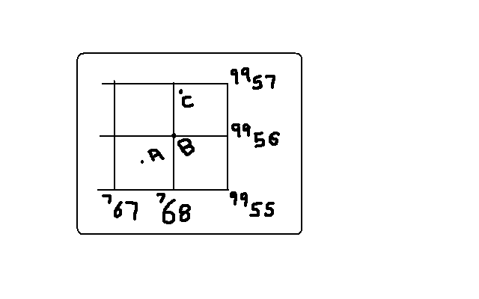

**Methods of Representing Relief on Topographical maps**

Relief is the nature of landscape e.g. plain, plateau, valleys, hills, etc.

**Spot Heights**

-Points on map whose positions and heights have been determined by surveyors. They are shown by a dot and a figure e.g. (.1827).

* Advantage-show actual heights
* Disadvantage-can’t be used to identify landforms.

**Trigonometrical Stations/Points**

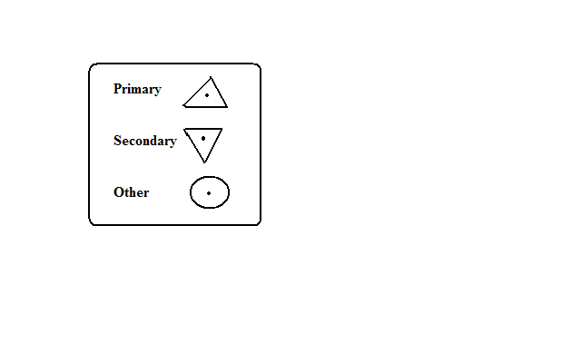

-Carefully chosen points carefully chosen and their altitude determined which ---Are used as a basis for surveying an area.

They are marked on the ground by concrete pillar or slab.

They are indicated on topographical maps by:

**Isohypes/Contours and Form Lines**

**A contour** is a line on a map joining all points of the same height above sea level. They are browner in colour and have heights written on them.

**Form lines** are lines drawn on a map joining places of approximately the same height above sea level. They are less brown than contours and not all have values written on them.

Both contours and form lines are referred to as contours.

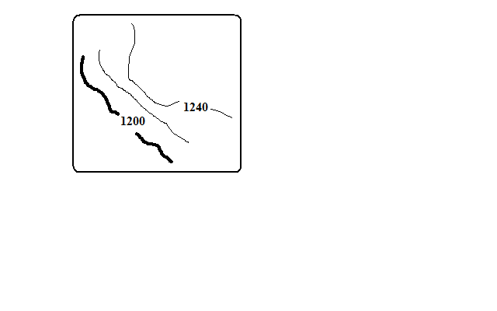

**Contour/Vertical interval** is the difference in height between any two successive contours.

Advantages of contours:

* They show actual heights.
* Can be used to identify land forms.

**Pictorials**

-Showing relief by drawing landforms at approximate positions where they are found e.g. mountains, hills, valleys, etc.

Disadvantages:

* They obscure details behind them.
* Don’t give height above sea level.
* Limited variety of landforms can be accommodated.

**Hachures**



-Short lines drawn to represent direction of slope.

* On steep land they are thick and close together.
* On gentle slopes they are thin and wide apart.

Their disadvantage is that they can’t be drawn on flat land.

**Hill Shading**

-Showing relief by shading to show shadows where by steepest slopes which are list lit have darker shade while hill tops, surfaces of plateaus and plains and valley bottoms are well lit have lighter shade.

**Layer Tinting**

-Colouring or shading land within a certain range of altitude or using a single colour with varying tones where the colour gets darker with increasing altitude.

**PHOTOGRAPH WORK**

A photograph is an image of an object, person or scene recorded by a camera on a light sensitive film or paper.

**Types of Photographs**

**1. Ground Photographs**

-Taken from the ground. They are of 2 types:

**Ground Horizontals-** taken with the camera at the same level as the object. They are of 2 types.

**Ground close ups/particular view photographs-**taken from the ground with a camera focused on one particular object.

**Ground General View Photographs-**taken from the ground with camera focused on general scenery.

**Ground Obliques-**taken from the ground with a camera slanting/held at an angle.

**2. Aerial Photographs**

**-**Taken from the air e.g. from aircrafts, balloons or satellites. They are of 2 types:

**Aerial Obliques-**taken from the air with camera tilted towards the ground.

**Vertical Aerial Photographs-**taken from the air with the camera directly above the object or scenery.

**Parts of a Photograph**

|  |  |  |
| --- | --- | --- |
| Left back ground | Centre background | Right background |
| Left middle ground | Centre middle ground | Left middle ground |
| Left foreground | Centre foreground | Right foreground |

**Uses of Photographs**

-Used in learning geography because they bring unfamiliar features in the classroom enabling the students to understand them better.

-Photographs showing vegetation and human activities can be used to deduce the climate of an area.

-Aerial photographs show vital information on land use.

-Photographs showing land forming processes help us to understand those processes.

**Limitations in the Use of Photographs**

-Coloured photographs are generally expensive to produce.

-Black and white photographs don’t show the real colours of objects or scenery e.g. it’s difficult to distinguish ripe coffee berries from green ones.

-Some aerial photographs have objects which are far away and hence unclear which may lead to the wrong interpretation.

-Vertical aerial photographs are difficult to interpret without special instruments like stereoscopes.

-Photographs are difficult to interpret if they are blurred because it’s difficult to distinguish objects which look similar e.g. wheat and barley.

**Interpretation of Photographs**

-Means to explain the meaning of the objects or features on a photograph. It involves the following:

**Determining the Title**

Photographs show human activities, physical features, natural catastrophes etc e.g. nomadic pastoralism, drought, flooding, etc. when determining the title examine the photograph carefully and apply the knowledge you have learnt in geography.

**Estimating Time**

-In the tropics the shadows are short at noon and longest in the morning and afternoon.

If the camera is facing south and the shadow is cast to the right it’s in the morning and if cast to the left it’s in the afternoon.

**Estimating Season**

**Dry season**

Bright clear skies

Dry vegetation

harvesting

Light clothes e.g. shirts and T-shirts since temperature is high (also an indication of high temperature.

**Rainy season**

Rain clouds

Luxuriant vegetation

Young crops

Flowering plants

Weeding

Heavy clothing e.g. pullovers or jackets since temps are low (also an indication of cool season).

**Determining Compass Direction**

It it’s in the morning and the shadow of flag pole is cast to the left the photographer is facing north and if cast to the right he was facing south.

It it’s in the morning and the shadow is facing towards you the photographer was facing east and it taken in the afternoon and the shadow is facing towards you the photographer was facing west.

**Interpretation of Physical Features on Photographs**

**Relief**

**Flat land**

* Rice crop
* Irrigation
* Combine harvesters
* Swamps
* Meanders
* Oxbow lakes
* Inselbergs (isolated hills)

**Hilly/Mountainous landscape/Highland Area**

Steep slopes

Terraced landscape

Tea, wheat crops which grow at high altitude

rapids

Water falls

Interlocking spurs

**Drainage**

**Youthful Stage**

Rapids

Waterfalls

Interlocking spurs

**Middle Stage**

Meanders

Oxbow lakes

**Lower Stage**

* deltas
* distributaries
* meanders and oxbow lakes
* flood plain

**Vegetation**

**Natural**

* Indigenous species
* Dense undergrowth
* Trees grow haphazardly
* Different species of trees
* Not of the same height

**Planted**

* Exotic species
* In rows
* Little undergrowth
* Same species
* Same heights

**Tropical Rain Forests**

* Trees
* Broad leaves
* Umbrella shaped

**Marshes**

* swamps

**Savannah Grassland**

* Grass and short trees (woodland).

**Desert Vegetation**

* Thorny leaves
* Baobab and acacia
* Scrub-land covered with shrubs and underdeveloped trees (shrubs).

**Climate**

**High Temperatures and low rainfall**

* Sugar cane
* Grass
* Sisal
* Scrub and bush land vegetation
* Dense forests
* Light clothes

**Cool Temperature and High rainfall (Sufficient, Reliable and well distributed)**

* Tea
* Coffee
* Wheat
* Dairy farming

**Soils**

**Acidic and Volcanic Soils**

* Coffee
* Tea

**Clay Soils**

* Rice

**Black Cotton Soils**

* Cotton
* Rice

**Loamy Soil**

* Horticultural crops

**Human Activities and evidence**

**Settlement**

-Group of dwellings where people live.

**Rural Settlements**

* Semi permanent houses
* Farming or fishing activity
* Uneven distribution of settlements
* Presence of villages

**Urban Settlements**

* Permanent buildings
* Storied buildings
* Heavy traffic presence
* Regular street patterns

**Agriculture/Farming**

**Subsistence Farming**

* Temporary and permanent houses
* Small pieces of land
* Mixed cropping
* Simple implements
* Local and exotic breeds of livestock

**Crop farming**

* Crops
* People preparing land or weeding or Harvesting

**Commercial Crop Farming**

* cash crops
* machinery
* feeder routes
* processing factories

**Plantation Farming**

* Single crop on extensive piece of land e.g. tea, coffee, etc.
* Many labourers
* Nucleated settlement within farms

**Livestock Rearing**

**Nomadic Pastoralism**

* Cattle grazing in a grassland or semi-arid region

**Daily Farming**

* Zero grazing
* Cattle with big udders

**Ranching**

* Paddocks
* Wind mills

**Mining**

* Quarry
* Large open pits
* Large excavators
* Lorries carrying loads of rocks

**Industrial Manufacturing**

* Buildings with large chimneys
* People engaged in a processing activity such as Jua kali artisans.

**Lumbering**

* People cutting trees using power saws
* People loading timber into lorries
* Logs pilled near a saw mill
* Forests with stumps
* Logs floating on a river

**Transport**

**Motor transport**

* Vehicles on roads

**Railway Transport**

* Railway line
* Trains

**Air Transport**

* Flat tarmacked piece of land
* Aircraft

**Water Transport**

* Boats
* Ships
* Ferries

**Communication**

* Telephone lines
* Telephone booths
* Post office
* Satellite masts
* T.V and radio stations

**Sketching Diagrams from Photographs**

* Draw a rectangle the same size as the photograph.
* Divide it into squares using faint lines.
* Subdivide the photograph into 9 sections.
* Insert the features in their exact positions using simple lines being guided by the squares.
* Label the important features e.g. vegetation, land use, prominent buildings, transport, and communication.
* Give the sketch a suitable title.

**Graphs**

-2 dimensional drawings which show relationships between 2 types of data representing two items also called variables. These are dependent variable which is affected by the other e.g. temperature (on y axis) and independent variable whose change is not affected by the other e.g. altitude (on x axis).

**Steps**

* Draw x and y axis.
* Choose suitable scale to accommodate the highest and lowest value.
* Plot the values accurately using faint dots.
* Join the dots using curved line. If it’s a bar graph the dots should be at the middle of the top line. Years should also be at the middle. You should have also decided on the width of the bars.
* In data without continuity e.g. crop production there should be gaps between bars and for one with continuity e.g. rainfall bars should not have gaps.
* Draw vertical lines on either side of the dot then draw horizontal line to join them with the dot.
* Shade uniformly if they are representing only one type of data and differently if representing one type of data.
* In combined line and bar graph temperature figures are plotted on the right hand side of y-axis while rainfall on the left
* Don’t start exactly at zero.
* Include temperature and rainfall scales.
* Start where the longest bar ends.

**What a Well Drawn Graph Should Have**

* Title
* Scale/scales
* Labelled and marked x and y axis starting at zero.
* Key if required e.g. in comparative bar graph.
* Accurately plotted and lines, curves or bars properly drawn.

**Simple Line graph**

**Advantages**

* Easy to construct
* Easy to interpret
* Easy to read/estimate exact values.
* Shows trend or movement overtime.

**Disadvantages**

* Doesn’t give a clear impression on the quantity of data.
* May give false impression on the quantity especially when there was no production.
* Poor choice of vertical scale may exaggerate fluctuations in values.
* Difficult to find exact values by interpolation.

**Simple Bar Graph/histogram**

**Advantages**

* Easy to construct.
* Easy to interpret.
* Easy to read.
* Gives a clear visual impression on the quantity of data.

**Disadvantages**

* Poor choice of vertical scale may cause exaggeration of bars.
* Doesn’t show continuity/ variation of data overtime.
* Unsuitable technique when values exist in continuity.
* Not possible to obtain intermediate values from the graph.

**Combined Line and bar Graph**

**Advantages**

-Easy to construct.

-Easy to read.

It shows relationship between two sets of data.

**Disadvantages**

* Difficult to choose suitable scale when values of variables differ by great magnitude.
* Considerable variation of data represented by the line may cause the line the bars thus obscuring the relationship.
* Doesn’t show relationship between the same sets of data of more than one place.

**Temperature and Rainfall for Thika**

|  |  |  |  |  |  |  |  |  |  |  |  |  |
| --- | --- | --- | --- | --- | --- | --- | --- | --- | --- | --- | --- | --- |
| Month | J | F | M | A | M | J | J | A | S | O | N | D |
| Temp(◦c) | 24 | 24 | 23 | 22 | 19 | 17 | 17 | 18 | 19 | 20 | 22 | 23 |
| Rainfall(mm) | 109 | 122 | 130 | 76 | 52 | 34 | 28 | 38 | 70 | 108 | 121 | 120 |

**Analysis and Interpretation**

* The month with heaviest rainfall is May.
* The month with lowest rainfall is July.
* The hottest month was January and February.
* The months with lowest temperature were June and July.

**Crop Production in Kenya in the Years 2001 and 2002**

|  |  |  |  |
| --- | --- | --- | --- |
| crop | Amount in metric tonnes | | |
|  | 2001 | | 2002 |
| Tea | 300,000 | 500,000 | |
| Coffee | 120,000 | 80,000 | |
| wheat | 120,000 | 150,000 | |
| Maize | 250,000 | 400,000 | |

**Value of export Crops from Kenya (ksh million)**

|  |  |  |  |  |  |
| --- | --- | --- | --- | --- | --- |
| Crop | 1997 | 1998 | 1999 | 2000 | 2001 |
| Tea | 24126 | 32971 | 33065 | 35150 | 34485 |
| Coffee | 16856 | 12817 | 12029 | 11707 | 7460 |
| Horticulture | 13752 | 14938 | 17641 | 21216 | 19846 |

If the data has large figures e.g. 195262 plot in 1000s=195, 184,988=185.

You can draw comparative/group/multiple line and bar graphs from the data.

**Comparative/Group/Multiple Line Graph**

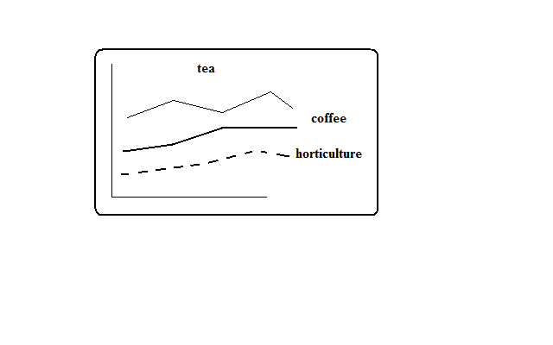

**Advantages**

* Simple to construct
* Suitable when comparing trends or movements
* Comparison of items is easy because the graphs are drawn using common axis
* It’s easy to read exact values from each graph

**Disadvantages**

* Number of items which can be represented are limited
* Crossing of lines may make interpretation and comparison difficult and confusing.
* Total amount of variable can’t be established at a glance.

**Comparative Bar Graph**

**Advantages**

* Easy to construct
* Easy to read and interpret
* Easy to compare similar components within different bars.
* Gives a good impression of totality.
* Individual contribution made by each component is clearly seen.
* Differences in quantity of components are clearly seen.

**Disadvantages**

* Doesn’t show trend of components over time.
* Not easy to compare components where bars are many
* Not suitable for many components.



**Divided Bars or Rectangles**

**Production of Sugarcane in 1000 tonnes of 5 major factories in Kenya**

|  |  |  |
| --- | --- | --- |
| Factory | Production(ooo tonnes) | Length in cm |
| Sony | 50 | 0.5 |
| Nzoia | 100 | 1 |
| Chemilil | 200 | 2 |
| Muhoroni | 250 | 2.5 |
| Mumias | 400 | 4 |
| Total | 1000 | 10 |

**Reported Visitor Arrivals by Continent for the Year 2000**

|  |  |  |
| --- | --- | --- |
| Continent | No. of visitors | Length of strip (cm) |
| Africa | 153904 | 1.5 |
| America | 77271 | 0.8 |
| Asia | 58784 | 0.6 |
| Europe | 663906 | 6.6 |
| Other | 82672 | 0.8 |
| Total |  | 10.3 |

**Look for a convenient scale say 1cm rep 100000 visitors**

* Draw a divided rectangle 10 cm long to represent the data.
* Show your calculations.

-It should have the following:

* Title
* Different shades
* Key
* Width of 2cm

**Analysis and Interpretation**

-To get the meaning of

* Factory leading in sugar production is Mumias.
* The 2nd leading is Muhoroni.
* Factory with the lowest production of sugar is Sony.
* Calculation of %s.

**Advantages**

* Easy to construct
* Easy to compare components because they are arranged in ascending or descending order.
* Takes less space than when the data is presented using graphs.
* Each component proportion to the total can easily be seen at a glance.

**Disadvantages**

* Can’t be used for a large data.
* Only one unit of measurement can be used.
* Difficult to assess values of individual component**s.**
* The visual impression isn’t as good as pie charts.

**Exercise**

**Temperature and Rainfall for Kisumu**

|  |  |  |  |  |  |  |  |  |  |  |  |  |
| --- | --- | --- | --- | --- | --- | --- | --- | --- | --- | --- | --- | --- |
| Month | J | F | M | A | M | J | J | A | S | O | N | D |
| Temp(◦c) | 19 | 20 | 20 | 18 | 20 | 19 | 19 | 18 | 18 | 18 | 18 | 18 |
| Rainfall(mm) | 18 | 38 | 66 | 127 | 114 | 84 | 112 | 104 | 69 | 56 | 38 | 31 |

1. Draw a bar graph to represent rainfall figures.
2. Calculate the mean monthly temperature for the place.
3. Calculate the mean annual temperature range.
4. Calculate the annual rainfall totals.

2.

|  |  |  |  |  |  |  |  |
| --- | --- | --- | --- | --- | --- | --- | --- |
| Temp/Day | Mon | Tue | Wed | Thurs | Fri | Sat | Sun |
| Max ◦c | 28 | 27 | 28 | 26 | 29 | 29 | 26 |
| Min ◦c | 18 | 18 | 20 | 16 | 22 | 21 | 19 |

1. Calculate the diurnal/daily temperature range for Tuesday.
2. Calculate the mean daily temperature for Sunday.
   1. Suppose at 40 ◦c air can hold 60g/m3 of water vapour and the maximum vapour it can hold is 70g/m3. Calculate the relative humidity.
   2. (a) Calculate the time at Lamu 70◦E when time at GWM is noon.

(b) Calculate the longitude of Watamu whose time is 6pm when time at GWM is 9am.

* 1. Students from a certain school obtained the following marks in their end of term geography examination.

74, 52, 48, 60, 48, 32, 80, 67 and 85.

Calculate the following:

1. Median
2. Mode
3. Mean
4. State their advantages and disadvantages.
   1. (a) Calculate the scale given that the ground distance is 200km while the distance on the map is 20cm.

(b) A student measured the length of a road on a map from point A to B and found it to be 3.6 cm. Use a scale of 1:50000 calculate the actual/ground distance in km.

* 1. Students intend to carry out field study of a forest around their school.

1. State two ways in which they’d prepare themselves.
2. State 2 objectives they’d have formulated for their study.
3. List two problems they’d have encountered in the field.
4. State two follow up activities they would have after the field study.

**CLIMATE**

-Average weather conditions of a given place over a long period of time usually 30-35 years.

**Factors Influencing Climate**

**Latitude**

* It influences temperature whereby low latitudes have high temperature and high latitudes have low temperature due to the angle at which the sun rays strike the earth and the distance travelled by the sun’s rays.
* It also influences rainfall whereby places in the equator receive rainfall in two seasons when the sun is overhead there while northern and southern tropical areas receive rainfall when the position of the sun is overhead in those areas.

**Inter-Tropical Convergence Zone**

It’s a low pressure belt around equator where trade winds converge.

It influences rainfall in the following ways:

* Places further from equator experience one rainy season when the sun is overhead and a long dry season when the sun is in the S. hemisphere.
* Regions near equator have 2 seasons of heavy rainfall because they experience passage of ITCZ twice.

**Altitude**

* It influences temperature whereby at low altitude temperature is high while at high altitude its lower due to the thickness of atmosphere determining the number of particles to store heat and distance from space where terrestrial radiation is lost.
* It also influences rainfall whereby mountains on the path of rain winds receive Orographic rainfall and the windward slopes receive heavier rainfall than leeward slopes.

**Distance from the Sea**

* It influences temperature whereby places in temperate regions near the sea experience low temperature during summer onshore winds blowing over cold ocean water and taking the cooling influence on adjacent land because the water is heated at a slower rate than land.
* Places near the sea also experience higher temperatures during the winter or cool season due to sea breezes carrying warmer air to the land because water loses heat at a slower rate than land.
* Temperatures in the interior of continents tend to be high in summer and very low in winter due to lack of marine influence.
* It also influences rainfall whereby coastal regions receive a lot of rain when the winds are onshore and the continental interiors receive less rain mainly in summer because onshore winds will have dropped most of moisture along the way.

**Ocean Currents**

* It influences temperature whereby coasts which are washed by warm ocean currents are warmer while those washed by cold ocean currents are cooler due to the onshore winds being either warmed or cooled and then taking the warmth or coolness to the land.
* It influences rainfall whereby coasts washed by warm ocean currents experience heavy rainfall when moist onshore winds are warmed by the current and made to hold on to moisture which they release on reaching the land.
* The coasts washed by cold ocean currents on the other hand experience low rainfall as a result of moist winds being cooled and moisture in them condensed resulting in rain falling over the ocean thereby bringing little or no rain to the coastal areas. This is the cause of western margin deserts e.g. Kalahari and Namib deserts.

**Aspect**

-Direction of slope in relation to sunlight and the rain bearing winds. Its effect on temperature is more pronounced in the northern and southern hemisphere.

* In the N and S hemispheres the slopes facing sun are warmer while those facing away are cooler.
* The slopes in the direction of rain winds i.e. the windward slopes receive heavier relief rainfall than the leeward side.

**Winds and Air Masses**

Wind blowing from a warm region warms the region its passing over and if blowing from a cool region cools the region it’s passing over since wind is a medium of transfer of heat.

* Sea breezes take cooling influence on land during hot afternoons.
* Katabatic winds cause low night temperatures on valleys and foot of mountains.
* Fohn and Chinook which are descending dry winds take dryness to the leeward sides of Alps and Rockies.

Winds influence rainfall in the following ways:

* Anabatic winds cause afternoon showers on mountainous regions.
* Moisture laden winds cause heavy rainfall.
* Persistent dry winds cause desert like conditions in the area they pass over e.g. Harmattan winds from Sahara which blow over W. Africa.
* Regions around large water bodies experience high rainfall because of the effect of land breezes.

**Configuration of Coastline**

Coastal regions across the path of moisture laden winds receive higher rainfall because winds deposit moisture on land e.g. Mombasa while those lying parallel to the path of those winds receive less rainfall because moisture is deposited on the sea e.g. Lamu.

**Forests**

Forested areas experience a micro climate whereby:

* Temperature is lower due to shades of trees reducing solar insolation reaching the ground.
* Rainfall is heavier due to high rate of evapotranspiration and friction between trees and rain bearing winds.

**Human Activities**

* Man has caused deforestation in the process of creating room for settlement and agriculture which has caused drop in rainfall amounts leading to semi-arid conditions.
* Man has constructed dams across rivers and done afforestation which has caused semi-arid regions to become wetland.
* Gases especially co2 emitted from burning fossil fuels and chlorofluorocarbons layer cause global warming through the green house effect and destruction of ozone layer respectively.

**The Climatic Regions of Kenya**

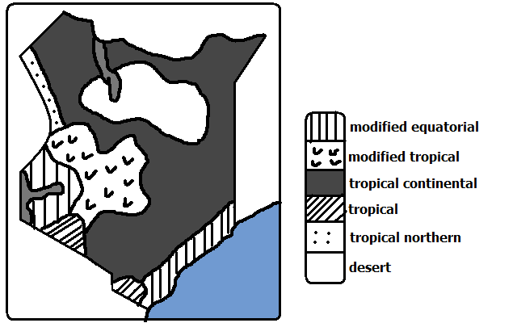

**Modified Equatorial Climate**

-Experienced along the coast and along the coast from Somali-Tanzanian border and L. Victoria basin regions around the lake.

**Along the Coast**

**Characteristics**

* High temperatures throughout the year mean annual about 27◦c.
* Small mean annual range of temperature about 4◦c.
* Hottest months are December and January.
* Experiences rainfall throughout the year/ no real dry season.
* Double maxima rainfall regime (2 rain seasons) in May and October.
* High humidity due to high temperature causing high rates of evaporation and nearness to the sea.

**L. Victoria Basin**

**Characteristics**

* Temperature is lower than the truly equatorial climate due to modifying influence of the lake (mean annual range between 22-26◦c).
* There are no real dry months.
* Heavy rainfall ranging from 1000-600mm.
* Double maxima rainfall regime.
* Receives convectional type of rainfall which falls mainly in the afternoons.
* High relative humidity due to high temperature and nearness to the lake which is a source of moisture.

**Modified Tropical Climate**

-Experienced in central highlands E and W of R. Valley.

**Characteristics**

* Mean annual temperatures averages between 17-24◦c.
* Lower warmer slopes and cooler higher slopes due to modification by altitude.
* Receives rainfall throughout the year (1000-2000mm).
* Receives Orographic rainfall caused by S.E Trade Winds.
* Double maxima rainfall regime in eastern highlands and single maximum in the W. highlands.
* Humidity is moderate.

**Tropical Continental/desert Climate**

-Experienced in about ½ of Kenya in most of N, N.E, most of E and S Kenya.

**Characteristics**

* High temperatures throughout the year with mean between22 and 27◦c.
* Generally dry with less than 500mm of unreliable rainfall.
* Large diurnal range of temperature.
* The skies are generally clear.
* Low humidity.
* Temperature has been modified by relief in some areas e.g. Voi-25◦c and Garissa -28.5◦c.

**Tropical Climate**

-Experienced in Narok, S. Taita and Kwale region.

**Characteristics**

* High temperatures (mean annual temp-16.5◦c).
* Temperature is modified by relief in some areas e.g. Loita, Taita and Narok which has made the place suitable for human habitation.
* Generally low rainfall amounts.
* Rain falls in one season.
* A long dry season lasting up to 6 months.

**Tropical Northern Climate**

-experienced in a small area in the N. W part of Kenya bordering Uganda.

**Characteristics**

* High average temperatures.
* Temperatures are modified in some places by altitude.
* Low mean annual rainfall of about 850mm.
* Rain falls mainly in June and September.
* Experiences a long dry season of up to 6 months.

**Desert Climate**

-Experienced in central northern Kenya where there are pure deserts such as Chalbi, Karoli and Kaisut deserts.

**Characteristics**

* Temperatures are very high throughout the year averaging 30◦c due to cloudless skies.
* Very low rainfall of less than 250mm per year.
* Characterised by diverging or descending winds which don’t bring any rain.
* Night temperatures are extremely low.
* Humidity is low.
* Sandstorms are common occurrences.

**World Climatic Regions**

**Classifications**

1. Hot climates
2. Warm climates
3. Cool climates
4. very cold climates
5. Mountain climates
6. micro/local climates

**Hot/Tropical Climates**

-Experienced within the tropical latitudes.

-Subdivided into:

1. Equatorial climate
2. Tropical monsoon climate
3. Savannah climate/Sudan type
4. Tropical desert climate
5. Tropical marine climate

**Equatorial climate**

-Experienced in the following areas:

1. Amazon basin in S. America.
2. Along west coast of Africa from guinea to Cote d’ Ivoire.
3. Southern part of Nigeria through Cameroon, Gabon, Central African Republic, Congo to Zaire.
4. S.E Asia in Malaysia, Indonesia and a stretch between Burma and Vietnam.

**Characteristics**

* + High temperatures throughout the year (between 24-27◦c).
  + Temperature neither rises nor drops too low due to thick cloud cover all year round.
  + Heavy rainfall throughout the year (mean annual of about 2000mm).
  + Double maxima rainfall regime.
  + Experiences convectional rainfall in low lands and relief rainfall in areas of high relief.
  + High relative humidity of over 80% due to convergence of moist air masses and high evapotranspiration rates.
  + Low pressure all year round.
  + There are no seasons.

**Tropical Monsoon Climate**

It’s found in the following areas:

1. S.E Asia in parts of Pakistan, India, Bangladesh, S. china and Philippines.
2. Along the northern coastal region of Australia.

**Characteristics**

* + High mean annual temperatures of about 28◦c.
  + Seasonal reversal of winds.
  + Heavy rainfall when monsoon winds are onshore (600-1300mm) climate.
  + Rain falls in a few months and the rest of the year is dry due to influence of latitude.
  + Low pressure in summer when winds blow onshore.
  + High pressure in summer when winds blow offshore.
  + Cloudy skies in summer and clear skies in winter.

**Tropical Marine Climate**

It’s found on windward slopes of islands and coastal areas on the east of continents under the influence of S.E Trade Winds in the following areas:

1. C. America in S. Mexico through Guatemala, Nikaragua and Panama.
2. N. coast of S. America.
3. Caribbean islands of Cuba, Haiti and Jamaica.
4. Coastlands of E. Africa from Kenya, Tanzania through Mozambique and E. Malagasy.

**Characteristics**

* + Summer temperatures are very high approximately 30◦c.
  + High rainfall totals in summer when winds are onshore (1000-2000mm).
  + Orographic and convectional rainfall in summer.
  + Dry winters due to winds being offshore.
  + High humidity due to coastal location.
  + Experiences tropical cyclones towards end of hot season.
  + Winters are cool (about 21◦c).

**Tropical Continental/Savanna/ Sudan type**

**-**The largest natural climatic region in Africa.

It’s found in the following areas:

1. In Africa it extends from Senegal through E. Africa to the northern part of s. Africa.
2. Western Madagascar.
3. A broad belt in N. Australia.
4. N.W and S.E of Amazon Basin called Llanos and Campos.

**Characteristics**

* + Higher temperatures of up to 32◦in hot season.
  + Large diurnal range of temperature in dry season.
  + Convectional rainfall in summer averaging 765mm annually.
  + High humidity during the hot wet season.
  + Low humidity in cooler drier months.
  + Prevailing winds are mainly trade winds.

**Types of deserts**

* **Erg -** Sandy deserts with large amounts of deposited sand.
* **Hamada - Rocky** deserts made of bare surfaces.
* **Reg** - Rocky deserts covered with angular pebbles, gravels and boulders.
* Hot continental interior deserts found on the interior of continents on the leeward sides of high mountains e.g. Sahara and Arabian Desert.
* Coastal deserts of western margins characterised by offshore trade winds and cold ocean currents e.g. Atacama of S. America, Namib in Namibia and Arizona in U.S.A.
* Mid latitude deserts of continental interiors with high summer and low winter like Gobi in C. Asia.

Ice and snow deserts of polar lands like Greenland and Antarctica desert. **Tropical Desert Climate**

-Found on the western coasts of continents washed by cold ocean currents.

They are the following:

1. Arabian Desert of the middle East
2. Sahara, Kalahari and Namib deserts in Africa.
3. Atacama Desert in S. America.

Mohave and Colorado deserts of U.S.A. and Mexican deserts in N and C America.

1. Jordan, Syria, Iran, Iraq, Saudi Arabia, Israel and Afghanistan.
2. The great Australian desert in the greater western part of the continent.

**Characteristics**

**-**High temperatures during the day and very low temperatures during the night due to high terrestrial radiation.

* Large diurnal range of temperature.
* Clear/ cloudless skies.
* Receives less than 250mm of rainfall annually.
* Rainfall is localised, short and torrential and accompanied by storms which cause flash floods.
* Rain falls for a short period and the rest of the year or even several years are dry.
* High wind velocity due to little frictional force.
* Some areas experience temperatures below zero in winter with ice forming on the oasis.
* Humidity is low and evaporation rate is high.
* Sand storms are very common i.e. sand being blown through the air by the wind.

**Warm Climates**

Theyborder tropical climates and they experience moderate temperatures lower than of tropical climates.

They are situated in the zone of divergence of trade winds and westeries (subtropical high pressure belt).

Subdivided into:

1. Warm temperate Western margin/Mediterranean Climate.
2. Warm Temperate Interior/continental Climate.
3. Warm temperate Eastern marginal Climate.
4. Warm temperate Deserts.

**Warm Temperate Western Margin**

-Also known as *Mediterranean Climate*.

-Found on the western margin or sides of continents in the following areas.

1. Southern Europe and N. Africa in the lands bordering Mediterranean Sea.
2. S.W tip of Africa around Cape Town.
3. Central Chile in S America.
4. S.W and S Australia.

**Characteristics**

* + Hot summers with temperatures of about 21◦c.
  + Mild winters with temperatures of about 10◦c.
  + Characterised by hot and cold local winds called Mistral and Sirocco.
  + There is high sunshine duration and intensity in summer.
  + Experiences cyclonic rainfall in winter when westeries are onshore.
  + Rainfall decreases inland.
  + Summers are dry due to trade winds blowing offshore.
  + There are distinct seasons i.e. summer, autumn, winter and spring.

**Warm temperate Interior Climate**

-Also called ***Steppe Type****.*

It’s found in the interior of continents in the following areas (grasslands):

1. Steppe Land of U.S.S.R.
2. Veldt of S Africa.
3. Prairie lands of Canada and U.S.A.
4. Pampas lands of Argentina.
5. Downs of Australia.

**Characteristics**

* + Warm short temperatures between 18-21◦c.
  + Long winters with extremely low temperatures due to continentality which can fall up to -20◦c.
  + Precipitation is received all the year round.
  + Most rainfall is received in summer and snow precipitation in winter.
  + Rainfall is moderate with annual mean of 500mm.
  + Summer rainfall is caused by convection and depressions.
  + There is high humidity in summer.

**Warm temperate Eastern Margin climate**

-Also known as *China Type.*

It’s experienced on the eastern margins of continents in the following areas.

1. S.E China and S. Japan.
2. S.E Australia.
3. S and S.E states of U.S.A.
4. S. America in S. Brazil, Uruguay, E. Paraguay and coast of Argentina.

**Characteristics**

* + Hot summers with a mean annual of about 26◦c.
  + Mild to cool winters due to marine influence and local winds (4-13◦c).
  + Receives rainfall throughout the year (about 1000mm).experiences hurricanes and typhoons.
  + Convectional rainfall is common in summer.
  + Rainfall is moderate between 760 and1500mm.

**Warm Temperate Deserts**

-Also known as Mid-Latitude Desert climate.

It’s experienced in the following areas:

1. Nevada and Utah states of U.S.A.
2. Pentagonia in S. America.
3. Gobi Desert extensive desert area of southern Mongolia and northern China and the largest desert in Asia.
4. Turkey, Turkmenistan, Uzbekistan and Kazakhstan.

**Characteristics**

* + High summer temperatures (27-37◦c).
  + Cold winters as low as -7◦c.
  + Very large diurnal and annual ranges of temperature.
  + Low and unreliable rainfall due to great distance from the sea about 250 mm annually.
  + Most rainfall falls in late winter or early spring.

**Cool Climates**

They differ from warm climates by having definite seasonal variations in temperature.

Subdivided into:

1. Cool Temperate Western Margin
2. Cool Temperate Continental Interior
3. Cool Temperate Eastern Margin

**Cool Temperate Western Margin Climate**

**-**Also known as ***British Type.***

It’s under coastal influence.

-Found in the following areas:

1. British Isles (Island)
2. Central and N.W Europe
3. N.W U.S.A. and British Columbia in Canada.
4. S. Chile
5. Tasmania in Australia

**Characteristics**

* Warm summers (13-15◦c).
* Cool winters (2-7◦c).
* Small temperature range.
* Well distributed rainfall throughout the year (760-2000mm).
* Cyclonic rainfall in the coastal lands and relief rainfall in mountainous areas.
* High humidity in winters.
* Long summer days with irregular thunderstorms.
* Convergence of sub-tropical and polar air masses.
* Onshore westerly winds are dominant.

**Cool Temperate Continental Interior Climate**

-Also called ***Siberian type.***

-Found in the following areas:

1. Alaska and most of Canada
2. Eurasia covering Sweden, Finland, Poland, Germany, across former U.S.S.R. up to Kamchatka Peninsula in the east.

**Characteristics**

* Warm summers with temperatures of about 18◦c.
* Generally short summers.
* Extremely cold winter temperatures which go below 20◦c.
* Long winters with long nights.
* Precipitation is mainly in form of snow during winter (annual precipitation 400-500mm).
* Convectional rainfall in summer is accompanied by thunderstorms.

**Cool Temperate Western Margin Climate**

It’s also known as ***Laurentian Type***.

Areas:

1. N. U.S.A. and S Canada.
2. S. Argentina.
3. N & S Korea, N. China, C and N Japan and E. Siberia.

**Characteristics**

-Long warm summers with temperatures of about 18◦c.

-Cold winters (-40-0◦c).

-Precipitation all year round (600-1000mm).

-Snow precipitation in winter.

-High humidity in summer.

**Cold Climates**

-Also known as ***Polar Desert Climates*** or ***Arctic*** and ***Antarctic Climates***.

-Found beyond Arctic Circle i.e. 66 ½◦N and S of equator.

-Classified into **Tundra** and **Polar** Climates.

**Tundra Climate**

Areas:

1. Coast of N. America bordering Arctic Ocean.
2. N part of America from Alaska through Canada to Greenland.
3. From N coast of Scandinavia to the N.E of Russia.
4. Baffin Island.

**Characteristics**

* Short cool summers with average temperatures of about 10◦c.
* Long cold winters (-29 - -40◦c).
* Continuous days in winter and summer for several days.
* Low annual precipitation of about 250mm.
* Precipitation in form of rain and snow in winter.

**Polar Climate**

-Experienced at the poles in the interior of Iceland, Green land and Antarctica.

**Characteristics**

Temperature is permanently below freezing point.

There is permanent snow cover and ice on the ground (permafrost).

Snow storms (blizzards) are common.

* Continuous winter nights and summer days with exception of equinox when sun rises above horizon.

**Mountain Climates**

-Experienced on high mountain ranges of the world.

Areas:

1. Mt. Kenya (5199)
2. Mt. Ruwenzori (5109)
3. Mt. Kilimanjaro (5895)
4. Mt. Everest (8848)
5. Atlas mountains in Africa
6. Rockies of N. America
7. Alps of Europe
8. Himalayas in Asia

**Characteristics**

* Temperature decreases with increasing altitude.
* Temperature ranges from cool to cold.
* Experiences Orographic rainfall.
* Rainfall increases with altitude up to 3000mm and starts to decrease because air is cold and hence has poor capacity to hold moisture.
* Windward slopes are wetter than leeward slopes.
* Atmospheric pressure decreases with increasing altitude.
* Local winds are common and blow up the slope during the day and down slope at night.
* In temperate regions slopes facing the equator are warmer than those facing the poles.
* Atlas mountains in Africa
* Rockies of N. America
* Alps of Europe
* Himalayas in Asia

**Local/Micro Climates**

Climate experienced within a small area which is slightly different compared to the general climate of the area.

It occurs on the immediate surroundings and within some phenomenon on the earth’s surface.

Micro-climates can be found in the following areas:

1. **Within and around a forest**

* Experience low temperatures due to trees preventing solar insolation from reaching the ground.
* Experiences high rainfall due to high rates of evapotranspiration.

1. **Urban areas**

* Higher temperatures due to green house effect (situation where atmospheric gases absorb heat that is given off by the earth (terrestrial radiation) before its sent back to space causing the temperature of the lower atmosphere to increase.

1. **Around manmade lakes**

* Experience high convectional rainfall due to high moisture content.
* Around natural lakes experiences land breezes which cause early morning showers and sea breezes which lower temperatures during the hot season.

**Aridity and Desertification**

-Aridity-state of land being deficient of moisture leading to little or no vegetation.

-Desertification-process in which desert like conditions slowly and steadily encroach on formerly productive agricultural land.

**Causes of Aridity and Desertification**

1. Low and unreliable rainfall below 250mm per annum causing little or no vegetation and absence of animal and biological life causing soil forming processes to be incomplete.
2. High temperatures which cause high rates of evaporation which exceed evaporation or low temperatures which reduces air capacity to hold moisture causing a place to receive little or no rain..
3. Where a place is washed by ocean currents causing moist onshore winds to cool and then drop moisture over the sea and reach the land as dry winds e.g. Kalahari when onshore westeries cross the cold Benguela Current.
4. Where relief barriers such as hills or mountains cause some areas to lie on the rain shadow hence rain winds drop most of their moisture on the windward side and they drop on the leeward side, are warmed and hold onto moisture causing dry conditions e.g. Kalahari and Namib on the rain shadow of Drakensberg mountains.
5. Location of some places very far from the sea causing them to be far removed from wet onshore winds e.g. Gobi Desert.
6. Where hot dry winds blow over a region causing drying effect on land e.g. Harmattan over West Africa.
7. Where cool air descends causing no rain because cool air has to rise before condensation takes place.

**Human Activities**

1. When people clear forests which causes runoff to exceed infiltration which interferes with the water cycle.
2. Keeping large number of animals which exceed the carrying capacity of land they eat vegetation leaving the land bear exposing the land to soil erosion.
3. Poor agricultural practices such as overcultivation, monoculture and slashing and burning which lead to soil erosion.
4. Industrialisation which releases green house gases such as co2 to the atmosphere which absorb more heat making the earth’s temperature to rise.
5. Reclamation of water logged areas which lowers the water table causing arid conditions to set in plants when plants can’t access ground water.
6. Poor irrigation methods when evaporation takes place and salt from below are brought to the surface and are deposited on the top soil making the soil salty and hence unable to support plants.

**Effects of Aridity and Desertification**

1. Infertile soils which support little or no vegetation.
2. Low agricultural production due to insufficient rainfall leading to famine.
3. Shortage of water for domestic and industrial use which may also lead to shutting down of my sons.
4. Migration of people from areas affected by aridity and desertification leading to population pressure and eventually conflicts.
5. Destruction of vegetation which exposes land to soil erosion.
6. Can lead to extinction of some plants and animal species causing loss of biodiversity.

**Solutions to Aridity and Desertification**

1. Afforestation and reafforestation because trees protect soil from erosion, increase run off and release moisture to the atmosphere leading to increased rainfall.
2. Adopting soil conservation measures such as terracing, contour ploughing, planting cover crops etc.
3. Rearing a number of animals which is proportional to the carrying capacity of land.
4. Irrigating dry lands.
5. Introduction of energy saving stoves to reduce demand for wood fuel which will reduce deforestation.
6. Use of alternative sources of energy which don’t pollute the environment e.g. solar and water.
7. Introducing drought resistant crops in the arid areas.
8. Controlling industrialisation by setting laws governing pollution.

**Climate Change**

-Establishment of a new climatic state.

-Continuous changes in climatic states such as temperature and precipitation over time.

**Causes of Climate Change**

**Natural Causes**

1. **Variations in the Earths Orbital Characteristics**

-Changing or earths orbital characteristics within 1000 years from elliptical (aphelion) to nearly circular (perihelion) when the earth is nearest to the sun and receives maximum solar energy and back to elliptical when the earth is farthest from the sun and receives least solar energy.

1. **Variation in the Atmospheric Carbon Dioxide**

-When natural rise in temperature cause carbon dioxide held up in cold ocean waters to be released to the atmosphere after oceans warmed.

1. **Volcanic Eruptions**
   * When large quantities of volcanic ash and dust thrown out of the ground block some of the solar insolation from reaching the earth’s surface causing temperatures on the earth’s surface to drop for a short period.
   * When sulphur dioxide given off during volcanic eruptions reacts with water vapour forming a bright layer within stratosphere reducing the amount of solar radiation reaching the surface by reflecting some of it back which also lowers temperatures on the surface.
2. **Variation in Solar Output**

**-**changes in the amount of solar energy given off by the sun whereby at times its less causing drop of temperature on the earth’s surface and at others its gives off more causing rise in temperature on the surface.

**Human Causes**

1. Burning of fossil fuels in industries, transportation, electricity generation etc. which contributes 65% of additional co2 in the atmosphere which is the main green house gas.
2. Burning of vegetation e.g. in shifting cultivation and forest fires which also adds co2 in the atmosphere.
3. Clearing large tracts of forests foe agriculture, settlement etc. which reduces the main deposal system for co2 from the atmosphere by photosynthesis.
4. industrial developments which add gases like methane, nitrous oxide and those containing chlorine and chlorofluorocarbons which damages ozone layer which filters a greater percentage of ultra violet radiation given off by the sun which causes the average temperatures on the earth to rise.

**Consequences of Climate Change**

1. Global warming due to green house effect by gases added in to the atmosphere and destruction of ozone layer.
2. Increased rainfall as a result of high temperatures causing high rates of evaporation causing wet areas to become wetter and dry areas to become drier.
3. Effect on agriculture by causing crop growing areas to shift to cooler altitudes and latitudes e.g. wheat growing areas of Canada shifting to the poles and causing dropping or failure of crop yields in area where temperatures have increased.
4. Water shortage when climate becomes drier causing less water to infiltrate underground and hence less water to feed rivers.
5. Submergence of coastal areas causing flooding when Antarctic and Arctic glaciers melt and water is added to the oceans.
6. Heat waves due to increased temperature which leads to death of people.
7. Receding and disappearance of ice caps on mountains e.g. Mt. Ruwenzori.
8. Abnormal growth of plants due to increased amounts of co2 causing increased rate of photosynthesis which may lead to increased yields of major crops, poor soils due to soils having to sustain high rates of plant growth.
9. increased levels of ultra violet radiation which causes human diseases such as skin cancer, lowering crop production by slowing photosynthesis and germination, lowering fish population by damaging plankton which fish eats and degradation of paint and plastics.

**Solution to Climate Change**

* Afforestation and reafforestation.
* Use of energy saving stoves to reduce the rate of deforestation.
* Use of alternative sources of energy which are environmentally friendly e.g. solar and water instead of fossil fuels.
* Proper maintenance of vehicle to reduce emissions from their exhausts.
* Use of public transport to reduce the amount of fossil fuel used and hence the amount of co2 added into the atmosphere.

**VEGETATION**

-Plant cover on the earth’s surface.

**Types of Vegetation**

1. **Natural Vegetation**

-Which grows by natural means of seed dispersal without interference and modification by man.

1. **Semi- Natural/Derived Vegetation**

-Natural vegetation which is in the process of recovering from interference by man.

1. **Planted/Cultivated Vegetation**

-Vegetation planted by people e.g. forests of exotic trees, trees in Agroforestry and plants used as hedges e.g. cypress.

**Factors Influencing Types and Distribution of Vegetation**

**Topographical Factors**

1. **Altitude**

* Coniferous trees are found at high altitudes because they are adapted to cool conditions.
* There is no vegetation on mountain tops because there are very low temperatures which inhibit plant growth.

1. **Terrain**

* Gentle slopes which have deep and well drained soils are best suited for plant growth than steep slopes which have thin soils due to severe erosion and less soil water to sustain plant growth due to high runoff.
* Flat areas have poor drainage hence are swampy and can only support swamp plants.

1. **Aspect**

There are a wide range of plants on the slope facing the sun and in the direction of rain bearing winds as they are warm and wetter. Grass lands are dominant on the leeward side because they are drier.

1. **Drainage**

There is a large variety of plants on well drained soils while water logged soils have swamp plants such as reeds and papyrus.

**Climatic Factors**

1. **Temperature**

* Plants in warm areas are large in number and grow faster e.g. in the tropical lands. Also there are deciduous trees which shed leaves to reduce the rate of transpiration.
* In areas with low temperatures there is slow growth of plants and coniferous forests are found there.

1. **Precipitation**

* There are a large number of plants in areas with high precipitation and these areas are dominated by forests which are broad leaved to increase the rate of transpiration.
* Areas with moderate rainfall are dominated by grasslands and those with little rainfall have scanty vegetation of scrub and desert types.

1. **Sunlight**

* There is large number of plants in areas experiencing long sunshine duration.
* There is little undergrowth in tropical rain forests because the canopy prevents sunlight from reaching the ground.

1. **Wind**

* There is heavy rainfall in areas where warm moist blow to and hence a large number of plants which may be broad leaved to increase the surface area for transpiration.

**Edaphic/Soil Factors**

* Fertile soils have a larger number of plants while infertile soils have scanty vegetation.
* Soil pollution e.g. oil spillage cause drying up of plants.
* Deep soils have deep rooted plants such as trees while shallow rooted soils have shallow rooted plants such as grasses and shrubs.

**Biotic/Biological Factors**

* 1. **Living Organisms**
* Bacteria, earth warms and burrowing animals improve soil fertility resulting into more vegetation growth.
* Insect and birds pollinate plants enhancing their propagation.
* Bacteria and insects cause plant diseases of plants resulting in death of some e.g. aphids which affected cypress in late 80s.
* Large herds of wild animals can destroy vegetation through overgrazing and can turn grasslands into deserts.

1. **Human Activities**

* Clearing of natural vegetation for settlement, agriculture etc. can lead to desertification.
* Bush fires such as burning grasslands for the grass to sprout can cause extinction of some plant species.
* Overstocking can lead to overgrazing turning grasslands into deserts.
* Rehabilitation of deforested areas can stop the spread of deserts.

**Vegetation in Kenya**

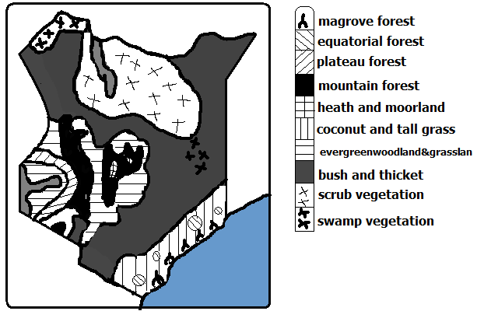

* 1. **Forests**

The area under forest is less than 7%.

The bulk is found in Central Highlands

1. **Plateau Forests**

It used to cover extensive areas around L. Victoria but today there are few patches around the lake in Maragoli, Kakamega, Kaimosi, Malava, Turbo and Tinderet forests.

They are tropical rain forests with tall trees standing among shorter trees intertwined with creepers.

1. **Lowland Forests**

-Found along the Kenyan coast.

The main types are:

* Mangrove forests which grow in shallow waters and
* Tropical rain forests in Shimba hills in Kwale District and Arabuko Sokoke in Kilifi.

1. **Highland/Mountain Forests**

-Found on the slopes of Mt. Kenya, Aberdare forests, Iveti, Mbooni, Kilala and Marsabit forests.

Indigenous hardwoods are olive, Meru oak, mvule, Elgon teak and camphor while indigenous softwoods are podocarpus and African pencil cedar and bamboo.

They have been planted with exotic hard wood trees e.g. eucalyptus and silver oak and exotic softwoods such as pines, cypress, fir and wattle.

**2. Savanna**

-Most widespread vegetation covering about 65% of the total area.

1. **Wooded/Tree Grassland**

-Found along the coastal strip and on the plateau bordering highlands east of rift Valley.

-Consists of grass of 1m mixed with thorny acacias.

Where rain decreases trees become fewer and shorter and the grassland becomes more open.

There are many large trees along water courses due to abundant moisture (riverine or gallerie forests).

The trees shed leaves during the dry season to reduce the loss of water by transpiration.

**(b) Bushland and Thicket**

**-**Covers about 48% of savannah.

-Found between coastal land and Machakos and extends into Kitui, Mwingi, Garissa, Wajir and Mandera districts.

-Consists of a mixture of thorny acacias and shorter thorny shrubs between forming thorn bush with gaps between bushes which are bare or covered by scattered varieties of grasses.

Plants are adapted by:

* Having thin leaves and hard cuticle to reduce transpiration rate.
* Baobab has large trunk to store water for use during long dry period.
* Shedding of leaves to conserve water.

**(c) Highland Grassland**

**-**Found on the undulating slopes of grasslands.

-Grasses are such as red oat, wire, Manyatta and Kikuyu grass where forests have been cleared.

-Clover grows along kikuyu grass where rainfall is over 1000mm.

**3. Semi-Desert and Desert Vegetation**

-Covers about 21% of Kenya.

It’s found on the parts of N.E and N Kenya including Marsabit and Turkana districts.

It receives insufficient rainfall of less than 380mm annually.

It has mainly scrub type of vegetation (covered with underdeveloped trees or shrubs). A shrub is a plant lower than a tree with a small woody stem branching near the ground.

The shrubs are up to 1m and grasses are up to 3m and in between there is bare ground.

Tree species are acacia and comiphora.

Real deserts hardly have any vegetation.

**Adaptations plants (Xerophytes)**

* Some have thick leaves to store water.
* Long tap roots to access water from rocks below.
* Needle like leaves to conserve water.
* Shedding of leaves to conserve water (deciduous).

**4. Heath and Moorland**

-Vegetation found towards the mountain tops.

* At lower altitudes there is groundsel, lobelia and heather.
* Where there is poor drainage there is mountain swamp vegetation referred to as bogs.
* At high altitudes there is tussock grasses, flowering plants and alchemilla shrubs. This vegetation is adapted to cold windy conditions towards the summit.

**5. Swamp Vegetation**

-Vegetation found in areas with flat relief in wet areas along river courses and areas experiencing periodic flooding e.g. along the course of R. Tana, Lorian swamp in Isiolo, Wajir and Garissa and the mangrove belt along he coast.

Vegetation found there are marshes, grasses with smooth surfaces and long blades and papyrus which is dominant.

**Vegetation Zones of the World**

**A. Forests**

A forest is a continuous growth of trees and undergrowths covering large tracts of land.

**1. Tropical Rain Forests**

-Known as Selvas in S. America.

It’s found in the following areas:

* 1. Congo Basin
  2. Amazon Basin
  3. Western sides of India, Burma and Vietnam.
  4. Coastal land of Queensland Australia.

**Characteristics**

* Closely set trees with three distinct canopies.
* There is less undergrowth on the forest floor due to light being obstructed by canopies.
* Trees take long time to grow.
* Trees have large trunks with buttress roots (radiating wall like roots).
* Trees have broad leaves to increase the surface area for efficient transpiration due to high precipitation.
* There is varied number of plants species over a small portion.
* Trees are tall, have smooth stems and straight trunks.
* Some trees are evergreen shedding a few leaves at a time while others shed leaves and are left bare.
* Some trees are very heavy and don’t float on water.
* Trees take very long time to mature between 70-100years.

Types of trees present are mahogany, ebony, ironwood, rose wood, camphor and Sapele.

Tree creepets and parasites are found around tall main trees.

**Uses of tropical rain Forests**

1. Trees are valuable sources of timber for furniture, building and construction.
2. Oil palms are for production of palm oil.
3. Cacao crops for production of cocoa beans used to make cocoa used to make chocolates and beverages.
4. Chicle from the bark of Zabote tree is used to make chewing gum.
5. Ivory nuts are used for making buttons.
6. Fibres from torquilla palm are used for making hats, mats, baskets and thatching materials.
7. Cinchona tree’s bark contains quinine used in malarial treatment.

**2. Mangrove Forests**

-Found in low lying muddy coasts of tropical seas with shallow salty waters.

**Areas**

1. Along the east coast of Africa.
2. Near the estuary of Amazon River in S. America.

**Characteristics**

* + Dominated by mangrove trees and 30 other species of trees.
  + Mangrove trees have special roots which are partly aerial to aid breathing. Some grow horizontally and then vertically downwards into mud while some grow horizontally in mud and bend upwards to aid breathing and others have net work of roots resembling stilts.

**Uses of mangrove Forests**

1. Mangrove trees provide tannin used for tanning leather.
2. Mangrove poles are used for building and construction because they are very strong.
3. Mangrove trees are also used for firewood.
4. Mangrove forests are habitats for marine life used for tourist attraction.

**3. Tropical Monsoon Forests**

**Location**

1. S.W and S coast of Mexico
2. parts of India, Bangladesh, Burma, Vietnam and Indonesia
3. Monsoon lands of Australia

**Characteristics**

* Most trees shed leaves during dry season and grow during hot wet season.
* Smaller number of tree species than tropical rain forests.
* Tall species of trees rising up to 30m.
* Trees don’t grow together.
* Trees have more branches because of light penetrating at lower levels.
* Denser undergrowth than tropical rain forests.
* Particular species of trees dominate an area (pure/definite stands) e.g.

-Leak in Burma

-Sal in India

-Eucalyptus in Queensland Australia

-Bamboo in S.E Asia

* Dominant tree species are leak, bamboo, acacia, camphor, ebony, Sapele and Pyinkaido.

**Uses of tropical Monsoon Forests**

1. Teak in Burma and Thailand is used for building houses and boats because it’s hard and resistant to termites.
2. Bamboo and rattan creeper are used for making furniture, baskets and weaving.
3. Young tender shoots of bamboo are consumed as vegetables.

**4. Mediterranean Forests**

**Areas**

1. S. Europe and N. Africa areas bordering Mediterranean Sea.
2. Around Cape Town on S.W end of Africa.
3. Central coast of California.
4. Around Perth in S.W Australia.

**Characteristics**

* Forests are open woodlands.
* Many trees are deciduous.
* Some trees are evergreen e.g. oak
* There is woody scrub vegetation in areas which are dry and with poor soils which is called marquis in France, Chaparral in California and Machia in Italy.
* Many plants are sweet smelling (aromatic) e.g. rosemary, lavender, oleander, broom and myrtle.
* Many trees are xerophytes e.g.

-Trees have long tap roots to reach the water deep below during long dry spells.

-Waxy leaves to reduce transpiration

-Storing water in their thick leaves or stems

-Small spiny leaves

* Types of trees are olive, sweet chestnut, beech, cedar, cypress, sequoia, eucalyptus

**Uses**

1. Cork oak is used to make corks for bottling wine.
2. Olive tree fruits are used for cooking and extraction of olive oil.
3. Timber from sweet chest nut, beech, cedar, cypress and pine is used for building houses and making furniture.
4. Shrubs and grasses are used as pasture for goats.

**5. Temperate Evergreen Forests**

-Found in areas experiencing warm temperate eastern margin or China Climate.

**Areas**

1. Along Natal coast in S. Africa
2. S. china and S. Japan
3. S.E Australia
4. S.E and S. states of U.S.A.

**Characteristics**

* Evergreen because of abundant rainfall throughout the year.
* Most trees have broad leaves to increase the surface are for efficient transpiration.
* Manyevergreen trees are hardwoods.

**Uses**

1. Hard woods such as oak and iron wood are used for furniture and building materials.
2. Soft woods such as cypress and pines are used for furniture.
3. Wattle trunks are used in the coal mines of natal.
4. Bamboo is used for making furniture and building in China and Japan.
5. Walnuts provide nuts used for making chocolate.
6. Ivory nuts are used for making buttons.
7. Young shoots of bamboo are eaten as vegetables in china and Japan.

**6. Temperate Deciduous Forests**

-Found in areas experiencing cool temperate western marginal climate.

**Location**

1. C. and W. Europe.
2. Most of E. states of U.S.A.
3. Chile in S. America.

**Characteristics**

* Trees are deciduous and shed leaves in autumn and become green in summer.
* Individual species of trees are scattered and their density per unit area is small.
* Trees are smaller in size.
* Trees are broad leaved.
* Most of the trees are hardwoods
* There is rich undergrowth because of being fairly open.
* Trees grow in pure stands in some regions and at others they are mixed.
* Trees are easier to exploit than tropical hardwoods.

**Uses**

1. Hardwoods such as oak and birch are used for timber, wood fuel and charcoal.
2. Chestnut and walnut nuts are edible.
3. Oak tree fruits are used for feeding pigs.
4. Tung tree yields oil for making paint and furnish.
5. Maple sap is used for making maple syrup.

Trees include eucalyptus (blue gum), olive, birch, walnut, elm and ash.

**Coniferous Forests**

It’s dominant in cool climates. It’s known as Taiga and Boreal in Russia.

**Location**

1. W. coast of Canada.
2. Scandinavia across Russia to the Pacific coast.

**Characteristics/of soft woods in Canada**

* Their seeds are cone shaped.
* Most trees are softwoods and are light in weight.
* Trees mature faster than hardwoods of tropical regions.
* Trees have big proportion of stem compared to leaves.
* Most tree species are evergreen with few shedding leaves e.g. larch and fir.
* Tree species occur in big pure stands.
* Very little undergrowth due to acidic humus from leaf fall.
* Trees have straight trunks.
* Trees mature after a long period of time (50-70 years) due to the cold conditions especially in winter.

Species of trees found here are pines, Fir, spruce, larch and Hemlock.

**Adaptations**

* Needle-like leaves to reduce transpiration.
* Leaves with tough waxy skin to protect them from winter cold.
* Tree crowns are cone shaped and flexible crowns to allow snow to slide off to prevent it from accumulating on the branches.
* Trees are evergreen to have maximum utilisation of sunlight during the short summers.
* Flexible tree trunks to allow swaying so as to allow swaying so as not to break during strong winter winds.
* Widely spread root system for maximum utilisation of moisture from top soil because sub soil is permanently frozen.

**Used**

Soft woods such as spruce, fir, pine and larch are used for construction, wood pulp used in paper manufacture.

**7. Mixed Forests**

-Found at the zone of transition between temperate deciduous and coniferous forests.

**Location**

1. Saskatchewan and Alberta provinces of Canada
2. Scottish regions in Europe
3. low lying Mediterranean regions

**Characteristics**

-A mixture of broadleaved deciduous and coniferous trees.

**Uses**

-Cedar and hazel are used for fencing posts.

-Grazing activities are carried out where forests are open.

-Softwoods such as spruce, fir and pine are used to make wood pulp used for paper manufacture.

-Hardwoods such as oak and birch are valuable sources of timber, wood fuel and charcoal.

-Maple tree syrup is used for making maple syrup.

**B. Grasslands**

-Found in climatic regions where a seasonal pattern occurs with a prolonged drought of about 5-7 months.

**Tropical Grasslands/ Savanna**

-Found in areas experiencing tropical continental climate.

**Areas**

1. N and S of Congo Basin.
2. Between Sahel and equatorial forests in E. Africa plateau.
3. N.E of Australian Desert.
4. Brazilian highlands

It’s divided into:

1. Open grasslands where grass is dominant and
2. Woodlands in areas which receive more rainfall.

**Characteristics**

* Grasslands with widely spaced trees such as acacias.
* Grasses die in dry season and sprout quickly when it rains.
* Grasses are tall (up to 3m with stiff blades and elephant grass is tallest reaching up to 4m.
* Trees are of medium size up to 13m
* Tree crowns are umbrella shaped to provide shade around roots to reduce evaporation.
* Most trees are deciduous and shed leaves during dry season.
* Trees have small leaves and thick barks to reduce transpiration.
* Trees have long tap roots to reach the water deep below during long dry spells.

**Uses**

1. Grass is for grazing and commercial ranching though it’s of low nutritional value due to lack of phosphorous.
2. Cereals e.g. wheat farming because the soil is rich in humus resulting from the grass cover.
3. Vegetation acts as soil cover to reduce soil erosion.
4. Homes of wild animals which attract tourists e.g. E. and C. African savannas.
5. Trees are habitats for bees which provide honey.
6. Some shrubs and herbs are used for medicine.
7. Trees such as acacia provide fuel wood and charcoal.

**Temperate Grasslands**

-Found in continental interiors of temperate grasslands where rainfall isn’t sufficient to sustain forests.

**Location**

**The Prairies**

**Areas**

-Canadian provinces of Alberta, Saskatchewan, Manitoba and neighbouring states of U.S.A.

**Characteristics**

-Continuous tuft grass

-Grasses are nutritious.

-Grass is short

-Grass is interspersed with bulbous and leguminous plants.

-Grass is mixed in some areas with species such as stipa, buffalo and gamma grasses.

-Tall grasses in areas with rainfall of over 500mm.

**The Steppes**

-Found in Eurasia- temperate interiors of Europe and Asia.

**Characteristics**

-True Steppes-rich carpet of grass and some flowering plants.

-Desert steppes-Coarse grass growing in tufts

-Grass doesn’t form a continuous cove on the ground.

-Short grass which grows very close to the ground.

**The Pampas**

-Found in Argentina.

**Characteristics**

-Feather-like grass

-Grass forms individual tussocks with patches of bare soil.

-Forests are present in some areas due to increased moisture.

-Xerophytic or drought resistant plants are present in some areas.

**The Veldt**

-Found in S. Africa.

**Characteristics**

* Grasses are extensively spread.
* There is little or no mixture of trees or shrubs.
* There is a uniform cover of grass on high plateaus.

**The Downs**

-Found in Australia and New Zealand.

**Characteristics**

* Tall grass mixed with trees.
* Semi desert areas have patches of dominant grass.
* Mixture of temperate and tropical grass species.
* Grass is nutritious and nutritious for livestock.
* Natural grasses of Argentina have been replaced by Alfalfa and in New Zealand British meadow grasses now dominate.

**Uses of Temperate Grasslands**

1. For grain cultivation e.g. wheat which requires as low as 325mm of rainfall.
2. For cultivation of other crops e.g. oil seeds, Soya beans, vegetables and millet and sorghum widely grown in the Veldt.
3. For livestock farming e.g. cattle, sheep, goats and horses. There are scientifically managed ranches called Estancias in Argentina.

**Desert Vegetation**

**Tropical Desert Vegetation**

-Found in tropical deserts.

**Characteristics**

* Vegetation is present except in bare rock and sand covered areas.
* There are more plants on oasis e.g. date palms and a variety of shrubs.
* Some plants are succulent to have high water storage capacity.
* Some have spines to protect them from animals.
* Some have thorn-like leaves to reduce rate of transpiration.
* Some have long roots to enable them to tap water from deeper parts of rocks.
* Some shed leaves during dry season and grow new leaves during wet periods to reduce water loss.
* Some are salt tolerant (halophytic) by having many water storing cells to counter soil salinity or alkalinity.

**Temperate and Arctic Desert Vegetation**

**-**Found in warm temperate deserts and arctic climates.

**Characteristics**

* Grasses and woody plants.
* Woody plants which are Xerophytic and halophytic.
* Shrubs have shallow roots due to permafrost.
* Plants flower and produce fruits within short wet season.
* There is scarce vegetation in Tundra.
* Plants present in arctic deserts are such as lichens, mosses and flowering plants such as anemones and marsh marigold.

**Uses of Desert Vegetation**

1. Bilberries in temperate deserts bear edible fruits.
2. Small trees are source of fuel foe Eskimos who live in arctic region.
3. Vegetation in tropical deserts is important in arresting sand dunes to prevent them from burying oasis and settlements.
4. In tropical deserts fringes vegetation is valuable food for animals.
5. Date palm is cultivated for its fruit.

**Mountain Vegetation**

**-**Vegetation found towards the top of the mountain.

**Uses of Mountain Vegetation**

1. Grasslands are used for grazing.
2. Alpine meadows in temperate regions provide summer grazing pastures.
3. Mountain forests provide timber, building materials, fuel wood and charcoal.
4. Mountain forests are habitats for wild animals e.g. elephants.
5. Mountain vegetation makes mountains to be water catchment areas.
6. Mountain forests help to purify air by absorbing carbon dioxide and providing oxygen.
7. Mountain vegetation is used for research.

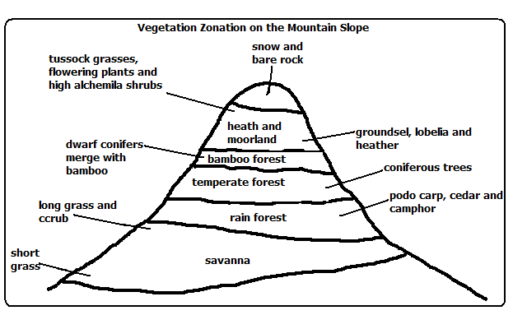

**Significance of Vegetation**

1. Forests add beauty to country’s landscape.
2. Vegetation protects soil from erosion by wind and rainwater.
3. Vegetation partly decays forming humus making the soil fertile.
4. Some plants roots, barks and leaves are used for medicine.
5. Forests modify the climate of the surrounding area by increasing rainfall and reducing temperatures.
6. Some plants such as bamboo shoots and wild fruits are consumed as food.
7. Some fibrous plants such as sisal and jute are used for making ropes, sacks, mats, etc.
8. Latex from rubber tree is used for manufacture of rubber used in tire manufacture.

**FORESTRY**

Forestry is the science of developing and managing forests including cultivating them.

**Type of Forests**

1. Natural forests-which grow by natural means of seed dispersal.
2. Semi-natural/derived/cultivated forests-which is in the process of recovering from interference by man.
3. Planted/cultivated forests-which have been planted by man.
4. Indigenous forests-which are native to a region or which have grown in a region from the beginning.
5. Exotic forests-which have trees which have been introduced to a place from other countries.
6. Other types have been discussed in the chapter of vegetation.

**Factors Influencing Types and Distribution of Forests**

**Temperature**

* High temperature causes fast growth of trees while low temperature causes slow growth.
* Rain forests are found at low altitudes which are warmer while coniferous forests are found at high altitudes which are cooler.

**Aspect**

* Dense forests are found on windward slopes of mountains because they are wetter than leeward slopes and they start at a lower level than on the leeward slopes.
* In temperate region slopes facing equator have dense forests because they are warmer while those facing the poles have coniferous forests which are adapted to low temperatures.

**Precipitation**

* There are dense forest where there is heavy precipitation while there is less forest cover consisting of stunted trees in areas with little precipitation.
* Coniferous forest have cone-shaped crowns to allow snow to slide off so as not to accumulate on the branches and cause them to break off.

**Soil**

* Deep soils support huge tropical trees while shallow soils support coniferous trees which have shallow and wide spread root system to be able to maximally utilise water on the top soil since the sub soil is permanently frozen.
* Poor or infertile soils have stunted trees.

**Human Activities**

* Deforestation and shifting cultivation- man has cleared forests to create room for agriculture settlement etc. which has reduced forest cover on the earth’s surface.
* Afforestation and Agroforestry-man has planted trees in areas where they never existed establishing forests there.
* Reafforestation-man has replanted forests which he has cleared with indigenous and exotic trees causing natural forests to become semi-natural/secondary or derived forests.

**Importance of Forests to Kenya**

1. Forests are water catchment areas which supports agriculture and H.E.P. generation.
2. Forests provide us with wood fuel e.g. firewood, charcoal and saw dust.
3. Forests prevent soil erosion by their roots binding the soil together, reducing run off thereby reducing incidents of flooding and dam siltation.
4. Forests are habitats of wild animals which are a tourist attraction which brings foreign exchange used to import goods and services and fund development projects.
5. Forests are a disposal system for carbon dioxide which they use in photosynthesis and release oxygen thereby purifying air and reducing global warming.
6. Forests increase soil fertility when leaves fall and rot forming humus.
7. Forests regulate the climate of an area by creating a micro climate causing heavy and frequent rain by evapotranspiration and lowering temperatures.
8. Forests are a source of timber for construction and furniture making.
9. Forests beautify the environment by flora (plants) and fauna (animals).
10. Some forest’s trees are a source of medicine.
11. Presence of forests has led to the development of infrastructure as roads have been constructed to make forests accessible.
12. Forests provide employment to people e.g. forest guards, forest officers, lumberjacks, carpenters and timber merchants.

**Importance of Forest Products**

1. Forests are a source of food e.g. fruits, honey, mushrooms and bamboo tender leaves which are used for vegetables.
2. Forests provide wood used for manufacture of paper, soft boards, ply wood etc.
3. Animals in forests are hunted for food, skins and horns.
4. Leaves of trees and forest undergrowth are used as livestock fodder.
5. Forests provide wood which is used in cottage industries for making carvings and wooden utensils which are sold locally and exported.
6. Forest flora and fauna are a rich reservoir for research.

**Problems Facing Forestry in Kenya**

1. Encroachment by people by clearing them to create room for agriculture and settlement, grazing etc. which puts some plants and animal species in danger of extinction.
2. Destruction especially of young trees by herbivorous wild animals such as elephants due to rapid increase in the population.
3. Destruction of huge tracts of forests by fires caused by poachers, honey harvesters etc. especially during the dry season.
4. Pests and diseases outbreak which can result in destruction of large tracts of land with valuable tree species e.g. there was an outbreak of aphids in 1980s which destroyed cypress.
5. Overexploitation whereby the trees are harvested at a higher rate than which they are being replaced naturally and also harvesting of immature trees.
6. Excision of forests e.g. by converting some parts of forests into private land, government land like Nyayo Tea Zones and public utilities like Agricultural Show Grounds which has resulted into reduction of the area under forests.
7. Poor management of forests e.g. clear cutting which may lead to harvesting of immature trees in future, government officials carrying out illegal logging and government in the past having not been strict in forest conservation of forests which led to destruction of large areas of forests.

**Management and Conservation of Forests**

Conservation of forests is protection of forests against interference and destruction by man while forest conservation is effective planning and control of forests and forest resources.

**Conservation Measures**

1. Creation of forest reserves to protect indigenous forests from extinction e.g. Mt. Kenya forest, Shimba Hills and Arabuko Sokoke.
2. Setting of forest guard posts in the forests to protect forests against illegal logging (tree felling).
3. Setting Nyayo Tea Zones to act as protective belts to prevent people from trespassing into the forests. They are also a source of employment and foreign exchange.
4. Afforestation and reafforestation.
5. Agroforestry (intercropping of various crops with trees) which:
   * Supplies wood resources
   * Provides animal fodder
   * Provide food e.g. fruits e.g. mangoes and avocadoes for good health and nutrition
   * Acts as wind breakers and
   * Shade for crops.

**Management Measures**

1. Research to determine which tree species are suitable for which area and how to combat pests and diseases outbreak.
2. Carrying out public campaigns through mass media on the importance of forests.
3. Use of alternative sources of energy e.g. sun, wind, biogas and water to reduce the rate of tree felling.
4. Use of energy saving stoves to reduce the rate of overexploitation of wood fuel.
5. Improvement on cutting practices by selective falling of trees and replanting more trees than those cut.
6. Control of pests and diseases which affect trees.

**Importance of Forest Management and Conservation**

1. Are a source of utility products e.g. firewood for fuel and food from fruits and nuts.
2. For ecological reasons in that they help in the following ways:
   * To preserve flora and fauna
   * It’s a water catchment area
   * Moderating the flow of water reducing soil erosion and floods which also prevents siltation of dams.
3. For posterity i.e. so that the future generation will have forest resources available for their use.
4. Industrial reasons because forest products are used as raw materials in the industries such as furniture, paper making, etc.
5. Forests are important for scientific research such as on herbal medicine and genetic mapping of the species of plants and animals which haven’t been identified.

**Softwood Forests in Kenya and Canada**

**Factors Favouring the Development of Softwood Forests**

**Kenya**

1. Cool climate of Kenya highlands which enables coniferous forests to thrive e.g. Mt. Kenya and Aberdares.
2. Heavy rainfall received in Kenya highlands and low evaporation rates which supports forest growth.
3. Ruggedness and steepness of some parts of Kenya highlands making them unsuitable for settlement thereby leaving forests to thrive.
4. High demand for timber and wood products locally and outside the country which encourages tree farming.

**Canada**

1. Cool and cold climate which favours growth of coniferous forests.
2. Very low average temperatures in the interior which favours the growth of coniferous forests.
3. Ruggedness and steepness such as of British Columbia which discourages agriculture and settlement leaving forests to thrive.
4. Very low population density leaving a lot of land available for forests.
5. Heavy rainfall on the windward slopes of mountain ranges of British Columbia and low evaporation in the east giving sufficient moisture to sustain forests.

**Mode of Exploitation**

**Kenya**

* Workers are transported daily to logging sites in Kenya while in Canada settlement is set for workers within forests.
* Power saws are used in both countries to fell trees but axes are used to a limited extent in Kenya.
* In Kenya transportation of logs is by tractors and lorries while in Canada rivers are widely used to transport logs by floating.
* In both countries logging is systematic and it is done in blocks.

**Factors Favouring Exploitation of Softwoods**

**Kenya**

1. Doesn’t experience winter so logging can go on throughout the year.
2. Soft wood forests in Kenya are easier to exploit because trees are planted in rows unlike in Kenya where they are natural and trees grow haphazardly.
3. In Kenya forests are accessible throughout the year unlike in Canada where forests in the north are inaccessible during severe winter and ruggedness.
4. In Kenya logging can go on throughout the year because there is no winter.
5. Availability of water from R. Nzoia for pulp and paper manufacture at Webuye.
6. Ready market due to high demand for wood products locally and outside in COMESA.

**Canada**

1. Mild winters in British Columbia which makes it possible to transport logs throughout the year.
2. Availability of water from many rivers providing plenty of water for paper and pulp manufacture.
3. Cheap H.E.P. for factories from many rivers in Canada.
4. Cheap and efficient land and water transport system easing transport of logs to factories and to markets.
5. Coastal location of major producing areas making exportation of timber to U.S.A. and Japan easy.
6. High demand for forest products in the neighbouring U.S.A. and locally due to high purchasing power.
7. Existence of natural coniferous forests in pure stands (one tree species covering a large area) making exploitation easy.
8. Absence of undergrowth which makes exploitation easy (due to dead leaves resulting in acidic humus.

**Planted soft Woods in Kenya**

* + Planted in clear rows.
  + Clear cutting
  + Mature at the same time.

**Products**

In Kenya and Canada products are poles sawn timber, pulp, paper, block board, ply wood, clip board etc.

**Economic Significance of Softwood Forests in both Countries**

1. Provides employment to people e.g. lumberjacks, tree farmers and in timber related industries.
2. Has led to development of timber/wood related industries e.g. furniture, paper manufacture etc.
3. A foreign exchange earner when in Canada timber is exported to U.S.A. and when products in Kenya are exported to COMESA.
4. Saving some foreign exchange when the country produce wood products to cater for their needs on which they’d otherwise spend foreign exchange.
5. Infrastructural development when roads are constructed to ease transportation of logs to industries and products to markets.
6. Provide income to tree farmers.

**Problems in Kenya and Canada**

1. Forest fires which destroy large tracts of land where in Canada the greatest number of fires are caused by lighting while in Kenya they are caused by illegal loggers, poachers, etc.
2. Pests and diseases e.g. aphids which destroyed cypress in 1980s.
3. Overexploitation leading to soil erosion as trees takes long time to mature and provide sufficient cover to the soil after planting.
4. Canada’s trees take long time to mature (50-60 years due to severe winters which slow their growth. In Kenya they take 12-35 years.
5. In Canada there is problem of inaccessibility of forests in the northern part in winter and due to rugged terrain while in Kenya they are planted and easily accessible.

**Comparison of softwood forests in Kenya and Canada**

**Similarities**

* Soft wood forests in both countries experience the problems of pests and diseases, fires, soil erosion and overexploitation.
* Softwood forest products are similar e.g. sawn timber, wood pulp, paper, poles, etc.
* Softwood forests in both countries grow in places with heavy rainfall, cool temperatures, heavy rainfall and rugged terrain.
* Forest products earn foreign exchange in both countries.
* Tree species are similar e.g. there is pine in both countries.

**Differences**

* Species of trees differ e.g. in Kenya there is Kenya cedar and podo while in Canada there is Douglas fir and white pine.
* Canada’s soft woods are mainly natural while Kenya’s are mostly planted.
* Kenya’s softwood forests are found in highlands while Canada’s are found in lowlands due to cool temperatures.
* Canada’s softwood forests cover large tracts of land than Kenya’s.
* In Kenya softwood forests are propagated by afforestation while in Canada it’s by leaving some trees uncut so that they produce seeds to be dispersed naturally.
* Canada’s softwood forests take longer to mature than Kenya’s due to severe winter temperatures.
* Kenya’s softwood forests are planted in rows and easily exploitable unlike Canada’s which grow naturally and haphazardly.

**F 3 GEOGRAPHY**

**STATISTICS COMPOUND/CUMULATIVE/DIVIDED BAR GRAPH**

Major cash crops exported in Kenya in tonnes

|  |  |  |  |  |  |
| --- | --- | --- | --- | --- | --- |
| CROP | 1990 | 1991 | 1992 | 1993 | 1994 |
| COFFEE | 4500 | 5000 | 5200 | 6000 | 5900 |
| TEA | 1300 | 1100 | 2500 | 2100 | 2200 |
| MAIZE | 800 | 900 | 500 | 400 | 400 |
| WHEAT | 600 | 500 | 600 | 700 | 500 |

**Steps**

|  |  |  |  |  |  |  |  |  |  |
| --- | --- | --- | --- | --- | --- | --- | --- | --- | --- |
| CROP | 1990 | CT | 1991 | CT | 1992 | CT | 1993 | CT | 1994 |
| COFFEE | 4500 | 4500 | 5000 | 5000 | 5200 | 5200 | 6000 | 6000 | 5900 |
| TEA | 1300 | 5800 | 1100 | 6100 | 2500 | 7700 | 2100 | 8100 | 2200 |
| MAIZE | 800 | 6600 | 900 | 7000 | 500 | 8200 | 400 | 8500 | 400 |
| WHEAT | 600 | 7200 | 500 | 7500 | 600 | 8800 | 700 | 9200 | 500 |
| TOTAL | 7200 | | 7500 | | 8800 | | 9200 | | 9000 |

1. Set cumulative totals for the data each year
2. Draw vertical axis(Y) to represent dependent variable
3. Draw horizontal axis(x) to represent independent variable
4. Label both axis using suitable scale
5. Plot the cumulative values for each year
6. Use values for components to subdivide the cumulative bar
7. The subdivisions are placed in descending order with the longest at the bottom(coffee)
8. Shade each component differently
9. Put title and key

**Advantages**

1. It’s easy to construct
2. It has good visual impression
3. There is easy comparison for the same component in different bars because of uniform shading
4. Easy to interpret because bars are shaded differently
5. Total value of the bar can be identified easily

**Disadvantages**

1. It doesn’t show the trend of components (change over time).
2. Can’t be used to show many components as there is limited space upwards
3. Tedious as there is a lot of calculation work involved.
4. Not easy to trace individual contribution made by members of the same bar
5. Poor choice of vertical scale causes exaggeration of bars length leading to wrong conclusions

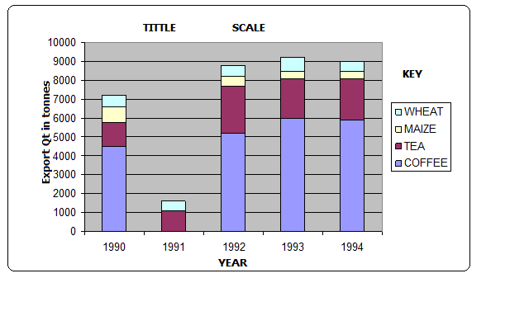

**Analysis**

* + Coffee was the leading export earner in the five years.
  + Tea was the second leading export earner.
  + Wheat had the lowest export quantity.
  + 1993 recorded the highest export quantity.
  + 1990 recorded the lowest export quantity.

*N.b.-leave half a page for example 2*

**PIECHART/DIVIDEDCIRCLES/CIRCLE CHARTS**

* A circle which has been subdivided into degrees used to represent statistical data where component values have been converted in degrees.

**Major countries producing commercial vehicles in the world in 000s**

|  |  |  |  |  |  |
| --- | --- | --- | --- | --- | --- |
| USA | FRANCE | JAPAN | UK | GERMANY | RUSSIA |
| 1800 | 240 | 2050 | 400 | 240 | 750 |

**Steps**

1. Convert components into degrees

USA 1800×360/5480=118.2◦

FRANCE 240×360/5480=15.8◦

JAPAN 2050×360/5480=134.7◦

UK 400×360/5480=26.3◦

GERMANY 240×360/5480=15.8◦

RUSSIA 750×360/5480=49.3◦

1. Draw a circle of convenient size using a pair of compasses.
2. From the centre of the circle mark out each calculated angle using a protractor.
3. Shade the sectors differently and provide the key for various shadings.

**Advantages**

* 1. Gives a good/clear visual impression
  2. Easy to draw.
  3. Can be used to present varying types of data e.g. minerals, population, etc.
  4. Easy to read and interpret as segments are arranged in descending order and are also well shaded.
  5. Easy to compare individual segments.

**Disadvantages**

1. Difficult to interpret if segments are many.
2. Tedious due to a lot of mathematical calculations and marking out of angles involved.
3. Can’t be used to show trend/change over a certain period.
4. Small quantities or decimals may not be easily represented.

**Analysis**

1. The main producer of commercial vehicles is Japan.
2. The second largest producer is USA followed by Russia.
3. The lowest producers were France and West Germany with.

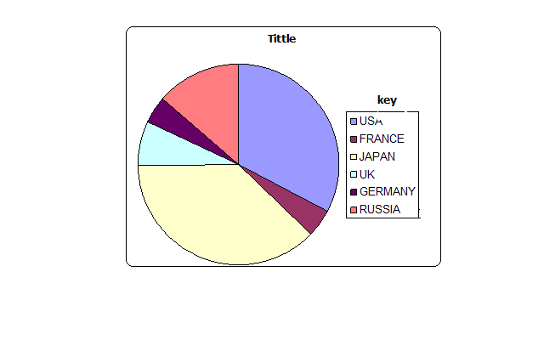

**PROPORTIONAL CIRCLES**

This is use of circles of various sizes to represent different sets of statistical data.

**Table showing mineral production In Kenya from year1998-2000**

|  |  |  |  |
| --- | --- | --- | --- |
| MINERALS | QUANTITY IN TONNES | | |
|  | 1998 | 1999 | 2000 |
| Graphite | 200 | 490 | 930 |
| Fluorspar | 30 | 255 | 450 |
| Soda ash | 270 | 300 | 350 |
| Diamond | 500 | 870 | 1270 |
| TOTAL | 1000 | 1915 | 3000 |

**Steps**

1. Determining the radii of circles by finding the square roots of the totals

1998 √1000=31.62=32

1999 √1915=43.76=44

2000 √3000=54.77=55

1. Scale:1cm represents 10 tonnes

1998=3.2 cm

1999=4.4 cm

2000=5.5 cm

1. Using a pair of compasses draw circles of different radii representing mineral production in Kenya between 1998 and 2000.
2. Convert component values into degrees

Component value/ total value of data×360

1998: Graphite-200/1000×360=72◦

Fluorspar-30/1000×360=10.8◦

Soda ash-270/1000×360=97.2◦

Diamond-500/1000×360=180◦

1999: Graphite-490/1915×360=92.1◦

Fluorspar-255/1915×360=47.9◦

S

`300/1915×360=56.4◦

Diamond-870/1915×360=163.6◦

2000: Graphite-930/3000×360=11.6◦

Fluorspar-450/3000×360=54◦

Soda ash-350/3000×360=42.1◦

Diamond-1270/3000×360=152.3◦

1. On the proportional circle for each year use a protractor and mark out the angles
2. Shade the segments and then provide a key.

**Advantages**

1. They give a good visual impression.
2. Easy to compare various components.
3. Simple to construct.
4. Easy to interpret as segments are arranged in descending order.
5. Can be used to present varying types of data.

**Disadvantages**

1. Tedious in calculation and measurement of angles
2. Actual values represented by each component cant be known at a glance
3. Difficult to accurately measure and draw sectors whose values are too small.
4. Comparison can be difficult if the circles represent values which are almost equal.

**Analysis/Conclusions**

1. Diamond was leading in production.
2. The second leading mineral in production was graphite.
3. The mineral with the lowest production was fluorspar.

**MAP WORK**

**Description of Relief**

1. Describe the general appearance of the entire area e.g. hilly, mountainous, plain, undulating landscape, has many hills, isolated hills, etc.
2. State the highest and lowest parts of the area.
3. Look out for valleys which are occupied by rivers.
4. Divide into relief regions such as plateau, escarpment and lowland.
5. Explain the type of slop e.g. gentle, steep, even or irregular.
6. Direction of slope.
7. Identify the land forms present in the area.

**Gentle Slope**

Slope is the gradient of land surface.

Gentle slope is one in which land doesn’t rise or fall steeply

Contours are wide apart

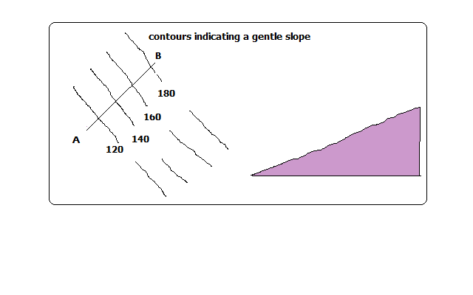

**Steep Slopes**

* Where land rises or falls sharply
* Contours are close to each other

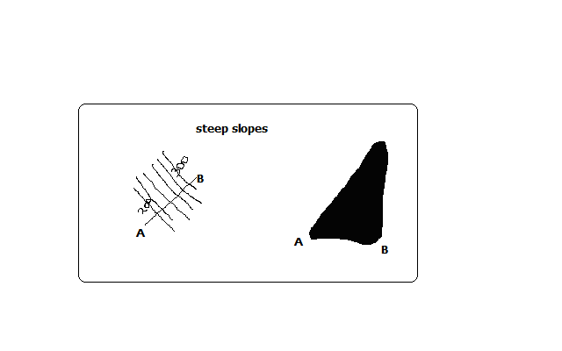

**Even Slopes**

* Shown by contours which are evenly spaced.

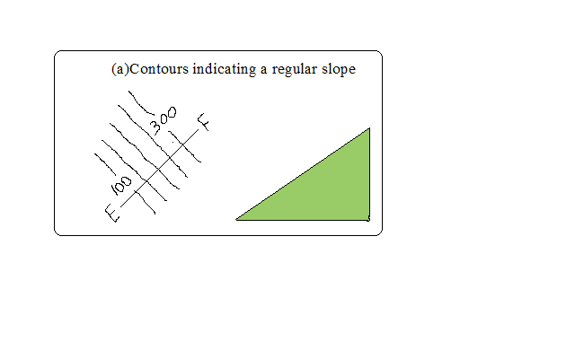

**Uneven Slopes**

* Indicated by unevenly spaced contours.

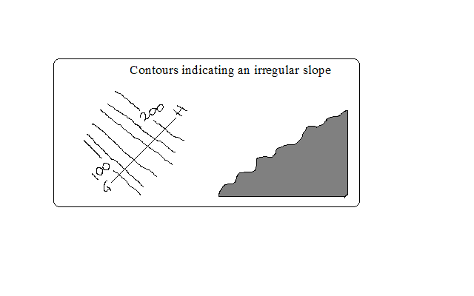

**Convex Slopes**

* One curved outwards
* Indicated by contours which are close together at the bottom and widely spaced together at the top.

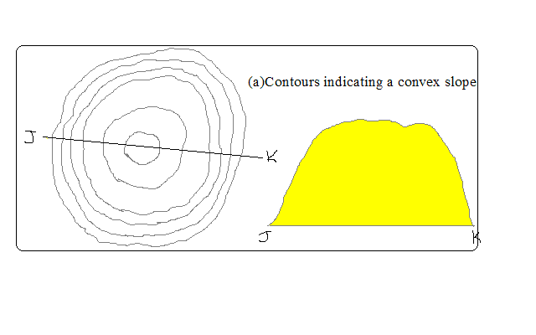

**Concave Slopes**

* One curved inwards.
* Contours are close together at the top and widely spaced at the bottom.

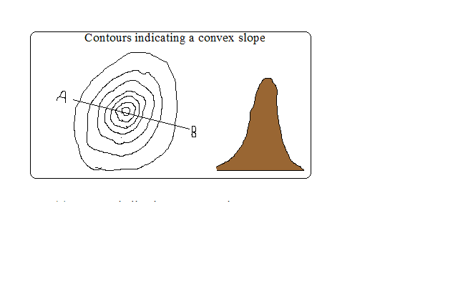

**A Valley**

* A low area between higher grounds.
* Indicated by U-shaped contours pointing towards a higher ground.

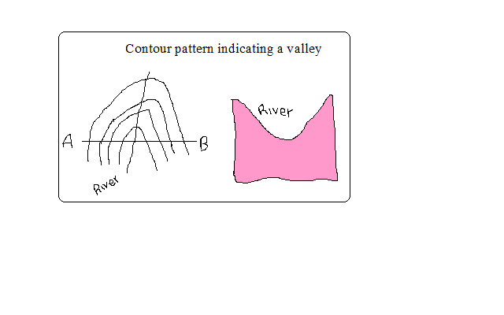

**A Spur**

* Land which is projected from high to low ground.
* Indicated by U-shaped contours bulging towards lower ground.

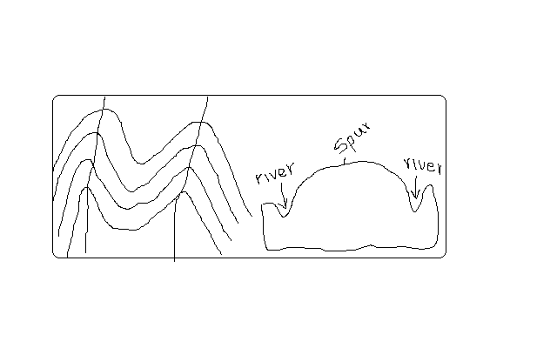

**Interlocking Spurs**

* Spurs which appear as if to fit together.

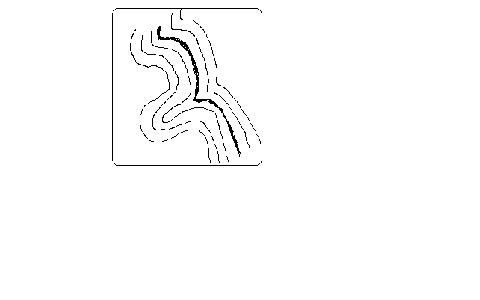

**Truncated Spurs**

* Spurs in glaciated highlands whose tips have been eroded and straightened.

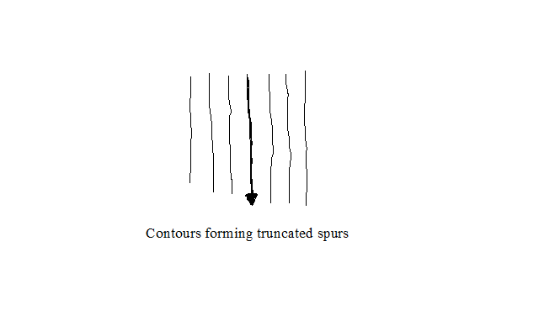

**Conical Hills**

* Hills are uplands which rise above relatively lower ground
* Conical hills are small rounded hills

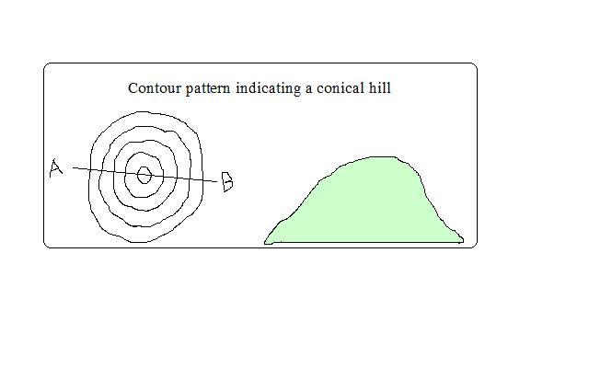

**Irregular Shaped Hills**

-A hill with some sides with uneven gentle and others with uneven steep slopes.

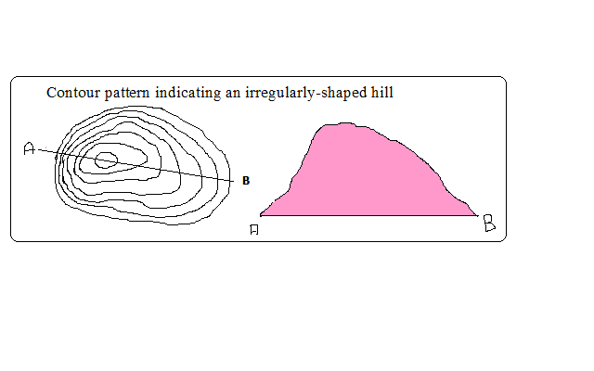

**Ridges**

* A range of hills with steep slopes on all sides.
* A ridge can contain hills, cols, passes or water shed.

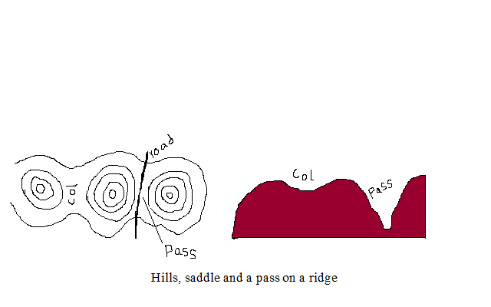

**A Col**

* A low area which occurs between two hills.

**A Pass**

* A narrow steep sided gap in a highland.

**A Water Shed**

* The boundary separating drainagesystemswhich drains into different directions
* Escarpment and ridges often form water sheds.

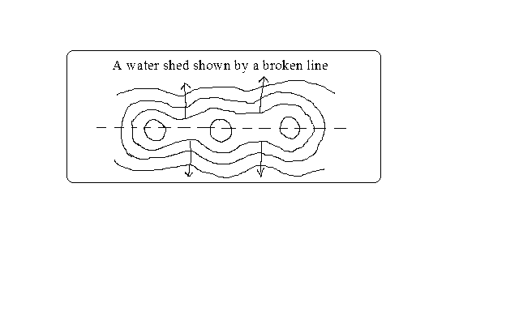

**Escarpment**

* A relatively continuous line of steep slopes facing the same direction
* Has two slopes: a long gentle slope (dip slope) and short steep slope (scarp slope).

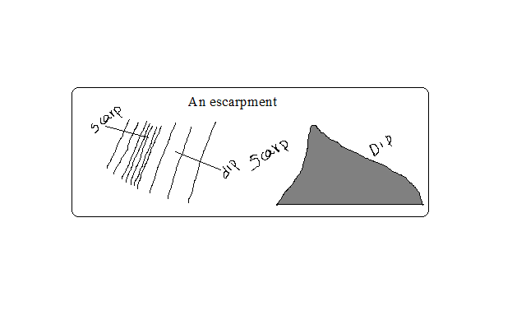

**A Plateau**

* A high flat land bound by steep slopes.

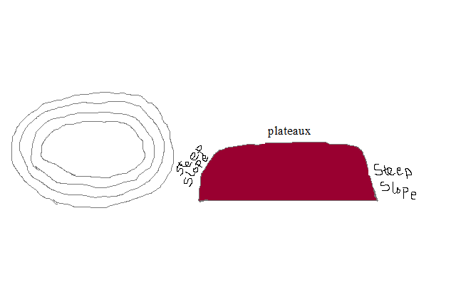

**Description of Vegetation**

Natural vegetation is classified as woodlands, thickets, scrubs or grasslands.

Symbols are given as pictures of vegetation.

* Types present
* Distribution
* Reasons for distribution e.g. seasonal streams, scrub or grassland due to low rainfall.

1. Forests

Likely indications of the following in the area:

* + Heavy rainfall
  + Fertile rainfall
  + Cool temperature depending on altitude

1. Thickets and shrubs

* Seasonal rainfall
* Poor soil
* High temperature

1. Riverine trees

* High moisture content in the river valley

**Describing Drainage**

* Identify drainage features present

Natural drainage features include lakes, rivers, swamps, sea, rapids, waterfalls, cataracts, springs, deltas, fjords, sand or mud, and bays

Artificial features include ponds, wells, boreholes, water holes, cattle dips, cattle troughs, canals, reservoirs, irrigation channels, aqueducts, water treatment plants and manmade lakes.

* Identify main rivers by name
* Size of rivers-big or small-shown by thickness of blue lines.
* Give the general direction of flow.
* Location of water shed if any
* Characteristic of each feature

**a) Permanent Rivers**

* Which flow throughout the year
* Shown by continuous blue lines



Likely indication of:

* Heavy rainfall
* Impermeable rocks

**b) Seasonal Rivers**

* Which flow seasonally or during the rain season
* Shown by broken blue lines

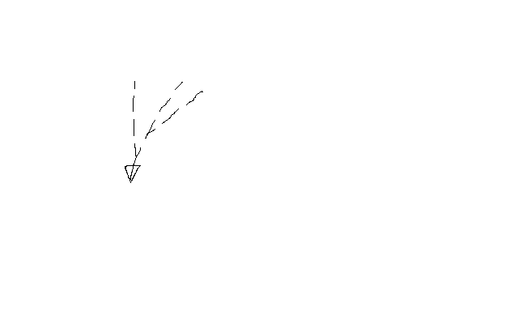

Likely indication of:

* Low rainfall
* River doesn’t have a rich catchment area

**c) Disappearing Rivers**

-Blue lines ending abruptly



Likely indication of:

* Permeable rocks
* Very low rainfall
* Underground drainage
* Identify drainage patterns and description

-Drainage pattern is the layout of a river and its tributaries on the landscape.

**a) Dendritic**

-Resembles a tree trunk and branches or veins of a leaf.

-Tributaries join the main river at acute angles.

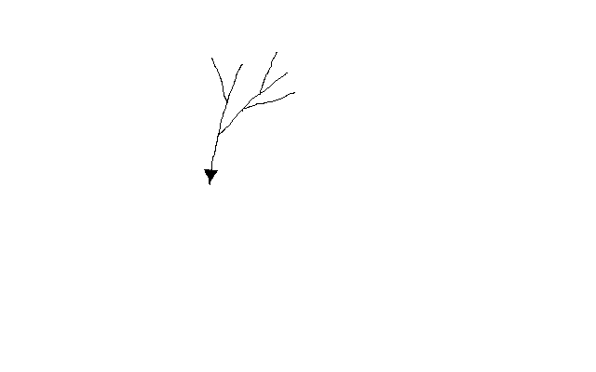

**a) Trellis**

Tributaries join the main river and other tributaries at right angles

of hard and soft rocks)

Common in folded areas where rivers flow downwards separated by vertical uplands.

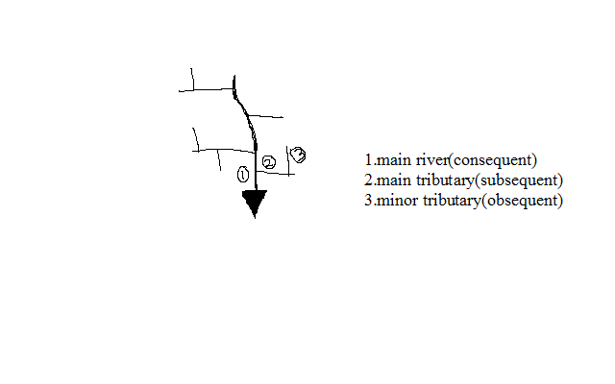

**b) Rectangular Pattern**

-Looks like a large block of rectangles.

-Tributaries tend to take sharp angular bends along their course.

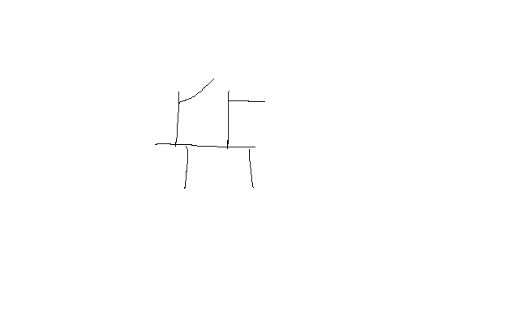

**c) Parallel Pattern**

-Rivers and tributaries flow virtually parallel to each other

Influenced by slope

-Common on slopes of high mountain ranges

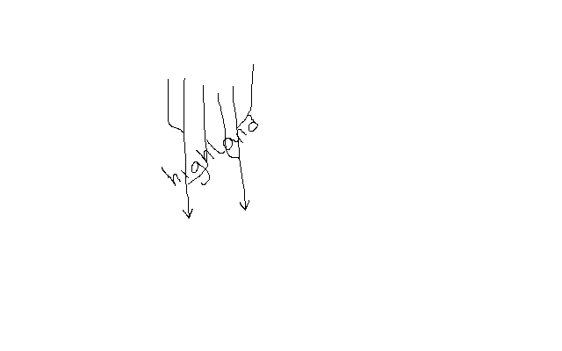

**d) Centripetal Pattern**

-Rivers flow from many directions into a central depression such as a lake, sea or swamp.

-Examples are rivers flowing into some of the Rift Valley lakes such as Nakuru and Bogoria.

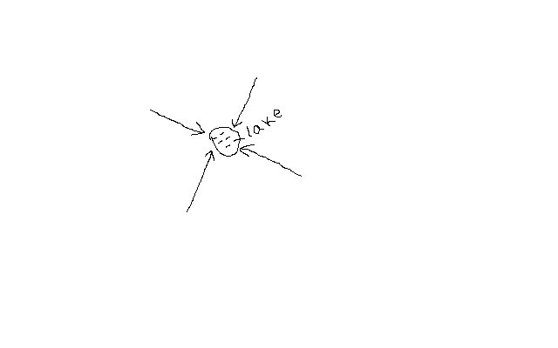

**e) Annular Pattern**

Streams (rivers which are small in size) are arranged in series of curves about a basin or crater

It’s controlled by the slope.

**f) Radial**

-Resembles the spikes of a bicycle

-Formed by rivers which flow downwards from a central point in all directions such as on a volcanic cone e.g. on Mt. Kenya, Elgon and Kilimanjaro.

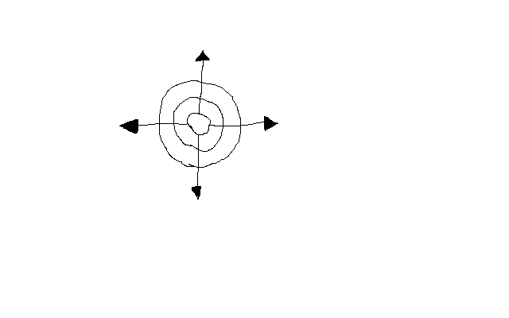

**g) Fault –Guided Pattern**

* Flow of river is guided by direction of fault lines

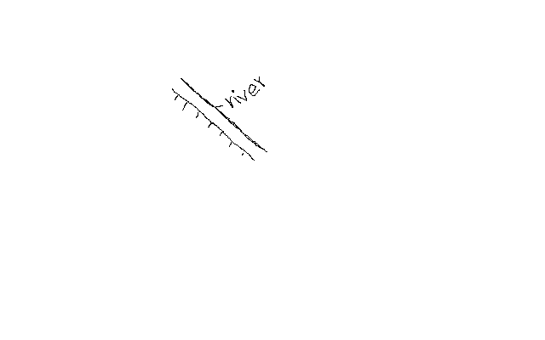

**Human/Economic Activities**

**Description of Human Activities**

* Identify types
* Evidence –man made features
* Reasons e.g. tea-cool temps and heavy rainfall

**Agriculture**

**a) Plantation farming**

Evidenced by presence of:

-“C”-coffee

-Named estates e.g. Kaimosi tea estate

**b) Small scale crop farming**

* Cotton ginnery or sheds
* Coffee hullerlies
* Posho mills for maize, millet, sorghum
* Tea factory/store

**Livestock Farming**

* Dairy farms
* Veterinary stations
* Cattle dips
* Creameries
* Water holes
* Dams
* Butcheries
* Slaughter houses

**Mining**

* Symbol for a mine/mineral works
* Name of the mine
* Particular mineral e.g. soda ash
* Quarry symbol
* Processing plant of a mineral e.g. cement indicates cement is mined in that area

**Forestry/Lumbering**

* Saw mills
* Forest reserves
* Forest station
* Forest guard post
* Roads ending abruptly into a forest estate used to transport logs to saw mills

**Fishing**

* Fish traps
* Fishing co-operative society
* Fish ponds
* Fish hatcheries
* Fisheries department
* Fish landing grounds(*banda)*

**Manufacturing/Processing Industry**

* Saw mills for lumber products
* Ginnery for cotton processing
* Mill for maize, millet, wheat processing
* Creameries for milk processing
* Factory for manufacturing or processing a known commodity.

**Services**

**a) Trade**

* Shops
* Markets
* Stores
* Trading centres

**b) Transport**

**i) Land**

* Roads
  + All weather roads- which are used all year round i.e. tarmac and murram roads.
  + Dry weather roads- which are used reliably during dry seasons.
  + Motorable trucks- rough roads which are used by people on foot and by vehicles on dry season.
* Other trucks and foot paths
* Railways, station, sliding, level crossing lines and railways light

**ii) Air**

* Air fields
* Airports
* Air strips

**iii) Water**

* Ferries
* Bridges

**c) Communication**

* Post offices(P.O.)
* Telegraph(T.G.)
* Telephone lines(T)

**d) Tourism**

* Camping sites
* Tourist class hotels and restaurants
* National parks
* Game reserves
* Curio shops
* Museums
* Historical monuments

**e) Administration**

* DO, DC, PC, police post, chiefs camp.

**Social Services**

**a) Religious Services**

* Church
* Mosque
* Temples

**b) Education**

* Schools
* Colleges
* Universities

**c) Health Services**

* Hospitals
* Dispensaries

**d) Recreational Services**

* Golf clubs/courses
* Stadiums

**Description of Settlement**

A settlement is a place with housing units where people live together

* Densely distributed settlements- high concentration of settlements(black dots)
* Moderately distributed settlements- settlements moderate in quantity
* Sparsely distributed settlements-few settlements spread over a large area.
* Very sparse if very few
* Identify type of settlement patterns present
* Type of Settlements

**a) Rural settlements**

Consist of villages and homesteads and homesteads in which people are involved in subsistence agriculture and traditional activities such as pottery weaving, curving, etc.

**b) Urban settlement**

Consist of dense permanent and sometimes high buildings and population engaged in non agricultural activities such as industrial activities.

**Factors Influencing Settlement**

**1. Physical Factors**

**a) Climate**

Areas with moderate temps and adequate rainfall are densely settled while those with extremely low or high temps have fewer settlements.

**b) Relief**

***Terrain:*** Steep slopes are less settled due to thin soils and difficulty to erect buildings.

***Aspect:*** Slopes facing away from the sun in high latitudes are less settled than those facing the sun.

Wind ward slopes of mountains on the path of rain bearing winds are more settled due to heavy rainfall making them ideal for agriculture.

**c)** **Drainage**

Rivers and springs attract settlements because they provide clean water.

Areas with drainage swamps are less settled because it’s difficult to erect buildings and they also harbour mosquitoes and snails which cause diseases.

**d) Vegetation**

Dense forests discourage settlements because of wild animals and also harbour disease vectors such as tsetse flies e.g. Miombo woodland of Tanzania and Lambwe valley in Kenya.

**e) Pests and diseases**

Areas prone to pests and diseases are less settled because people like to live in healthy environment.

**f) Natural resources**

Settlements start where there is mineral extraction. e.g. Magadi

Lakes with abundant fish may also attract settlement.

**g) Human Factors**

**i) Political factors**

* 1967 TZ settled peoples in villages and the rest of land was left for farming (Ujamaa villages)
* After independence Kenya settled its landless in settlement schemes e.g. Mwea, Laikipia, Nyandarua.
* Settlement of refugees in refugee camps due to political upheavals

**ii) Historical factors**

* Weaker communities were forced to move elsewhere by wars.
* Settlement of communities in strategic sites such as hilltops or plateaus to see approaching enemies e.g. Fulani of Nigeria in Jos plateau.

**iii) Cultural factors**

* Farming communities settled in agriculturally productive areas.
* Pastoralists settle in areas with enough land to provide pasture for their animals at ease.

**iii) Economic factors**

* Rural to urban migration for employment and trading.
* Mining activities may lead to development of settlements e.g. Magadi due to trona mining.

**Types of Settlements Patterns**

* + 1. **Nucleated/Clustered Settlement Pattern**



* Buildings are close to each other

**Factors**

* Availability of social amenities such as schools and health care
* Shortage of building land
* Favourable climate leading to high agricultural potential e.g. Kenya highlands.
* Fertile soils.
* Presence of natural resources e.g. minerals in Magadi, Mwadui, Kimberly.
* Security concern especially in banditry prone areas

**b) Linear Settlement**

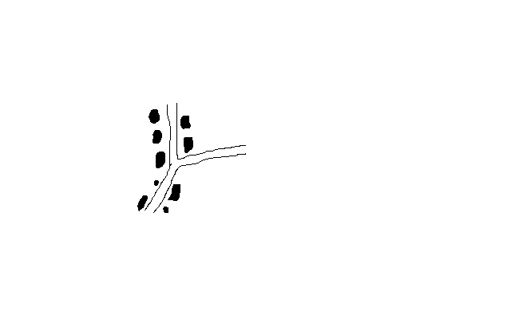

* Buildings are arranged in a line
* Presence of a transport line e.g. road or railway.
* Presence of a river or a spring to provide water for domestic or commercial use
* Presence of a coast line which has a favourable fishing ground e.g. shore of E. African coast.
* Suitable terrain for cultivation of crops such as at the foot of a scarp

**c) Dispersed/Scattered Settlement**

* Buildings are scattered
* Plenty of land to build whenever they want
* Avoidance of harsh climate e.g. arid and semi-arid areas.
* Poor infertile soils.
* Pests and diseases.
* Physical features such as ridges, valleys which separate houses.

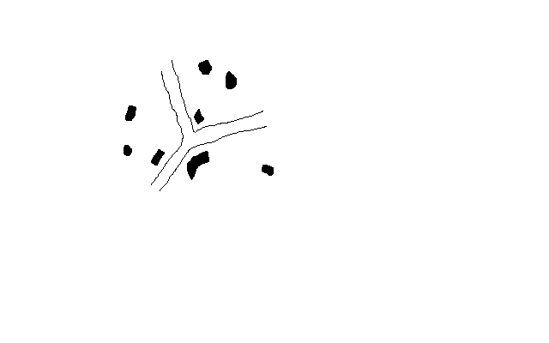

**d) Radial Pattern**



Buildings are arranged like a star

-Common at cross roads where housing units point in all directions.

**Enlargement and Reduction of Maps**

**Steps**

1. Identify the area requiring to be enlarged
2. Measure its length and width
3. Multiply (E) or divide (R) the by the number of times given. The scale also changes e.g.1:50000/2(enlarged)×2(reduced)
4. Draw the new frame with new dimensions
5. Insert the grid squares e.g. 2×2cm, 2/2, etc.
6. Draw diagonals on the frame
7. Transfer features exactly where they were

**Drawing a Cross Section/Profile**

-Line drawn on a piece of paper showing the nature of relief of a particular area.

**Steps**

1. Identify the given points and name them A and B
2. Joint point A and B using a pencil
3. Take a piece of paper and fold it into two parts
4. Place the papers edge along the line joining A and B
5. Mark all contours and their heights
6. Mark features along A-B e.g. R- river, H- hill, M- mountain
7. Determine the highest and lowest contour height to determine the appropriate vertical scale
8. Draw horizontal axis and mark it A-B
9. Draw vertical axis from A to B

10. Place the edge of folded paper along horizontal axis

11. Use values along vertical axis to plot contour heights. Remember to show features marked along A-B

12. Join plotted points using smooth curve (cross

Section)

13. Include title on top vertical and horizontal map scale.

**Calculation and Interpretation of Vertical Exaggeration and Gradient**

**Vertical Exaggeration**

Number of times that the vertical scale is larger than horizontal scale

V.E. =Denominator of H.S. /D. of V.S. (cross section scale.

e.g. V.S. =1:20M

H.S=1:50000

V.E.=50000/20×100 (To convert into cm) =25

**Interpretation**

The vertical height has been exaggerated 25 times compared to the horizontal distance

**Intervisibility**

-Ability of one place to be seen from another

**Steps**

* Draw cross section
* Join points A-B using visibility line
* If the visibility line is above the cross section, the two points are ***intervisible***. If below they are ***not intervisible***.

**Gradient**

Degree of steepness of a slope between two given points

STEPS

1. Identify the two points
2. Calculate difference in height between the two points(**V**ertical **I**nterval) e.g. 500m
3. Joint them with a light line
4. Measure ground distance between the two points(**H**orizontal **E**quivalent)e.g.12 cm

G=V.I./H.E.

=500×100/12×50000=50000/600000=1/12=1:12

**Interpretation**

For every 12 m travelled on the Ground, there is a vertical rise of 1m

**EXTERNAL LAND FORMING PROCESSES**

* Processes operating on the exterior of the earth resulting in the formation of natural physical features.

These are:

1. weathering
2. mass wasting
3. erosion
4. transportation
5. deposition

**Weathering**

* + Mechanical breakdown or chemical decay of rocks “in situ” (without movement)

**Agents of weathering**

-Things that work to cause it:

1. Weather elements:

* + rainfall
  + temperature
  + frost
  + gases e.g. CO2,O2

2. Plants

3. Animals

4. People

**Factors That Influence Weathering**

**Climate**

* Different areas with different climatic elements experience different types of weathering e.g. block disintegration are experienced in arid areas while frost action is experienced in temperate regions and mountainous regions of tropics.
* **Topography**
* Weathering is faster on steep slopes than on gentle slopes because weathered material is washed away quickly exposing the rock once again to agents while on gentle slopes materials remain in one position shielding the rock from weathering agents.
* **Nature of rocks**
* Dark coloured rocks absorb more heat than light coloured ones hence break faster due to excessive expansion and contraction.
* A rock with different minerals may disintegrate faster due to differential expansion and contraction of minerals.
* A well jointed rock will break faster because physical and chemical agents can penetrate faster e.g. by freezing and thawing.
* Fine textured rocks have a large surface area on which chemical processes can act e.g. Limestone.

**Biological organisms**

* Bacteria facilitate rotting of organic matter producing organic acids which reacts with some minerals causing the rock to break up.
* Plant roots and burrowing animals penetrate rocks resulting in cracks providing passage for agents such as water to act on rocks.
* People accelerate the rate of weathering by exposing rocks buried deep below by digging, blasting and drilling.

**Types of Weathering**

**1. Mechanical Weathering**

* Physical break up of rocks without change in their chemical composition.

**Processes**

**a) Block Disintegration/Separation**

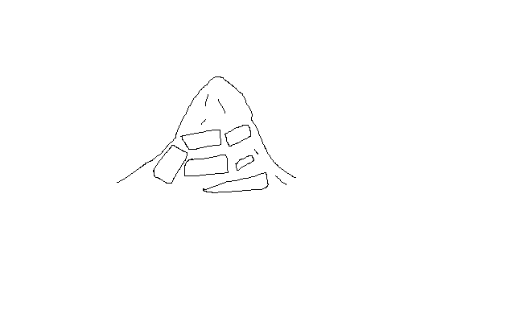

* Breaking of rocks into blocks along the joints.
* It’s effective in arid areas because of great diurnal temperature range.
* Day, well jointed rocks are subjected to intense heating causing minerals in it to expand.
* In the night the rock is cooled causing it to contract.
* The rock joints enlarge due to the alternating cooling and contraction.
* The process is repeated over a long time causing the rock to disintegrate into blocks along the joints e.g. Mundanda rock in Tsavo East.

**b) Exfoliation**

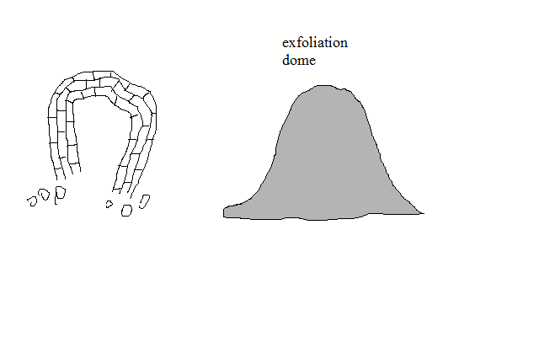

* Peeling off of layers of rocks.
* Also common in arid areas.
* Day, rock surface is heated more than inner layers because rocks are poor conductors of heat.
* The surface expands more than inner layers causing strain between the two layers.
* With time outer layer develops cracks and later peels off and pieces of rocks fall down under gravity e.g. along Mombassa-Nairobi road between Mtito Andei and Voi.

**c) Granular Disintegration**

* Disintegration of rocks into grains.
* Occurs in rocks with different minerals.



* When the rock is heated, different minerals expand differently.
* Internal stress results and with time the rock disintegrates into grains.

**d) Pressure Release/Sheeting/Unloading**

* Disintegration of rocks due to expansion when weight is removed from over it.
* Soil and other materials lying on top of a rock are removed by erosion and mass wasting (denudation).
* The exposed rock expands when the weight that was pressing it is removed.
* The outer layer curves and eventually shells are pulled out from the rock.
* The result is formation of a high rocky hills called granitic tors e.g. Maragoli and parts of Machakos.

**e) Frost Action**

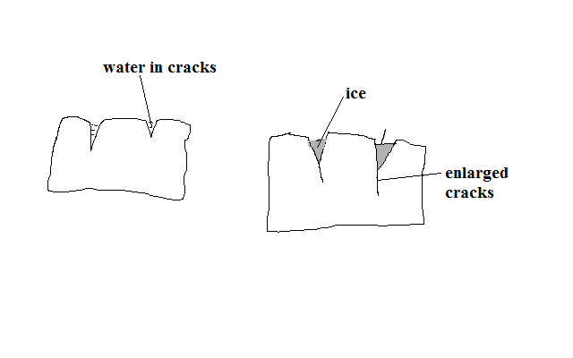

* Breaking of rocks into angular blocks due to repeated freezing and thawing.
* Common in temperate regions or mountainous regions of tropics where temperature fall below zero.
* Water from melting ice collects into small cracks of rocks.
* It freezes and expands and exerts pressure on cracks widening them.
* Repeated freezing and thawing causes the rocks to break into angular blocks e.g. on Mt. Kenya, Kilimanjaro and Ruwenzori.

**f) Crystal Growth**

* Break up of rocks due to crystal growth.
* It occurs in arid areas.
* High rate of evaporation draws out moisture and dissolved minerals from the rock interior through capillary action.
* The moisture evaporates when it gets to the surface of the rock leaving behind crystals in the cracks and pores of rocks.
* The crystals continue to grow exerting pressure on the cracks or pores widening them and eventually causing the rock to break down e.g. at Hells Gate near Naivasha.

**g) Slaking/Rain Water Action**

* Breaking up of sedimentary rocks due to alternate wetting and drying.
* When it rains, the rock absorbs water and swells.
* When dry season comes, the rock loses water and the outer surface shrinks.
* The process is repeated and the minerals become loosely attached to another e.g. in Kenyan Coast at Tudor and Miritini areas.

**2. Chemical Weathering**

* Weathering involving changes in the chemical composition of minerals making up rocks

**Processes**

**a) Solution**

* Break up of rocks as a result of dissolving of minerals in water without chemical change in them.
* Rain water falls on rocks with soluble minerals.
* The minerals are dissolved and carried down in solution.
* The rock gets weakened and crumbles.

**b) Carbonation**

* Weathering caused by reaction of calcium carbonate in rocks with rain water containing a weak carbonic acid.
* Common in temperate regions.
* Rain water absorbs small quantities of carbon dioxide forming a weak carbonic acid.

H2O+CO2🡪H2CO3

* The weak carbonic acid falls on limestone rocks reacting with calcite forming calcium bicarbonate.

CACO3+H2CO3🡪CA (HCO3)

* Calcium bicarbonate is removed from the rock in solution.

**c) Hydrolysis**

* Weathering caused by reaction of hydrogen ions of water and ions of rock minerals.
* Igneous rocks are greatly affected.

**d) Oxidation**

* Weathering in which minerals in rocks combine with oxygen in the presence of moisture to form new minerals.
* Rocks containing iron are affected.
* Ferric oxide is formed on the rock surface which appears as a soft brown or red earth which can be scooped by hands.

**e) Hydration**

* Weathering in which hygroscopic minerals in rocks take up water causing them to swell and expand causing disintegration of rock due to internal stress.

**3. Biological Weathering**

-Weathering of rocks due to action of living organisms on them.

**a) Action of plants**

**Mechanical**

* The roots grow bigger into the cracks and joints of rocks widening them.
* With time the rock separate into blocks (wedging mechanism).
* The widened joints and cracks also provide passages for moisture and air to penetrate deeper into cracks facilitating hydrolysis and solution to act at deeper levels.
* Burrowing animals dig and break up small bits of rock from the main rock mass and bring them to the surface.
* By digging they also provide passages for other elements like gases and moisture to reach rocks that are deep.
* Large herds of animals such as cattle, zebra etc. pound the rocks with their hooves as they move resulting in resulting in mechanical breakdown of rocks.
* People break up rocks by using explosives in mining by exploding bombs on the ground and during building of houses and construction of roads.

**Chemical**

1. Plants rot on rock in the presence of moisture and produce organic acid
2. It reacts with some minerals within the rock causing decay.
3. Animals excrete on rocks and release chemical substances which react with some minerals in rocks causing them to break up.
4. Chemical substances released from the industries to rivers cause the water to act on rocks over which it flows.
5. Gases such as CO2 emitted from motor vehicles and industries are
6. Absorbed by rain and acids such as carbonic or sulphurous which react with minerals causing rock to decay.

**Significance of Weathering**

**Positive**

1. Leads to soil formation which is important for agriculture.
2. Produces other natural resources such as clay used in pottery, brick making, etc.
3. Weathered rocks form beautiful scenery for tourist attraction e.g. Hells Gate and crying stones of Kakamega.
4. Weakens rocks easing their exploitation by quarrying and mining

**Negative**

1. May weaken the earth’s crust resulting in unstable foundations of buildings and roads and eventually lead to their collapse.

**MASS WASTING**

* Movement of weathered material down slope under the influence of gravity

**Factors Influencing Mass Wasting**

**a) Degree of slope**

* Movement of weathered material is faster on steep slopes than on gentle slopes due to the influence of gravity.

**b) Climate**

* Weathered material in areas receiving heavy rainfall move faster since wet materials have less cohesion.

**c) Nature of the material**

* Material saturated with water is more likely to move down slope as its heavy.
* Mass wasting is more likely to occur in areas where the weathered material is deep.
* Weathering is more likely where massive rocks lie on weak rocks such as clays, shale than where fine materials lie over weak rocks.

**Vegetation**

* Surfaces with vegetation experience less mass wasting because it binds weathered material together.

**Tectonic movements**

* Earth movements such as earthquakes, volcanic eruptions or faulting cause large and widespread mass wasting.

**Human activities**

* Explosives used in mining and quarrying shake the ground initiating downward movement of materials.
* Mining and quarrying also interferes with the stability of the surface by loosening it making it easy for the loosened materials to move down slope.

**Types of Mass Wasting**

**1. Slow Mass Wasting**

* Slow but steady movement of soil or loose rock debris down slope.

**Processes**

**a) Soil Creep**

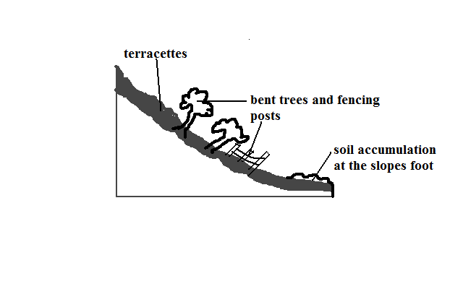

* Slow and steady movement of soil and other fine materials along a very gentle slope.

**Causes**

1. Alternate heating and cooling causing expansion and contraction of particles causing them to change their positions.
2. Alternate wetting and drying of soil whereby when it’s wet its compact and when dry the particles are loosened and tend to move away from each other.
3. Trampling and burrowing of animals.
4. External forces e.g. shaking by earthquakes, explosives, heavy vehicles, etc.
5. Ploughing down hill
6. Freezing of soil water causing it to expand which lifts particles at right angles to the slope in a process called heaving.

**b) Solifluction**

* Movement of saturated soil, gravel and weathered rock down a moderate slope.
* Common in mountainous and very cold climates
* Thawing occurs during spring causing top soil to become saturated.
* Saturated soil begins to creep over the subsoil which still remains frozen(permafrost)**.**

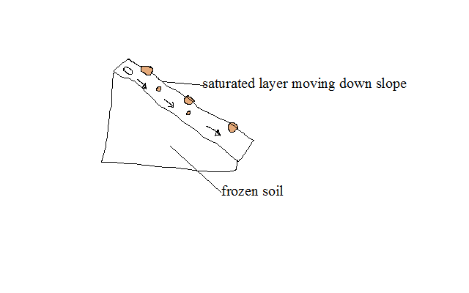

**c) Talus Creep**

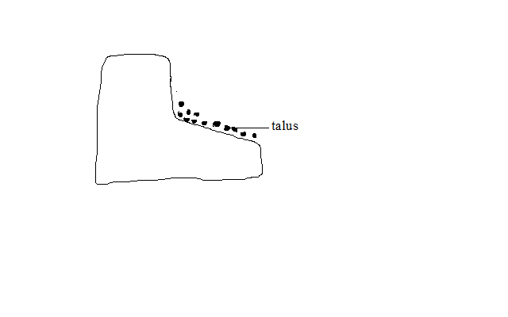

* Slow and gentle movement of the mass of broken rock particles which accumulate at the base of cliffs (scree) downhill.

**d) Rock Creep**

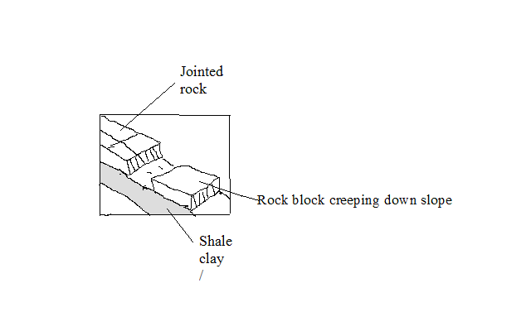

* Slow movement of individual rocks which lie on clay at a very low speed down slope in the presence of moisture.

**2. Rapid Mass Wasting**

* Type of mass wasting involving large amounts of weathered material moving suddenly and fast down slope.

**a) Mud Flow**

* Movement of oversaturated weathered material inform of liquid down slope.
* It occurs mainly in dry areas after heavy rains.

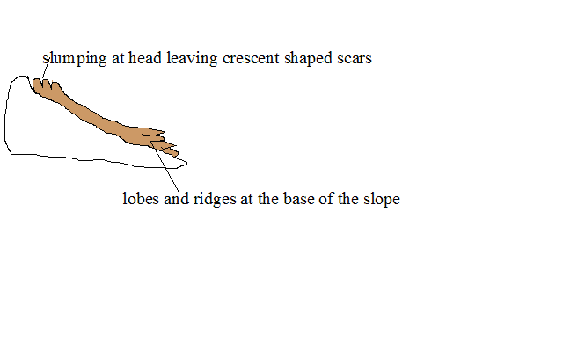

**b) Earth Flow**

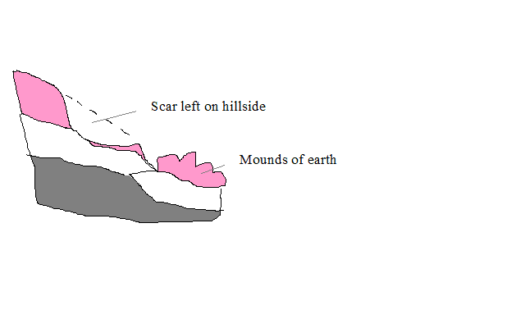

* Movement of saturated earth material on hill sides down slope.

**c) Land Slide**

* Sudden slipping of large quantities of loosened surface rock or soil down a slope.

**d) Slump**

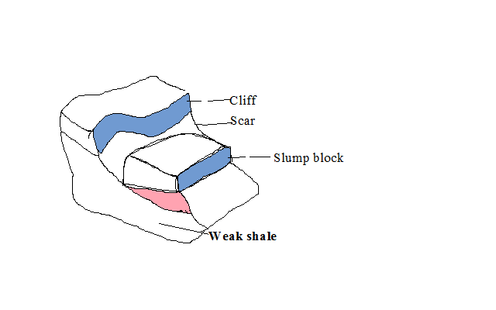

* Erosion occurs on the weak rocks at the base of a cliff undercutting the weak rock.
* The overlying rocks break off causing the overlying rocks to slide down hill rotating around a curved plane.

**e) Debris Slide**

* Sudden downhill movement of accumulated rock debris and other loose material downhill as a whole

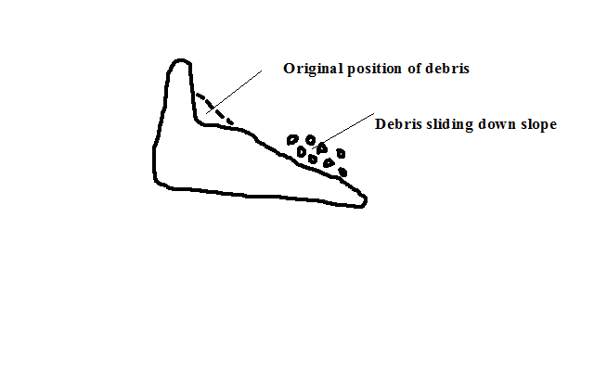

**f) Debris fall**

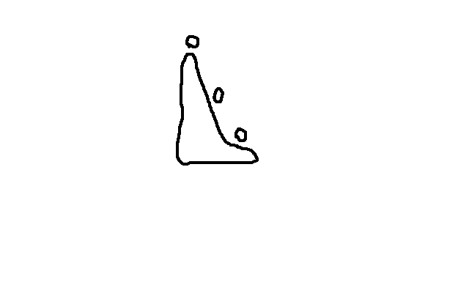

* Sudden free fall of debris from a vertical or hanging cliff to the base of the slope.

**g) Rock Slide**

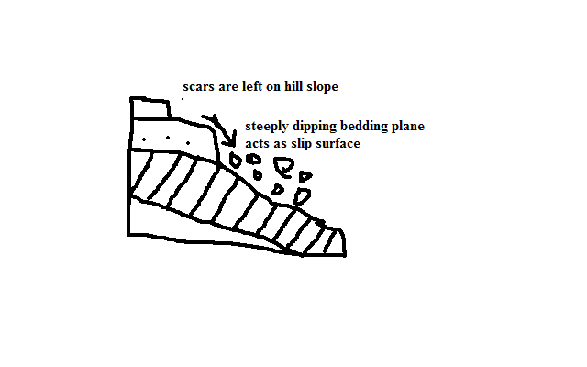

* Sliding down of masses of rock a steep slope along a bending plane, joint of fault.

**h) Rock fall**

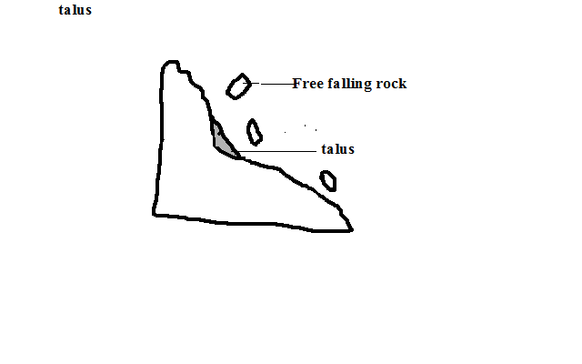

* Falling or rolling of individual rocks or boulders down a steep slope or a cliff.
* Most rapid of all mass wasting.

**h) Avalanche**

* Sudden slipping and falling of a large mass of snow, ice and loose rock materials down a mountain side.

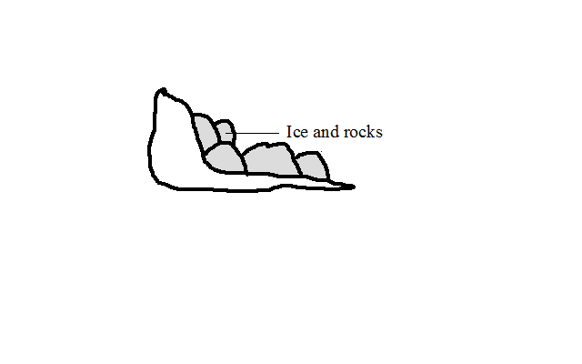

**i) Rain Wash**

* Type of mass wasting involving removal of weathered materials by rain water.
* When rains come, the first drops scatter soil particles that have been loosened by drying.
* The increasing downpour then washes large quantities of loosened soil downhill.

**Types**

**a) Sheet wash**

* Uniform removal of soil from a large area.
* Rainfall with uniform drops fall on loosened soil on a land with uniform slope.
* The water from the rainfall then flows down slope.
* As it does so, it uniformly sweeps all the loose soil from the surface. Its common around L. Baringo and Marigat.

**b) Gulleying**

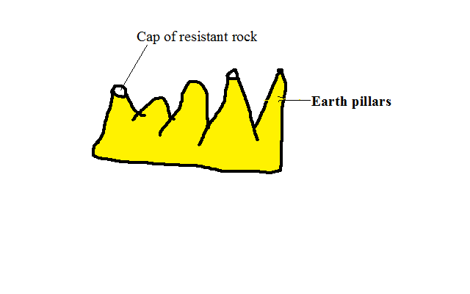

* Removal of soil through wide and deep channels called gullies.
  + Rain falls on an even slope
  + The water irregularly runs down slope along specific channels called rills.
  + The channels are widened and deepened by the water to form gullies.
  + Neighbouring gullies are widened and the ridges between them are reduced to form earth pillars.

1. **Splash erosion**

* Removal of soil by rain drops scattering loose particles and carrying them down slope by runoff.

**Effects of Mass Wasting On Physical and Human Environment**

**Positive**

* 1. Make the soil to become fertile where soil from fertile areas is deposited.
  2. Leads to formation of new land forms such as scars, depressions, lakes, rock pillars, etc.

**Negative**

1. Soil creep may destroy walls built across the slope when creeping soil exerts pressure on them.
2. Decrease soil fertility where fertile soil moves down slope.
3. Makes the ground prone to soil erosion especially where scars have formed.
4. Hinders transport and communication by blocking railway lines making maintenance to be costly.
5. Hinders mechanisation of agriculture e.g. gulleying does not allow movement of vehicles and machinery on farms.
6. Leads to destruction of property and loss of live by burying people in their housesandstones falling on escarpments along roads causing accidents.
7. May Cause Rivers to change their courses e.g. mud flow.

**HYDROLOGICAL/WATER CYCLE**

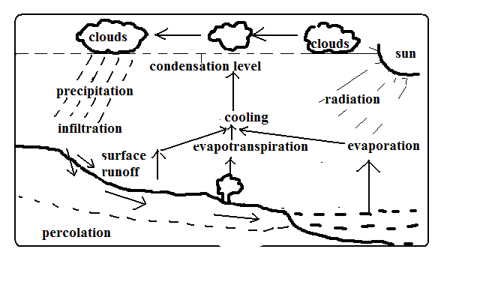

* Endless interchange of water between the sea, atmosphere and land.

**Processes in Which Circulation Is Carried Out**

1. **Evaporation**
   * Changing of water into water into water vapour when it’s heated by solar radiation.
   * ***Evapotranspiration:* C**ombined loss of water from the soil through direct evaporation and transpiration by plants.
2. **Cooling**

* Reduction of water vapour temperature as it rises into the atmosphere when it expands due to reduced temperature and pressure.

1. **Condensation**

* Turning of water vapour into tiny water droplets which form clouds when cooling continues below dew point.

1. **Precipitation**

-The process in which the earth receives moisture from the atmosphere.

It occurs when droplets formed by condensation combine forming heavier drops which fall on the ground as rain or may become frozen to form snow, hail, sleet, etc.

1. **Surface runoff**

* Some of the water from precipitation that flows on the surface into valleys, ponds, lakes, etc.

1. **Infiltration**

* Entry of water into the ground through pores, joints and cracks in rocks.

1. **Percolation**

* Downwards and sideways movement of water that has entered into the ground.

1. **Overland flow**

Surface runoff makes the overland flow.

River water flows back to the oceans where evaporation takes place again and water cycle is repeated.

**Significance of Hydrolological Cycle**

**Positive**

1. Provides water to man from precipitation and underground water.
2. Provides rain to man who is useful in agriculture.
3. Atmospheric water is important in regulating heat loss from the earth by absorbing terrestrial radiation and reflecting it back to the earth keeping the lower atmosphere warm.

**Negative**

* 1. May lead to shortage of water when evaporation rate exceeds precipitation.
  2. May lead to decreased agricultural production as a result of excessive evaporation causing weathering of crops.
  3. May lead to flooding when excessive evaporation cause increased rainfall.
  4. May lead to shortage of rainfall if there is less evaporation due to low temperature.

**ACTION OF RIVERS**

A river is a mass of water flowing over the land in a definite channel.

**Work of a River**

1. Drain excess water from the land.
2. Sculpturing land through erosion, transportation and transportation.

**River Erosion**

* Removal by river water of materials from the sides and bed of the river channel.

**Factors Influencing River Erosion**

1. **River volume**

* A river with a large volume has a greater kinetic energy to erode than one with a small volume.

1. **Slope of land**

* A river flowing on a steep channel has greater velocity and therefore more energy to erode its channel than one flowing over gentle or flat land.

1. **Rivers load**

* A river with large, rough and heavy load e.g. tree trunks and boulders erodes more than one with light, fine and smooth materials e.g. sand.
* A river carrying more load erodes more than one with less load as it has more abrasive tools.

1. **Nature of bed rock**

* Erosion is faster where a river flows over soft bed rock and less where it flows over hard rock.

**Processes/Ways of river erosion**

1**. Solution/Corrosion**

* River water dissolving soluble minerals and carrying them away.

**2**. **Hydraulic Action**

* Erosion by the force of river water when it thrusts itself into cracks and joints of rocks on the sides of the channel dislodging lumps.
* Also by pushing air into the cracks, compressing it increasing pressure which widens the cracks eventually dislodging lumps.

**3. Abrasion/Corrosion**

* Abrasion is scratching of the bed and banks by materials are carried away by the river.
* Corrosion is hurling of rock fragments carried by the river against rocks which weaken and eventually break them.

**4. Attrition**

* Hitting against one another of rock fragments carried by river water breaking one another into smaller pieces.

**Types of River Erosion**

**1. Vertical Erosion**

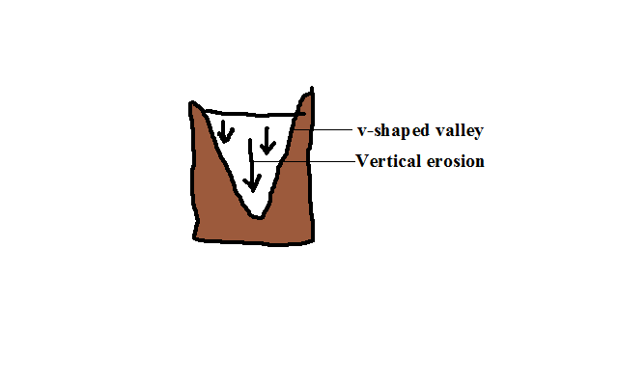

* Erosion in which the river cuts downwards into its channel.

**2. Lateral Erosion**

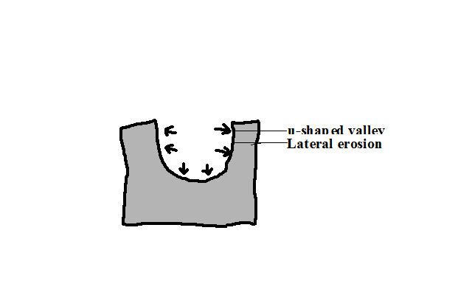

* Erosion in which the river erodes the sides of the channel.

**3. Headward Erosion**

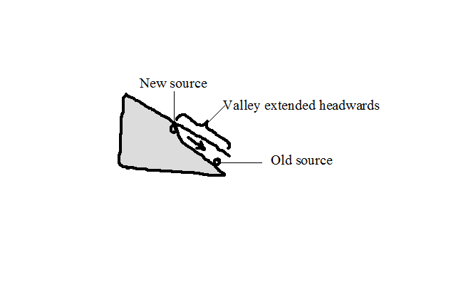

* Erosion in which a river cuts back at its source.

1. Where there is a water fall.

* The river undercuts at the base of a waterfall.
* The rock above the undercut cliff collapses.
* The position of waterfall shifts upstream.

1. Where gulleying or soil creep occurs where there is a spring causing its position to shift upstream (spring sapping).

**Resultant Features of River Erosion**

**1. Stream Cut Valleys**

* + Valleys with V, open V or U shaped cross sections along the river channel.

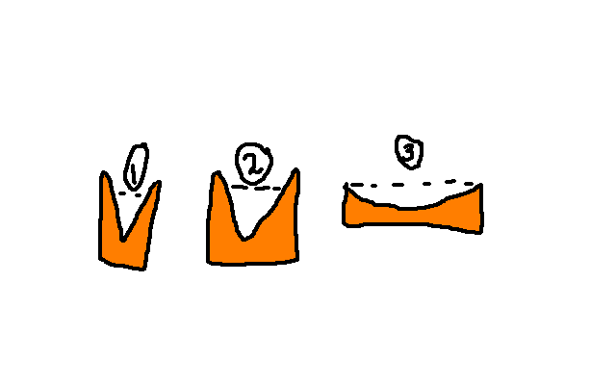

* In the source region a river cuts itself a channel which starts as a gulley.
* The channel is deepened by vertical erosion resulting into a v-shaped valley.
* In the middle stage lateral erosion widens and deepens the valley resulting in a more open v-cross section.
* In the old stage lateral erosion creates a very wide channel with a U-shaped cross section.

**2. Gorges**

* Narrow, deep, steep-sided valley.

**Ways/modes of formation**

1. Where a river flows along a fault or a section of soft rocks eroding the channel vertically through the soft rocks or fault.
2. By headward erosion at a water fall when the river’s erosive activity is increased due to increased gradient causing the river to undercut at the base of the water fall, then the rock above the undercut base collapses causing the waterfall to shift upstream resulting in a gorge below the water fall.
3. Where a river flows across a plateau with alternating horizontal layers of hard and soft rocks eroding them resulting in a gorge with stepped sides called a canyon e.g. Grand canyon on R. Colorado in USA.
4. Due to river rejuvenation when the river’s erosive activity is renewed causing the river to vigorously erode deep into its channel.
5. Where a river maintains its course across land which is being uplifted gradually.

**Rapids**

* A section of the rivers course where the bed is suddenly steepened causing the water to suddenly flow swiftly.

**How they are formed**

1. Where a less hard rock lies below a soft rock and the soft rock is eroded more resulting in a steep slope.

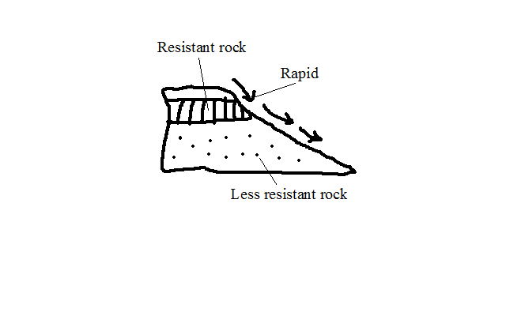

1. Where a water fall has been eroded by headward erosion reducing its height.

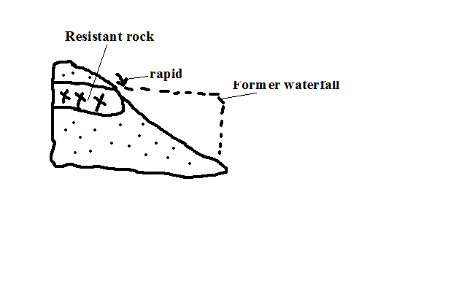

c) Where resistant rock dips downstream and is unevenly eroded.

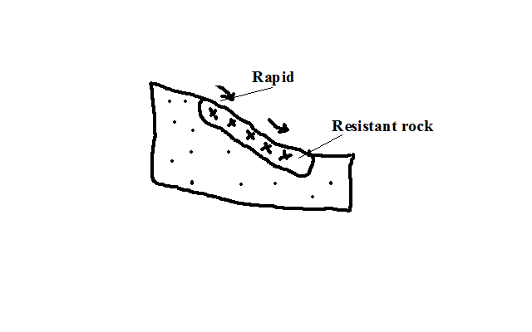

**Water Falls**

* A place on a rivers course where a river bed is vertical or nearly vertical.

**Formation**

1. Where a river descends over a sharp edge of a plateau encountering a sharp drop.
2. Where a river descends a cliff into the sea.
3. Where a river descends a fault scarp.
4. Where a river descends a sharp edge of a plateau.
5. Where a river is blocked by lava flow causing water to accumulate on the upstream side and a water fall forms at the point of overflow.
6. Where a resistant rock lies across a river with a less resistant one on the downstream side and the less resistant one is eroded faster causing a rapid to be first formed, then a waterfall.

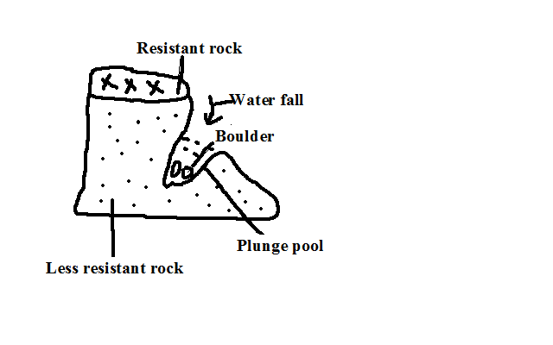

**Pot Holes**

* Circular depressions on a river bed.
* Form where a river flows over shallow depression and develops strong circulating currents which cause the load to scratch the bed in circular motion.

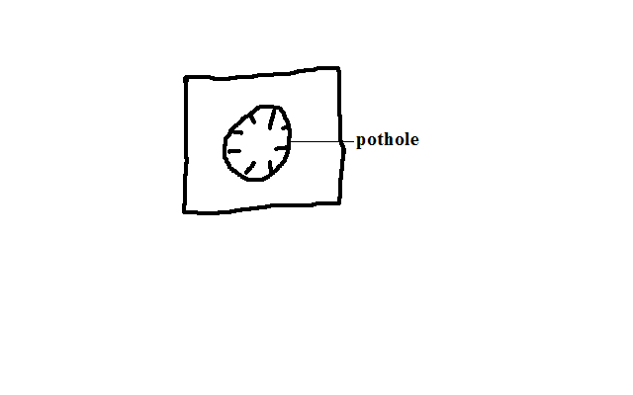

**Interlocking Spurs**

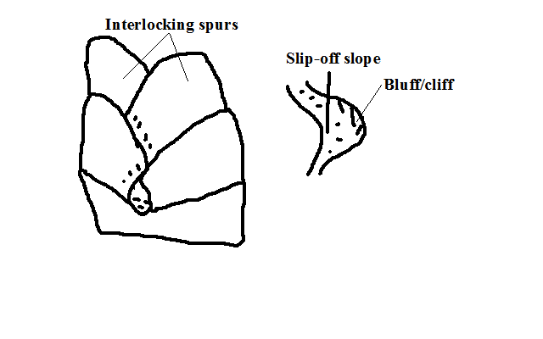

* Highland projections which appear as they fit together.

**Formation**

* Where In the youthful stage, a river flows around spurs undercutting the outer bank more than the inner bank causing the bends to be more pronounced making the spurs to appear as if to fit together. The outer bank becomes river cliff/bluff and the inner bank slip off slope.

**River Transportation**

* River carrying away materials that its water has eroded from the channel.

**Factors Influencing River Transportation**

**a) Rivers Volume**

A river with large volume of water has more energy and therefore greater carrying ability than one with a small volume.

**b) Gradient**

A river flowing on a steep channel has greater ability to transport than one on a gentle slope because it flows fast due to gravity.

**c) Rivers Load**

* Small and light particles are transported over long distances while heavy materials are transported for a short distance.
* Dissolved load is carried all the way to the rivers mouth.
* Small amount of load is transported for a long distance while large amounts of load collide reducing the speed and therefore rivers ability to transport causing some of the load to be dropped along the way.

**Processes/ways of River Transportation**

**a) Suspension**

* River transportation of light and insoluble materials in form of a mixture.

**b) Saltation/Hydraulic Lift**

* River transportation of large particles through a series of jumps and hops.
* Materials are lifted by force of moving water and pushed for a short distance and land back on the river bed by gravity.
* The process is repeated causing the load to be transported downstream.

**c) Traction**

* River transportation of heavy materials like boulders by rolling them by the force of water.

**d) Solution**

* River transportation of load in solution form.

Load transported by suspension, Saltation and traction is called clastic load while that by solution is called dissolved load.

**Deposition**

* Laying down of some of the load carried by the river when energy decreases.

**Factors Influencing Deposition**

**a) Gradient**

When gradient reduces the river’s speed decreases and hence its energy is reduced causing it to drop some of the heavy load.

**b) Rivers Volume**

When rivers volume decreases its energy also decreases causing it to deposit heaviest load then lighter ones.

**c) Obstacles**

Obstacles such as swamp vegetation and rock outcrop reduce the river’s speed and also trap some of the load thereby facilitating deposition.

**d) River Bed Width and Depth**

Where a rivers channel becomes wide and shallow there is less water per unit area and hence the river has lower capacity to transport so deposition of excess load begins.

**Resultant Features of River Deposition**

**a) Alluvial Fans and Bajadas**

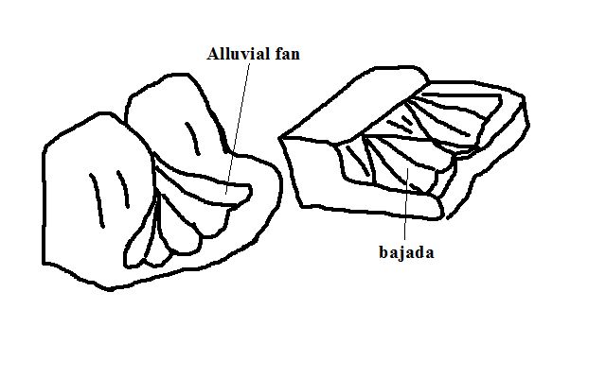

* Fan shaped deposits of alluvium.

**Formation**

* The river flowing through a narrow channel enters a plain from a higher ground and suddenly spreads out.
* There is a sudden loss of velocity causing the river to scatter alluvium all around to form an alluvial fan.
* Alluvial fans merge to form a continuous feature called bajada or piedmont fan.

**b) Meanders and Oxbow Lakes**

Meanders are loop-like bends in a rivers course.

Oxbow lake is a horse shoe shaped section of a former river.

**Formation**

* In mature stage river flows sluggishly due to reduced gradient.
* It meets an obstacle and flows around it.

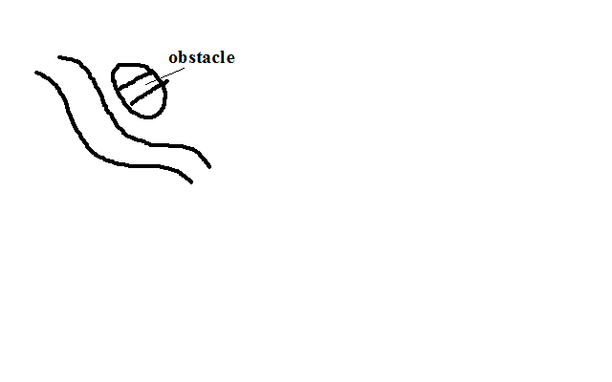

* Erosion is greater on the outer bank and deposition on the inner bank causing the river to form loop like bends.

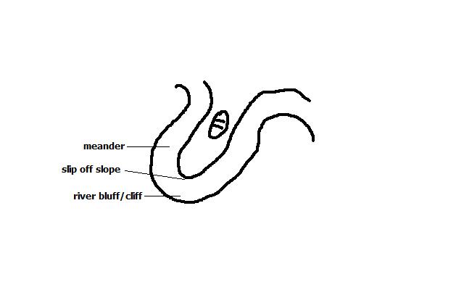

* Erosion continues on the outer bank (bluff) narrowing the land between the two outer banks forming a pronounced meander e.g. on rivers Yala, Nzoia and Tana.

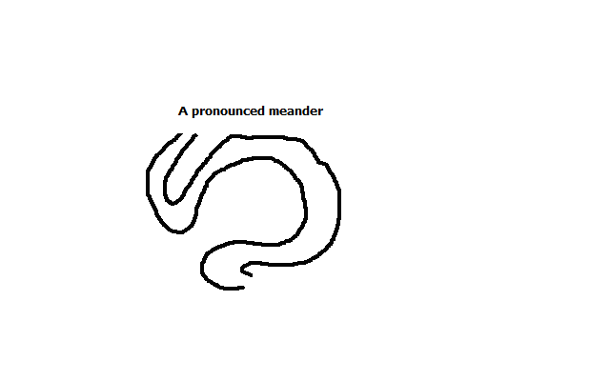

* During the floods when the river has more energy it cuts across the narrow land.
* The former bends are cut off by deposition to form an oxbow lake e.g. Kanyaboli on R.Yala and Shakababo on R.Tana.

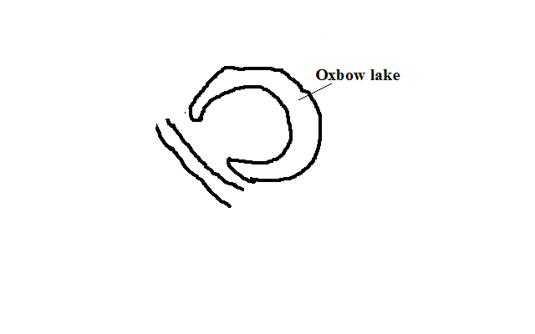

**Flood Plains**

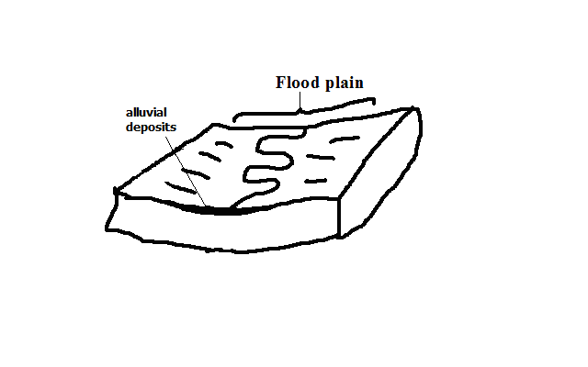

* Wide gently sloping plain of alluvium on the floor of a river valley.

**Formation**

* A river meanders.
* There is erosion on outer bank and deposition on the inner bank.
* The process continues and layers of alluvium deposited on inner bank join to form a plain e.g. Nzoia and Yala flood plains.

**River Braids**

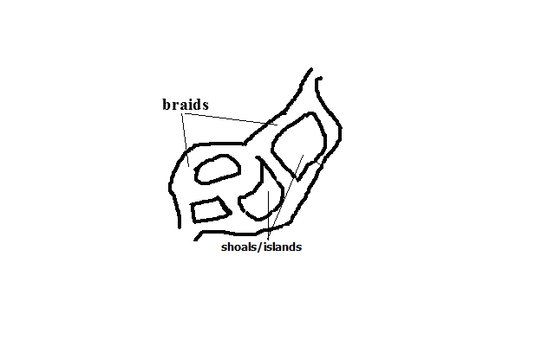

* Net work of diverging and converging channels along a rivers course.

**Factors favouring formation of braids**

1. River must be carrying large load.
2. Reduced gradient on the section.
3. Reduced amount of water such as in dry season or arid conditions.
4. Presence of obstacles such as rock out crops.

**Formation**

* River flows sluggishly due to low gradient.
* Deposits of alluvium are laid on river bed.
* The deposits raise the river bed causing the channel to be subdivided into channels or distributaries.

**Natural Levees**

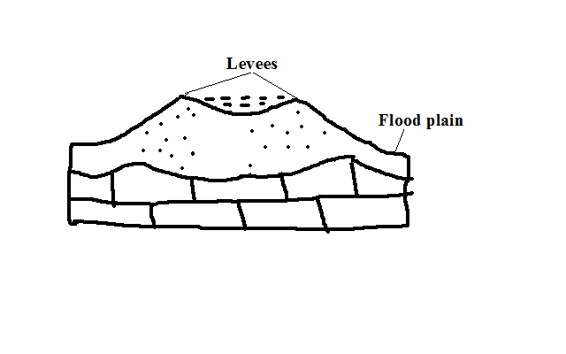

* Raised river banks which are made of alluvial materials.

**Formation**

* River floods and spills over its banks.
* Deposition of coarse materials near the banks and fine materials are carried further on the flood plain.
* Coarse materials accumulate raising the banks above the general level of the flood plain.

**Effects of Levee Formation**

1. Creation of differed tributaries and confluences.

Differed tributary: Tributary blocked from joining the main river by levees.

Differed confluence: New point where the differed tributary joins the main river downstream.

1. Destructive flooding.

* Due to the river bursting its banks during the flood season due to the bed being raised above the general level of the flood plain.
* Due to differed tributaries flowing into the flood plains.
* Because the river channel has become narrower and shallower due to deposited alluvium.

**Estuaries**

* Broad channel at the mouth of a river where the river enters the ocean as a whole.
* Some are deep and narrow because sediments are carried away by ocean currents while others are wide and shallow due to sediments covered by water e.g. on R. Congo and Gabon.

**Deltas**

* Low lying tract of alluvial deposits formed at the rivers mouth.

**Ideal Conditions for Formation of A Delta At A Rivers Mouth**

1. Large load such as from a large catchment area where erosion is taking place actively.
2. The rivers course to be free from obstacles such as swamps so as not to filter sediments before they reach the mouth.
3. Low speed at the point where the river is entering a sea or lake for deposition to take place.
4. The rate of deposition should be higher than the rate of erosion by sea or lake currents.

**How a Delta Forms**

* + The speed of the river is checked by sea or lake.
* Heavy load is first deposited.
* Lighter load is carried further into the sea causing that part of the sea to become shallower.
* The part is colonised by plants making it swampy but firmer.
* Plants trap more alluvium making the delta to grow in height.
* The river builds levees making it narrower.
* The river burst its banks and small channels branch off the main river and carries water into the sea or lake (distributaries).

**Types of Deltas**

1. Marine: Type formed at sea.
2. Lacustrine: at a lake.
3. Inland Delta: Deltas which form along a rivers course before it reaches the lake or sea.

**Formation**

* The velocity of the river is checked on entering a relatively flat swampy land.
* The river builds up levees.
* The river bursts banks forming distributaries.
* Alluvial deposits are spread over vast areas when river floods e.g. Niger and Okavango deltas.

1. Arcuate Delta

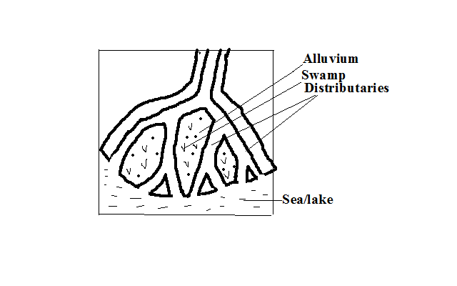

* A delta with a convex shoreline on the seaward end due to strong currents spreading materials over a wide area on seaward side.
* Has many distributaries e.g. Tana and Rufiji deltas.

1. Birds Foot Delta

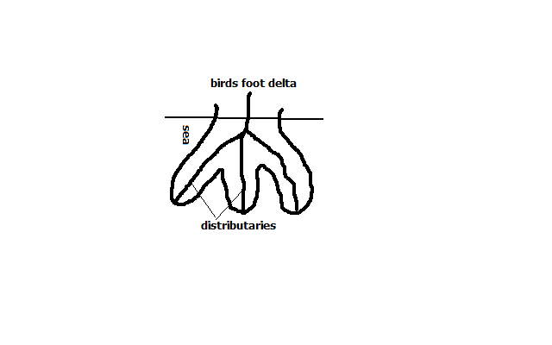

* Type of a delta with a pattern resembling the foot of a bird.
* Has few distributaries.
* Formed on a river carrying large quantities of fine alluvium into water where there is low wave energy e.g. Omo and Mississippi deltas.

1. Estuarine Delta

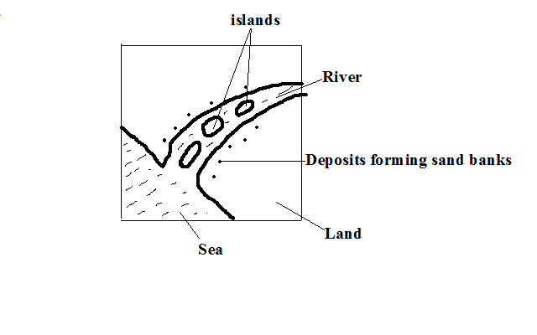

* Delta which has formed on an estuary.

**Formation**

* The rivers load is deposited on the estuary when the speed is checked by sea.
* The river cuts across in a single channel that may be bordered by levees e.g. on R.Volta in Ghana and on R. Zambezi.

**Development of a River Profile**

* Longitudinal section of a river from source to mouth.

**1. Youthful/ Torrent Stage**

**Characteristics**

1. Steep gradient.
2. The river flows very fast.
3. Vertical erosion is dominant
4. Headward erosion is evident.

**Features**

1. V- shaped valleys
2. Waterfalls
3. Rapids
4. Potholes
5. Gorges
6. Interlocking spurs.

**2. Mature/ Valley Stage**

**Characteristics**

1. Low and almost regular gradient.
2. The flow is less swift.
3. The river is wider due to being joined by tributaries.
4. Lateral and vertical erosion but lateral is more active.
5. Deposition starts at some sections.

**Features**

1. Wider open v-shaped valley
2. Meanders
3. River bluffs/cliffs
4. Slip off slopes

**3. Old/ Plain Stage**

**Characteristics**

1. Very gentle/almost level gradient.
2. Very slow flow of river.
3. The main work of the river is deposition.
4. Some lateral erosion occurs.
5. Seasonal floods are common.

**Features**

1. Shallow broad flat bottomed u-shaped valley.
2. Meanders
3. Oxbow lakes
4. Natural levees
5. Differed tributaries
6. Differed confluences
7. Braided channels
8. Flood plains
9. Deltas
10. Distributaries

**River Capture/Beheading/Piracy/Abstraction**

* Diversion of head waters of one river into the system of an adjacent powerful river due to erosion.

The river that captures is called ***pirate.***

The captured one is called ***victim***.

**How it occurs**

* At first there are a powerful river and a weaker river flowing adjacent to each other.

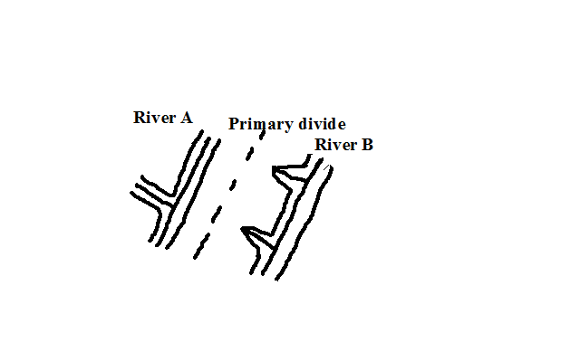

* The powerful river erodes vertically and laterally than the weak river making it to flow at a lower level.
* At the same time, it extends its valley backwards by headward erosion.
* The stronger river eventually joins the valley of the weak river.
* The headwaters of the weaker river start flowing into the valley of the stronger river e.g. R. Tano in Ghana was captured by the Black Volta River and R. Eyong was captured by Imo in S. Nigeria.

The remaining section of the beheaded river is called a ***misfit/beheaded river***.

The dry valley between the elbow of capture and the new course of the misfit stream is called a ***wind gap***.

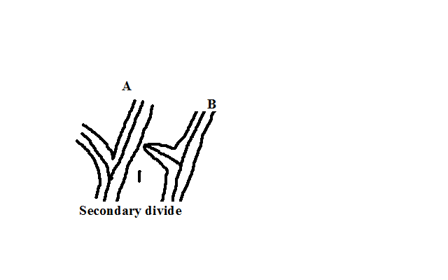

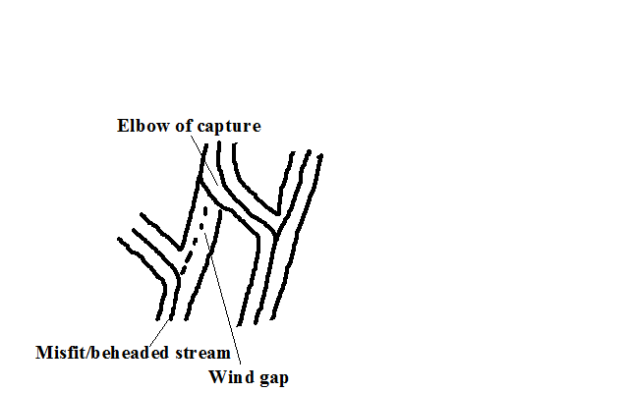

**River Rejuvenation**

* Renewal of erosive activity of a river.
* Happens in the old stage.

**Causes**

**A. Change in the Base Level**

Base level is the lowest level to which a river can erode its bed.

Rejuvenation resulting is called dynamic rejuvenation

1. **Drop in sea level**
   * The river mouth moves further seawards.
   * A steep gradient occurs between the old and the new mouths causing the river to starts to move swiftly.
   * Vertical erosion resumes extending back to the flood plain.
2. **Uplift of a section of land along the rivers course.**

* Faulting or folding may occur.
* A section of land along a rivers course is uplifted.
* The gradient is increased causing the river to flow swiftly and undercut through the uplifted section.
* An antecedent gorge is formed.

1. **Unequal sinking of land along a rivers course.**

* The downstream side sinks more than the upstream one.
* An increase ingredient occurs causing the river to flow swiftly
* The river starts to undercut more vigorously than before.

**B. Increase in Rivers Discharge**

Rejuvenation resulting is called static rejuvenation

* The rivers discharge increases due to high precipitation or capture.
* The rate of erosion becomes higher due to increased discharge.
* The river starts to undercut more vigorously.

**C. Change in Rock Structure**

* A river passes a resistant rock and starts flowing over a less resistant rock.
* The river starts eroding more vigorously into the softer rocks.

**Features of River Rejuvenation**

**1. Knick Points**

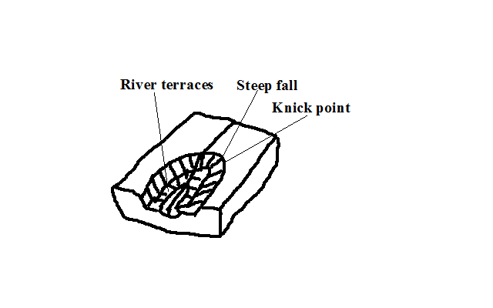

* A sudden break of slope in a rivers profile as a result of change in sea level.

**2. River Terraces**

* Step like features formed when a river rejuvenates and cuts a new valley through the flood plain causing a plat form will form where the floor of the former flood plain was.

**3. Water Falls**

-Are formed when knick points are deepened e.g. Charlotte falls in Sierra Leone.

**4. Antecedent Gorges**

* Gorges which form where a river undercuts though a section of land that is being uplifted e.g. Turkwel gorge.

**5. Incised Meanders**

* Meanders that have been cut deeper into by a rejuvenated river.

**Types**

**a) Entrenched Meanders**

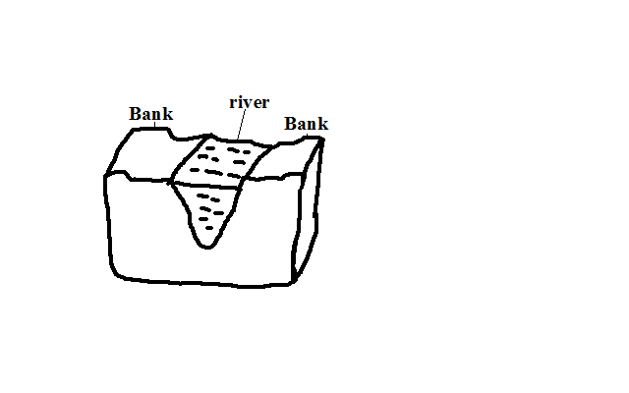

* Formed from vertical erosion causing both valleys to be steep and symmetrical.

**b) Ingrown Meanders**

* Formed by lateral and vertical erosion causing one valley side to be steeper than the other and hence asymmetrical in cross section.

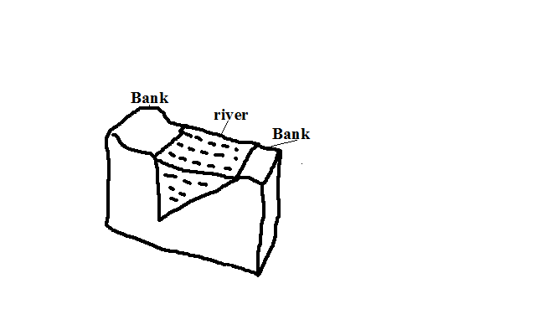

**6. Abandoned Meanders**

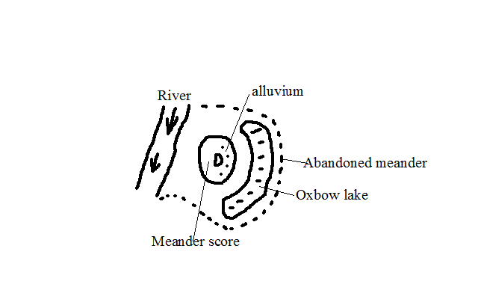

* Meanders abandoned during formation of oxbow lakes when the river takes a short-cut leaving an enclosed portion of land surrounded by an oxbow lake.

**Drainage Systems**

* Main river together with its tributaries.

**Types**

1**. Accordant Drainage System**

* Drainage system in which a river flows according to slope and rock structure by following areas of weak lines.

2**. Discordant Drainage System**

* Drainage systems in which rivers don’t flow in accordance with the slope, rock structure and land forming processes.

**Types**

**a) Antecedent Drainage System**

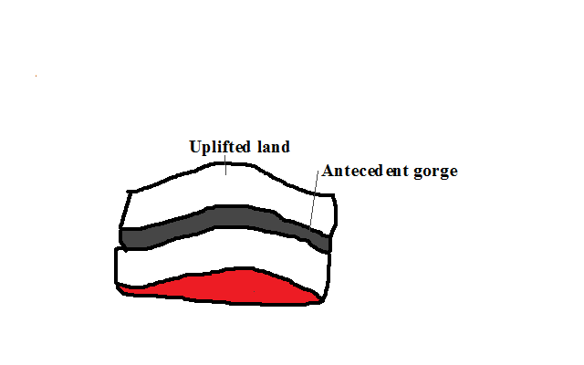

* Drainage system where a river maintains its course while the surrounding land is being uplifted.

**b) Superimposed Drainage System**

* Drainage system which develops where a river maintains its flow over a new set of rocks after removing a former set of rocks.

**3. Back Tilted/Reversed Drainage System**

* Drainage system where direction of flow is reversed be due to capture, uplifting or down warping e.g. R. Kagera, Katonga and Kafu.

**Significance of Rivers and Their Features**

**Positive**

1. Rivers are sources of water for domestic and industrial use.
2. Rivers water is used for irrigation.
3. They provide port facilities where they have rias and estuaries.
4. Some rivers are used for transportation e.g. R. Congo and Nile.
5. Some rivers are fishing grounds e.g. Tana.
6. Rivers are dammed and used for H.E.P generation.
7. Features formed by river action such as waterfalls, gorges and oxbow lakes are a tourist attraction.

**Negative**

1. Rivers flood causing loss of life and property.
2. Rivers may lead to drowning accidents especially when they are flooded.
3. River water can be a medium of spreading diseases such as bilhazia and malaria.
4. Some wide rivers are barriers to transport and communication.
5. Some rivers also harbour dangerous wild animals which can kill humans e.g. crocodiles, hippos and snakes.

**LAKES**

A lake is a depression on the earth’s surface where water has accumulated.

**Classification /Types of Lakes**

**-According To the Nature of Water**

1. **Fresh water lakes which** contain fresh water.
2. **Salty lakes** which have salty water.

**-According To the Mode of Formation of Depression They Occupy**

**1. by Earth or Tectonic Movements**

**a)** **Faulted or Rift Valley Lakes**

* During Rift Valley formation some parts of the rift valley floor sunk more than others.
* A long narrow and deep depression formed.
* Water from seepage and rain accumulated into these depressions to form lakes.

**b) Down Warped and Tilted Lakes**

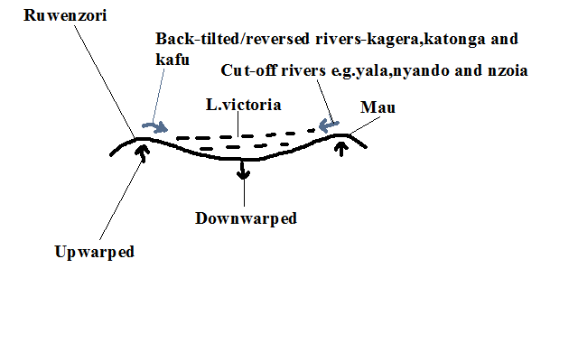

* Tensional and compression forces caused some parts of the earths crust to up warp while others down warped.
* A shallow depression formed.
* The depression may also be filled with water from rain or ground water.
* In the case of L. Victoria Rivers Kafu, Kagera and Katonga were tilted eastwards and Nyando, Yala and Nzoia continued flowing west wards adding water into the depression.
* L.Victoria is the second largest fresh water lake after L.Superior.
* Has a maximum depth of 87m deep. Other examples of lakes are L. Kyoga and Wamala.

**Playas/sebkha** is alake contained in an inland drainage basin in a desert formed when rain or flood water flows into a basin formed by crustal warping e.g. Chemchane Sebkha in Mauritania.

**2. by Vulcanicity**

**i) Crater Lakes**

* Lake formed by water accumulating into a crater.
* Are usually salty.
* A crater lake formed on an explosion crater is called maar.
* Examples are Lakes Mossoko in Tanzania, Paradise in Marsabit and Myungu in Uganda.

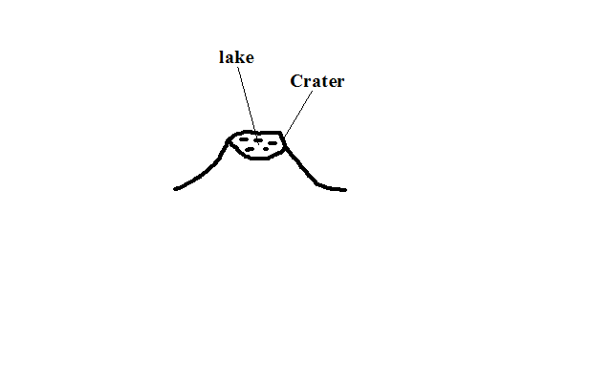

**ii) Lava Dammed Lakes**

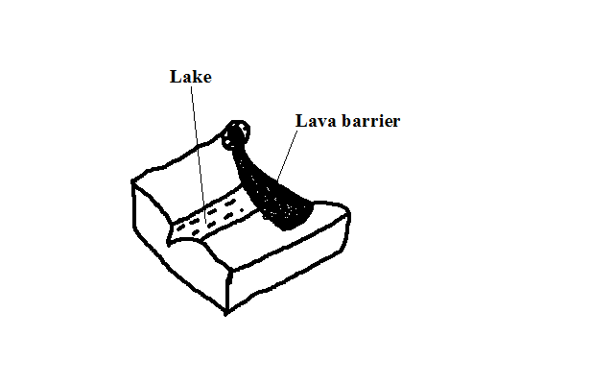

* Formed as a result water accumulating on the upstream side of a lava barrier across a river.
* Highly viscous lava erupts across a rivers course.
* It solidifies and blocks the river forming a lava dam.
* The rivers water accumulates behind the lava dam.
* A narrow and winding lake is formed e.g. Lakes Bunyonyi, Mutanda and Bulera in Uganda.

**3. by Erosion**

**a)** **Glacial Erosion**

**(i) Corrie/Tarn Lakes**

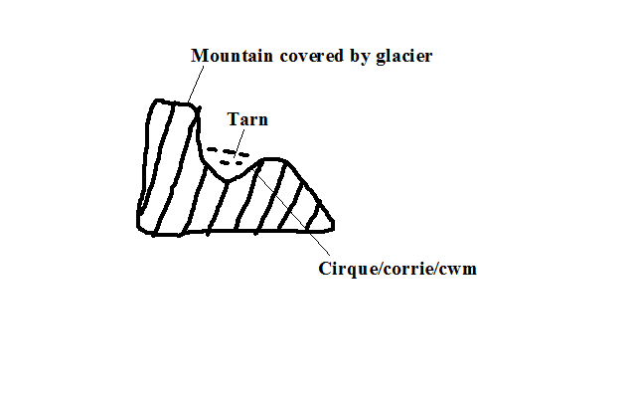

* Lake formed when water from melting snow accumulates into a corrie/cirque e.g. Teleki, Nanyuki and Hidden tarns on Mt. Kenya.

**(ii) Ribbon Lakes**

* Finger like on a glaciated valley.
* Glacier erodes the floor of a u-shaped valley.
* It over deepens some of its sections.
* Elongated hollow results.
* Water from melting ice accumulates into it forming a lake.

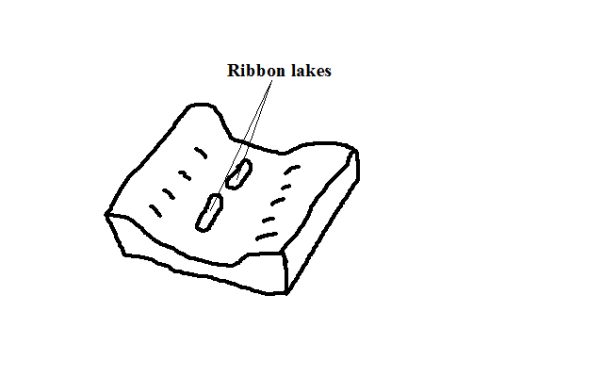

**b)** **Wind Erosion**

* Lakes formed when ground water accumulates in a depression formed by wind deflation and abrasion.
* Wind continuously erodes the earth’s crust by deflation and abrasion.
* The water bearing rocks are reached.

Water oozes from the water table into the hollow or water from flash floods may accumulate in it to form temporary lakes called pans e.g. in Quattara depression between Egypt and Libya and Etosha pan in Namib.

**c)** **Solution Lakes**

* Lakes formed when rain or ground water accumulates in depressions formed in limestone rocks when rain water containing a weak carbonic acid dissolves limestone rocks e.g. Lakes Barber in Morrocco and Ojikoto in Namibia.

**4. by Deposition**

**a)** **River Deposition**

* Formed when river deposition occur cutting off a section of a pronounced meander e.g. oxbow lakes Shakababo and Mukunguya at lower part of Tana.

**b) Wave Deposition**

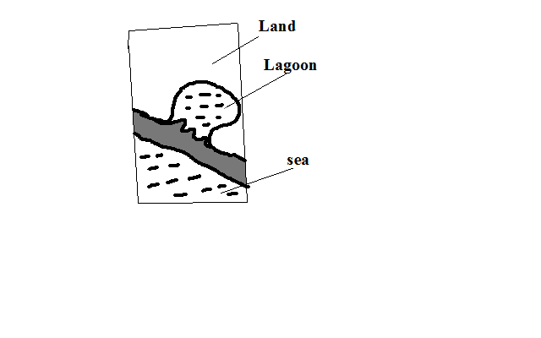

* Lakes formed when wave deposition occurs across a rivers mouth or where the coastline changes suddenly enclosing a body of calm water.
* Waves break at an angle.
* The long shore drift causes materials to be progressively arranged across a rivers mouth resulting in a body of calm water called a lagoon/sound.

**5.** **by Man**

**a) Dams** areLakes formed when water accumulates behind dams constructed across rivers resulting into a large man made reservoir called manmade lake e.g. behind Seven Forks Dam and Lakes Volta in Ghana and Nasser in Egypt.

**b) Barrage** is abank of earth or stones built across a river to provide water for farming.

**Significance of Lakes**

**Positive**

1. Fresh water lakes provide water for domestic and industrial use.
2. Fresh water lakes also provide water for irrigation e.g. Naivasha for horticultural farms around it.
3. Manmade lakes and some other lakes e.g. Victoria (Owen falls) are used for generation of H.E.P.
4. Lakes are used for transport.
5. Some lakes contain valuable minerals e.g. trona at L. Magadi and salt at L. Katwe in Uganda.
6. Many lakes have fish which is a source of food and employment to fishermen and traders.
7. Lakes are also a tourist attraction by providing recreational facilities and being habitats for wildlife.
8. Some lakes are sources of rivers e.g. Victoria for White Nile and L.Tana for Blue Nile.
9. Lakes modify the climate of surrounding areas by sea breezes and convectional rainfall.

**Negative**

1. Lakes are habitats for disease vectors e.g. mosquitoes and snails which transmit Malaria and bilhazia.
2. Lakes may cause flooding due to excessive rainfall or when dams break leading to loss of life and property.
3. Lakes are habitats for dangerous animals like crocodiles, hippos and snakes which kill humans.
4. Lakes cause drowning accidents to people in time of storms.

**OCEANS, SEAS AND THEIR COASTS**

An ocean is a large and extensive body of saline water occupying a basin between continents while a sea is a large body of saline water on the margins of continents.

**Nature of Ocean Water**

1. **Ocean water is salty**

* Due to abundant sodium chloride which rivers dissolved from land, from rocks that the water is in contact with and volcanic materials on the ocean floor?
* Ocean water has high salinity in areas where there is addition of little water and high rate of evaporation leading to high salt concentration e.g. Dead Sea and lower where there is low temperatures and addition of fresh water from rivers, rain or snow melts e.g. Baltic Sea.

1. **Surface water is warmer than that at the** bottom except in Polar Regions where a thin layer of cold water may overlie warmer water.
2. **Ocean water is a habitat for living organisms**

**Planktons** are plants and animals occupying ocean surface.

a) **Phytoplankton** are ocean plants e.g. algae.

b) **Zooplankton** are ocean animals e.g. lobsters, jelly fish, crabs, etc.

**Types**

1. Nektons are all forms of fish.
2. Benthos are ocean creatures which live only at the bottom of margins of continents where sunlight reaches Sea floor e.g. snails, starfish and sea anemones.
3. **Ocean water is polluted** e.g. by industrial effluents, pesticides and herbicides carried by rivers and runoff to the sea.
4. **Ocean topography is composed of several features**

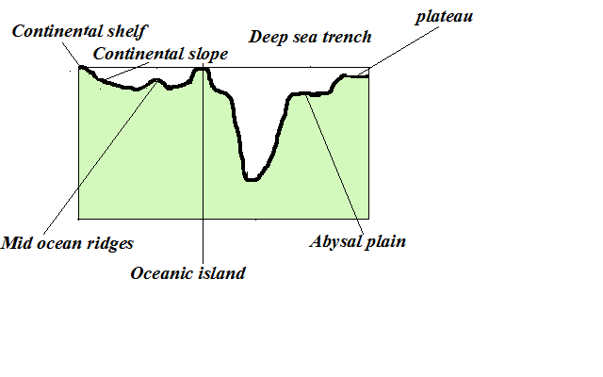

1. **Continental shelf-** Relatively flat part of the continent covered by ocean water.
2. **Continental slope-** Steeply dipping surface between continental shelf and the ocean basin proper.
3. **Abbysal plain-** Almost level area of the ocean where sediments are deposited.
4. **Mid ocean ridges-** Range of hills which are submerged formed by volcanic and seismic activities.
5. **Sea Islands**- pieces of land surrounded by water.

i)Continental islands**-** Ones rising from continental shelf.

ii)Oceanic islands**-**Ones which rise from the sea floor e.g. Canary and Cape Verde.

iii)Coral islands-Ones made of coral.

1. **Deep sea trenches** - narrow steep sided submarine valleys on the ocean floor.
2. **Guyot*s***- submerged atolls forming an underwater mountain.
3. **Sea mount**- a volcano which doesn’t rise above the sea floor.
4. **A portion of ocean water moves**

There are two types of movements namely:

**Vertical Movements**

* Movement of ocean water from surface to bottom and vice versa.

**How they occur**

* 1. Cold polar water sinking before moving horizontally towards equator.
  2. Ocean currents converge
  3. When ocean water sinks at lower depths after ocean currents converge.
  4. When ocean water rises to the surface in a process called upwelling.

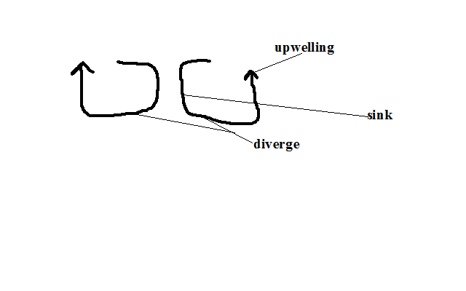

**Significance of vertical movements**

i)Carries nutrients for sea animals by upwelling.

ii) Oxygenation of water vital for fish survival.

**Horizontal Movements**

It occurs in the following ways:

**1. Ocean Currents**

An ocean current is a large mass of surface ocean water which is moving in a particular direction e.g.

* Mozambique- warm
* Canaries -cold
* Benguela-cold
* N. Atlantic drift-warm
* Gulf stream drift-warm

**Factors that influencing formation of ocean currents**

1. **Wind** by blowing over water causing a mass of surface ocean water to move in its direction forming drift currents.
2. **Rotation of the earth** by causing deflection of ocean currents.
3. **Shape of land mass** by influencing current direction and causing it to flow following the coastal outline.
4. **Differences in temperature** bycausing cold polar water which is dense due to low temp moves towards the equator passing on the ocean floor and warm water of the tropics to move towards the poles passing on the surface.

**2. Tides**

* Periodic rise and fall in the level of ocean and other large water bodies.
* Occurs when the moon and to some e the sun exert gravitational pull on the water bodies on the earth.

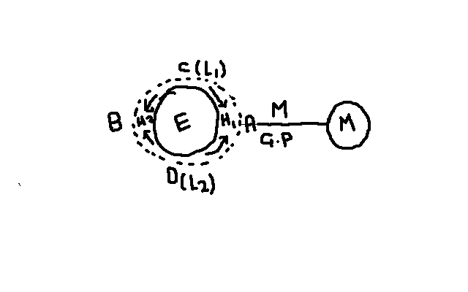

* Moons gravitational pull is exerted on the earth causing the water on that side A to ***bulge*** resulting in high tide 1
* Some water flows from sides C and D to side B to occupy space created by the moons pull resulting in high tide 2 and low tides 1 and 2 at C and D.

**Rotation of the Earth**

* It brings any longitude under the influence of 2 high and 2low tides in a lunar day.
* Similar tides occur at an interval of 12hrs 26 minutes.
* A lunar day is time taken by the earth to complete one rotation with respect to the moon (24 hrs 52 min)
* Lunar month is time taken by the moon to complete one revolution around the earth (27.3 days)
* The moon is always ahead of the earth by 52 minutes due to its revolution e.g. if Nairobi is opposite the moon at 6pm the following day the high tide will be at 6.52pm.

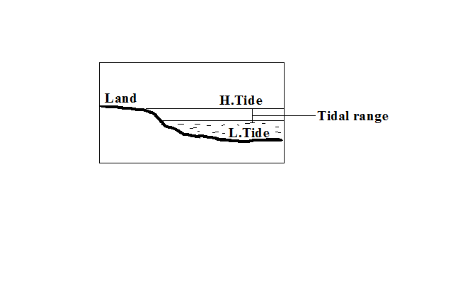

Tidal range is the difference between the highest level reached by high tide and lowest level reached by low tide.

**Types of tides**

* Caused by relative positions of the moon and the sun from the earth.
* Sometimes the moon and the earth are nearer or farther from each other due to their elliptical orbits.

**a) Spring Tides**

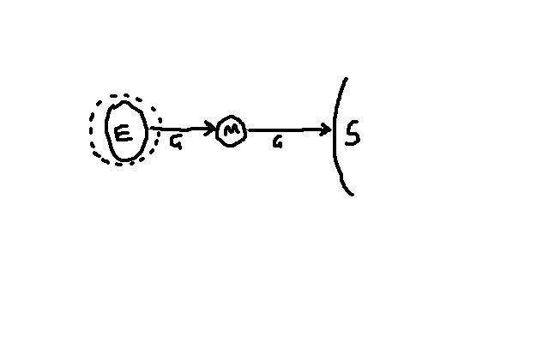

* In which the highest and lowest tides occur.
* Occurs when the sun, moon and the earth are in a line (**syzygy** position) and pulling in the same plane causing pulling force to be greatest.

**b) Neap Tides**

* In which high tide is lower than normal and low tide is higher than normal.
* Occurs when the sun, moon and earth form a right angle and pulling water to themselves.

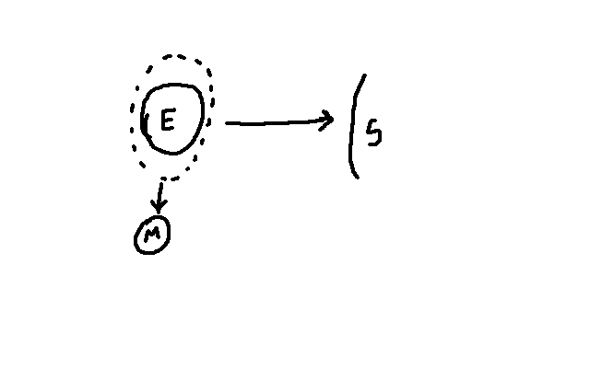

**c) Perigian Tides**

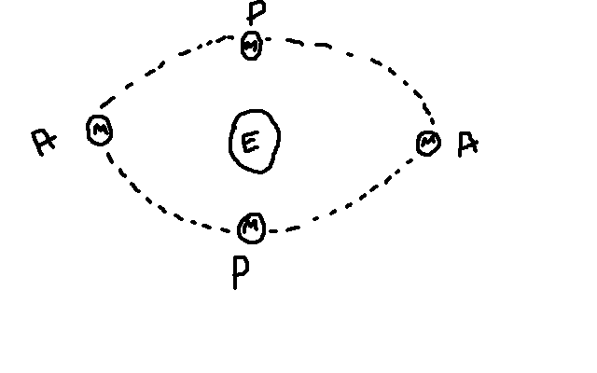

* In which tidal range is 20% higher than normal.
* Occur when the moon is nearest to the earth **(perigee** position) causing pulling force to be greatest.

**d) Apogean Tides**

* In which tidal range is lower than normal.
* Occur when moon is farthest from the earth (**apogee** position) causing pulling force to be weakest.

**e) Diurnal Tides**

* 1H1L in a lunar day

**f) Semi Diurnal Tides**

* 2H2L in a lunar day which may rise or drop at the same level.
* Occur in most of Pacific Ocean.

**g) Mixed Tides**

* 2H2L in a lunar day where one pair may fluctuate in level while the other remains constant.

**3. Waves**

* A wave is a moving ridge of water on the sea.
* It’s formed when wind blows over an open water body causing oscillation of water particles.

**Parts of a wave**

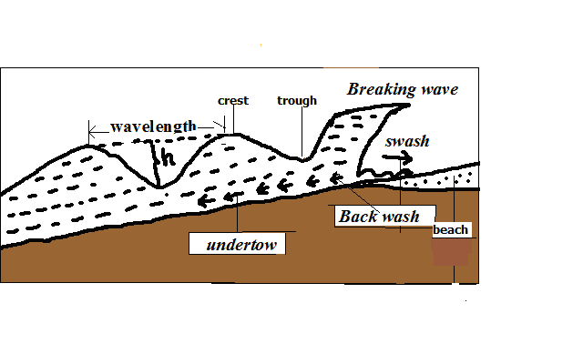

**Crest** - the top of a wave.

**Trough** - the bottom of a wave.

**Wavelength** - horizontal distance between two successive crests.

**Height** - difference in height between crest and trough.

* When a wave reaches the shore, the water particles below the surface start touching the ocean floor causing it to break.
* There is forward movement of water to the beach which is called **swash/send*.***
* There is backward movement of water to the sea due to gravity called **backwash.**
* The rest flows at the bottom back into the sea in a water current called **undertow*.***

**Types of waves**

**a) Constructive Waves**

* Waves in which swash is stronger than backwash resulting in deposition.

**b) Destructive Waves**

* Waves in which swash is weaker than backwash resulting in erosion.

**Wave Erosion**

**Processes of Wave Erosion**

* 1. **Abrasion**
* Scratching ofocean floorby materialscarried by the back wash.
  1. **Corrasion**
* Hurling of pebbles and rock fragments against the rocks causing some particles to break off.

**c) Attrition**

* Rock fragments dragged up and down by the swash and backwash hitting against each other becoming smaller in size. It provides tools for abrasion and corrosion.

**d) Hydraulic Action**

* Removal of materials from the coast by action of the force of moving water.

**i) Direct wave force**

* Large amounts of wave water crush against a rock face weakening and eventually breaking of the rock.

**ii) Compressed air action**

1. Waves crush against a rock.
2. The force of water pushes air into cracks compressing it and exerting pressure causing them to widen.
3. Wave retreats causing trapped air to expand resulting in sudden pressure release causing cracks to expand further.
4. The process is repeated several times causing the rocks to shatter.

**e) Solution**

* Some soluble minerals in rocks dissolve directly in water and are carried away in solution leaving cavities in rocks.

**f) Corrosion**

* Some minerals such as limestone reacting with sea water which has dissolved carbonic acid.

**Factors influencing wave erosion**

**a) Waves** must have strong backwash and a weak swash

**b) Slope -**The coast that slopes steeply into the sea favours erosion.

**c) Load-**large amount provides more abrasive tools. Angular shaped load is more effective in abrasion.

**d) Amount of water in a wave -** the larger the amount the greater the hydraulic force.

**Features Resulting From Wave Erosion**

**a) Cliff and Wave Cut Platform**

**Cliff –** A steep rock face which borders the sea.

**Wave Cut Platform -** A fairly flat part of the shore formed when a cliff retreats inland.

* Breaking waves erode rock surface of a steep coast cutting a notch.

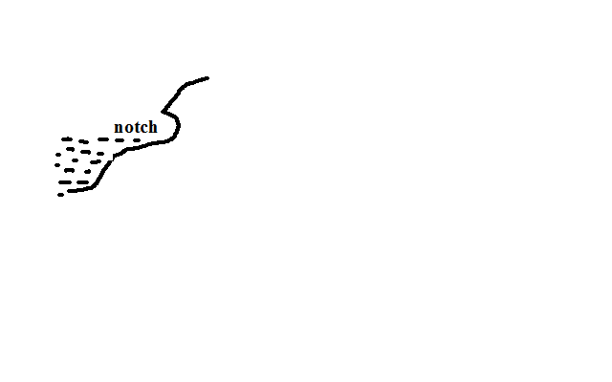

* Erosion continues causing the base of the rock to be undercut resulting into an overhanging rock.

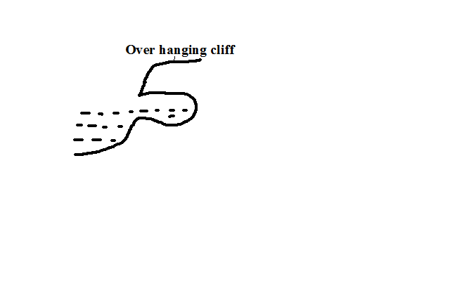

* Undercutting continues causing the overhanging rock to eventually collapse forming a cliff.

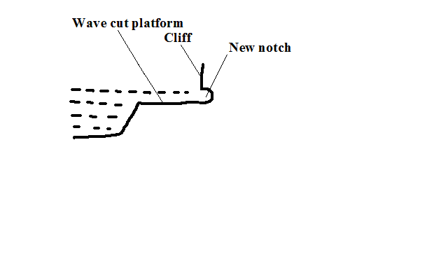

* The process is repeated and a fairly flat part of the shore is formed between the new and the former cliff.

**b) Bays and Headlands**

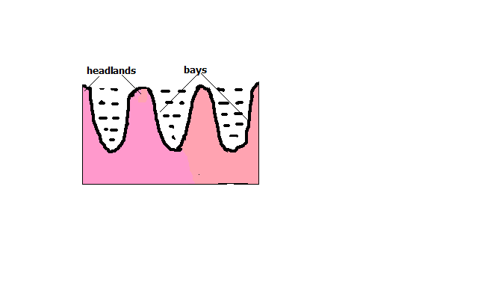

**Bay** – Piece of sea water jutting into the land or a curved inlet of sea.

**Headland** - a piece of land jutting into the sea.

* At first there is a coast with hard and soft rocks.
* Soft rocks are eroded more by wave action to form sea inlets called bays.
* Resistant rocks called headlands are left sticking into the sea. A big bay is called a **gulf*.***

**c) Caves, Blow Hole and Geos**

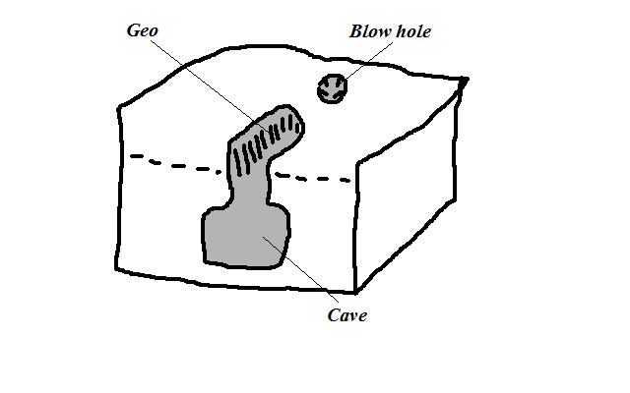

**Cave -** Natural cylindrical tunnel like chamber extending into the cliff or into the side of a headland.

* A small hollow form on a weak area of the cliff after limestone is acted upon by carbonation.
* Corrosion and direct dissolving act on the hollow extending it into the cliff forming a cave.

**Blow Hole**/ **Gloup -** Vertical hole formed on the side of cliff bordering the land.

* Formed when a cave reaches the surface some distance inland as a vertical pit.

It’s called a blow hole because when the waves break water is forced out of the hole.

**Geos -** Narrow sea inlet formed when the roof of a cave between the blow hole and the sea collapses.

**d) Natural Arch, stack and stump**

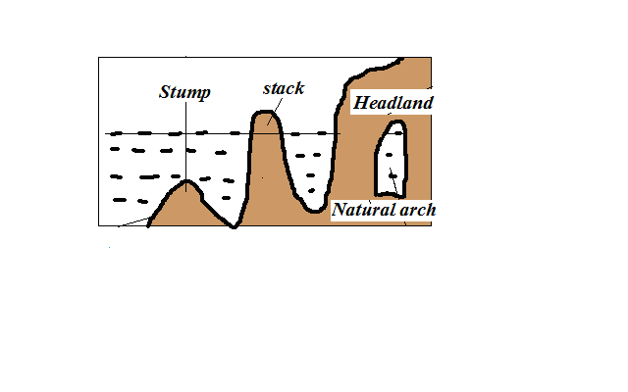

**Natural arch** – Opening from one side of a headland to the other.

* Formed when a cave extends into the head land to the other side.
* Or when caves which have developed on both sides of headland join each other.

**Stack -** Pillar of rock left standing on the seaward side.

* Formed when continuous wave erosion causes the roof of the arch to collapse.

**Stump -** The base of stack left when it collapses as a result of erosion at the base.

**Wave Transportation**

Types of load moved by waves are such as shingle, sand, mud and other objects dumped into the sea.

**How the sea acquires its load**

1. Materials brought by rivers and wind.
2. Products of weathering.
3. Materials brought by rivers and wind.
4. Debris from volcanic eruptions in the sea or on land bordering the sea.

Waves transport load by a process called **long shore drift**. Long shore drift is progressive dragging of materials along the beach as a result of waves breaking at an angle.

* Waves break at an angle.
* Swash pushes materials up the beach at an angle.
* Backwash brings them back at right angle to the edge of water.
* Process is repeated causing materials to be progressively dragged along the beach.

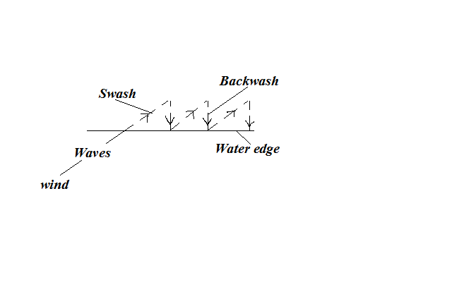

**Factors Influencing Wave Transportation**

1. **Strength of waves**

Strong waves carry large quantities of load over a long distance while weak waves carry small quantities of load over a short distance.

1. **Tides**

Tides cause waves to break farther inland causing materials that were not in contact with breaking waves to be moved about.

1. **Ocean currents**

Ocean currents cause movement of materials from one part of the ocean to another e.g. coconut fruits from southern part of Africa to Gulf of Guinea by Benguela current.

1. **Gradient of the shore**

On gentle coasts transportation of materials is favoured by long shore drift while on a steep coast they bounce off cliffs and remain floating.

1. **Orientation of coast line.**

Transportation by long shore drift is favoured where coast is aligned obliquely to the direction of breaking waves while on transversely aligned coast swash moves materials back and forth along the same line.

1. **Nature of the load.**

Lighter materials such as sand are carried over long distances while heavy load is transported over a short distance.

**Deposition**

* Process in which materials transported by waves are laid down on the shore.

**Factors Influencing Wave Deposition**

1. **Load**

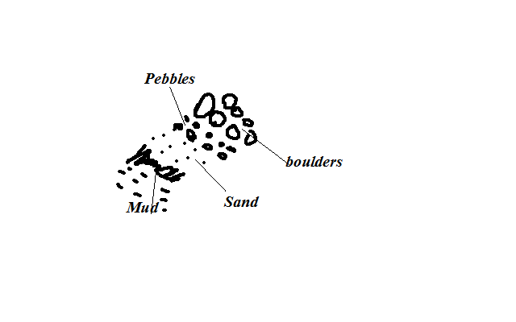

Deposition occurs in selective manner:

* + Boulders are deposited at farthest end of land because they are swept towards the land by powerful swash during high tide followed by pebbles.
  + Then sand and finally mud because the weak backwash brings them back towards the sea as they are light.

1. **Waves**

Waves must have a strong swash and a weak backwash in order to cause excess load to be left behind on the shore.

1. **Gradient of the shore**

The coast must be sloping to reduce the velocity and hence the energy of waves so that depositing occurs.

1. **Depth of Water**

Deposition takes place where water is shallow for waves to come into contact with ocean floor and break the cyclic motion of water.

**Features Resulting From Wave Deposition**

**a) Beaches**

* Gently sloping mass of accumulated materials such as sand, shingle and pebbles along the coast.
* Formed by constructive waves during a relatively calm weather when backwash is weakest resulting in materials accumulating at the shore.

During storms destructive waves destroy beaches creating other minor features such as: **i) Beach cusps**

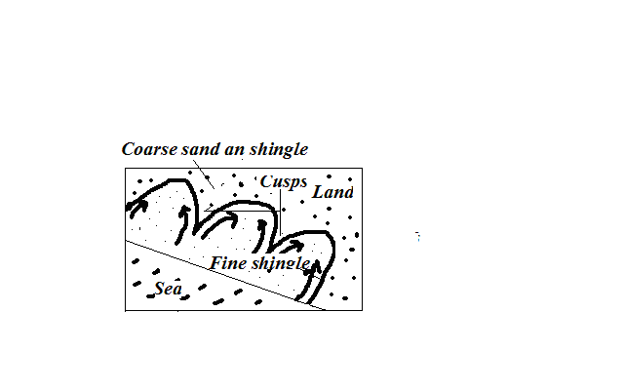

* Horn like projections of sand and gravel which gives the coast line a series of curves.
* Waves break at right angles.
* Powerful swash in form of eddies scour depressions moving coarse materials to either side forming head like projections called cusps leaving finer materials forming bay like inlets.

**ii) Beach Ridges and Beach Berms**

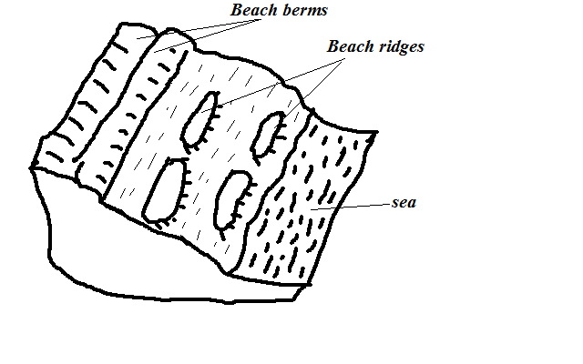

**Beach Ridges -** Low ridges of coarse sand, boulders and shingle deposited roughly parallel to the shore formed by waves approaching the coast at right angles.

**iii) Beach Berms**

* Narrow terrace of shingle thrown up the beach by storm waves formed where tidal range is high.

**iv) Beach Rock Shells**

Masses of sand, shells and pebbles cemented together by calcium carbonate forming projections above the beach.

**b) Spits**

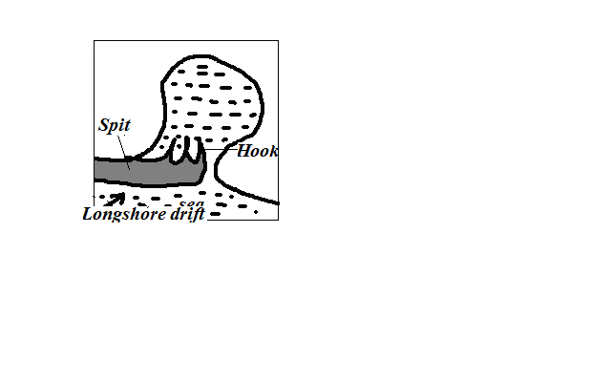

* Low lying ridge of sand, shingle and pebbles with one end attached to the coast and the other projecting to the sea.
* Movement of materials by long shore drift is halted causing deposition due to coast changing its direction towards the land e.g. across estuary or entrance of a bay.
* The process continues and the accumulation grows towards the sea.
* Waves carry sand to the inner end of the spit creating a hook like feature e.g. at the mouth of R. Senegal.

**c) Tombolo**

* Spit that grows out from the coast into the sea and joins an island e.g. Ras Hafur in Somalia and Ngomeni on Kenyan coast.

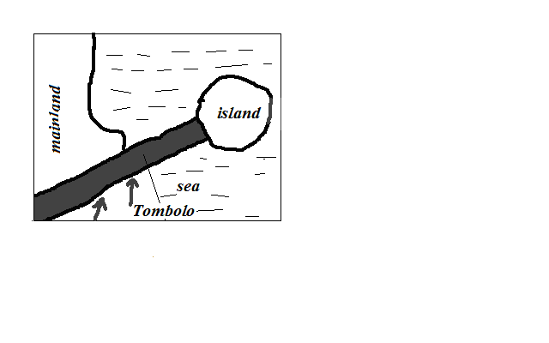

**d) Bars**

* Ridge of sand, shingles and mud which lies almost parallel to the coast.

**Types**

**i) Bay bar –** Barwhich forms across the entrance of a bay.

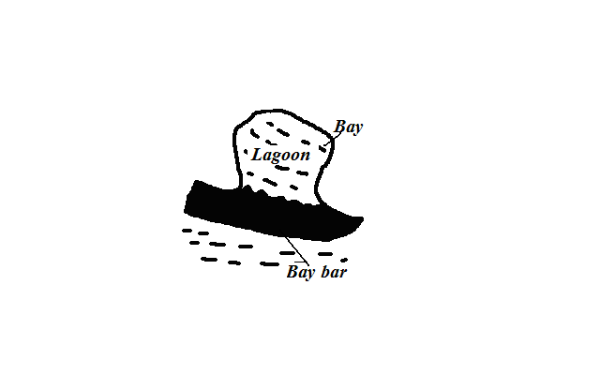

**Offshore bar -** Barwhich forms off a very shallow coast line.

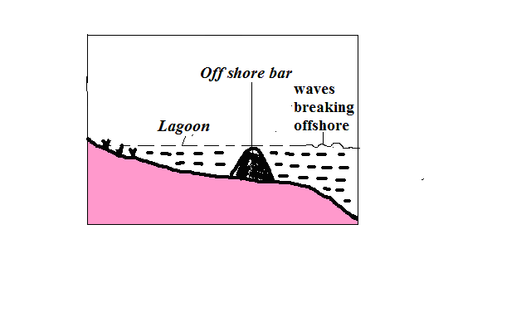

* Wave is forced to break off shore due to water shallowness.
* They throw up a ridge of materials off the coast.
* Between the bar and the coast there will be a shallow lagoon colonised by marsh plants.

**e) Cuspate foreland**

* Broad triangular shaped deposits of sand or shingle projecting from the mainland into the sea.
* Two spits grow towards each other at an angle.

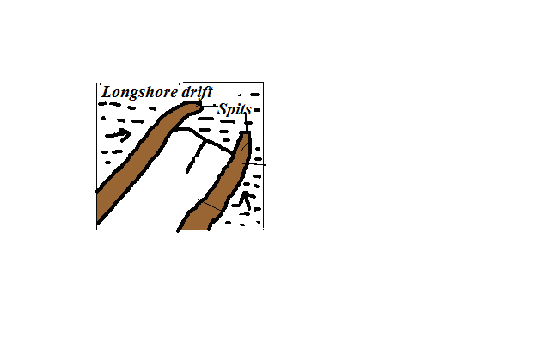

* A triangular feature called cuspate barrier develops which encloses a lagoon.
* The lagoon is filled with mud and sand to form the foreland.

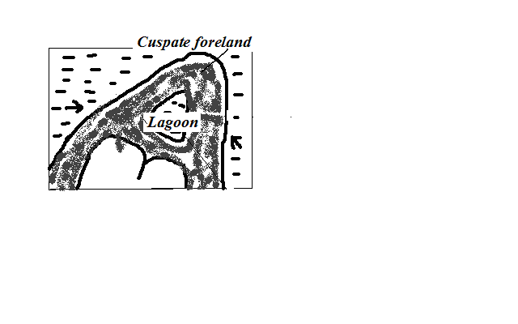

* Vegetation grows on the marsh and with time dries up e.g. ‘A’ Laree in Malagasy.

**f) Dune Belts**

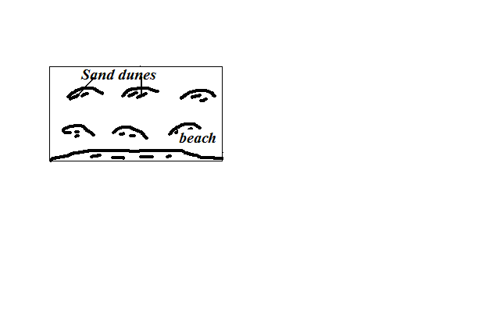

* Belt of low lying mounds of sand found on extreme landward side of the beach above the high tide level.
* Sand on the beach dries up during the high tide.
* It’s picked by onshore winds and deposited at a distance away from the reach of breaking waves.
* It collects behind obstacles like grass or other vegetation and gradually builds up forming a dune.
* The dunes may be covered with vegetation to form marshes.

**g) Mud Flats and Salt Marshes**

**Mudflats -** Platform of mud consisting of fine silt and alluvium deposited in sea inlets such as bays and river estuaries.

**Salt marshes -** Vegetation such as grasses and mangrove that grows on a mudflat

* Fine silt and river alluvium are deposited in sea inlets by tides.
* A platform of mud builds up and is colonised by vegetation forming a swamp called salt marsh.
* The dense network of plants roots trap more mud and alluvium causing the mudflats to extend seawards.

**Factors Determining the Type of Coasts**

1. **Wave action**

Wave erosion makes a coast to have erosion features while deposition causes depositional features.

1. **Tidal currents**

Where tidal range is high more surface area is exposed to wave action.

1. **Nature of rocks**

Weak rocks are eroded to form bays (inlets) while resistant ones are left standing to form headlands.

1. **Alignment of coast**

There is more erosion on exposed coasts while deposition occurs where the coast is obliquely aligned to the breaking waves.

1. **Change in sea level**

Fall in sea level leads to emergence and rise to submergence.

**Types of Coasts**

**According To the Alignment of Coast**

1. **discordant/transverse/irregular coast**

* Coast which lies transversely to the coast line.
* Has a large number of inlets and receives heavy rainfall because winds blow onshore e.g. Mombasa.

1. **Concordant coasts/regular/longitudinal coasts**

* One which lies almost parallel to the coastline.
* Almost straight and lacks inlets and receives little rainfall due to winds blowing offshore e.g. Lamu.

**According To Features Present**

**1. Submerged Coasts**

* Coasts where a part of coastal land lies under the sea.

**Causes of submergence**

a) Rise in sea level e.g. when large quantities of melt water were released to the sea causing its level to rise due to climate change at the end of ice age.

* 1. Sinking of coastal land and a part of the sea floor.

**Types**

**a) Submerged Highland Coasts**

* Found where submergence occurs on a coast characterised by steep slopes.
* Characterised by drowned features.

**i) Ria Coast**

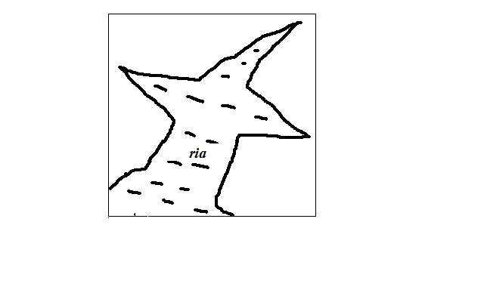

A Ria is a drowned river mouth.

**Characteristics**

1. Funnel shaped
2. U-shaped in cross section.
3. Deeper and wider on the seaward side and shallower and narrower inland e.g. the Kenyan coast at Kilindini and Mtwapa.

**ii) Fiord/Fjord coast**

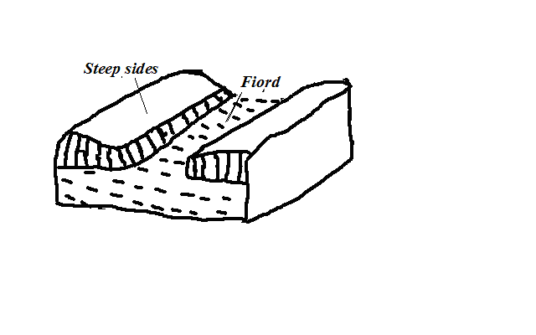

A fiord is a submerged glaciated valley.

* Ice deepens and widens glacial valleys until the floor lies below the sea level.
* When the ice retreats sea water flows in drowning the valley forming inlets called fiords.

**Characteristics**

1. Deeper inland.
2. Shallower at the sea ward end due to terminal moraine deposited when glacier was melting.

**iii) Longitudinal/Dalmatian Coasts**

* Coast where ridges and valleys lying parallel to the coast line are drowned.
* Valleys form inlets called sounds while ridges form islands.

**b) Submerged Lowland Coasts**

* Found where submergence occurs on a coast characterised by gentle slopes.

**Types**

**i) Estuarine Coast**

* Coast characterised by broad shallow estuaries and mud flats which are visible at low tide.
* Wider and shallower than rias e.g. coastlines of Guinea and Senegal.

**ii) Fjard Coast**

* Coast characterised by numerous inlets formed by submergence of glaciated rocky lowland coasts.
* Have numerous islands and are deeper than rias e.g. S.E. coast of Sweden.

**2. Emerged Coasts**

* Coast where part of seafloor has become permanently exposed.

**Causes of Emergence**

1. Decrease in sea level due to decline in the source of water e.g. waters being held up in a glacier instead of it flowing back as rivers to the ocean.
2. Uplift of the coastal land by faulting, folding or isostatic adjustment.

**Types**

**i) Emerged Highland Coasts**

* Found where emergence occurs on a coast characterised by steep slopes.
* Characterised wave action features which are isolated on land e.g. raised beaches, raised cliffs, raised wave cut platforms and raised arches.

**ii) Emerged Lowland Coasts**

* Found where emergence occurs on a coast characterised by gentle slopes.
* Characterised by exposed depositional features e.g. spits and offshore bars which are found on land and a coastal plain formed as a result of a part of continental shelf becoming exposed.

**3. Coral Coasts**

* Coasts composed of coral rocks which are exoskeletons of marine organisms called coral polyps.
* They live in colonies/groups, feed on plankton and extract lime from the sea and build shells for protection.

**Conditions Necessary for Coral Growth**

1. warm water(25-29◦C)
2. Saline and clear water.
3. Sunlight should penetrate at least to a depth of 50m to allow plankton growth.
4. Plentiful supply of plankton which they feed on.
5. Shallow water.

**Types of coral reefs**

**i) Fringing Reefs**

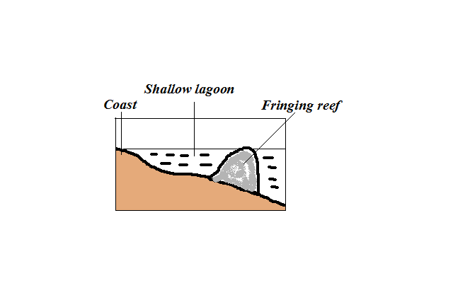

* Platform of coral formed when coral polyps start building a reef near the shore.

**Characteristics**

1. Flat or concave shaped
2. Higher on the seaward side
3. Outer edge falls steeply into the sea

**ii) Barrier Reefs**

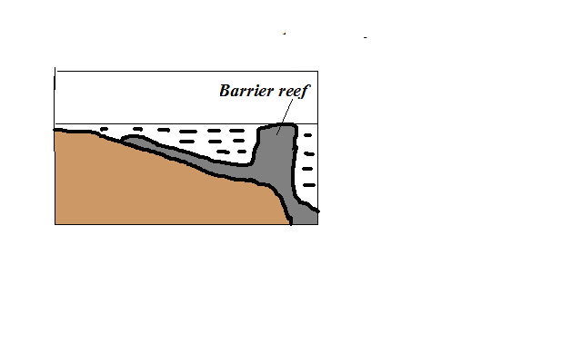

* Platform of coral formed a long distance from the shore.
* Formed when polyps start to grow and extend seawards where conditions are favourable.

**Characteristics**

1. Its coral is joined to the shore.
2. Its outer edge falls steeply into the sea.

**iii) Atoll Reef**

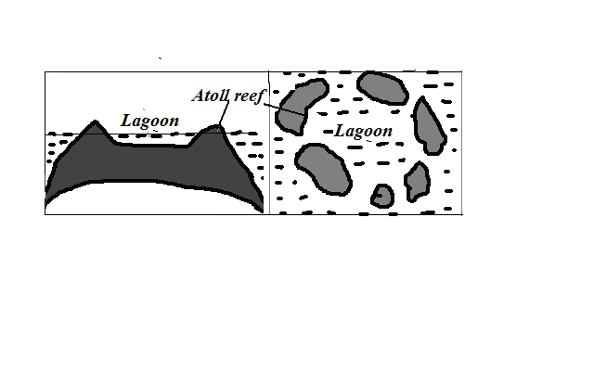

* Coral ring formed around a submerged island.

**Characteristics**

1. Circular in shape.
2. Encloses a fairly deep lagoon.

**Theories of Formation**

**Darwin’s Theory**

* Fringing reef develops around an island.
* The island starts to sink.
* Coral continues to grow upwards to keep pace with rising sea level and seawards because there is more food and water is clear.
* The reef extends great distance away from the land to become barrier reef.
* The island continues to sink becoming completely submerged.
* The barrier reef forms a ring of coral called atolls.

**Murray’s Theory**

* Fringing reef grows on a submarine hill.
* It disintegrates due to wave attack.
* Coral fragments accumulate on the seaward end.
* Polyps start building on it upwards where there is more food and clear water to form barrier reef.
* The barrier reef forms a ring of coral called atolls.

**Daly’s Theory**

* During ice age there was withdrawal of water causing global fall in sea level.
* Coral growth was retarded by low temperatures.
* Waves pounded coral reefs and islands and flattened them to the same level as the sea.
* At the end of ice age temperatures began to rise again favouring the growth of coral once again.
* More water was added to oceans causing polyps to continue to grow upwards to keep pace with the rising sea level.
* They were permanently exposed on the surface to form atolls

**Significance of Oceans, Coasts and Coastal Features**

**Oceans**

**Positive**

1. Influence climate by contributing the bulk of precipitation, warming effect in cool season and cooling effect in hot season by breezes and ocean currents.
2. Used for transport by means of boats, steamers and ferries.
3. Tourist attraction by beingsite for recreation e.g. swimming and sport fishing and marine life in parks such as in Mombasa and Lamu.
4. Oceans are a source of fish which is a source of food, income and employment.
5. Source of fresh water when its water is distilled.
6. Tropical seas have mangrove forests with mangrove trees which provide strong building and fencing posts and tannin for tanning leather and also habitat for marine life which is a tourist attraction.
7. Source of salt which crystallizes naturally after water evaporates in constricted bays in hot climates.

**Negative**

1. Tsunamis from oceans flood the neighbouring coastal areas causing great loss of life and property.
2. Oceans may also flood the neighbouring coastal areas as a result of rise in sea level caused by melting of glaciers caused by global warming.
3. Also harbour dangerous animals such as sharks and crocodiles which may attack and hurt or kill people.
4. Drowning accidents when there is breakdown of vessels or ship wrecking.

**Coasts and Coastal Features**

**Positive**

1. Fiords, rias and lagoons favour development of deep and well sheltered harbours.
2. Fiords are also a good breeding ground for fish as their shallow continental shelf encourage growth of plankton which is food for fish.
3. Coral rocks are used locally as building materials.
4. Coral rocks are also a source of coral limestone for cement manufacture.
5. Features such as coral reefs, caves, cliffs and fiords are a tourist attraction.

**Negative**

1. Some emerged coastal lands have infertile soils unsuitable for agriculture for being covered by sand, gravel and bare rock.
2. Deposited sands, bars and coral reefs are barrier to transport as they can cause ship wrecking if vessels hit them.

**ACTION OF WINDAND WATER IN ARID AREAS**

An arid area is a land which is deficient of moisture leading to scanty or no vegetation.

**Action of Wind in Arid Areas**

**Wind Erosion**

Physical weathering is the initial process then it’s followed by wind erosion.

Wind is more effective in tropical deserts due to:

1. Presence of loose unconsolidated dry masses of mud, sand and gravel.
2. Occurrence of strong tropical storms.
3. Absence of vegetation leading to high wind velocity due to little frictional force.

**Factors influencing wind erosion**

1. **Wind speed**- wind with high velocity has more energy to erode than with low velocity.
2. **Load**- angular shaped load provide more effective abrasive tools than one which is round shaped.
3. **Nature of surface**- Wind erosion is faster where the surface consists of unconsolidated materials.

**Processes/Ways in Which Wind Erodes Deserts**

**a) Abrasion**

* Materials carried by wind such as sand grains scratching rock surfaces across the path of wind.
* Greater close to the ground because it’s where heavy and more effective abrasion tools are lifted and carried.

**b) Deflation**

* Removal of unconsolidated materials such as sand and dust rolling and lifting or scooping and blowing away.

**c) Attrition**

* Sand grains carried by wind knocking against each other causing each other to become smaller and rounded in shape.

**Resultant Features of Wind Erosion**

**a)** **Millet seeds**



* Sand grains which have been rounded to the shape of millet seeds by wind attrition.

**b) Ventifacts**

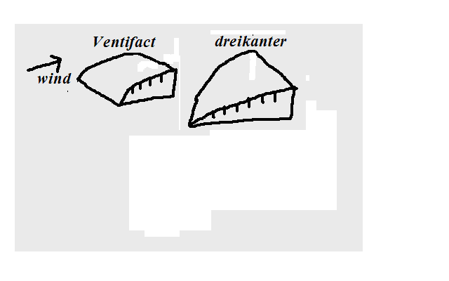

* Boulders, stones and pebbles which are flattened by wind abrasion one or more sides due to changes in wind direction.
* **Dreikanter** - Ventifact with three wind faceted surfaces formed when wind is blowing in different directions.

**c) Mushroom Block**

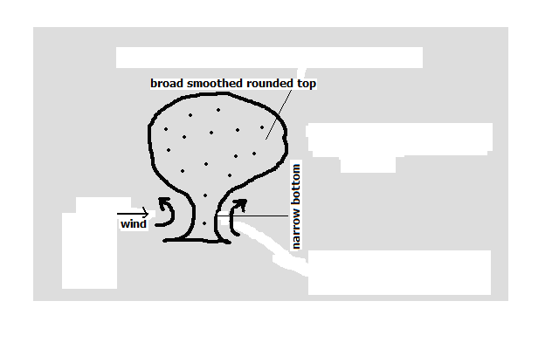

* Mushroom shaped rock in desert landscape.
* Wind abrasion acts on a rock with uniform hardness.
* It’s intensely undercut at the base and top part is slowly polished by light and less effective abrasive materials.
* There results a rock with broad smoothed rounded top and a narrow base resembling a mushroom

**d) Rock Pedestal**

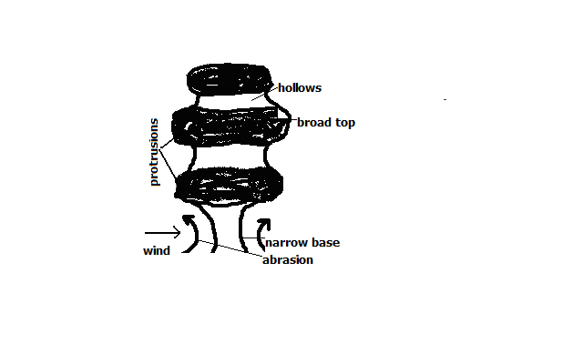

* Irregular rock pillar with a broad top and a narrow base found in the desert landscape.
* Wind abrasion acts upon rock with alternating hard and soft layers.
* Soft layers are eroded more than hard layers leaving hollows and protrusions.
* There is more undercutting at the base where there is more abrasion.
* There results an irregular rock with a narrow base.

**e) Deflation Hollows**

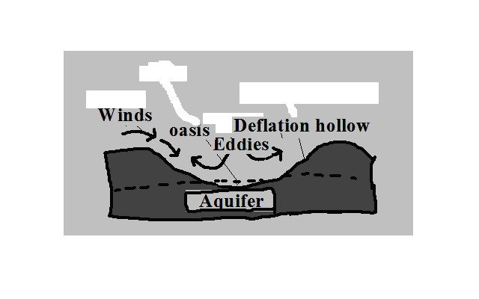

* Shallow depressions found in desert landscapes formed by deflation.
* Wind scoops and blows away unconsolidated materials such as dust and sand in a desert.
* Circulating wind deepen the depression.
* The hollow reach the water table forming an oasis.
* If the depression doesn’t reach the water table flash floods water may accumulate into them to form temporary lakes called pans e.g. Etosha pan in Namib.

**f) Zeugen (Singular zeuge)**

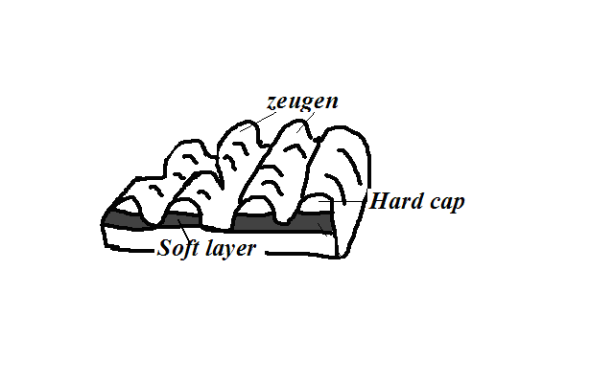

* Ridges on a ridge and furrow desert landscape.
* First there is a landscape with horizontal alternating layers of hard and soft rocks.
* Weathering opens joints and cracks on the top resistant layer.
* Abrasion erodes the opened joints while deflation carries away the eroded materials.
* The process continues and with time causes a ridge and furrow landscape to develop. The ridges are zeugen.

**g) Yardangs**

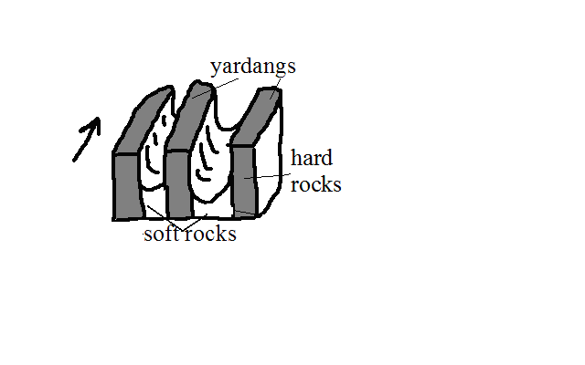

* Narrow elongated rock ridges about 6m high on a desert landscape.
* At first there is a surface with vertical alternating hard and soft rocks lying parallel to wind path.
* Wind abrasion acts more on soft rocks and deflation carries away worn out particles.
* The undercut rocks are left standing forming ridges called Yardangs.

**Wind Transportation**

**Factors Influencing Wind Transportation and Deposition**

Wind velocity: when speed decreases strength also decreases and its ability to transport so wind starts to deposit materials.

1. Wind direction- Winds blowing from different direction converge and cause load to collide causing some of it to be deposited.
2. Nature of desert surface:

* Wind transportation is more efficient on bare surfaces and hence less deposition there.
* Water surfaces such as oasis and moist surfaces impede transportation through friction causing wind to deposit materials.
* Less transportation on surfaces with vegetation as it reduces wind speed and also binds sand particles together.

1. Obstacles- Objects such as rock masses, land forms and vegetation block and reduce wind speed causing deposition.
2. Changes in weather conditions such as sudden showers halts transportation and causes deposition by washing down suspended materials.
3. Load- Heavy load is deposited before light load when wind energy decreases. When many materials are transported by wind they collide causing each other to be deposited.

**Processes/ Ways in Which Wind Transports Load**

**i)** **Suspension**

* Wind lifting and holding particles such as dusts by air currents and transporting them over long distances.

**ii) Saltation**

* Wind transportation of heavy particles by a series of jumps and hops.
* They are rolled.
* They collide.
* Bounce and get lifted.
* Transported short distance ahead.

**iii) Surface Creep**

-Wind transportation of heavy particles such as gravel and pebbles by pushing and rolling along the desert.

**Resultant Features of Wind Deposition**

**1. Sand Dunes**

Dune - Low ridge of sand accumulated by wind deposition.

**Types**

**i) Barchans**

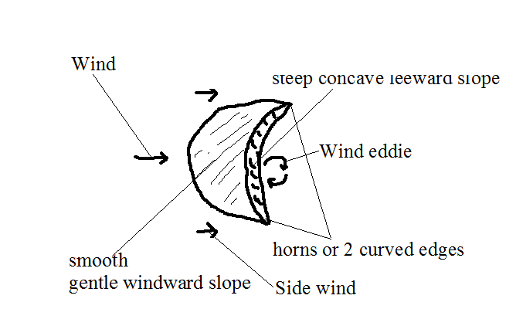

* Crescent shaped mound of sand in a desert.
* Sand accumulates around an obstacle lying on the path of wind.
* Deposition continues making the mound to grow bigger.
* Wind blows sand over leeward side creating smooth gentle windward slope.
* Wind eddies act on the leeward slope making it to be steep and concave in shape.
* Side wind move the sand grains on the sides forward creating the two edges which are curved e.g. in Sahara and Arabian Deserts.

**Characteristics**

1. Crescent/moon shaped
2. Smooth gentle windward slope
3. Steep concave leeward slope
4. Horns or 2 curved edges
5. Occurs individually or in groups

**ii) Seif Dunes**

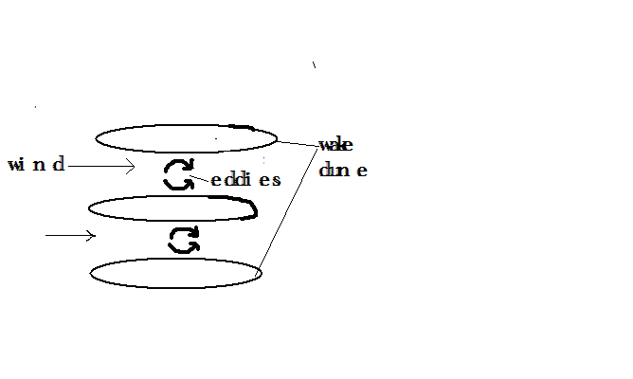

* Ridge shaped mounds of sand lying parallel to the path of prevailing wind.
* Wind blows between barchan dunes.
* Wind eddies move sand towards the sides.
* Sand accumulates on the sides resulting into ridge shaped mounds e.g. in Namib Desert.

**iii) Transverse/Wake Dunes**

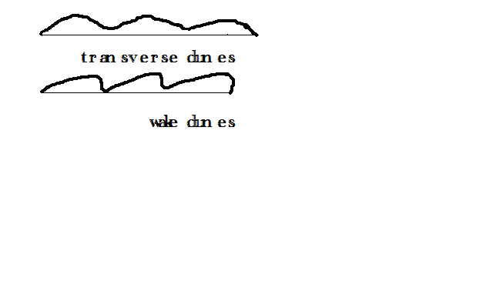

* Wave like mounds of sand in a desert which lie at right angles to the prevailing wind.
* Less strong winds blow over sand from one direction.
* The wind concentrates larger grains of sand into series of transverse ridges.
* Wind may continue pushing the sand causing it to accumulate on the leeward side to form wake dune e.g. in W. Sahara.

**2. Drass**

* Biggest sand features in a desert with surface resembling a plateau and with a height of up to 200m.
* Barchans and Seif dunes may form on such features e.g. in E. Sahara desert.

**3. Loess**

* Fertile soils with great thickness of about 100m formed from deposition of dust from deserts.
* Dust from deserts is carried beyond to wet areas.
* It’s washed down by rain causing its deposition.
* It accumulates into layers.
* Deposition continues and the layers are compacted forming sedimentary rocks.
* The sedimentary rocks wither to form fertile soils which favour cultivation e.g. Temperate lands of Europe along Rhine valley from Sahara dusts and along Huang He valley in N. China from dust of Gobi desert.

**Action of water in arid areas**

* Receives short occasional rains causing flash floods which erode transport and deposit large loads of materials produced by weathering.
* Water action is short lived.

**Resultant Features of Water Action in Arid Areas**

**a) Wadis**

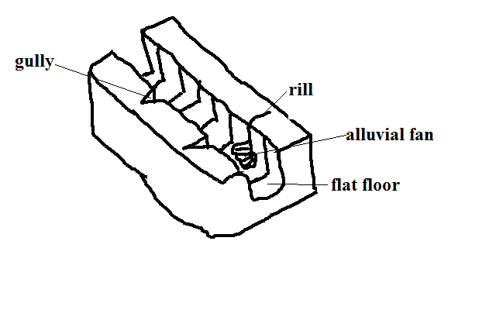

* Wide deep steep sided dry valley in a desert
* Strong surface runoff and flash floods form rills.
* Rills are enlarged into gullies.
* Flash floods flow into gullies widening and deepening them to form wadis.

**Characteristics**

* Wide and deep
* Steep with cliff like walls
* flat floor
* Dry (lack permanent drainage)

**b) Dry River Valleys**

* Valleys in arid areas through which streams flow during the wet season and dry up in dry season e.g. in Turkana, Wajir and Mandera.

**c) Mesas and Buttes**

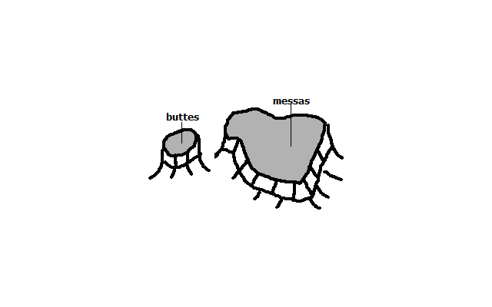

**Mesas** **-** Extensive table like residual hills found in arid areas.

**Buttes -** Smaller blocks of table like residual hills found in arid areas.

* First there are sedimentary rocks occurring in layers with a resistant one on top and a less resistant below.
* Weathering breaks the hard cap.
* Then sheet floods break the surface and carries materials away.
* Large outstanding blocks are left which are called mesas.
* Mesas may be eroded farther to form smaller blocks called buttes.

**Features in an Inland Drainage Basin**

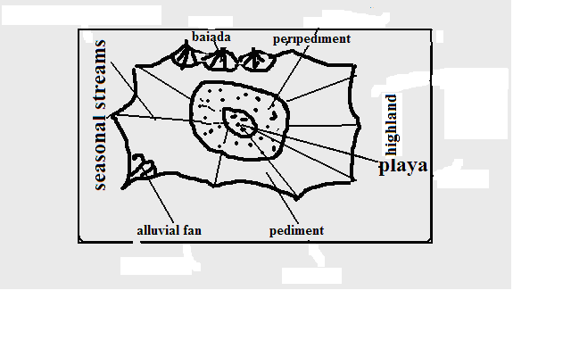

* Gently sloping rock surface formed at the edges of desert uplands.
  + A steep/scarp slope of a highland is eroded by sheet flooding reducing its height.
* The process continues causing the scarp slope to shift its position upwards.
* The gently sloping surface of 6-7◦results at the foot of the upland.

**d) Playas/sebkha**

* Extensive inland drainage basin in a desert formed by deflation or crustal warping or a small fluctuating salty lake contained in an inland drainage basin in a desert formed when water from torrential outpours flows into the basin by multiple temporary streams e.g. Chemchane sebkha in Mauritania.

**e) Peripediment**

* Zone of thick alluvial deposits at the edge of playas in form of alkaline crust of mud, sand and gravel formed when streams deposit a lot of materials at the edge of the playa. Materials dry up leaving a hard salty crustal surface called **Salina/salar** e.g.in Arizona desert in U.S.A.

**f) Pediment**

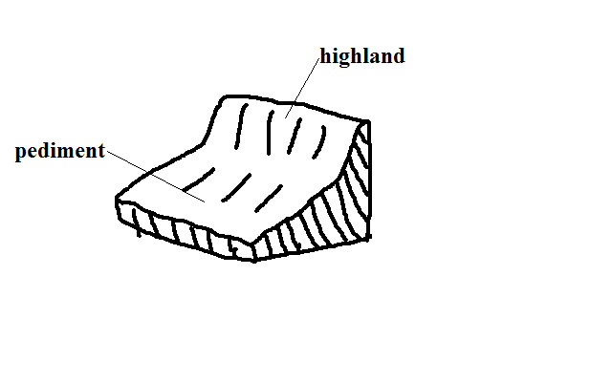

**g) Peneplain**

Low level plain formed when pediments are eroded to form a low level plain.

**h) Pediplain**

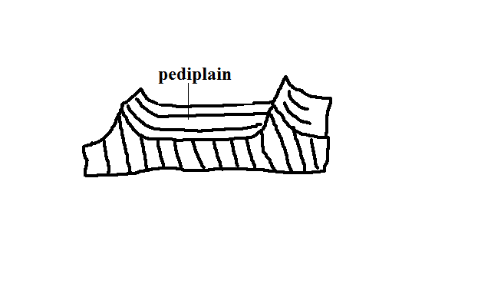

* Extensive low and gently sloping lands common in deserts.
* Pediments surrounding a highland are extended by sheet erosion.
* With time the highland is reduced to a residual hill like Inselbergs.
* The hill is eventually eroded forming a continuous plain(Pediplain)

**i) Inselbergs**

* Prominent residual rocks in a desert.
* Formed by extension of pediments into upland areas.

**Types**

**Bonhardt -** Steep isolated round topped mass of rock rising steeply from desert surface.

* Dissection of plateau by streams producing steep sided valleys.
* The plateau is further eroded forming remnant hills e.g. Sugar Loaf Mountain in Rio de Janeiro in Brazil.

**Castle kopje –** Residual rocks in a desert found in groups.

* Formed from break down of Bonhardt with closely spaced joints.
* Or deep withering of a plateau edges.
* Weathered rocks are then removed by water reducing plateau into Inselbergs e.g. Nzambani rock in Kitui.

**Significance of Deserts and Desert Features**

**Positive**

1. Loess soils are used for agriculture because they are very fertile e.g. in Huang He valley and Ukraine.
2. Loess soils in Europe and china have dug in caves which are inhabited during winter to provide warmth.
3. Desert features are a tourist attraction e.g. rock pedestals, Yardangs, Zeugen and sand dunes.
4. Oasis in deflation hollows are sources of water for domestic use.
5. Oasis water is also used for irrigation such as of date palms.
6. Deserts are good sites for testing military weapons, military training and experimenting ground for aircraft because they are sparsely populated.
7. The scarce vegetation in deserts such as shrubs can be used in livestock keeping e.g. goats, camels etc.
8. The hot sun in deserts can be harnessed to provide electricity for lighting, pumping of water, etc.
9. Seasonal streams can be dammed to supply water to surrounding areas e.g. Kigombo dam in Mbororo in Taita which supplies water to Voi town.

**Negative**

1. Some desert features can prevent physical development e.g. sand dunes can bury roads and it is difficult to construct bridges across wadis.
2. Sand dunes can cover oasis and settlements.
3. Sand dunes may destroy rich agricultural land.
4. High temperatures, shortage of water, unreliable rainfall and lack of transport and communication infrastructure discourage settlement.

**UNDER/GROUND WATER**

* Water that exists beneath the earth’s surface in pore spaces in soil and rocks.

**Sources of Ground Water**

**a) Rain Water**

* Some rain water which percolates and is trapped after meeting an impermeable rock.

**b) Melt Water**

* Water that infiltrates into the ground when snow melts during spring and summer.

**c) Surface Water**

* Water from rivers, seas, swamps, oceans, lakes and ponds that seep into the ground.

**d) Magmatic/Plutonic Water**

* Water trapped in rocks beneath surface during vulcanicity

**Factors Influencing Existence of Ground Water**

**a) Precipitation**

* For ground water to exist precipitation must exceed evaporation.
* Light rain falling over a long period of time infiltrates more than heavy short lived downpour.

**b) Slope**

* On flat and gently sloping areas rain water has ample time to infiltrate because it remains in one place for a long time.
* On steep areas there is low infiltration since a lot of water turns into runoff because of getting less time to percolate.

**c) Nature of Rocks**

* There is a greater possibility of existence of ground water where there are permeable surface rocks.
* Ground water exists where impermeable rock overlie an impermeable one so that when water infiltrates and percolates underground it’s trapped by impermeable rock and accumulates above it.

**Aquifer** - permeable rock which is permanently saturated with water.

**Permeable rocks** - Rocks which allow water to pass through them.

**Types**

**a) Porous** - Those with pores/airspaces between rock grains through which water passes e.g. sandstone, limestone and chalk.

**b) Pervious** - Ones with cracks fractures and joints through which water enters and passes e.g. granite, limestone and chalk.

**Impermeable rocks** - Ones which don’t allow water to pass through them.

**Types**

**a) Aquifuge** - Impenetrable impermeable rocks e.g. gabbro, shale and slate.

**b) Aquiclude** - Porous rocks which absorb water and expand narrowing air spaces between grains preventing water to percolate downwards e.g. clay.

**d) Vegetation Cover**

* Plants break the speed of rain drops causing drops to hit the ground gently giving rain water ample time to percolate.
* On bare surfaces most of precipitation flows away as run off.

**e) Level of Saturation of Ground**

* Infiltration is more on dry ground because it has wide open air spaces while and less on a ground whose air spaces are saturated with water.

**Water Table**

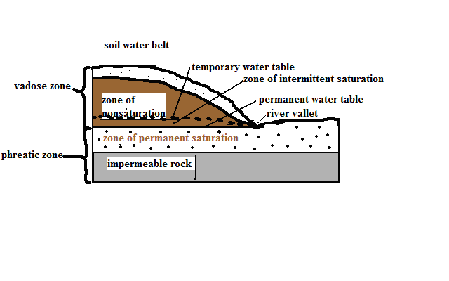

* Water that infiltrates and percolates into the ground fills air spaces creating zones of saturation whose upper levels are called water tables.

**Zones of Saturation**

**a) Zone of Non-saturation**

* Zone of permeable through which water passes but doesn’t remain in the pores for a long time.
* Well sunk to this zone doesn’t contain any water.

**b) Zone of Intermittent Saturation**

* Zone which during the rain season the rocks are saturated with water while during the dry season they are unsaturated.

**Temporary water table** - Upper level of ground water in the zone of intermittent saturation.

* Zone of non-saturation and that of intermittent saturation are called **vadose zone**.

**c) Zone Of Permanent Saturation**

* Zone where pores spaces are permanently filled with water.

**Permanent water table** - Upper level of ground water in the zone of permanent saturation.

Presence of ground water leads to formation of springs, wells boreholes and artesian basins.

**Springs**

Place where water flows out naturally onto the earth’s surface along a slope.

**Ways/Modes Formation**

**a) Hillside Spring**

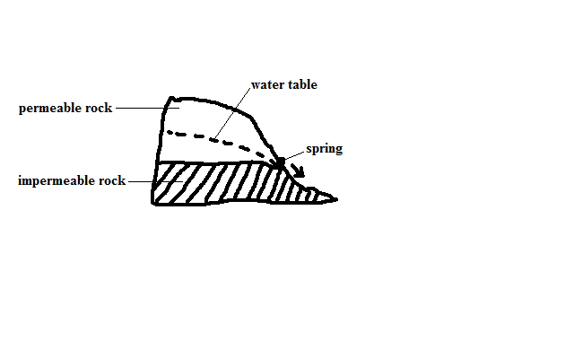

* Type formed where a permeable rock lies above an impermeable one on a hill and water comes out at the junction of those two rock layers.

**b) Dyke Spring**

* Type formed where an igneous dike cuts across a layer of permeable rock.
* Ground water on the upslope side is trapped causing water table on that side to rises.
* A spring develops where the water table is exposed on the surface.

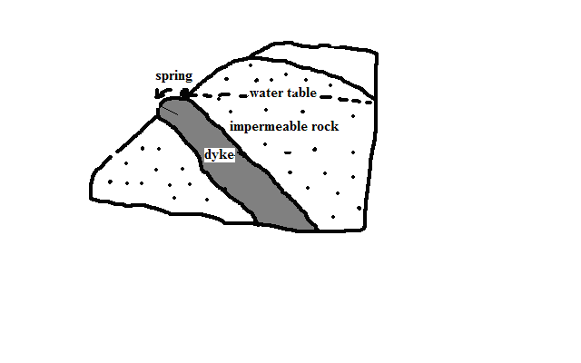

**c) Vauclusian Spring**

* Type formed on a limestone hill or escarpment overlying an impermeable layer.
* Limestone rock becomes saturated with water.
* Water comes out of the ground where water table appears on the surface.

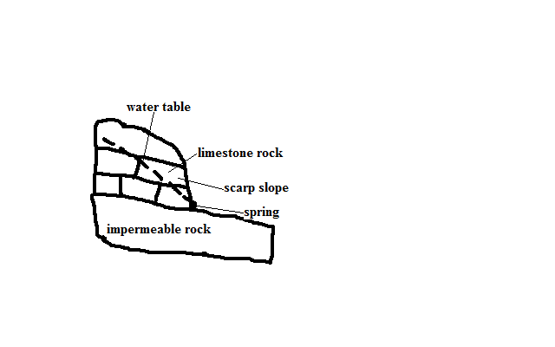

**d) Valley Spring**

* Type formed where water table intersects the surface along the side of the valley.

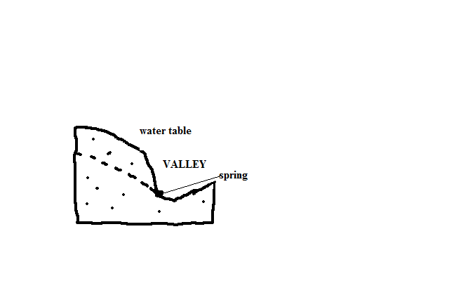

**Artesian Basins**

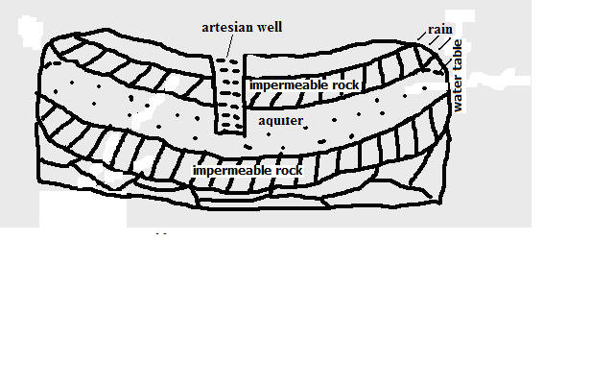

* Saucer shaped depression consisting of a layer of permeable rock sandwiched between two impermeable rocks and the whole system forms a syncline.

**Characteristics**

1. One or both ends are exposed on the surface on a rainy area or beneath a lake.
2. Water enters at the exposed end or ends.
3. With time the permeable rock is saturated with water and becomes an aquifer e.g. between Chad and Egypt across Quattara depression.

**Artesian well**

Well sunk into the aquifer of an artesian basin from which water will come out without being pumped.

**Ideal Conditions for Formation of an Artesian Well**

1. Aquifer to be sandwiched between impermeable rocks to prevent evaporation and percolation.
2. Aquifer to be exposed in a region which is a source of water e.g. rainy area or lake.
3. Aquifer to dip from the region of water intake.
4. Mouth of the well to be at a lower level than the intake area to develop hydraulic pressure which will force water out.

**Problems Associated With Artesian Wells**

1. Water may be hot due to high temperatures.
2. Water may be salty because of water taking long to percolate through rocks thus dissolving large quantities of mineral salts.
3. Water may fail to come out naturally when water is drawn faster than it’s being replaced in the source region and necessitating pumping.

**Significance of Underground Water**

1. Source of rivers and their tributaries.
2. Source of water for domestic and industrial use e.g. wells, springs, boreholes and oasis.
3. Used in agriculture e.g. oasis water is used for irrigation of date palms.
4. Influences settlements due to the availability of water e.g. in deserts people settle near oasis and spring line settlements in limestone areas.
5. Hot springs are a tourist attraction and their water is trapped and pumped into houses through pipes for heating during winter e.g. in Iceland.
6. Underground streams help in keeping some lakes fresh e.g. L. Naivasha.

**Action of Water in Limestone Lime stone Areas (Karst Region)**

**Karst** **region** - Region where the surface and the ground is covered with limestone rocks.

**Karst scenery -** Unique features in a Karst region resulting from the action of water e.g. Shimoni caves at the coast of Kenya.

* When calcium carbonate is exposed a weak carbonic acid formed by rain dissolving CO2 it’s dissolved to form calcium hydrogen carbonate which is removed from the rock in solution resulting in surface and underground features in such a limestone region.

**Factors Influencing Development of Karst Scenery**

1. Surface rock and the rock below should be hard and well jointed for acid water to percolate and cause solution to happen e.g. limestone, chalk or dolomite.
2. Climate should be hot to speed chemical weathering and humid for availability of rain which is a solvent.
3. Should have a lot of vegetation to release CO2.
4. Water table to be far below the surface so that the whole limestone rock is not dissolved and underground features fail to be formed.

**Surface Features in Limestone Areas**

**a)** **Grikes and Clints**

**Clints** - Blocks of limestone rock left standing when water infiltrates through the limestone rocks widening and deepening the joints.

**Grikes** - Deep groves or gullies formed when rainwater infiltrates through limestone rocks widening the joints by solution.

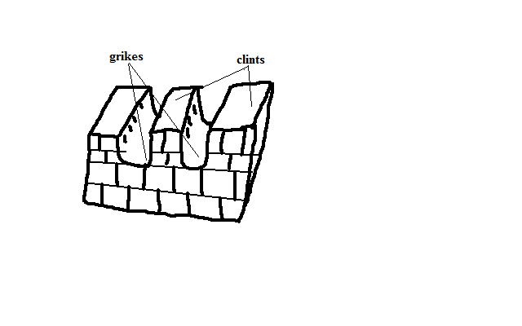

**b) Swallow/Sink Holes**

* Deep vertical holes formed on limestone rocks when solution extends the grikes.
* Referred to as swallow/sink holes because surface runoff or river water may disappear through them as a waterfall and come out of the ground as a vauclusian spring further downhill.
* Vertical shaft from the surface of the sink hole down into the ground is called **ponor**.

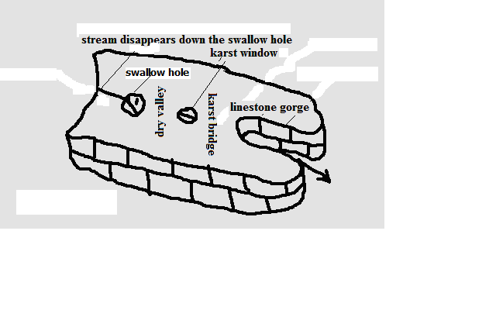

**c) Dry Valley**

* Steep valleys with no permanent streams on limestone surface at the section between the swallow hole and where the river emerges.

**d) Karst Window**

* Small outlet to the surface from a cavern formed when continuous carbonation at the surface causes the roof of the cave to collapse.

**e) Limestone Gorge**

* Deep steep sided river valley in limestone rocks formed when the swallowed river causes solution to continue underground causing the roof of underground water course to collapse.

**f) Karst Bridge**

* Small section left joining the roof between the karst window and gorge.

**g) Dolines**

* Elliptical hollow with gently sloping sides on the surface of a limestone region formed when several swallow holes collapse and merge.

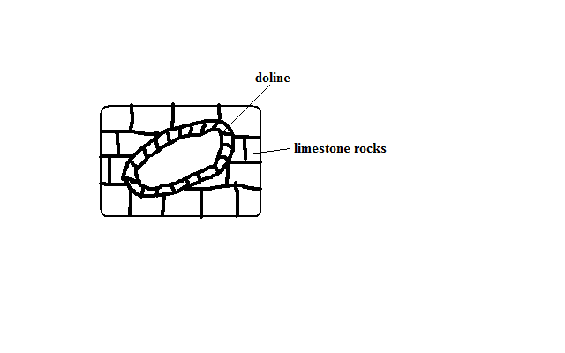

**h) Uvala**

* Depression which may be as wide as 1 km in diameter formed on the surface of limestone regions when several dolines collapse and merge.

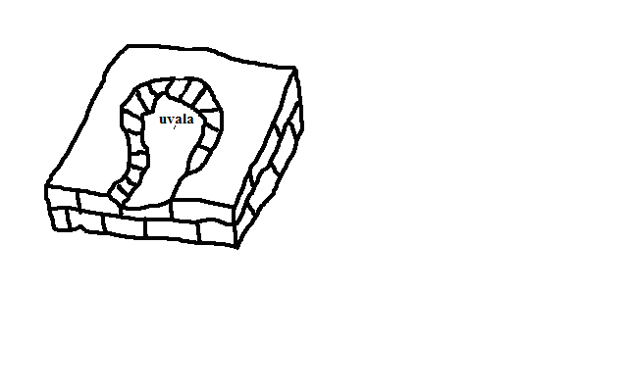

**i) Polje**

* Largest, shallow, elliptical and flat floored depressions on a limestone region formed when several uvalas collapse and merge.
* May become a temporary lake or may be covered by a marsh.

**Underground Features in Limestone Areas**

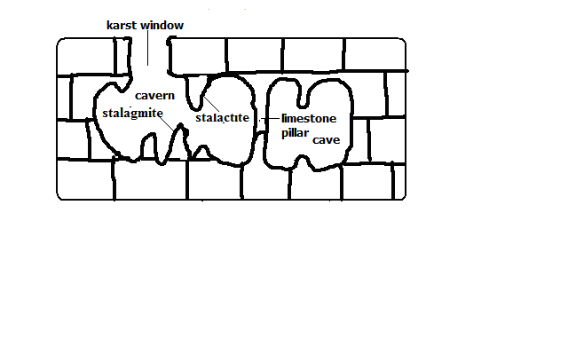

**a) Stalactites**

* Finger like masses of calcite hanging vertically from the roof of a limestone cave or cavern formed by repeated evaporation of water and giving off of carbon dioxide from drops of water containing calcium bicarbonate hanging from the roof of the cave causing crystallisation of calcium bicarbonate into calcite.

**b) Stalactite**

* Stumpy rock masses of calcite which grow from the floor of a limestone cave upwards formed by repeated dripping of solution of calcium bicarbonate from the end of stalactite to the floor of a limestone cave then it spreads out and crystallizes.

**c) Limestone Pillars**

* Pillar like structures in limestone caves formed when stalactites and stalagmites grow towards each other, stalagmite grows until it touches the roof of a cave or when a stalactite grows until it touches the floor of the cave.

**d) Limestone caves**

* Underground chambers or cavities in limestone rocks.
  + Underground rivers dissolve limestone in horizontal joints forming a horizontal tunnel.
  + Surface water and underground water percolates through the joints into the tunnel enlarging it forming a **phreatic cave** i.e. cave below the water table.
  + The water flows out at the vauclusian spring lowering the water table causing the phreatic cave to become a limestone **cave**.
  + Continued solution from water percolating through the caves roof widens and lowers its floor to form a larger cave called limestone **cavern** e.g. Carls band cave in New Mexico U.S.A.

**Significance of Karst Scenery**

**Positive**

1. Features in karst scenery are a tourist attraction e.g. caves, gorges, stalactites, stalagmites, etc.
2. Limestone rock is used in the manufacture of cement e.g. cement factory at Bamburi in Mombasa and Athi River.
3. Limestone blocks are also used for building.
4. Limestone regions are very good for grazing particularly sheep because the surface is dry.
5. Large villages called spring line settlements form at the line of vauclusian springs due to the availability of water.

**Negative**

1. Limestone landscape discourages settlement because the surface is rocky, soils are thin and unsuitable for agriculture, surface is rugged with features like grikes and Clints and the water supply is inadequate due to rivers disappearing into swallow holes.

**GLACIATION**

* Action of moving ice.

**Glacier -** Mass of ice moving outward from an area of accumulation.

* Formed when snow accumulates on the surface, lower layers are compressed to a harder mass resulting in opaque ice due to air bubbles and accumulation continues compression lower layers squeezing out air forming glassy ice called glacier.

**Types**

1. **Cirque glacier** - ice occupying a cirque.
2. **Valley glacier** - Ice confined within a valley
3. **Piedmont glacier**: Glacier formed when valley glaciers converge at the foot of the mountain.

**Ice bergs -** Large mass of ice floating in the ocean formed when an ice sheet moves to the sea e.g. in Arctic and N. Atlantic Ocean.

**Ice sheet -** Continuous mass of ice covering a large area on the earth’s surface.

**Ice caps -** Ice covering the mountain peak.

**Snow line -** Line beyond which there is a permanent snow cover.

**Ways of Ice Movement**

**a) Plastic Flowage**

* Movement of ice like a viscous liquid.
* Great pressure is exerted at the bottom sides and centre causing some ice particles to melt slightly and move slowly down hill like a viscous liquid.

**b) Basal Slip**

* Movement of ice by sliding over the underlying rock.
* Pressure is exerted on deepest layers of ice in contact with the rock beneath causing melting.
* A film of water is created which acts as a lubricant between the ice and the rock causing ice to slip and slide over the rock and move down slope.

**c) Extrusion Flow**

* Movement of ice by spreading out.
* Ice accumulates building to great thickness at the centre causing compression of layers of ice beneath.
* The layers beneath are forced to spread out where there is less pressure.

**d) Internal Shearing**

* Breaking of ice into smaller pieces which move alongside one another.
* Uneven movement causes ice to develop cracks on the surface.
* The glacier breaks into smaller pieces which move alongside each other down slope.

**Factors Influencing Ice Movement**

**a) Gradient of the Land**

Ice moves faster on steep slopes than on gentle slopes due to the influence of gravity.

**b) Season**

Ice movement is faster in summer due to frequent thawing melting compared to winter when thawing is rare.

**c) Friction**

Central parts of ice move faster than sides and bottom which are in contact with rock beneath due to friction.

**d) Thickness of Ice**

Thicker masses of ice cause more pressure between them and rocks beneath which cause slight melting and therefore faster movement.

**Glacial Erosion**

**Processes/Ways in Which Ice Erodes**

**a) Plucking**

* Pulling away of parts of a rock at the base of glacier when the ice freezes into the cracks of a well jointed rock.

**b) Abrasion**

* Scratching of the underlying ground by stones and boulders carried by the ice as the glacier moves.

**Factors Influencing Glacial Erosion**

**a) Nature of Underlying Rock**

* Abrasion is more effective on soft rocks than hard rocks.
* Well jointed and faulted rocks are more eroded than those which are not because cracks and joints enable water to enter rocks and freeze which facilitates plucking.

**b) Gradient of Slope**

* Glacier on steep slopes moves faster and has greater kinetic energy to erode than slow moving glacier

**c) Thickness of Ice**

* Thick ice is heavier and exerts greater pressure on rock debris making them to abrade the underlying rock more effectively.

**d) Availability of Debris**

* The more the rock debris the more effective abrasion will be since it acts as abrasive tools.
* Too heavy debris makes erosion impossible since ice is not able to transport it but glides over it without acting on the rock below.

**Erosion Features**

**On Glaciated Highlands**

**a) Cirque**

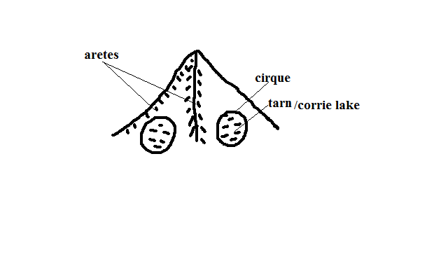

* Arm chair shaped depression on glaciated slopes of high mountains.
* Snow accumulates into a shallow depression on the side of a mountain.
* Freezing in winter and thawing in summer causes rocks to wither and break up resulting in enlargement of the hollow.
* Accumulated ice advances by slipping down slope.
* A deep crevice called bergshrund develops at the top of ice due to unequal movement.
* Freezing occur deep down the bergshrund causing the back wall and sides to be steepened by plucking.
* Plucked debris is carried forward scratching the floor of the basin deepening it forming the cirque, corrie or cwm.
* Water from melting snow may accumulate in a cirque to form a tarn e.g. Teleki tarn.

**b) Arêtes**

* + Narrow knife- edged steep ridge separating two cirques.
  + Formed when two cirques cut backwards on adjacent sides of a mountain leaving a narrow steep ridge separating them.

**c) Pyramidal Peaks**

* Sharp steep sided peak at the top of a mountain.
* Formed when three or more cirques erode on mountain side towards each other leaving a sharp pointed rock separating them at the top of the mountain e.g. Corydon and Delamere on Mt. Kenya.

**d) Glacial Trough**

Glacial Trough and Related Features

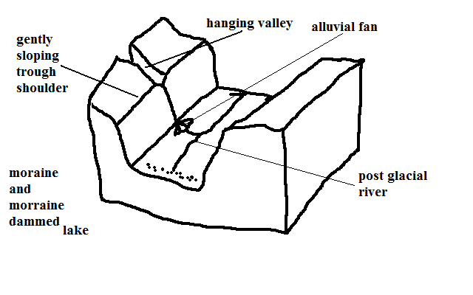

* Wide flat bottomed valley with steep sides on a glaciated highland.
* Ice accumulates in a v-shaped valley.
* Plucking and abrasion by ice occurs.
* The v-shaped valley is deepened, widened and straightened to become a glacial trough.
* Glaciated trough may be submerged to form a fiord.

**e) Truncated Spurs**

* + Interlocking spurs of former river valleys which are eroded and straightened by valley glacier.

**Erosion Features on Glaciated Lowlands**

**a) Roche Mountonnee**

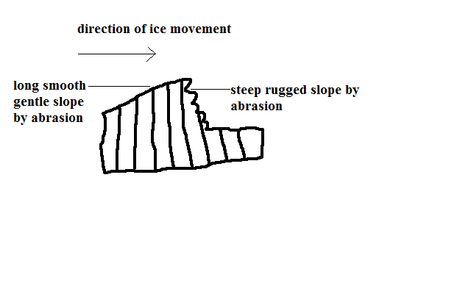

* + Rock outcrop with a long smooth gentle slope on the upstream side and a rugged steep slope on the downstream side found on glaciated lowland.
  + Formed ice acts on a rock on its way causing the side facing the upstream side to be polished by abrasion resulting into a smooth gentle slope and the downstream side is affected by plucking resulting in a rugged steep slope leaving a rock outcrop standing just above the surface.

**b) Crag and Tail**

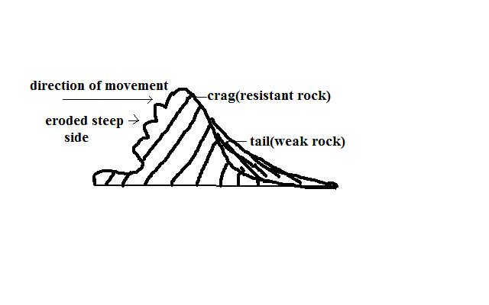

**Crag** - projection of resistant rock which protects a mass of softer rock on the downstream side of the glacier.

* The ice moves over and around over the resistant rock eroding it slightly by abrasion.
* Cracks develop on the upstream side causing the ice to move and pluck materials from the resistant rock leaving a projection of resistant rock with a steep rugged upstream side is formed.

**Tail** - elongated feature on the downstream side of the crag formed by formed by material deposited by the glacier on the downstream side and the weaker rock.

**c) Depressional Lakes**

* + Depressions filled with water from melting ice found in glaciated lowlands.
  + Formed when soft rocks are scooped out by moving ice sheet forming depressions which are filled with water to form a lake.

**Glacial Deposition**

* + Material carried by the glacier is called moraine.

**Types of Moraine**

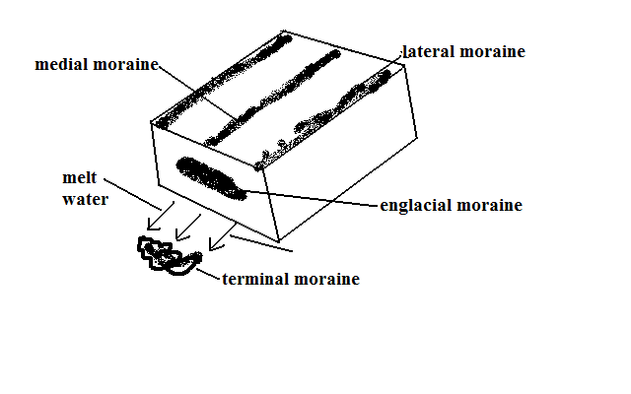

a) **Ground/sub-glacier moraine** - load carried at the base of the glacier.

b) **Englacial mora**ine - load within the glacier.

c) **Lateral moraine** - load carried at the sides of the glacier.

d) **Medial moraine** - load carried in the centre of the valley by glacier.

e) **Terminal/recessional moraine** - load deposited at the point where a glacier melts.

**Types of Glacial Deposits/Drift:**

a) Till - directly deposited by ice on melting in unstratified manner.

b) Fluvial - materials deposited by water from the melting ice in stratified manner.

**Causes of Glacial Deposition**

1. **Amount of glacial drift**

When ground moraine is too much the glacier glides over it leaving it behind.

1. **Weight of glacier**

When more ice is added to a stationary glacier pressure is exerted at the base causing melting and the material which was embedded in the ice is dropped.

1. **Climatic change**

During summer and spring ice melts depositing some materials the glacier was carrying.

1. **Friction beneath the ice**

Friction between ice and surface reduces ice speed causing heavy materials to be deposited beneath ice sheets.

1. **Slope**

Lowlands allow glacier to accumulate a lot of materials which are finally deposited by melting ice.

**Features Resulting From Glacial Deposition**

**a) Till Plain**

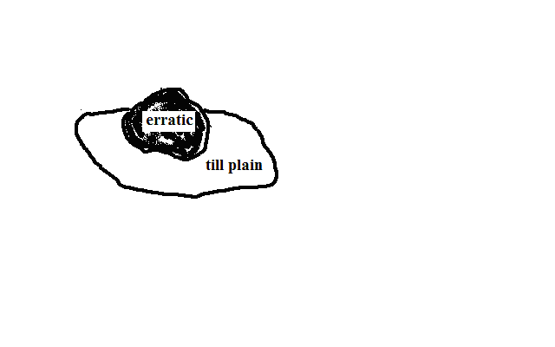

* + Extensive area of flat relief resulting from burying of former valleys and hills by glacial deposits.

**b) Erratics**

* + Large boulders of resistant rocks transported by glacier from highland and deposited on the till plain.

**c) Drumlins**

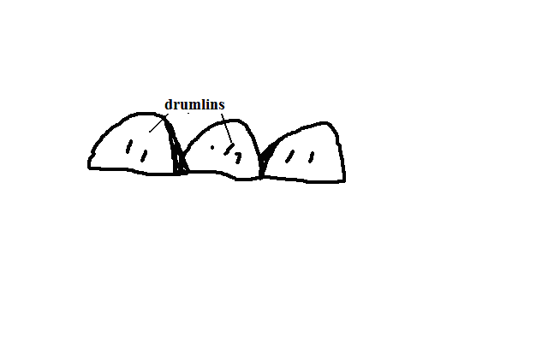

* + Long egg shaped hills deposited and shaped under an ice sheet of very broad glacier.
* Glacier deposits boulder clay at the valley bottom due to friction between the bed rock and the boulder clay.
* With more deposition large mounds of deposits are formed.
* The moving ice streamlines the till that has been deposited irregularly resulting into the upstream sides of the till being steep but smoothed.

**d) Terminal Moraine Ridge**

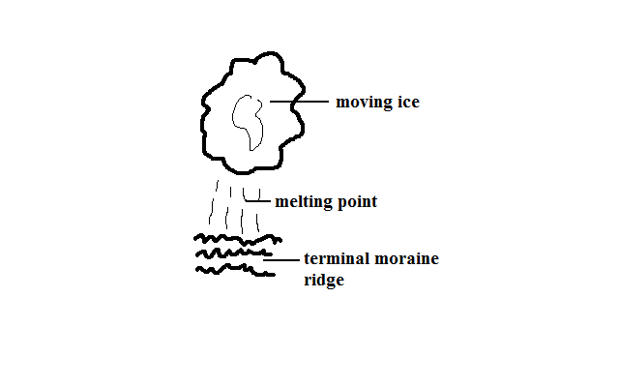

* + Ridge like feature formed by extensive deposition of moraine along the edge of an ice sheet.
* Ice remains stagnant for a very long time.
* The ice at the edges of sheet melt and a lot of materials are deposited.

**e) Eskers**

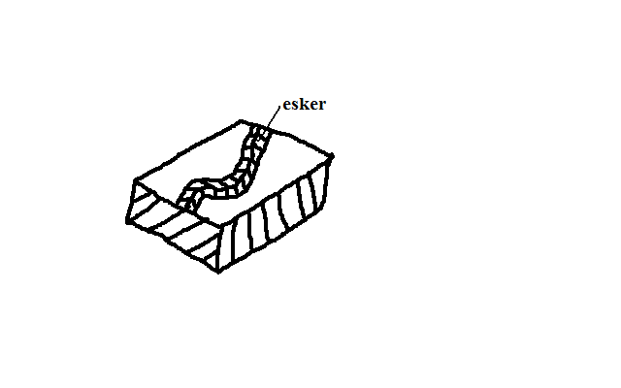

* + Long winding ridge composed of gravel formed by glacial deposition.
* Streams carrying large amounts of load flow fast in a sub-glacial tunnel parallel to the direction of moving ice.
* When the ice melts the tunnels collapse causing streams to slow down and deposit much of the load forming a ridge.

**f) Kame**

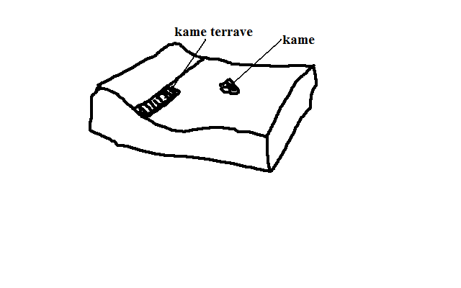

* + Isolated hill made of sand and gravel which have been deposited in strata by glacial water.

**g) Kame Terrace**

* + Ridge of sand and gravel occurring in narrow lakes that exist between the glacier and an adjacent highland.

**h) Outwash Plains**

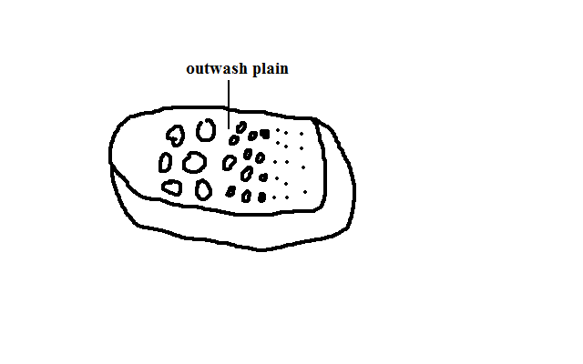

* + Wide gently sloping plain composed of gravel and sand formed by glacial deposition.
  + Formed when finer materials of terminal moraine are deposited in very thick layers over an extensive area forming a plain.

**Significance of Glaciation**

**Positive**

1. Some outwash plains have fertile morainic soils suitable for agriculture e.g. Canadian prairies where wheat is grown.
2. Water falls on hanging valleys are used for generation of H.E.P.
3. Glaciated highlands are a tourist attraction especially during winter when sporting activities such as skiing and ice skating are carried out.
4. Glacial lakes such as great lakes of N.America provide natural route ways and fish sources e.g. L.Superior and Huron.
5. Glaciated mountains are catchment areas for permanent rivers.
6. Sheltered water of fiords is a suitable bleeding ground of fish as natural harbours.
7. Sand excavated from outwash plains and eskers is used for construction.

**Negative**

1. Land in glaciated areas can’t be fully utilised for agriculture due to being marshy because of boulder clay deposits e.g. central Ireland.
2. Infertile sands deposited in outwash plains make land unsuitable for agriculture.
3. Numerous lakes formed as a result of morainic deposits reduce the land available for agriculture.
4. Settlement and transportation in glaciated landscape is difficult due to ruggedness caused by glacial action.

**SOIL**

* + Uppermost layer of the earth’s crust on which plants grow.

**Constituents/Composition of Soil**

**1. Inorganic Matter**

* + Weathered rock fragments made of minerals from parent rock.
  + Forms skeleton or fabric of soil.
  + Forms 45% of total volume.

**2. Organic Matter**

* Decomposed remains of animals and their wastes.
* Forms 5% of total volume.

**Significance of Organic Matter**

1. Broken down by bacteria forming humus improving the soil fertility.
2. Soil with high organic matter is alkaline while one with low organic matter is acidic.

**3. Soil Water**

* + Water contained in the soil.
  + Forms 25% of total volume.

**Types of Soil Water**

**Hygroscopic Water**

* Water held as a thin film around soil particles.

**Gravitation Water**

* Excess water which moves downwards to the zone of ground water.

**Importance**

1. Solvent of minerals and nutrients essential for plant growth.
2. Causes leaching Carrying of minerals.
3. Causes water logging which blocks air circulation causing soil to lack oxygen and become acidic.

**4. Soil Air**

* + Air contained within air/pore spaces of soil.
  + Forms 25% of total volume.

**Importance**

a) For plant and soil organisms metabolism.

b) For oxidation which causes conversion of part of organic material into nitrogen.

1. For respiration of aerobic micro-organisms which break down organic matter to form humus e.g. bacteria.

**Soil Formation**

**Factors Influencing Soil Forming Processes**

**a) Parent Material**

* Determines the type of soil, mineral composition and texture e.g. granite and sandstone weather to form sandy soils rich in quartz, volcanic lavas form clay soils with low quartz content and plants decompose to form loam rich in humus.

**b) Climate**

* Affect rate and type of weathering e.g. heavy rainfall results into deep soils due to heavy weathering and leaching.
* Wind in deserts causes formation of loess soils.

**c) Living Organisms**

* Micro-organisms such as bacteria cause plant and animal remains to decay into humus.
* Burrowing animals and worms mix organic remains with mineral soil component.
* Roots penetrate and add more porosity, improve soil depth and aeration.

**d) Topography**

* There is maximum soil development in rolling and well drained uplands where the rate of erosion matches that of soil erosion.
* Steep slopes result in shallow immature soils due to severe erosion.

**Time**

* The longer the time taken by soil forming processes the deeper and well developed soil is.

**Soil Forming Processes**

**1. Weathering**

* Breakdown of parent rock to form rock particles called regolith.

**2. Decomposition of Organic Matter**

**Processes**

**a) Mineralization**

* Biological and chemical breakdown of dead plant tissues by soil micro-organisms to simple soluble organic substances.

**b) Humification**

* Regrouping of mineralised dead plant material into large molecules to form humus.

**3. Leaching**

* Carrying of minerals from top layer down to the middle layer.

**Types**

**i) Ferralisation/lateralisation**

* Moving in solution or in suspension of weathered material from horizon “A” to “B.”
* Red soil form in horizon A as ferrisols/laterites (murrum).

**ii) Illuviation**

* Accumulation/redeposition of materials which had been leached to horizon B.
* Hard soil mass (hard pan) results.

**iii) Eluviation**

* Mechanical washing down of fine mineral particles in suspension from upper layer to lower layers by water which is percolating downwards. e.g. clay

**iv) Podzolisation**

* Heavy depletion of horizon A of all minerals especially bases and iron by soluble organic substances.
* Forms ash like soils which are acidic.

**v) Calcification**

* Limited leaching which allows redeposition of calcium compounds within the same soil profile.

**vi) Ribification**

* Dehydration of soils during dry season and leaching during the rainy season.

**Properties and Characteristics of Soil**

**a) Texture**

* Composition of soil in terms of its particles.

|  |  |
| --- | --- |
| SOIL CLASS | PARTICLE DIAMETER |
| Coarse sand | 0.2 - 2mm |
| Fine sand | 0.2 - 0.02mm |
| Silt | 0.02 - 0.002mm |
| Clay | Below 0.002mm |

* Can be coarse/gritty (sand), medium (loam) or fine (clay).

**Importance**

1. Determines soil water retention by that coarse grained soils have poor retention while those fine grained have high water retention.
2. Influences ease of root penetration into the soil whereby it is easy on coarse textured and difficult in fine textured.
3. Determining soil fertility in that clay content prevents humus from being washed down the soil by water.

**b) Structure**

* + Arrangement of soil particles into aggregate compound particles.

**Types**

1. **Crump soil structure -** soil made of small, soft, groups of particles of irregular shape.
2. **Granular structure -** soil made of porous groups of particles of irregular shape called granules.
3. **Plate structure -** soil made of plate like flat particles arranged in horizontal manner.
4. **Prismatic structure -** soil made of vertical prism like particles with rounded tops.
5. **Blocky structure -** soil made of irregular pieces of soil with sharp corners and edges.

**c) Soil PH**

* + Basicity or acidity measure of a soil.
  + Sulphate/phosphate - acidity
  + Calcium/magnesium - Basicity

|  |  |
| --- | --- |
| PH VALUE | REACTION DESCRIPTION |
| 8 | Alkaline |
| 7 | Neutral |
| 6 | Slightly acidic |
| 5 | Moderately acidic |
| 4 | strongly acidic |

**Importance**

1. Influences the activity of soil micro-organisms and hence decomposition of organic matter.
2. Influences rate at which roots absorb minerals.
3. Determines the types of crops to be grown e.g. tea-acidic.
4. Determines availability of different nutrients to the plants e.g. phosphorous is not available at low PH while potassium and iron not available at high PH.

**d) Soil Colour**

* + Visible quality of soil.

-Dark brown or black – considerable amount of organic matter.

-Grey - poorly drained or water logged.

-Whitish- lacks organic matter, iron oxides and has soluble salts concentration.

**Importance**

1. Influences soil temperature in that light coloured soils have low temperature and hence low organism activity.
2. High temp destroy humus, increase organism activity and provide warmth required for germination.

**e) Soil Porosity**

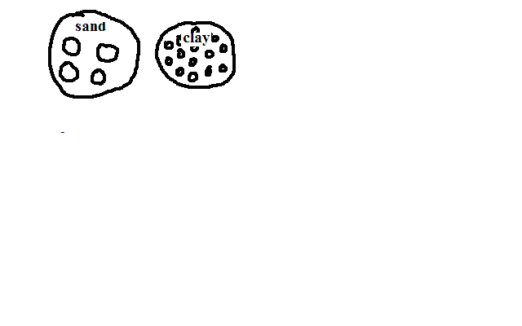

* + Amount of pore spaces in a soil sample.

**Importance**

1. Influence soil water retention. Clay has high retention and is water logged because it doesn’t allow drainage due to many tiny pore spaces while sand has poor water retention due to rapid percolation caused by large pore spaces.

**f) Soil Permeability**

* + Ability to allow the water to pass through.
  + Depends on texture and porosity. Clay is impermeable due to being fine textured and tiny pored while sand is permeable due to being coarse textured and very porous.

**Soil Profile**

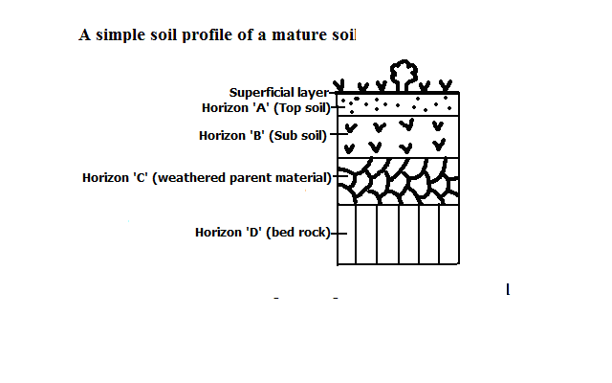

* + Vertical arrangement of different soil layers from the surface to the bed rock.

A mature soil is one with a fully developed profile while a young soil is one with a not fully developed profile.

**Superficial layer**

* + Dry decaying organic matter covering the soil surface.

**Horizon ‘A’**

* + Lies under a mat of surface vegetation and raw humus.
  + Darker due to high humus content.
  + Contains most of plant nutrients.
  + Where most plant roots are found.
  + Contains active micro organisms which breakdown organic matter into humus.

**Horizon ‘B’**

* Lies below top soil.
* Has small spaces between particles and hence less aerated.
* Has a hardpan or layer impeding drainage.
* Where most materials washed from horizon A have accumulated.

**Horizon ‘C’**

* + Lies below sub soil.
  + Made of partly mechanically weathered rock.
  + Product of bed rock or may have been transported.

**Horizon ‘D’**

* Solid underlying rock.
* May have ponds of water which can be used by deep rooted plants during dry season.

**Importance of Soil Profile**

1. Determines the crops to be planted i.e. mature soils favour deep rooted crops while young soils favour shallow rooted crops.
2. Bed rock determines the chemical properties of the soil such as PH and nutrients.

**Soil Catena**

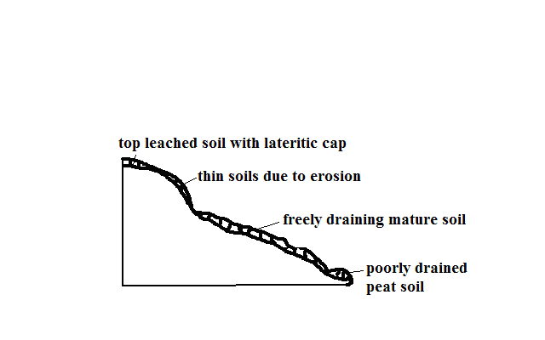

* Arrangement of soil on a mountain slope from top to bottom.

**Factors Influencing Development of a Soil Catena**

**a) Relief**

* On steep slopes there is high rate of erosion resulting in thin soils while on gentle slopes rate of weathering and erosion is balanced resulting in thick soils.
* On flat areas such as valley floors where there is deposition there are peat or alluvial soils.

**b) Drainage**

* First drainage at mountain tops results in thin stony immature soils.
* Poor drainage in flat areas results in peat or alluvial soils.

**c) Transportation of Debris**

* Surface runoff transports sediments to lower gentle slopes where it accumulates forming deep ***colluvial*** soils while thin stony immature soils with little organic matter called ***xeromorphic*** soils are left on steep slopes.

**Soil Degeneration**

* Decline in the usefulness of a soil.

**Types**

**1. Physical Degeneration**

* Decline in usefulness of a soil in which texture, structure, moisture and quality of soil are affected.

**Causes**

1. **Deforestation** which leads to removal of vegetation which forms a protective cover of the soil exposing it to erosion agents.
2. **Overgrazing** which causes excessive loss of water from the soil causing it to become loose and fine grained and easily eroded.
3. **Poor Cultivation Techniques**
4. Pulling hoe along the surface when removing weeds which loosens the soil and when it rains it’s washed away.
5. Ploughing of land down slope which accelerates soil erosion.
6. Cultivation of steep slopes and along river banks which encourages soil erosion.
7. Burning which destroys vegetation covering the soil exposing it to erosion agents.
8. Growing crops on the same piece of land from season to season which sucks nutrients from the soil making it fine, loose and easy to be eroded.
9. Planting crops such as maize whose foliage doesn’t provide adequate soil cover encourages soil erosion.
10. Cultivation in areas that suffer prolonged droughts which loosen the soil causing it to be exposed to erosion during dry seasons.
11. Heavy rain resulting to excessive soil erosion and thus poorly aerated.
12. Drought which deprives the soil of moisture which holds the soil together causing particles to loosen making it to be easily brown by wind.
13. Excavation works such as quarrying, open-cast mining, building of estates and road construction which loosen and expose the soil to erosion agents.
14. Soil erosion which robs the soil of top fertile layer.

**2. Chemical Degeneration**

* Decline in usefulness due to changes in mineral nutrients of the soil.

**Causes**

1. Leaching which makes minerals inaccessible to shallow rooted crops.
2. Excessive application of fertilizers which interferes with bacterial activity and causes the soil to become too acidic and unable to support a variety of crops.
3. Excess water causing water logging causing acidic conditions.
4. Planting one type of crop repeatedly which makes the soil deficient of some nutrients.
5. Excessive drought which causes accumulation of salts in the top soil.
6. Burning such as in slash and burning which kills micro-organisms causing nitrogen deficiency when nitrogen fixing bacteria is killed.

**3. Biological Degeneration**

* Degeneration due to decline of organic content of the soil and organic matter.

1. Deforestation which deprives the soil of its organic content and moisture making it loose and more vulnerable to erosion.
2. Burning such as in slash and burning which kills micro-organisms causing low decomposition rate which robs soil of organic matter.
3. Overgrazing which causes removal of vegetation causing excessive loss of water from the soil and hence reduced micro-organism activity resulting into shortage of humus.
4. Drought and excessive moisture which may lead to a shortage of essential organisms such as bacteria, earthworms, termites and burrowing animals.

**Soil Erosion**

* + Removal of top soil.

Agents of soil erosion are water, glacier and wind.

**Causes** of soil erosion are human activities and geomorphic processes such as earthquakes and faulting which cause landslides and soil creep.

**Conditions Favouring Soil Erosion**

**a) Slope**

* + Steep slopes accelerate soil erosion while gentle slopes experience less erosion.
  + Places with rugged terrain experience gulley erosion.
  + Hilly and Steep areas experience rill and gulley erosion.

**b) Soil Texture**

* Areas with fine textured soils such as volcanic ash are more vulnerable to erosion e.g. Nyambene Hills around Karama and Muthara.

**c) Climate**

* Erratic and heavy rains cause splash, rill and sheet erosion.
* Intense heating by the sun causes loosening of soil particles.
* Low rainfall and high temperature leads to scanty or no vegetation which forms protective cover on the soil.

**Types of Soil Erosion**

**a) Splash Erosion**

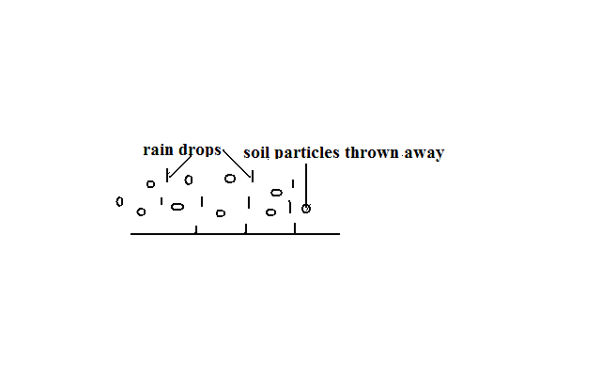

* Removal of soil by rain drops scattering loose particles and carrying them down slope by runoff.

**b) Rill Erosion**

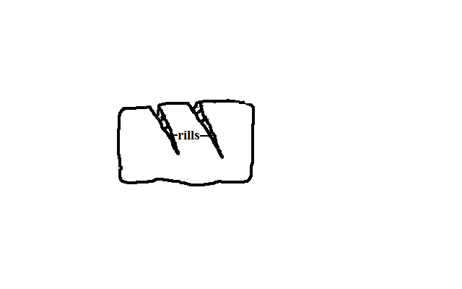

* Removal of top soil by rain water through small channels.
* Occurs when rate of runoff exceeds infiltration and rain water flows over the surface forming small channels called rills.

**c) Gulley Erosion**

* Removal of soil through wide and deep channels.
* Occur when moving water or glacier widen and deepen the existing rills.

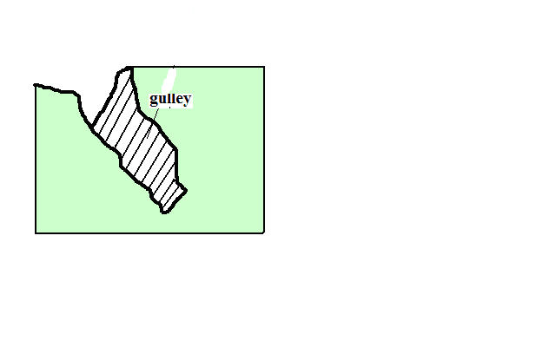

**d) Sheet Erosion**

* Removal of top soil inform of a thin sheet.
* Common around L.Baringo and Marigat.

**Impact/effect of Soil Erosion**

**Positive**

1. Creation of rich agricultural lands when eroded soil is carried and deposited e.g. loess and alluvial soils in lower courses of R.Tana.
2. Sand eroded from steep slopes and deposited on river bed is scooped for construction purposes e.g. Machakos.

**Negative**

1. Lowers the agricultural productivity of land when fertile top soil is eroded.
2. Contributes to desertification when top soil is eroded leaving bare ground destroying vegetation.
3. Causes water pollution when agro-chemicals and other chemicals are carried to rivers, lakes or oceans.
4. Contributes to flooding by blocking river channels causing them to burst their banks during the rainy season flooding the adjacent areas.
5. Causes siltation of water reservoirs reducing their utility e.g. For H.E.P. generation.
6. May cause collapsing of structures such as buildings and bridges when soil around them is eroded weakening their foundation.

**Management and Conservation of Soil**

Soil management is controlling processes and activities that would cause soil deterioration while soil conservation is protecting soil from destruction.

**Soil Management and Conservation Measures**

**a) Crop Rotation**

* Growing crops which require different nutrients on the same piece of land on rotational basis to prevents exhaustion of particular mineral nutrients from the soil e.g. leguminous plants to improve nitrogen content of the soil.

**b) Mixed Farming**

* Growing crops and keeping animals on the same farm.
* Manure from animals is used to enrich the soil with minerals and improve its structure.

**c) Contour Ploughing**

* Ploughing across the slope rather than down the slope.
* Helps to trap water on horizontal furrows thus preventing excessive soil removal.

**d) Terracing**

* Dividing the slope into a series of wide steps and crops are grown on them.
* Trap the soil from being carried away by running water and also traps water allowing it to gradually infiltrate into the soil.

**e) Afforestation and Reafforestation**

* Leaves reduce the force of rain drops preventing soil particles from being removed.
* Vegetation increases the rate of infiltration of rain water into the soil thus reducing runoff.
* Roots bind the soil particles together.
* Decayed vegetation provides humus which binds the soil particles together.

**f) Planting Wind Breakers**

* Planting hedges or trees around plots in large fields.
* Act as wind breakers and also trap soil being carried by water.

**g) Regulating Livestock Numbers**

* Matching the number of animals kept to the carrying capacity of land.
* Overgrazing can also be prevented by paddocking which ensures there is always pasture for animals and no area is overgrazed.
* The pasture is subdivided into portions by fencing.
* Animals are left to graze in one paddock at a time.
* Then they are transferred to the next after a few days.

**h) Constructing Gabions**

* + Construction of wire mesh boxes which are filled with soil.
  + Allow water to pass through but trap the soil then vegetation gradually grows on the trapped soil.

**i) Planting Cover Crops**

* Planting crops which cover the soil properly and holds the soil in place e.g. sweet potato vines.

**j) Mulching**

* Covering the soil with crop residues.
* Reduces the impact of rain drops on the soil.
* Decays enriching soil with nutrients.
* Reduce the rate of moisture evaporation from the soil.

**Significance of Soils**

1. Gives physical support for the rooting system of plants and protects root system from damage.
2. Habitat for burrowing animals and bacteria necessary for breakdown of organic matter into humus.
3. Medium through which nutrients and air are made available to plants.
4. Provides mineral elements to plants e.g. nitrogen, calcium, phosphates, etc.
5. Is used in building and construction e.g. clay for making bricks and tiles.
6. Clay soil is used in ceramics such as making pots.
7. Some soils are used for decorative purpose e.g. ache used among Maasai.
8. Source of minerals especially to expectant mothers.
9. Soil contains valuable mineral elements such as alluvial gold.
10. Soil supports plant life which is a source of food for people and animals especially herbivores.
11. Soils are used for medicinal purposes e.g. clay is mixed with some herbs for medical purpose in some communities.

**Significance of Soil on Plant Growth**

Characteristics and properties of a particular soil influences plant growth and distribution.

**PH**

* High PH values favours growth of particular crops e.g. tea requires fairly acidic soils.

**Drainage**

* Water logged soils allow growth of particular plants like papyrus, tree swamps and mangrove on poorly drained saline soils.

**Depth**

* Deep soils support deep rooted plants e.g. large trees while shallow soils favour shallow rooted plants with spreading root system e.g. grasses.

**Moisture content**

* Soils deficient of moisture support drought resistant plants.

**Temperature**

* There are stunted plants on cold soils and heath and moors on upper levels of mountains.

**Aeration**

* Poor aeration retards the growth of plants and impairs the roots ability to absorb water and nutrients.

**Mineral composition**

* Mineral deficiency in the soil causes retardation.

**Soil Classification**

-Grouping of soil according to specific properties such as age, texture, colour and climate.

**1. Zonal Order**

Mature soils with a well developed profile due to having undergone long time soil formation processes under good drainage conditions.

**Sub-orders**

**a) Podsols**

* Infertile and acidic soils which are heavily leached with base compounds like calcium removed leaving aluminium and iron compounds
* Found in forested areas and higher latitudes e.g. Scandinavian countries and Canadian Shield.

**b) Podzolic Soils**

* Soils similar with Podsols but found in areas with deciduous forests and hot climates e.g. Congo Basin and Kenya highlands.

**c) Tundra Soils**

* Soils with excessive moisture due to low evaporation rate causing permanent freezing of the soil.
* Associated with tundra climate e.g. Iceland and northern edge of Europe and Asia.

**d) Latosols**

* Soils with low organic content and high titanium salts content which form in conditions of high rainfall and temperatures.
* Crumbles into dust if ploughed during dry season and cracks if not ploughed.
* Found in volcanic areas e.g. Uasin Gishu and Laikipia plateau.

**e) Nitosols**

* Deep porous friable red soils known as Kikuyu red loam in Kenya.
* Well aerated and high capacity for moisture storage.
* Higher fertility and can support a variety of cash and food crops.

**f) Phenozems (Prairie Soils)**

* Dark brown and generally fertile soils.
* Suitable for growing of cereals e.g. wheat.
* Common in Prairie Provinces of Canada, Narok and Athi-Kapiti plains.

**g) Sierozems (desert soils)**

* Soils found in desert conditions with little seasonal rainfall and high temperature.
* Relatively little humus due to sparse vegetation.
* Plenty of calcium carbonate inform of lime crust deposited on surface due to excessive evaporation.

**h) Pedocals**

* Dark soils which have had little leaching and rich in calcium carbonate.
* Common in semi-arid and sub-humid grasslands.

**Sub-groups existing in Kenya**

**i) Chermozems**

* Dark coloured soils with relatively high organic matter from grass vegetation and a calcareous sub-soil.
* Conducive for cereal crop cultivation due to being found in rolling land and favourable climate for grass growth.
* Found at bottom lands around Nyambene Hills and N. grazing areas between Isiolo and Nyambene Hills.

**ii) Vertisols/Black Cotton Soils**

* Dark cracking clay soils.
* Poorly drained due to high clay content leading to poor permeability.
* Suitable for growing of rice, cotton and sun flower.
* Found in Mwea plains and Kano plains.

**2. Intrazonal Order**

* Soil formed under poor drainage conditions.

**Sub-orders**

**a) Hydromorphic soils**

* Grey coloured soils formed in water logged areas.

**Groups**

i) **Plano soils** - found on flat old land surfaces.

ii) **Bog and m**eadow - found in meadows, marshes and swamps e.g. Lorian and Yala swamps.

**b) Halmorphic Soils**

* Soils formed under semi-arid and arid conditions through salinisation.
* Infertile and poorly drained.
* Found in Amboseli and N.E.Kenya.

**c) Calcimorphic Soils**

* Soils formed by calcification e.g. redzina soils which are shallow and rich in lime and humus on the upper profile developed under grass on limestone e.g. in England and steppes of Russia.

**d) Andosols**

* Dark brown volcanic ash soils formed from recent volcanic material.
* High silt content and very vulnerable to soil erosion.
* Found in Kenyan highlands and support extensive agricultural activities like coffee, tea, wheat and maize growing.

**3. Azonal Order**

* Soils without a well developed profile due to having not undergone full soil forming processes.
* Found on steep slopes and areas with poor drainage which don’t offer them time to mature.

**Sub-orders**

**a) Lithosols**

* Soils with thin stony soil which is shallow over bedrock without a definite “B” horizon.

**b) Regosols**

* Soils without genetic horizons which have developed from material deposits like alluvium.
* Common in hilly and mountainous areas of the world.

**c) Alluvial Soils (Fluvisols)**

* Soils developed from alluvium of recent origin.
* Common along river valleys and mouths like Tana.

**d) Mountain Soils**

* Shallow soils found in mountainous regions.
* Vulnerable to erosion on steep slopes.

**e) Histosols**

* Soils formed from accumulation of organic matter which is 20% of the soil composition.
* If drained can be used to grow truck crops like vegetables.

**f) Arenosols**

* Soils having the appearance of sand largely composed of sand.
* Less fertile due to low organic matter.
* Common in coastal areas and N.E. provinces.

**AGRICULTURE**

* The practice of cultivating crops and rearing of animals

**Factors Influencing Agriculture**

**1. Physical Factors**

**a) Climate**

**i) Temperature**

* Some domestic animals do well in hot and warm areas e.g. goats and camels while others do well in cool areas e.g. exotic breeds of cattle such as Guernsey.
* Some crops do well in cool areas e.g. tea and wheat while some others do well in warm areas e.g. sisal and cotton.
* High temperatures increase the rate of evaporation of moisture which causes crops to wither and eventually die.
* Night frosts damage tender leaves of some crops e.g. tea and bananas.

**ii) Sunshine**

* Needed for photosynthesis process in which plants manufacture food for growth and formation of fruits and seeds.
* Sufficient sunshine is required during ripening of crops to ensure that they have high sugar content.
* Sunshine is required during harvesting to prevent crop from rotting and also for drying harvested crops.

**iii) Winds**

* Winds accelerate evaporation and transpiration which may cause crops to wither and eventually die.
* Hot and dry winds damage crops such as cocoa by causing them to ripen prematurely.
* Wind is important for pollination necessary for fruit and seed formation.
* Violent wind may cause falling of tall varieties of crops like maize and bananas.

**iv) Moisture**

* Inadequate moisture causes failed germination and retarded growth of crops.
* Too much water causes root and fruit rot.
* Livestock rearing is realised in areas which receive moderate to abundant rainfall
* Insufficient rainfall leads to shortage of pasture for animals causing poor quality and low production

**b) Soil**

* Deep soils favour growth of deep rooted crops while shallow soils favour growth of shallow rooted crops.
* There is retarded growth of crops in infertile soils.
* Clay soils are suitable for growing of rice because they retain water for a long time.
* Volcanic soil favour growth of crops requiring acidic soils e.g. coffee and tea.
* Soil water is required for germination and facilitating uptake of minerals in solution.

**c) Topography/relief**

**i) Altitude**

* Influences temperature determining type of crops and animals to be reared.

**ii) Terrain**

* Most crops do well on sloping land as it is well drained e.g. coffee and tea.
* Rolling plateaus and plains are suitable for large scale mechanized farming and irrigation.
* Gentle terrain eases cultivation and favours animals as they can graze with ease.

**iii) Aspect**

* Slopes facing the sun can support crop growing and livestock rearing because they are warmer while those facing away tend to be cooler and are dominated by forests and grasslands.
* Windward slopes are wetter than leeward slopes and more suitable for growing crops and rearing animals while leeward slopes are dominated by grasslands and more suitable for beef livestock rearing.

**2. Biotic factors**

**a) Weeds**

* Compete with plants for moisture, nutrients and sunlight leading to low and poor quality yields.
* Can choke pastures on which animals feed.
* Can increase the cost of agriculture as a lot of money is spent on hiring labour to weed the farms and buying chemical herbicides.

**b) Insects**

* Locusts and army warms eat green leaves and stems on their way destroying everything.
* Tsetse flies and ticks transmit livestock diseases i.e. trypanosomiasis and East Coast Fever.
* Some insects such as bees and butterflies are useful to crop farming because they aid in pollination.
* Bees give us honey.
* Controlling pests increases cost of agriculture.

**c) Small Animals**

* Squirrels eat newly planted maize.
* Rats and mice destroy harvested grains.
* Quelea birds feed on rice while on the farm reducing its yield.

**d) Diseases**

* Diseases weaken and eventually kill plants and animals.
* Diseases also weaken and kill humans which cause labour shortage increasing labour costs.
* Controlling diseases also increases cost of agriculture.

**3. Human/ Social factors**

**a) Traditions**

**i) Gender**

* In some communities, food production is a sole responsibility of women and children so the produce and land under cultivation will depend on women and children labour input e.g. W. Africa.

1. **Traditional foods**

* Types of crops grown in most parts are traditional/staple foods of those communities.

1. **Prestige**

* Maasai value cattle and whoever has the most cattle is regarded in high esteem.

**b) Land Tenure System**

* Cash crops such as coffee can’t be grown on leased land.
* Large scale farming can’t be practiced on excessively fragmented land.
* Nomadic pastoralism and shifting cultivation can be practiced in communally owned land.

**c) Religious Beliefs**

* Hindus don’t practise commercial cattle rearing because they treat cow as a sacred animal.
* Pig rearing isn’t practiced in regions with large presence of Muslims such as Arabic countries because Koran terms pig as unclean.

**4. Economic Factors**

**a) Operating Costs**

* If capital isn’t available he will farm on a smaller piece of land and vice versa.
* A farmer may decide not to grow a type of crop such as those easily perishable to avoid incurring cost in transporting and storing of produce to maintain their freshness.

**b) Price Fluctuations**

Price fall discourage some farmers causing some to neglect or uproot their crops and venture in other areas such as horticulture and dairy farming.

* When prices are favourable farmers may expand acreage under production.

**c) Govt Policy/Political Factors**

* Govt may encourage productivity by subsidies and guaranteeing prices.
* May tackle overproduction by withdrawing the same.
* May affecting acreage under particular types of crops e.g. by encouraging growing of cash crops or food crops.

**Trade Restrictions**

* Quota system ensures production doesn’t greatly exceed demand since a country won’t be able to export more quantity than it has been allocated.

**Types of Agriculture**

**1. Arable Farming**

* + Cultivation and management of crops.

**Types**

**a) Subsistence Arable farming**

* + Growing crops to provide for the farmer and his family.

**Types**

**i) Shifting Cultivation/Simple Subsistence Farming**

* + Farming in which a plot in a virgin forest is cultivated for 3-5 years after which its left fallow to regain fertility and a new section of forest is cultivated.
  + Areas where it’s practiced - D.R.C, Zambia and Malaysia.

**Method of Cultivation**

* + 1. A plot is sited in a virgin forest on well drained hill slopes.
    2. Land is slashed and vegetation put on fire for ashes provide potash which improves fertility.
    3. The land is dug using simple tools such as hoes or digging stick.
    4. Staggered planting is done throughout the year to have a continuous supply of food.
    5. The plot is cultivated for a period of 3-5yrs after which it’s abandoned and a new section of forest is cleared.

**Characteristics**

1. There is migration from one plot to another when the former plot loses fertility.
2. Cultivated areas are usually small (1-3 acres).
3. Very little attention is given to land and crops.
4. Short periods of crop occupancy alternate with long periods of fallowing.
5. Mainly uses manual labour provided by the immediate family.
6. Use of simple tools.
7. Crops are mainly starchy foods e.g. cassava, yams, millet, etc.
8. Land is cultivated by slash and burning.

**Disadvantages**

* 1. Exposes land to soil erosion on the plots which have been left fallow.
  2. Doesn’t guarantee sufficient food production.
  3. Extensive destruction of vegetation when fires get out of control.
  4. Wasteful because sections of land stay fallow for a very long time.
  5. Only practicable in areas with sparse population and plenty of land.
  6. There are hardly any monetary gains because the produce is only enough for home consumption.

**ii) Sedentary Subsistence Agriculture**

* Farming in which the community permanently stays in one place.
* Areas where it’s practiced –tropical lowlands, C. America and S.E Asia.

**Characteristics**

* + 1. The community occupies a permanent dwelling spot.
    2. Fallowed fields are frequently reused.
    3. Crop rotation is practiced in some areas.
    4. More attention is given to the land and crops sown.
    5. More labour is used in the field.
    6. Can support a larger population compared to shifting cultivation.

**iii) Intensive Subsistence Agriculture**

* Farming which involves maximum utilization of all cultivable land.
* Carried out in areas experiencing population pressure so as to grow sufficient food to feed the population e.g. Japan, China, Srilanka, Pakistan, Kakamega, Nyeri, Kisii, etc.

**Types**

* + 1. Dominated by other types of crops
    2. Dominated by wet paddy

**Characteristics**

1. Very small plots resulting from years of fragmentation.
2. Intensive use of land.
3. Most work is carried out by hand.
4. Simple implements e.g. hoes, ploughs etc.
5. Several crops are grown on the same piece of land during the course of the year.
6. Crops vary from region to region e.g. Kenya - maize, beans, potatoes, Asia - rice in some areas, others-wheat, soya beans and barley.
7. Livestock rearing is almost nonexistent because there is no land for growing pasture.
8. Use of manure and chemical fertilizers to sustain high soil fertility for maximum yields.
9. Use of Irrigation to make up inadequacy of moisture.

**b) Commercial Arable Farming**

**i) Plantation Agriculture**

* Cultivation of cash crops on large tracts of land called estates or plantations.

**Characteristics**

1. Large tracts of land are cultivated.
2. Cash crops are grown e.g. coffee, tea, cocoa rubber, etc.
3. A single crop is usually grown.
4. Done for commercial purpose.
5. High capital is required to start and meet recurrent expenditure.
6. Crops take some years after planting before they start yielding.
7. Most plantations are owned by foreign companies.
8. Employment of scientific management to produce a lot of output.

**Problems**

1. Crops may be destroyed by climatic hazards reducing production.
2. High expenditure in maintaining plantations.
3. Subdivision of some plantations to provide land for the landless shareholders who bought them causing decline in output from plantations.
4. Crops may also be destroyed by insect pests and diseases which also affect labourers.
5. Rapid deterioration of soil due to monoculture, soil erosion due to complete weeding and most crops not providing sufficient soil cover.
6. Fluctuations of world prices causing the farmer to suffer great losses as they have no other crop to supplement their income.
7. Poor management whereby managers misuse funds and shareholders fight over management leaving plantations unattended.

**ii) Extensive Mechanised Grain Cultivation**

* Cultivation of grains on large tracts of land.
* Best developed in temperate grasslands of Prairies, Pampas, Veldt, and Downs which make the granary of the world.
* In Kenya it’s carried out in Uasin Gishu plateau, Nakuru and Narok.

**Characteristics**

* + 1. Extremely large farms in mid-latitudes.
    2. Cultivation is highly mechanized due to large farm sizes and its more economical and efficient.
    3. Wheat is the main crop cultivated with other crops including barley, corn, millet and sorghum in Veldt etc.
    4. Yield per farmer is high due to mechanisation.
    5. Grain is raised on unirrigated land since it requires as little as 325mm annual precipitation.
    6. Farms are individually owned.

**iii) Intensive Commercial Agriculture**

* + - * Intensive use of land to produce maximum yield of crop per unit area for sale.
      * Areas - N.W. Europe, E. U.S.A, former U.S.S.R and slopes of Mt. Kenya and Kilimanjaro.

**Characteristics**

1. Soil is utilised intensively to ensure maximum yields per unit area.
2. Farms are generally small in size.
3. Manual labour is used to tend crops
4. Proper care is given to planted crops.
5. Mechanisation where farms are a bit larger.
6. Farmers use large amounts of fertilizers, hybrid seeds and pesticides.
7. Irrigation water is used to supplement rainfall insufficiency.
8. Farming is sometimes highly specialised with some farms growing crops or keeping animals.

**c) Mediterranean Agriculture**

* + Type distinct to areas experiencing Mediterranean climate.

Main areas - middle Chile, Piedmont district in N. Italy and Andalistic District of S. Spain.

**Characteristics**

1. Farming is intensive.
2. It’s highly specialised.
3. Subsistence farming is practiced alongside commercial farming.
4. Cereal crops are most widespread e.g. barley and wheat.
5. Orchard farming is carried out and it’s the leading producer of citrus fruits, olives, dates and figs.
6. A small number of sheep, goats and cows are reared due to prolonged droughts and coarse bunchy grasses unsuitable for livestock.

**Crop Farming**

Cash crops are grown mainly in southern part of Kenya due to the following factors:

* 1. Suitable climatic conditions for a variety of crops such as temperature ranging from cool to cold, rainfall ranging between 800-2000mm annually and dry sunny periods between rainy seasons.
  2. Fertile volcanic soils in highlands or alluvial soils in the lake basin of Kenya suitable for crop growing.
  3. Adequate labour supply due to high population.
  4. Long tradition of cash crops growing emanating from cash crops introduction by European settlers.
  5. Govt policy to support small scale farmers

**Some of the major cash crops grown in Kenya**

1. Pyrethrum - Nakuru, Kisii, Limuru, Nyandarua.
2. Sisal -Thika, Taita-Taveta, Baringo, Kilifi.
3. Wattle - Uasin Gishu, Thika, Kiambu.
4. Cashew nuts - Kilifi.
5. Cotton-Rachuonyo, Busia, Meru, Kitui, Makueni.
6. Rice - Busia, Kirinyaga.

*Diag;fig 12.7MAP OF KENYA TEA GROWING IN KENYA;*

**Tea Farming In Kenya**

* + Tea is a tropical plant with a botanical name Camellia Sinesis.
  + First introduced in Limuru in 1903

Tea types

1. Aswan variety­ common in India and Srilanka.
2. Chinese variety.
   * Kenya is the largest producer in Africa, among top 6 world producers and has the best tea in the world market.

**Major Growing Areas**

W. Highlands – Kericho, Nandi, Kakamega, Cherangani hills.

E. Highlands – Nyeri, Murang`a, Kiambu, Thika, etc.

**Conditions Necessary for Tea Growing**

**Physical Requirements**

1. Warm temperature throughout the year (15◦C-30◦C).
2. Heavy and well distributed rainfall (1000-2000mm annually).
3. Deep and slightly acidic soils.
4. High altitude of about 1000-3000m above sea level.
5. The area to be free from frost.
6. Gently sloping land which is well drained.
7. Area to be shielded from strong sunlight and violent winds.

**Human Requirements**

1. Adequate labour for cultivation and processing which are labour intensive.
2. Good transport routes for quick transport of tea leaves to factory before they start withering.
3. Location of tea factories near farms for quick processing of tea as soon as possible.
4. Availability of capital to pay for the labour required in land preparation, planting, regular picking etc.

**Tea Cultivation**

* Tea cuttings are raised in a nursery for 6-10 months.
* Holes are dug at intervals of 0.7-0.9 m with rows being 1.5 m apart.
* Transplanting is done at the beginning of the rainy season.
* Young tea plants are intercropped with other crops to prevent soil erosion and to act as mulch.
* Pegging lateral branches to force them to grow horizontally to aid frame development.
* Tips of shoots are periodically plucked to encourage growth of more shoots.
* Tea is ready for harvesting when it attains 4 years.
* The bushes are pruned to a new level after every 3 years to increase production through new vegetative growth.
* Tipping or cutting shoots back to required height.

**Harvesting Of Tea**

* Picked after 5-7 day during rainy season and 10-14 days during dry season.
* 2 leaves and a bud are picked and thrown in a basket strapped on the back.
* A straight stick is used to determine the height.
* It should not be pressed to prevent premature fermentation.

**Processing Of Tea**

* At the factory the leaves are withered by blowing hot and cool air alternately.
* Passed through a machine which crushes them into small pieces.
* Crushed leaves are fermented for a few hours.
* Fermented leaves are dried by blowing with a machine called drier.
* The cooled tea is graded by passing through a strainer which sieves it.
* The various tea grades are winnowed by blowing out unwanted fibres.
* Tea is then packed in chests or bags to await sale or exportation.

**Problems Facing Kenyan Tea Farmers**

1. Pests e.g. weevils and beetles which attack tender leaves supposed to be picked.
2. Diseases e.g. root rot which causes the bush to wither, dry and eventually die.
3. Hail stones which fall on tea bushes causing damage e.g. in Kericho and Nandi.
4. Fluctuations of world prices which causes the farmers to lose morale and neglect or uproot the crop.
5. Shortage of rainfall leading to reduction in leaf production.
6. Transport problems in some areas due to dilapidated roads which cause spoilage of harvested tea before it reaches the factory.
7. Shortage of labour in some tea growing areas where young people have migrated to towns.
8. Shortage of capital to meet production costs.

**Marketing of Tea in Kenya**

* + Some tea is consumed locally and a huge amount is sold on the international market.
  + Major marketer is K.T.D.A.

**Functions of KTDA**

1. Collection of tea from buying centres.
2. Processing of tea.
3. Providing farmers with inputs such as fertiliser.
4. Sensitizes farmers on high quality production of tea.
5. Facilitates sale of tea at best possible prices.
6. Ensures prompt collection of payment from all tea buyers.
7. Promotion of tea with the aim of expanding market share.

**Outlets through Which It Markets Tea**

1. Factory door sale of tea in polythene bags to farmers accounting for 3% of sales.
2. Through Mombasa auction where its exported to other countries such as Britain, France Afghanistan. It accounts for 75% of sales.
3. Dealing directly with interested buyers which accounts for 15% of sales.
   * KETEPA is the largest tea packing company in Africa belonging to tea grower’s grades, blends and packs some of the tea then sells to local market and exports superior qualities.
   * Other companies which pack tea for local sale include Kikuyu Highland Tea Company and Unilever Kenya (Home Cup).

**Significance of Tea Farming in Kenya**

1. Earns foreign exchange from tea export.
2. Saves some foreign exchange that would be used to import tea.
3. Farmers earn income which raises their standard of living.
4. It creates employment such as for people working in farms and factories.
5. Has led to development of industries such as processing factories, blending and packaging industries.
6. Has led to development of infrastructure by roads being improved to ease transportation of tea to factories..

**Sugar Cane Growing In Kenya**

* + Sugarcane is a coarse perennial grass belonging to sacharum family.
  + It was introduced in Kenya in 1902 by an Australian farmer whereby commercial growing began in Miwani, Kibos and Ramisi.

**Main Growing Areas**

Nyanza: Muhoroni, Miwani, Chemilil and Awendo.

Coastal: Ramisi.

Western: Mumias, Nzoia, Kabras, Nambele.

**Conditions Favouring Sugarcane growing (requirements)**

**Physical**

1. High temperatures(21◦c-27◦C)
2. High and well distributed rainfall (1200-1500mm annually).
3. Dry and sunny weather during harvesting to increase sugar accumulation in the cane.
4. Fertile and well drained soils.
5. Undulating land for machinery to be used and for easier transportation of cane to factories.
6. Altitude between sea level and 1600m.

**Human Requirements**

1. Abundant labour for planting, weeding, cutting and loading onto trucks.
2. A good transport infrastructure for sugarcane to reach the factory within a week after harvesting.
3. Location of processing factories within the growing areas for quick processing of sugarcane before losing its sugar content through drying.
4. Availability of capital to pay workers in the field, buy farm machinery, etc.

**Cultivation of Sugarcane**

* Shallow furrows are made across the field at intervals of 1.2m-1.8m apart.
* Pieces of older sugarcane are laid horizontally in the furrows.
* They are covered lightly with the soil which they grow a cluster of shoots called stool.
* Nitrogenous fertilizer is applied when plants are growing at a high rate.
* Weeding is done when the crop is fairly short.
* After about 14 months the cane is ready for harvesting.
* After harvesting two ratoons the stools are dug out, land tilled and new setts are planted.

**Harvesting of Sugarcane**

* The cane may be set on fire to rid it of husks, trash, and harmful insects and animals.
* it is then cut using pangas within 48 hours if burnt to avoid conversion of tea sugar.
* The husks and the top green part are removed if it wasn’t burned.
* The cane is then loaded onto trucks using machines called mechanical grabs.
* Then it’s transported to the factory to be processed within 48 hours.

**Processing of Sugarcane**

* + At the factory the cane is put in large water tanks where it is washed.
  + It’s passed through a machine which cuts it up into short pieces.
  + The pieces are passed between rollers to crush and squeeze out the juice.
  + Fine matter in suspension and soluble non-sugars are precipitated leaving the juice.
  + The juice is boiled with lime until it turns into thick syrup.
  + The syrup is passed through crystallizers where sugar crystals grow.
  + It’s then led into centrifuges to separate crystals from molasses resulting into a raw coarse brown sugar.
  + The brown sugar is decolourised with carbon black.
  + Repeated crystallization is done to obtain various grades and sizes.
  + The sugar is then dried and screened.
  + It’s then packed in bags for storage and sale.

**Uses of Sugar**

* + 1. In baking to sweeten bread, cakes, etc.
    2. Sweetening foods and drinks e.g. porridge, chapati, tea, coffee, etc.
    3. Making local brews e.g. Karubu, nguru, etc.
    4. In soft drinks industries e.g. soda, juice, etc.
    5. Making sweets and chocolates, etc.
    6. Manufacture of drugs e.g. syrups and sugar coated tablets.

**Uses of By-products**

* 1. Molasses is used as a sweetener for livestock feeds.
  2. It’s also used to manufacture ethanol, acetone and ethyl-acetate.
  3. Bagasse or fibre left after squeezing the juice is used as fuel for boilers, for preparing pulp for making paper used for making cement and fertilizer bags and as fodder or manure.
  4. Filter cake resulting from filtration process is used as manure for cane.

**Marketing of Sugar**

* Consumed locally.
* Factories sell to wholesalers and retail outlets to consumers.

**Significance of Sugarcane growing**

1. Creation of employment e.g. in estates, factories, sugar mills.
2. Promotes development of industries such as processing sugar cane, industrial spirit and breweries manufacturing, etc.
3. Has led to growth of towns in growing areas e.g. Muhoroni, Awendo and Mumias.
4. Saves some foreign exchange that would be used in sugar importation.
5. Farmers earn income through cane sale raising their standards of living.
6. Provision of social amenities to workers such as schools, houses and health centres to take care of workers welfare e.g. Mumias.

**Problems Facing Sugarcane Farming In Kenya**

1. Pests e.g. termites which attack setts lowering the farmers yield.
2. Diseases e.g. sugarcane mosaic which causes the crop to become stunted with leaves becoming yellow.
3. Mismanagement of some sugar factories resulting in their closure and subsequent loss of income and jobs.
4. Inability of some factories to cope with supply of cane from out-growers due to low production capacity and outdated technology.
5. Local sugar industry faces competition from cheap imported sugar from COMESA countries.
6. Strikes by cane farmers and transporters due to inadequate pay resulting in drop in output.
7. Frequent fires which destroy many hectares of cane annually.

**Maize Farming in Kenya**

* An annual crop of the grass family with a botanical name zea may.
* Brought by Portuguese traders to E. African coast in 18th century.
* Single most extensively grown crop.

**Main Growing Areas**

* Transnzoia, Nakuru, Bungoma and Uasin Gishu districts.

**Conditions Favouring Maize Growing In Kenya**

**Physical Requirements**

1. Warm temperatures (above 15◦c).
2. High annual rainfall(635-1145mm)
3. Deep well drained fertile soil with abundant amount of nitrogen.
4. Undulating landscape to allow use of machines.
5. Lower altitudes of about 1800m or below sea level.

**Human Requirements**

1. Abundant labour for preparation of land, sowing, weeding, shelling and packing.
2. A good transport network to enable farmers to transport harvested grain to millers and buying centres.
3. A good and sufficient storage facility for the grain after it has been harvested and before it is sold.
4. Availability of capital to pay for labour, buy inputs and pay for transportation of grain to the market.

**Cultivation of Maize**

* Holes for planting seeds are dug in rows about 1m apart using hoes, pangas or tractor driven planters.
* Fertilizer is put in holes and mixed with soil.
* Maize is planted by hand or tractor driven planters.
* Nitrate fertilizers top dressing is applied when plants reach knee length.
* The maize is thinned to remove weak seedlings when it is about 15cm high and weeded.
* Maize takes 4-12 months to mature depending on altitude and seed variety.
* Maize is left to ripen and dry when standing on the farm.

**Harvesting of Maize**

* + The cobs are picked by hand and put in sacks.
  + Maize cobs are then shelled by beating using heavy sticks or machines.
  + It’s then packed in sacks ready for sale to consumers, millers or NCPB.

**Processing of Maize**

* At the mill maize is put on trays to sieve to remove undesired matter e.g. rock particles.
* It’s then passed through the milling machine which crushes it into flour of various grades.
* The floor is then packed in small packets and sacks according to desired weight.

**Uses of Maize**

1. Used as food for githeri and flour for ugali and porridge.
2. Grains are also used in the manufacture of animal feeds e.g. maize jam.
3. Tender maize plants are chopped and mixed with molasses to make silage for livestock.
4. Used to make salad oil for cooking, industrial alcohol and starch.
5. Stalks and cobs are used as organic manure and to provide domestic fuel.

**Marketing of Maize**

* Mainly sold by NCPB.
* Farmers also sell directly to consumers and millers.

**Importance to Kenya’s Economy**

1. Saves foreign exchange by avoiding importing maize all the time.
2. Promotes growth of industries where it’s used as raw material e.g. milling and corn oil industries.
3. Has created employment e.g. for farm workers, milling workers.
4. Provides income to farmers raising their standard of living.
5. Government earns revenue from taxes levied on maize products such as corn oil and alcohol.

**Problems Facing Maize Farmers in Kenya**

1. Pests such as stalk borers which penetrate to the centre of the plant.
2. Diseases such as white leaf blight which causes oval, grey lesions on the leaves.
3. Reduction of maize prices in the local market caused by irregular importation of maize which discourages the farmers.
4. Inadequate capital on the farmer part to buy inputs such as seeds, fertilizers and insect sides.
5. Soil exhaustion due prolonged planting of maize leading to poor yields.
6. Exploitation of farmers by middle men who buy their produce at throw away prices making the farmers unable to meet production costs.

**Cocoa Growing In Ghana**

* Cocoa originated from lowlands of C. America.
* Is grown in W. African countries such as Ghana, Nigeria, Cote d’ivoire and Cameroon.
* They account for nearly 3/4 of the world’s cocoa production.
* Ghana is the second leading producer after Cote d’ivoire.

**Main Growing Areas**

* Cocoa triangle formed by Accra, Kumasi and Takoradi.

**Conditions Favouring Cocoa Growing in Ghana**

**Physical Factors**

1. High temperatures of over 26◦c throughout the year.
2. High and well distributed rainfall (1300-1500mm annually).
3. Low altitude areas below 700m above sea level.
4. Slightly drier period during harvesting.
5. High relative humidity of over 75%.
6. Fertile well drained soils rich in iron and potassium.
7. Protection from sunshine which causes high rate of evaporation and winds which cause pods to fall off by inter-planting with shady trees such as bananas, oil palms and kola trees.

**Human Factors**

1. Abundant labour for cultivation, harvesting and processing.
2. Availability of market.

**Cultivation of Cocoa**

* + A piece of land in the forest is cleared of all trees leaving a few to provide shade for the crop.
* The vegetation is then cleared and set on fire for ashes to enrich the soil.
* The seeds are planted in nurseries where there is light shade.
* After 4-5 months the seedlings are transplanted during short rains. Cuttings can also be grown.
* Crops such as cassava, yams and bananas are inter-planted with young plants to provide shade for the crop.
* Manuring and weeding are done regularly while tending the crops.
* Fruiting begins after 5 years with abundant production being reached being attained after 10 years.
* Pruning is constantly done to rid the plant of any branches that may grow to allow good quality pods to form on the branches.

**Harvesting and Processing of Cocoa**

* The ripe pods are cut off from stems and branches using a long knife.
* The pods are split open using machete to expose the beans.
* The beans are covered with banana leaves and allowed to ferment for 5-6 days for juicy pulp to drain away.
* Fermented beans are washed.
* The beans are dried until they turn brown.
* Dry beans are put in sacks.

**Marketing of Cocoa**

* Farmers take dried beans to the collecting centres.
* Licensed agents buy the produce e.g. Ghana Co-operative Marketing Association and Cocoa Merchants Limited.
* The beans are weighed and cash paid to farmers.
* They are then transported to the ports of Tema and Takoradi.
* The Cocoa Marketing Board then exports the beans to countries such as U.S.A, Germany and Britain.

**Uses of Cocoa**

* + Consumed as a beverage.
  + Used to make cocoa butter, chocolates and drugs.

**Significance of Cocoa to Ghana’s Economy**

1. Earns Ghana a most foreign exchange (60%).
2. The foreign exchange from cocoa is used to improve infrastructure and social amenities.
3. A source of employment for over 20% of working population.
4. Provides a steady income for farmers which has improves their standard of living.

**Problems Facing Cocoa Farming in Ghana**

1. Pests e.g. capsid bug which sucks the pulp in pods and causes the tree to die.
2. Diseases e.g. black pod which affects the pods.
3. Fluctuations of cocoa prices in the world market causing the farmer and the country to receive low income.
4. Shortage of labour during harvesting season which causes delay in harvesting and high expenses when hiring labour from neighbouring countries.

**Oil Palm Farming in Nigeria**

* Oil Palm originated from W. Africa.
* Grows in bunches with each carrying up to 1000 egg shaped fruits which weigh 50 kg.
* Nigeria is the 2nd leading exporter of palm oil after Malaysia.

**Main Growing Areas**

* Forest belt around port Harcout where it’s grown on small farms and Sapele and Calabar where it’s grown in estates.

**Conditions Favouring Oil Farming in Nigeria**

**Physical Factors**

1. High temperatures throughout the year (over 21◦c).
2. Heavy and well distributed rainfall throughout the year.
3. High relative humidity.
4. Well drained porous and fertile soils.
5. Undulating land which is less exposed to strong winds.

**Human Factors**

1. Abundant labour for clearing land, tendering seedlings, regular weeding, etc.
2. Proper transport network for harvested fruits to reach the processing factories the same day so as not to change into fatty acids.
3. Location of processing factories within or near growing areas since oil palms are perishable and must be processed the same day.
4. Efficient management to ensure that the crops are inspected frequently for any disease or pest attack for spraying to be done to control their spread.
5. Capital to pay labour wages, maintain feeder roads, vehicles and factories.

**Cultivation of Oil Palm**

* Oil palm seeds are planted in a nursery where they are watered and sprayed.
* They are transplanted in the field after one year.
* They are inter-planted with food crops to force the farmer to weed the fields regularly.
* The plants are inspected regularly for pests and diseases and sprayed promptly.
* The palms reach maturity after 10 years by changing their colour to deep orange or red.

**Harvesting of Oil Palm**

* Harvested by cutting the base of the bunch using a curved knife tied on a long pole.
* The fruits are immediately collected and transported to the factory in lorries.

**Processing/Extraction of Oil from Oil Palm Fruit**

**Traditional Technique**

* Fruits are removed from the stalk and boiled in metal drums for up to 3 hours.
* They are then put in boat like containers and pounded using pestles until pericarp becomes pulp.
* The nut and the softened pericarp are then put in a hand press and oil squeezed out of the pulp.
* The nuts are cracked and oil squeezed out of kernels for domestic use.

The method produces very little oil which lacks consistency in quality.

**Use of Pioneer Mills**

* Bunches are put in tube-like cages with holes all around.
* Then cooked by hot steam to ensure they don’t change into fatty acids.
* Bunches are shaken off stocks using a machine called stripper.
* Then cooked in digesters.
* The pericarp is separated from the nut.
* It’s pressed to remove the oil.
* The oil is left to settle in tanks so that impurities settle at the bottom.
* The nuts are cracked to remove the kernels using grinders.
* The kernels are pressed to produce oil or may be packed whole and exported.

**Uses of Palm Oil**

* 1. Used domestically for cooking, lighting and polishing.
  2. Used in the manufacture of cooking fats, soaps and candles.
  3. Kernel is used to make expensive cooking oil, margarine, cosmetics and oil soaps.
  4. Used as a cleaning agent in industries.

**Uses of Palm Tree**

1. Palm leaves are used for thatching, making mats, baskets and brooms.
2. Pericarp fibres and nut shells are used as fuel.
3. Palm trees are used as building poles.
4. The tree is tapped for its sap which is fermented to make palm wine.

**Marketing of Oil Palm**

* Most of palm oil and kernels are consumed locally and less than 50% is exported.
* Most of the kernels are exported to Britain, W. Europe and U.S.A.

**Significance of Oil Palm to Nigeria’s Economy**

1. It’s a source of foreign exchange.
2. It saves some of foreign exchange.
3. Provides employment to people as farm hands, processing, etc which raises their standard of living.
4. Has led to development of infrastructure to link processing areas with processing factories.
5. Promoted development of industries where it’s used as a raw material e.g. making cosmetics, toilet soaps etc.
6. Farmers earn regular income which raises their standard of living.

**Problems Facing Oil Palm Farming in Nigeria**

1. Pests and diseases which young plants due to their vulnerability which calls for regular spraying which is expensive.
2. Inadequate capital to purchase inputs leading to low yields.
3. Transport problems in some areas due to impassable roads leading to delays in delivering fruits to processing mills leading to low quality oil.
4. Government policy to encourage food production to reduce food importation which lowers oil palm production.

**Coffee Farming in Kenya and Brazil**

* + Coffee tree originated from southern highlands of Ethiopia.
  + Was introduced in Kenya by St. Austin’s missionaries in Nairobi via Kibwezi, Taita and Bura.

**Growing Areas**

* + 1. Central Province - Nyeri, Muranga, Kiambu, Thika, Kirinyaga.
    2. E. Province - Embu, Machakos, Tharaka, Makueni and high areas of Meru.
    3. Coast Province - Taita Taveta in Wundanyi area.
    4. W. Province - Bungoma, Vihiga, Kakamega.
    5. Nyanza Province - Kisii, Nyamira, Nyabondo, Oyugis.
    6. Nairobi Province - outskirts bordering Kiambu and Thika.

**Factors Favouring Coffee Growing**

**Kenya**

**Physical Factors**

1. High altitude (910-2100m).
2. Cool temperatures (14-26◦c).
3. High and well distributed rainfall (1000-2030mm) annually.
4. Deep and well drained acidic soils.
5. Undulating landscape to ensure good drainage and aeration.

**Human Factors**

* 1. Adequate supply of cheap labour for land preparation, planting, weeding, etc.
  2. Good roads for transporting coffee to factories and to the markets.

**Brazil**

* + - She is the leading producer of coffee.

**Physical Factors**

1. Cool temperatures (14◦c-26◦c).
2. High rainfall of 1525mm.
3. A long dry season of up to 5 months to allow ripening and harvesting.
4. Terra Rosa soils which are deep, porous and rich in potash and humus.
5. Undulating surface at the Brazilian plateau around Sao Paolo.

**Human Factors**

1. Availability of cheap labour from tenant labourers given small plots to grow subsistence crops which makes production costs to be low.
2. A good transport infrastructure with roads and railways linking estates to export ports and cities like Sao Paolo, Salvador and Rio de Janeiro.

**Methods of Coffee Production**

* Coffee seeds are sown in a nursery for 1 year.
* Holes are in the field and filled with manure.
* Seedlings are planted in the holes.
* Weeding is done regularly to reduce competition for water and nutrients.
* Plants are pruned regularly to control cropping and facilitate picking.
* Fertilizers are applied on older plants to maintain soil fertility.
* Between 2 and 4 years, coffee starts to bear berries.

**Brazil**

* Most of land is owned by rich land owners and a small percentage by small holders.
* Two sets of labourers are employed and given small plots to grow subsistence crops, one to care for the crop until maturity and the other to tend crop after it begins to bear fruit.
* Farmers mainly rely on natural fertility of the soil.
* Relatively little care is given to soil therefore it becomes exhausted leading to soil erosion.
* Old estates are abandoned and new estates established by clearing more land in a forest.

**Coffee Harvesting**

* + Berries are harvested by hand.
  + In Brazil little supervision leads to picking of unripe berries which lowers the quality of beans.

**Processing**

**Wet Processing**

* + Ripe berries are soaked in water.
  + Then fed into a machine which removes the outer skin leaving the coffee seed.
  + Seeds in water are passed over sieves to grade them according to weight and size.
  + They are fermented in a tank for 12 hours.
  + Then washed with clean water and dried to a moisture content of 10-11%.
* The method produces coffee of high quality.

**Dry Processing**

* Berries are allowed to ripen and dry on the tree.
* They are harvested and dried further to a moisture content of 12%.
* The coffee’s outer cover is removed by hurling leaving the seeds.
* The seeds are put though a machine that peels off two layers of the inner husk.
* The seeds are winnowed, graded and packed.
* They are finally roasted to make a powder.

**Marketing**

**Kenya**

* Handled by co-operatives which own factories.
* After processing they sell coffee to KPCU.
* KPCU then passes to Coffee Board of Kenya.
* Owners of large plantations can directly export their coffee.
* Exported to countries such as Britain, Germany, Finland, Norway, Japan and N. through the world market where quota is allocated each country.

**Brazil**

* Marketing is mainly handled by companies such as Poxupe - Santos.
* Export sale is through the world market where she’s allocated a bigger quota because she produces more coffee.
* She also markets its coffee via the internet website which enables her to reach a bigger market.
* She markets her coffee to the same countries as Kenya.

**The Role of Coffee in the Economies**

* 1. It’s a source of foreign exchange used to import commodities which are not available locally and develop other sectors of the economy.
  2. Saves some foreign exchange that would otherwise be used to import coffee.
  3. Source of income to farmers which reduces poverty and raise their standard of living.
  4. Source of employment for the workers in farms, factories, co-operatives, etc.
  5. It’s a source of foreign exchange used to import unavailable commodities and develop other sectors of the economy.
  6. In Brazil it has led to infrastructural development as roads have been constructed to link estates to export cities.
  7. It also saves some foreign exchange that would otherwise be used to import coffee.

**Problems Facing Coffee Farming**

**Kenya**

1. Poor payment which causes farmers to neglect or uproot the crop and venture in other areas such as horticulture and dairying.
2. Diseases e.g. C.B.D and leaf rust which reduce the coffee yields.
3. Pests e.g. leaf miner which attacks coffee leaves causing them to fall off.
4. Mismanagement of some co-operatives and embezzlement of funds by leaders which has caused some co-operatives to close up.
5. Exhaustion of soil as coffee uses a lot of nutrients from the soil.
6. Inadequate capital making the farmer unable to buy inputs such as fertilizers and chemicals leading to low production.
7. Unreliable rainfall and drought conditions which causes young berries to ripen prematurely and fall off.
8. Competition from other crops which have caused farmers to abandon coffee due to low prices.

**How the Government Is Assisting Small Scale Farmers**

1. Carrying out research into new species of coffee and control of pests and diseases.
2. Construction of new roads and improvement of the existing ones to enhance transportation of coffee.
3. Providing extension workers through the ministry of agriculture to advice farmers on the best farming methods.
4. Advancing loans to farmers through K.P.C.U. to assist them improve on their farming.
5. It helps the farmers to market their produce through Coffee Board of Kenya.
6. It holds courses and has set demonstration farms to update farmers on new farming methods.

**Brazil**

The future of coffee production is unstable because coffee production has been declining due to the following reasons:

1. Fluctuations of world prices which has forced some farmers to abandon coffee in favour of other crops.
2. Diversification or introduction of new crops which fetch higher prices e.g. cotton, sugarcane, and maize which have lowered coffee production.
3. Increased competition from other coffee producing countries such as Kenya, Columbia and W. Indies.
4. Indiscriminate picking of ripe and unripe berries causing coffee quality to be among the lowest and thus fetching low prices in the international market.
5. Climatic hazard of frost which has caused coffee to be replaced with less vulnerable crops such as sugarcane and Soya beans.
6. Soil exhaustion as a result of exploiting the soil without renewing it which leads to low yields.
7. Uncontrolled planting where by farmers plant more trees when there is coffee boom resulting in overproduction.

**How the Government Is Responding To the Problems**

1. The government lobbies for higher quotas in the world market.
2. Prohibiting new planting.
3. Buying and storing surplus to artificially stabilise supply to maintain profit margins.
4. Creation of artificial shortage of coffee in the world market by the institute for permanent defence of coffee to maintain high prices.
5. Encouraging crop diversification and mixed farming to reduce overdependence on coffee.

**Comparison between Coffee Farming in Kenya and Brazil**

**Similarities**

* Kenya and Brazil grow similar varieties of coffee i.e. Arabica and Robusta.
* Coffee is grown in small and large scale in both countries.
* Coffee farming in both countries is affected by falling prices in the world market.
* Coffee experiences stiff competition from other producing nations in both countries.
* Coffee faces competition from other well paying crops in both countries e.g. horticultural crops in Kenya and maize and Soya in Brazil.
* Problem of soil exhaustion is common in both countries.
* Coffee farming is scientifically managed in both countries e.g. spraying, application of fertilizers and advanced research.
* In both countries the governments are involved in coffee marketing.
* Brazil exports coffee to the same countries as Kenya e.g. Britain, Germany, etc.
* Cultivation and processing in both countries is done in much the same way.

**Differences**

* In Brazil work is done by tenants while in Kenya it’s done by family members or casual labourers.
* Brazil earns more foreign exchange from coffee than Kenya.
* In Kenya only ripe berries are picked while in brazil ripe and unripe berries are picked due to little supervision which affects the quality of coffee.
* In Brazil, coffee is mainly grown on plateaus while in Kenya it’s mainly grown in the highlands.
* In Brazil farmers are faced with the climatic hazard of frost which is not experienced in Kenya.
* Brazilian government encourages diversification while Kenyan government doesn’t.
* Brazil’s coffee production is higher than Kenya’s so it’s allocated a bigger quota in the world market.
* In Brazil there are two sets of labourers while in Kenya the same set of labourers do all the work.
* In Brazil there is a good network of roads and railways connecting plantations to export ports while in Kenya transport system requires to be improved.
* In Kenya coffee is grown in soils such as red volcanic soils while in Brazil it’s grown mainly in terrarossa soils which are quite good for coffee.
* In Kenya most coffee is produced by small scale holders while in Brazil it’s by large holders.
* In Brazil little attention is paid to soil fertility leading to soil exhaustion and erosion while in Kenya there is application of fertilizers and manure and control of erosion.

**Wheat Farming in Kenya and Canada**

**Kenya**

Wheat was introduced in Kenya by Lord Delamere around Nakuru.

**Main Growing Areas**

1. Uasin Gishu District
2. Nakuru
3. Narok
4. Laikipia
5. Trans Nzoia
6. Nyandarua
7. Timau
8. Mweiga in Nyeri

**General Conditions Favouring Wheat growing**

1. Average temperatures not to exceed 20◦c or fall below 6◦c.
2. Gently sloping landscape for proper drainage and allow use of machines.
3. Warmth during early periods of growth and sunny dry conditions in later stages for harvesting.
4. Rainfall of between 305-1015mm annually.
5. Grows best on light clay soils because they are stiff and give plant firm support.

**Factors Favouring Wheat Growing in Kenya**

**Physical Conditions**

1. Warm temperatures in growing areas of 15-20◦c at least for three months which promotes growth of wheat and protects it against frost.
2. Moderate rainfall of 1800-1270mm which promotes growth of wheat.
3. High altitude of growing areas of 1500-2900m which reduces incidences by high humidity.
4. Deep fertile volcanic soils which lead to high production.
5. Gently or fairly level land for proper drainage and to allow mechanisation.

**Human Factors**

1. Adequate labour for planting, weeding, application of fertilizers etc.
2. Availability of transport facilities such as lorries and tractors to transport grains from the fields to the store and then to buying centres.

**Canada**

The main growing areas are the following Prairie Provinces:

1. Alberta
2. Saskatchewan
3. British Columbia
4. Ontario
5. Manitoba

**Factors Which Have Favoured Wheat Growing In Canada/Which Have Led To the Rise of Canadian Prairies to Be One of the Leading Wheat Producing Regions in the World**

* 1. Warm summer temperatures (about 15.5◦c) which is ideal for wheat growing.
  2. Low altitude lowlands which are warm and favourable to wheat growth as highlands are too cold for the crop.
  3. Sufficient rainfall of 560mm per annum which supports wheat growth well.
  4. Extensive uninhabited tracts of land which have enabled large scale mechanised wheat cultivation.
  5. Good connection of prairie lands to domestic and international markets by railways, roads and sea ways.
  6. Fertile soils of prairies on which humus has accumulated without disturbance for a long time.
  7. Undulating topography of prairies which offers well drained suitable for wheat cultivation.

**Cultivation (Production Methods)**

* + - Land is prepared by ploughing using tractor driven ploughs.
    - It’s then hallowed several times to allow weeds and stray wheat grains to be killed in the next harrowing.
    - Manure and phosphate fertilizers are applied after the last harrow before sowing.
    - Sowing is done using drills that are pulled by tractors or hands.
    - Weeding is done by spraying or pulling using hands.
    - The crop is regularly inspected for pests and diseases.

**Canada**

* + - * Wheat is grown in extensive farms.
      * All work is done by machines e.g. ploughing, harrowing, sowing, weeding, spraying and harvesting.
      * Large amounts of grains are produced on these farms.
      * The grain is mainly for export.
      * Farmers are specialised.

**Harvesting**

* Wheat is harvested by cutting heads using sharp knifes for small scale farms or combined harvesters for large scale farms which also threshes the grain.
* The grain is pumped into trucks or tractors which move alongside the harvesters.
* It’s taken to farm stores where it’s passed through driers before it’s packed for sale.

**Processing**

* Wheat is cleaned and soaked in water to make it easier to remove the outer layers.
* It’s passed through breaker rolls to separate endosperm with the bran.
* The grain undergoes a series of grinding and sifting to obtain fine flour.
* The flour may be bleached to give it desirable white qualities.
* It may also be enriched with vitamins and iron.

**Wheat Uses**

* 1. For bakery e.g. cakes, bread, etc.
  2. Wheat products are also used to make alcohol, preparation of glue and adhesive.
  3. Outer part of kernel is used to make bran for animal and poultry feeds.

**Marketing**

**Kenya**

* All wheat produced is consumed locally.
* There is no surplus for export.
* Farmers take their produce to NCPB stores.

**Canada**

* Its large urban population offers a sizeable market where it’s delivered by elaborate road and railway network.
* The bulk is exported to countries such as Russia, Britain, China, etc. through the Saint Lawrence Sea Way.

**Role of Wheat to the Economies**

**Kenya and Canada**

1. Has promoted development of related industries such as bakery, alcohol manufacturing, etc.
2. It saves some foreign exchange.
3. It creates employment in farms, processing, and other related industries.
4. Provides income to farmers, traders which alleviates poverty and also raises the standard of living.
5. In Canada it has led to improvement of infrastructure in growing areas to ease transportation of wheat.

**Problems**

**Kenya**

* 1. Farmers have inadequate capital to buy inputs which lowers the yields.
  2. Pests such as dusty brown beetle which eat stem damaging the plant.
  3. Diseases such as the fungal stem rust which attacks the stem.
  4. Price fluctuations on the domestic market especially when selling through middle men.
  5. Shortage of storage facilities because the produce is transported to straight to NCPB before it sells it.
  6. Climatic hazard such as the stormy rains which flattens the crop leading to rotting and drought which may destroy entire crop.
  7. Soil exhaustion due to monoculture.

**Canada**

1. Pests and diseases leading to low yields.
2. Soil exhaustion due to monoculture which necessitates use of fertilizers.
3. Adverse climatic conditions such as frost, hail and drought during summer.
4. Price fluctuations in the world market which reduces farmer’s income.
5. Transport problem during winter when export routes are frozen causing difficulty in accessing the sole market in USA.

**Comparison**

**Similarities**

* There is mechanisation in both countries.
* There are extensive farms in both countries.
* There is a dry sunny spell in both countries.
* Both countries experience the problem of pests and diseases.
* Wheat in both countries is grown in areas with gently sloping terrain.
* Wheat growing in both countries is affected by climatic hazards.

**Differences**

* In Kenya wheat is grown in highlands while in Canada it’s grown in lowlands.
* In Kenya wheat is consumed locally while in Canada most of it is for export.
* Kenya experiences wheat shortage while Canada experiences overproduction.
* Canadian farmers specialise while Kenyan farmers carry out mixed farming.
* In Canada all work is mechanised while in Kenya there is usage of human labour.
* Kenya has no incentives such as subsidies such as in Canada.
* In Kenya farming is all year round but Canada experiences winters.
* In Kenya farming is carried out on plateaus while in Canada it’s on plains.
* Canada produces more wheat grain than Kenya.
* Kenya grows spring wheat while Canada grows both spring and winter wheat.

**Horticultural Farming in Kenya and Netherlands**

Horticulture is the practice of growing fruits, vegetables and flowers for sale.

**Main Features/Characteristics of Horticulture**

1. Farms are generally small in size.
2. Farms are located near good transport routes due to produces perishability.
3. Farms are located mostly near urban centres close to the markets.
4. Land is intensely used to get maximum benefits.
5. Advanced scientific techniques of crop production are used e.g. selected seeds, regular spraying, application of manure and fertilizers.
6. Most of the work is done manually.
7. The produce is market oriented (for export or local sale).
8. It’s capital intensive because a lot of farm inputs are required.
9. It involves quick and expensive modes of transport e.g. aeroplane because the produce is perishable, the mode is the quickest and the produce is in high demand.

**Factors Favouring the Development of the Industry**

**Kenya**

1. Fertile volcanic soils which support a variety of crops.
2. Variation of climate from cool to hot with moderate to high rainfall where tropical crops such as pawpaw and pineapple are grown while in cool areas temperate crops such as plums and peers are grown.
3. High demand for products both locally and internationally (in winter when tropical vegetables, fruits and flowers are in high demand.
4. Technical and financial assistance from friendly countries.
5. Availability of capital from large and local overseas companies e.g. Del Monte, Kakuzi, etc.
6. High labour due to high population as it is labour intensive.
7. Accessibility to the market of most growing areas through roads and air transport.
8. Government’s policy of diversification of export crops with the aim of broadening export base.
9. Well organised marketing systems managed by Horticultural Co-operative Union and Horticultural Development Authority which help farmers to export their produce.

**Netherlands/Holland**

* + It is a W. European country at the mouth of R. Rhine and Meuse on N. sea.
  + It’s highly specialised in horticulture.

**Conditions for Growth of the Industry**

**Physical Factors**

1. Well drained and quickly warmed sandy soils of the coast which are ideal for horticultural crops.
2. Warm Gulf Stream Current which washes the coast making the area free from frost throughout the year.
3. Accessibility to foreign markets due to central position in Europe.
4. Shortage of land making it appropriate to establish horticultural farms.

**Human Factors**

* + 1. Advanced technology such as the use of glass houses.
    2. Good transport system easing movement of horticultural products throughout the country e.g. good harbours like Rotterdam, canals, navigable rivers, roads and railways.
    3. Skilled labour which ensures high production and quality packaging.
    4. High demand in the populous urban areas of continental Europe.
    5. Availability of capital as there are highly organised co-operative societies which provide loans to farmers.

**Crops Grown and their Distribution**

**Kenya**

**Vegetables**:cabbages, kales, carrots, tomatoes, turnips, cassava, sweet potatoes etc.

**Fruits**: oranges, mangoes, lemons, apples, pears, plums, bananas, paw paws.

**Flowers**: roses, orchids, gladioli, lilies, carnations etc. grown in Limuru, Naivasha, Murang’a, Kiambu, Thika, etc.

**Netherlands**

**Vegetables**:lettuces, cucumber, peaches, leaks, asparagus, cauliflower, melons.

**Fruits**:apples, pears, cherries, goose berries, redcurrants, raspberries etc.

**Flowers:** azalea, rhododendrons, tulips, hyacinths, roses and clematis.

**Cultivation**

**Kenya**

* Vegetables and fruits are grown in open fields.
* Flowers are grown in green houses.
* Moisture is made available to vegetables and flowers through sprinkling.

**Advantages of Green Houses**

1. Plants don’t suffer effects of excessive rainfall.
2. Plants aren’t affected by drought.
3. Pest and disease spread are controlled.
4. Uniformity of climate is created for all plants.
5. Plants are protected from damaging effects of strong winds and airborne diseases.
6. Crops can be grown throughout the year.
7. It’s easier to control weeds by chemicals because the area is small.

**Netherlands**

* + Horticultural crops are grown in the open and in green houses.
  + Tree fruits are mainly grown outdoors.
  + There is the use of glasshouses (green houses made of glass).
  + They are connected to boilers and furnaces used to heat to maintain warm temperatures in winter.
  + There is use of predators to control pests e.g. flies, spider mites and lady birds to avoid degrading the environment.
  + There is specialisation with different areas growing different crops e.g.

i) Flowers in Aalsmear near Amsterdam and Lei den in Harlem.

1. Vegetables in the triangular area formed by Hague, Rotterdam and Hook of Holland.
2. Fruits in the interior of Rotterdam in provinces of Guilderland, Limburg and Utrecht.

**Uses of Horticultural Crops**

Fruits and vegetables are used as food while flowers are for decorating houses, offices, churches, weddings and funerals.

**Marketing**

**Kenya**

* Small scale farmers transport their produce to the collecting centres to buyers or middle men.
* It’s checked and graded.
* Then packed in packaging materials.
* Then transported to the airports where most of it is airlifted to W. Europe where it may find its way to Japan and USA.

**Netherlands**

* The produce is transported to go-downs of collecting agents or to the markets.
* It’s transported via roads, railways, air or through canals and navigable rivers.
* It’s destined for Britain, France, Germany, Sweden, Belgium and Luxemburg.

**Role to the Economies**

* 1. A source of foreign exchange**.**
  2. Saves some foreign exchange**.**
  3. Has led to industrial development by providing raw materials e.g. fruit canning, vegetable oil manufacturing, etc.
  4. Provides employment to many due to being labour intensive**.**
  5. It has led to development of infrastructure in the areas with large scale horticultural farms which have been served with better roads, water and electricity.
  6. Earns farmers income when they sell their produce to buyers and middlemen.
  7. Promotes better health and nutrition.
  8. Has led to effective land use e.g. swampy areas in C. Province have been reclaimed for vegetable production.

**Problems**

**Kenya**

1. Inadequate capital in part of small scale farmers to buy inputs which lowers yield quality and quantity.
2. Transport problem during rainy season in areas served only by seasonal roads leading to losses.
3. Pests and diseases such as leaf blight which destroy the crops leading to losses.
4. Lack of organised marketing system such as co-operatives causing exploitation by middlemen and inability to access credit and advisory services.
5. High transport costs leading to sale of produce to middlemen who exploit farmers.
6. Exploitation of workers by large horticultural companies leading to unrests e.g. working for long hours with less pay.

**Netherlands**

* 1. Frost affects crops growing in the open.
  2. Inadequate capital to start new farms due to technology being very expensive.

**Comparison**

**Similarities**

* + Similar crops are grown e.g. fruits, flowers and vegetables.
  + Horticultural crops are grown both in open and in green houses.
  + It’s market oriented in both countries.
  + There is employment of scientific methods of farming.
  + It’s done extensively in both countries to get maximum returns.
  + Crops grown partly on reclaimed land in both countries.

**Differences**

* + Farmers have well organised marketing systems (co-operatives) in Netherlands than Kenya.
  + In Kenya the produce is first taken to collecting centres while in Netherlands it’s taken to the go downs of collecting agents or to the markets.
  + Kenya experiences the problem of impassable roads while Netherlands’s transport system is developed and efficient.
  + In Netherlands farming is carried out in coastal areas which are free frost while in Kenya it’s carried out in the cool and hot areas.
  + Netherlands’s soils are generally sandy while Kenya’s are volcanic.
  + There is biological control of pests in Netherlands unlike in Kenya.
  + There is a higher demand for Netherlands’s produce than Kenya’s due to a larger urban population.
  + There is use of more advanced technology in Netherlands than Kenya e.g. use of glass houses.
  + Netherlands produces more horticultural produce than Kenya.
  + There is specialisation in Netherlands with certain areas producing certain crops.
  + Netherlands farmers have more access to capital while Kenyan farmers have inadequate capital due to lack of organised marketing systems.

**2. LIVESTOCK FARMING**

* Rearing of domestic animals including poultry.

**a) Traditional/Pastoral/Subsistence Livestock Farming**

* Rearing of animals on natural pasture involving seasonal migration in search of water and pasture.

**Main Areas**

* N and N.E Kenya e.g. Turkana, Wajir, Garissa, Marsabit, Kajiado, Narok, etc.
* Communities: Maasai, Somali, Borana, Rendile, etc.

**Factors Influencing Nomadic Pastoralism**

* 1. Grazing areas are free from animal pests especially tsetse flies for being dry and hot.
  2. Savannah grassland and semi-desert conditions which cause grass to sprout during rains and drying during the hot dry season.
  3. Availability of grass most times of the year in the bush and wooded savannah.
  4. Gentle or relatively flat terrain of the areas which makes it easy for the movement of animals from one place to another.
  5. Sparse population of N and N.E region due to harsh climatic conditions which encourages nomadic pastoralism because each community is able to occupy large tracts of land.
  6. Desert and semi-desert conditions which don’t favour agriculture making livestock rearing to be way of earning livelihood.
  7. Tradition of the people whereby animals are a sign of wealth and are used for paying dowry and slaughtered for festivals.

**Characteristics of Pastoral Farming**

1. They keep large numbers of animals as an insurance against natural deaths.
2. They practice uncontrolled breeding which results into large herds.
3. Many kinds of animals are kept e.g. cattle, sheep, goats and camels.
4. Animals are reared for subsistence not for commercial purposes.
5. They keep indigenous cattle which are hardy such as Zebu and Boran.
6. They keep animals of poor quality due to lack of quality feeds and weakening by diseases making them to be of low value.
7. Animals are a sign of wealth and are reared for the purpose of paying dowry and slaughter during cultural festivals.
8. There is seasonal movement whereby they sped the dry season in one place and wet season in another.
9. Disease incidences of both livestock and human are common due to tropical conditions.

**Products**

* + Milk, blood, meat and skin for shields, sheaths and clothing.

**Problems**

* + 1. Shortage of water and pasture due to long dry spell making animals to be of poor quality.
    2. Pests such as ticks and fleas which weaken animals and diseases such as east coast fever, foot and mouth and anthrax which cause heavy losses of stock.
    3. Overstocking causing overgrazing leading to severe erosion, poor pastures and poor quality animals which fetch low prices.
    4. Lack of extension and veterinary services due to insecurity and constant movement hindering improvement of animals reared.
    5. Low levels of education and culture leading to keeping animals for wealth and prestige making them to overstock leading to severe erosion, poor pastures and poor quality animals.
    6. Poor pastures resulting from poor soils with most areas consisting of tuft grasses and bare land.
    7. Cattle rustling which causes loss of live and destruction of property.
    8. Inaccessibility of pastoral areas due to poor roads making the farmers unable to get their animals to the market.
    9. They rear indigenous cattle such as zebu and boran which mature slowly, yield little milk and have poor quality beef.
    10. Exploitation by middlemen due to lack of market information.
    11. Small local market due to sparse population.
    12. Competition from national parks leading to conflicts.

**Improvements in Pastoral Areas (Measures Taken By the Government to Improve Pastoral Farming)**

* 1. Encouraging pastoralists through the ministry of livestock to start ranching in order to improve the quality of their animals.
  2. Improvement of water supply in drier areas by sinking boreholes, wells, construction of dams, etc.
  3. Establishment of demonstration ranches to sensitize pastoralists on better methods of animal husbandry.
  4. Construction of cattle dips, and setting animal pest and disease organisations to control pests and diseases.
  5. Providing extension services to advice pastoralists and offer drug treatment to animals.
  6. Teaching pastoralists through formal education about advantages of keeping manageable sizes of herds.
  7. Encouraging them to keep smaller number of animals to solve the problem of quality.
  8. Ploughing and resowing pasture with more nourishing drought resistant grass.
  9. Purchasing pedigree animals and cross breeding with indigenous animals resulting in hybrid stock which is able to resist many tropical diseases, give more milk and better quality meet.

**b) Commercial Livestock Farming**

**i) Dairy Farming**

* + Keeping cattle for milk production.

**Characteristics**

* + Dairy cattle are reared.
  + It’s usually practiced in areas with good economy i.e. developed infrastructure for quick transportation of milk and good ready market because dairy products are perishable.
  + Employment of high modern technology of processing, packaging because milk is a perishable product which should be processed short time after it is milked.
  + High milk yielding cows are reared e.g. Friesian, Ayrshire, Guernsey, Jersey, Alderney, Sahiwal.

**Kenya**

* + The main breeds are Friesian and Ayrshire and cross breeds between indigenous and exotic breeds.
  + Farmers use AI administered by veterinary extension officers or bulls directly to sire calves and keep the herd ‘in milk.
  + In the past the government used to provide the services but they have been privatised making them inaccessible to many Kenyans.

**Types of dairy farming**

**a) Lowland Dairy Farming**

* Keeping traditional cattle for consumption by family members.

**b) Highland Commercial Dairy Farming**

* Practiced in the Kenyan highlands. in the following dairying areas:

**Rift valley**

* Kericho, Bomet and Nakuru, Laikipia, Trans Nzoia and Uasin Gishu which are the leading dairying areas.

**Characteristics**

* Large scale farms
* Milking is mechanised
* Fed on fodder and grass

**Central**

* All districts
* Small farms
* Ranches exist in Makuyu Murang’a
* Intensive farming
* Zero grazing and fodder feeding practiced

**Western**

* Kakamega, Vihiga, and Bungoma.
* Small scale dairying
* Open grazing is common

**Eastern**

* Meru, upper Embu, Tharaka Nithi, Kangundo, Machakos, Mbooni hills and Makueni.
* Large scale dairying in Timau and Kibirichia in Meru
* Small scale in higher altitudes
* Open grazing common
* Minimal zero grazing

**Nyanza**

* Kisii, Nyamira and Oyani and suna in higher parts of Migori
* Dominated by small scale dairying
* Zero grazing in some parts of Nyamira and Kisii districts.

**Conditions Favouring Dairy Farming**

**Kenya Highlands**

**Physical**

* 1. The region experiences low temperatures ideal for survival of exotic breeds (averaging 18◦c).
  2. The areas receive high and well distributed rainfall which ensures abundant supply of natural pasture and water from permanent rivers.
  3. Fertile volcanic soils which have ensured there is quality nutritious cover of grass.

**Human**

* 1. Well established infrastructure e.g. roads which ensures quick transportation of milk to processing plants.
  2. High population which offers ready market for dairy products.
  3. Availability of processing and storage facilities near dairy farms to transform milk into less perishable products which has increased the rate of milk production.
  4. Provision of veterinary services and demonstration farms by the government which promotes rearing of high quality dairy breeds.

**Denmark**

* + A small country in W.Europe.
  + The greatest exporter of dairy products.

**Physical Factors**

1. Low lying relatively flat land which makes it ideal for dairy farming.
2. Low lying relatively flat land which makes it ideal for dairy farming.
3. Cool to warm temperature (0.4-16.6◦c) which facilitates the growth of natural pasture.
4. Soils derived from boulder clay which is constantly enriched with animal manure and fertilizer which are good for the growing of fodder crops.
5. Availability of a variety of fodder crops, manufactured feeds and supplements leading to high milk production.

**Human Factors**

-Mechanisation of most dairy farms e.g. machines for milking are widely used.

-Big market for dairy products locally and in other European countries due to a high purchasing power.

-Availability of adequate capital and modern technology which has improved production and storage of dairy products.

-Extensive use of artificial insemination which improves the quality of breeds making dairy farming a success.

-Rapid growth of co-operative movement which are very competitive causing farmers to strive to get products of high quality.

**Organisation of Dairy farming**

**Kenya**

* The main breeds kept are Friesian and Ayrshire and cross breeds between indigenous and exotic breeds.
* Carried out for both subsistence and commercial purposes.
* Farmers depend on fodder and natural grass.
* There are cooperatives which provide processing, marketing and credit services to farmers.
* Dairy farming is less mechanised.
* Few farmers have access to AI services since their privatisation.

**Denmark**

Dairy farming is carried out by individual farmers in large scale.

It’s carried out for commercial purposes.

The breeds reared are Danish Holstein which is the traditional cow, Friesian (75%), Ayrshire and channel island cows.

Livestock are kept indoors for between 4-5 months during winter.

Farmers mainly depend on fodder than natural grass because temperatures are cold most of the year.

There are thousands of co-operatives provide processing, credit, advisory and research services.

Dairy farming is highly mechanised with machines such as combined harvesters, Lorries, ploughs and seed drills being provided by co-operatives.

**Processing of Milk**

* Pasteurisation - Heating liquid milk to 75◦c for about 15 minutes.
* Sterilisation - Heating to 100◦c for a short time to kill bacteria which survived pasteurisation.
* Homogenising - Breaking and distributing fat particles throughout the milk to ensure a layer of cream doesn’t form of milk.
* Ultra heat treatment - Heating milk beyond 100◦c.
* Processed further into products such as butter, ghee or cheese.
* The products are packed ready for distribution to consumers.

**Marketing**

**Kenya**

* It’s done by KCC and Dairy board of Kenya.
* Farmers may take the milk to KCC by themselves.
* Local co-operatives also collect milk from farmers at various collection points and take it to KCC.
* After processing the products are sent to KCC depots for distribution to consumers.
* Some is exported to neighbouring countries such as Uganda.
* Other processors also market their milk locally and internationally.

**Denmark**

* Done by co-operatives.
* The products are sold locally and abroad with major destination being EU such as Germany, UK, Sweden, etc.
* The government monitors quality by use of inspectors who endorse the quality by Lurmark.
* Agricultural Marketing Board and Danish Dairy Board promote exports by international trade fares and surveys.
* New markets are being explored in Korea, Malaysia, Indonesia and China.

**Problems Facing Dairy Farming in Kenya**

1. Small scale dairy farms face stiff competition from other cash crops like tea, coffee, vegetables and passion fruits, etc.
2. The cost of inputs is very high which has minimised mechanisation and resulted into to low profit margins.
3. Impassability of roads during the rainy season making milk delivery difficult.
4. Excessive droughts which result in inadequate feeds which causes temporary milk shortage.
5. Risk of cattle pests and diseases which has restricted dairy farming to Kenyan highlands.
6. Poor management of co-operatives at grassroots resulting to delayed payments which kills farmers’ morale.
7. Shortage of proper storage facilities at the collecting centres such as cooling plants causing milk to go bad before it gets to processing factories.
8. AI services have been privatised making them very expensive and inaccessible to many small scale farmers resulting in low quality breeds and hence low milk production.
9. Lack of training especially to small scale farmers.

**Improvements (How Govt Is Laying Emphasis to Dairy Farming)**

1. Appointing supervisory boards for dairy co-operatives.
2. Extending credit facilities to farmers through co-operatives.
3. Holding agricultural shows to educate farmers on good dairy farm management.
4. Setting up demonstration farms which breed high quality bulls to be released to farmers.
5. Establishing well maintained roads for delivery of milk.
6. Carrying out extensive research on possible solutions to diseases.

**Denmark**

-Rare incidents of diseases such as mastitis and Salmonella Dublin.

-It’s expensive to run farms in winter when animals are kept indoors and fed on fodder.

-Dairy animals emit a considerable amount of carbon dioxide and methane which contributes to green house effect.

-Reduced market share due to competition from other dairy producing countries and restrictions.

-Occasional spells of drought causing a considerable drop in milk production.

**Role of Dairy farming to the Economies**

1. Earns Kenya foreign exchange by exporting milk and dairy products.
2. Saves some foreign exchange.
3. Government also earns revenue by taxation from the sale of dairy products which is used to fund various development projects.
4. Provides employment in dairy farms, milk processing plants and dairy related industries.
5. Gives farmers an income which has alleviated poverty and raised living standards.
6. Promoted development of industries such as milk processing plants, input manufacturing industries which has created more employment and raised per capita income.
7. Promotes good health and nutrition by providing proteins, fats and vitamins that are essential for human growth and development.
8. Has led to improvement of infrastructure in Kenya by government improving existing roads to ease milk delivery.

**Comparison**

**Similarities**

* Dairy farmers in both countries sell their products to co-operatives.
* Both countries experience similar problems of adverse weather changes and diseases**.**
* Animals kept are similar e.g. Friesian, Ayrshire, Jersey, etc.
* Milk processing and dairy products are similar e.g. liquid milk, cheese and butter.
* In both countries milk is consumed locally and for export.
* Both countries keep traditional and exotic breeds.
* Open and zero grazing are practiced in both countries.

**Differences**

* Dairy farming in Kenya is carried outdoors most of the year while in Denmark the animals are kept indoors for about 6 months in winter.
* Dairy farming depends mainly on grass in Kenya while in Denmark it’s mostly dependent on fodder.
* Dairy farming in Denmark is evenly distributed while in Kenya it is restricted to highlands.
* Dairy farming is heavily mechanised in Denmark while mechanisation lacks in many farms in Kenya.
* Dairy farming is a major foreign exchange earner in Denmark while in Kenya most of dairy products are consumed locally.
* Denmark achieves high yields throughout the year because they feed animals on fodder while in Kenya yields are affected by climatic changes.
* Kenyan farmers practice mixed farming while Denmark farmers specialised.
* Dairy co-operatives are highly developed in Denmark whereby they give grants and supply farmers with machines.
* AI services are more widely used in Denmark than Kenya where only a few farmers have access to AI services since their privatisation.

**ii) Beef Farming**

* Rearing of cattle for production of meet.

**Conditions Favouring Beef Farming**

**Kenya**

**Physical Factors**

1. Extensive flatlands with natural grass within Nyika plateau and Rift Valley region.
2. Moderate temperatures of about 28◦c.
3. Moderate rainfall of about 750mm or above which ensures there is enough pasture.
4. Availability of watering sites like Lorian swamp and a number of permanent rivers flowing through beef farming areas.

**Human Factors**

1. Availability of ranching schemes which control overgrazing and the spread of pests and diseases.
2. Cultural practice of local people who carry out livestock keeping as their occupation.

**Argentina**

* + Argentina is the world’s top beef exporter.
  + Beef farming is mainly carried out in pampas grasslands with the major beef farming areas being Chaco Formosa and Santiago del Estero.

**Physical Factors**

1. Extensive rolling pampas grasslands which provides good natural grazing landscape and allows cattle to graze freely.
2. Fertile soils from the slopes of Andes which have given rise to good natural pasture.
3. Moderate and well distributed reliable rainfall (about 1000mm annually) received in Pampas which favours growth of good pasture throughout the year and ensures regular water supply for animals.
4. Temperatures ranging between 24◦c in summer and about 10◦c in winter which enables grass to grow throughout the year.

**Human Factors**

1. High quality exotic breeds such as Short horn and Hereford which mature faster and have quality and quantity beef.
2. Availability of alfalfa which matures faster and is more nutritious which has been planted to replace natural grass.
3. Well developed infrastructure like the railway network used for movement of beef cattle from ranches to factories and to the markets.
4. Availability of large scale ranches which are well managed and mechanised.
5. Availability of adequate capital making it possible to have refrigeration for proper storage of beef products.
6. Availability of local markets in E.U and U.S.A.

**Organisation of Beef Farming**

**Kenya**

* 90% of beef cattle are reared by subsistence farmers and pastoralists and the rest by commercial ranching.
* Pastoralists constitute the greatest majority.
* There is small scale farming distributed all over the country and large scale farming carried out in the ranches in Rift Valley, Laikipia, Nakuru, Trans Nzoia, Kajiado, Kilifi, Kwale, Taita Taveta, Kitui and Machakos.
* The main indigenous breed kept is Zebu while imported breeds include Aberdare Angus, Hereford, Galloway, Short horn and Charolais.
* Animals are fed on natural grass in pastoralism and nutritious drought resistant pasture introduced in some ranches to improve beef quality.
* Fertilizers are being applied on the pasture to improve its quality.
* Cattle are frequently inoculated against fatal diseases like anthrax.
* Cattle dips and veterinary services are provided by the government to improve farming activity.

**Argentina**

* There are large scale ranches known as *Estancias.*
* Each *Estancia* has a manager.
* Farms are paddocked.
* The animals are reared mainly on natural pasture though there are areas which have been sown with alfalfa.
* Cowboys called *gauchos* drive horses around farms to look after the cattle.
* There are quarters for stockmen at strategic points of the farm.
* Farming is mechanised and aeroplanes jeep and land rover cars are used.
* There are cattle dips and wind pumps to provide water in some farms.
* Calves enter pastures with about 180kg.
* They are branded, fattened using cultivated pastures and supplementation for 16-17 months.
* They are slaughtered and taken to meet packing plants and put in cold storages and packed into tins or taken by rail to slaughter houses of main towns such as Buenos Aires and Rosario.

**Marketing of Beef Products**

**Kenya**

* Small scale farmers sell their animals to butchers who slaughter and sell to consumers after it’s inspected.
* Livestock Marketing Division is in charge of marketing beef from pastoral areas.
* It acts as a co-operative society and buys beef cattle and puts them in holding grounds.
* The animals are vaccinated against diseases and then sold to individual butchers or to slaughter houses through auction.
* Pastoralists sell to middlemen who transport livestock to big towns like Nairobi.

**Argentina**

* Most beef is consumed locally although there is a large surplus for export.
* Marketing channels are mainly found in urban areas such as Buenos Aires and Rosario.
* Beef and beef products undergo stringent sanitary tests and certification before exportation.
* Chilled or corned beef is exported to European countries such as Germany.

**Role to the Economies**

1. It’s a source of foreign exchange when beef and beef products are exported.
2. Provides employment to people working in ranches, slaughter houses, butcheries etc.
3. Saves foreign exchange by supplying beef for local consumption.
4. Provides income to farmers and butchers raising their standard of living.
5. Has promoted development of industries by providing raw materials e.g. shoe making.
6. The governments earn revenue from tax levied on beef products.
7. In Argentina it has led to infrastructural improvement from the interior to the coast to ease transportation.

**Problems Facing Beef Farming**

**Kenya**

* Refer to problems facing pastoralism and improvements by the government.

**Argentina**

* Diseases such as rinderpest, African swine fever, foot and mouth.
* Stringent sanitary conditions which have to be fulfilled before exporting beef and beef products.
* International trade barriers due to diseases such as mad cow diseases which has restricted exportation to processed beef only.
* Economic and political crisis.

**Comparison**

**Similarities**

* Indigenous and exotic breeds are kept in both countries.
* Beef animals kept are similar e.g. Aberdeen Angus, Hereford, etc.
* Beef farming is for local and export market in both countries.
* There is employment of modern methods of farming in countries e.g. cross breeding, AI and research.
* Both experience the problem of pests and diseases.
* Ranching is common in both countries.

**Differences**

* Argentina has extensive natural pastures while Kenya has inadequate pastures.
* There is a higher local demand for beef in Argentina than in Kenya due to low purchasing power.
* Pests and diseases are a major problem in Kenya while in Argentina the problem has been controlled.
* In Argentina beef farming is mainly carried out in extensive ranches while in Kenya it’s mainly carried out by small scale farmers and ranches are few.
* Farmers in Argentina have more access to capital while Kenyan farmers have inadequate capital.
* There is a well developed transport network in Argentina while Kenyan roads are poor which hinders transport to markets.
* Beef farming is more highly mechanised in Argentina than Kenya.

**3. Mixed Farming**

* Growing crops and rearing animals on the same farm.

**Characteristics**

* + 1. Crops are grown and animals reared on the same farm.
    2. Portion of land is reserved for animal pasture.
    3. Farms are moderate in size.
    4. Crop residue is used for fodder.
    5. Manure from animals is used to fertilise the soil.

**Advantages**

* + 1. When crop fails or prices fluctuate the farmer can depend on livestock and vice versa.
    2. The farmer gets income continually.
    3. Income is larger.
    4. Farmer is busy throughout the year.
    5. Using crop residue as fodder saves money for buying it.
    6. Using manure from animals ensures sustained crop production and also saves money that would be used to buy manure.

**FORM 4 GEOGRAPHY**

**LAND RECLAMATION**

Land reclamation is the process of converting wasteland into farm land for growing of crops and keeping of animals while land rehabilitation is the process of restoring land to its former productive state.

**Importance**

1. Intensify food production to feed the ever increasing population
2. To overcome land shortage and pressure.

**Methods of Land Reclamation**

**Irrigation**

* Artificial method of supplying water to a region which doest receive adequate rainfall or to ensure continuous crop production.
* Done in dry areas with low rainfall and regions experiencing dry periods to sustain growth of crops.
* Dams are used to store water.

**Advantages**

1. Can be used for HEP generation
2. For fish farming
3. Supply water for domestic use
4. Control floods.

**Negative effects**

* 1. Can be a cause of deaths by drowning
  2. Breeding ground for mosquitoes which transmit Malaria.
  3. breakage can cause destruction of life and property

**Factors Determining the Amount of Water Required for Irrigation**

* + 1. Climate: Areas receiving low rainfall require more water.
    2. Soils: Sandy soils require more water than clays due to low water retention ability.
    3. Crop: Paddy rice requires water logged soils while vegetables require wet and well drained soils.
    4. Size of fields: Small plots require small amounts of water while large plots require large amount of water.

**Methods of Irrigation**

* 1. Water lifting method
     + Lifting water from a source by using a bucket or watering can and pouring it on the crops.
     + Used widely in market gardens and on farms adjacent to the water.
  2. Flood/basin irrigation
     + Diverting river water into a canal then to plots where it’s flooded.
     + Commonly used in irrigation schemes.
  3. Sprinkler or overhead irrigation
     + Taking water to the fields by pipes and applying it on crops by rotating sprinklers mounted on vertical pipes.
     + Used on golf courses and market gardening.
  4. Trickle irrigation
     + Plastic pipes with holes laid in the fields through which water trickles to the base of plant.
     + Popular where fruits and flowers are grown.
  5. Canal irrigation
     + Directing water through canal to farms.
     + Commonly used in areas experiencing low rainfall e.g. Yatta in Machakos
  6. Drip irrigation
  + Inverting bottles filled with water into the roots of a plant.
  + Used in low rainfall areas to grow trees, fruits and flowers.

**Drainage of Swamps**

* Process of draining excess water from the land.
* Problems of land with excess water are:

1. Is breeding ground for disease causing vectors.
2. Is water logged and unsuitable for agriculture.
3. Is prone to flooding which destroys life and property.

**Processes Involved**

1. Digging ditches for water to ooze into and flow away by gravity
2. Planting eucalyptus which takes up a lot of water e.g. at Kakuzi in Makuyu.
3. Laying perforated pipes in ditches which water will seep into and flow away by gravity.
   * Areas in Kenya with have been reclaimed by draining are:
4. Yala on lower courses of R.Yala
5. Bunyala on lower courses of R.Nzoia.
   * The project was conceived in 1970.

**Objectives of the Project of Draining Them**

1. Free the area of pests.
2. Prepare land for settlement and agriculture.
3. Ease population on Kano plains.
4. Reduce flooding and associated hazards.
5. Develop the otherwise remote area.

**Achievements**

1. Flooding has been controlled.
2. About 800 hectares are available for agriculture and settlement.
3. Water borne diseases have been brought under control.

**Control of Pests**

Mosquitoes

* 1. Fumigation
  2. Draining of stagnant water
  3. Spraying
  4. Clearing of bushes near settlements.

Rodents, birds, squirrels and porcupines

1. trapping
2. poisoning
3. hunting
4. Scaring away

Tsetse flies

* + They thrive in damp areas with high temperatures and prefer bushy vegetation as breeding grounds.
  + Examples of tsetse fly infested areas are Lambwe valley in Kenya and Miombo woodland in Tanzania.
  + The control of tsetse fly at Miombo woodland was aimed at:
  + The control was done by The International Centre for Insect Physiology and Ecology (ICIPE).

1. Eliminating the pest to obtain land for agriculture.
2. To treat the sick people and animals to check the spread of resultant diseases.

**Measures Taken**

**Bush Clearing**

* Selective clearing of bushes was applied to prevent soil degradation.
* Caused tsetse fly to lack a place to breed and killed adult flies and pupae due to low humidity.

**Bush Spraying**

* Spraying from the ground or from a low flying aircraft.
* Doesn’t affect other organisms.

**Disadvantages**

1. Some insecticides such as DDT have serious environmental effects.
2. The fly develops resistance and a high dose of chemicals has to be used.
3. Kills other useful organisms.

**Sterilisation males**

* Making the insect unable to reproduce by obstructing its reproductive organs.
  + Luring the male flies to some chemical substance which sterilises them.
  + When they mate with the females fertilisation doesn’t occur which reduces insect population.

**Traps**

1. Square of black cloth coated with glue on which the insects stick.
2. Traps impregnated with insecticides which kills the insects.

**Creation of Buffer Zones**

-Belt of 5 km wide with dense cultivated vegetation to create barrier which the fly couldn’t cross.

**Killing of the Hosts**

Wild animals which the fly fed were selectively hunted and killed.

**Methods of Land Rehabilitation**

**Afforestation and Reafforestation**

* Improve the productivity of land in the following ways:
  1. Controls soil erosion by:
* Acting as wind breakers
* Leaves reduce impact of raindrops on the soil
* Roots hold/bind the soil particles together.
  1. Vegetation reduces runoff and increases the rate of infiltration of rain water ensuring there is a complete water cycle.
  2. Decayed vegetation provides humus which restores soil fertility.
  3. Roots help moisture to percolate deeply into the ground.
  4. Modifies the climate of an area by moisture being released to the atmosphere causing higher rainfall and lowering the temperature.

**Bush Fallowing**

* Cultivating a field for a period of 2-3 years then abandoning it for another so that it may regain fertility naturally by wild vegetation adding humus into the soil.

**Grass Strips and Cover Crops**

* Grass and cover crops e.g. sweet potato vines, beans and peas reduce the speed of running water thus helping to check soil erosion.

**Mulching**

* Covering the soil using crop residues or artificial materials such as polythene sheets.
* Helps to conserve the soil in the following ways:

1. Reduces evaporation helping to conserve moisture in the soil.
2. Help to check the speed of running water.
3. Reduces the splashing effect of rain drops.
4. Reduces runoff and increases infiltration ensuring more moisture is going to be available for plants growth.
5. Mulch from crop residues decomposes releasing nutrients into the soil.
6. Controls weeds.

**Application of Manure and Fertilizer**

* Replenishing nutrients depleted from the soil by constant application of manure or chemical fertilizers.

**Controlled Grazing**

To solve the problem of overgrazing:

1. The government is advising the farmers through extension officers on the importance of matching the number of livestock with the carrying capacity of land.
2. Emphasizing on quality than quantity by introducing exotic breeds and cross breeds.
3. Establishing ranches in livestock farming regions e.g. Kaptuei group ranch.
4. The land should be subdivided into paddocks so that different sections have time to regain pasture at different intervals.

**Filling Quarries**

* + Filling the pits with rocks and topping with fertile soils e.g. Bamburi Nature Trail where trees have been planted and animals introduced.

**Drainage Trenches**

Flooded areas can be rehabilitated by:

* + Digging trenches to drain off excess water to rehabilitate flooded areas.
  + Another method is to construct dams across rivers.

**Planting Drought Resistant Crops**

* Planting in Arid and Semi Arid Lands drought resistant and quick maturing crops which take advantage of the short wet season e.g. Pigeon peas, cassava, millet, sorghum, Katumani maize etc.

**Irrigation Schemes in Kenya**

**Mwea Irrigation Scheme**

* Located in Kirinyaga district in central province in Mwea plains on the foot of Mt. Kenya.
* Started by the colonial government in 1954.

**Objectives**

1. To reclaim the unproductive land from semi-arid conditions.
2. To occupy detainee labour since Mwea was a detention camp for political detainees during 1952s state of emergency.
3. To settle former detainees and the landless.
4. To create employment for former detainees.
5. To increase agricultural production.

**Factors Which Influenced the Location of the Scheme**

**Physical Factors**

1. Availability of extensive land which made created room for future expansion.
2. Black cotton soils with high water retention capacities suitable for rice growing.
3. Freely draining clay loamy soils suitable for growing of other cash and food crops.
4. Gently sloping land which allows use of tractors and allows water to flow by gravity reducing the cost of pumping it to the fields.
5. Availability of plenty of water from permanent rivers Thiba and Nyamindi draining the area.
6. Experiences warm weather during the second part of the year suitable for rice growing.

**Human Factors**

1. The land was not inhabited due to its arid conditions therefore there was no displacement of people from the area.
2. Availability of labour for rice growing to presence of former detainees.
3. Desire by the colonial government to start a project that could occupy detainees.
4. Location near major urban centres such as Nairobi, Embu, Nyeri and Kerugoya which provide immediate market for rice.

**Irrigation/Cultivation Method Used**

1. Basin irrigation.
   * The ground is levelled.
   * Embankments are constructed.
   * Water to the enclosed sections.
   * The paddy fields are flooded to a depth of 10 cm.
2. Furrow irrigation.

* Water flows from irrigation canals to furrow which are in between rows of crops wetting them.

**Crops Grown**

1. Wet paddy (rice).

1. Basmati/Pishori which more valuable.
2. Sindano which is resistant to diseases.

2. Subsistence crops e.g. maize, peas and beans in small scale.

Horticultural crops e.g. tomatoes, French beans, melons, etc.

**Organization of the Scheme**

* The scheme is divided into Mwea, Thiba, Wamumu and Tebere sections.
* 6000 hectares are under rice cultivation.
* Tenants live in 36 small villages.
* There are 17 primary schools and more than 5secondary schools one of which is for disabled and one mission hospital (Karira).
* The area under rice cultivation is divided into one acre which is surrounded by a bank of earth (bund) for keeping water within the field.
* Each tenant is given 4 acres of land and expected to maintain a nursery covering 1/8 of an acre.

**Marketin**g

Farmers sell rice to local consumers in the urban centres especially Thika and Nairobi.

**Benefits of the Scheme**

1. Saving the country foreign exchange by contributing most of Kenya’s rice production.
2. Providing income to farmers, traders etc. which alleviates poverty and raises the living standards.
3. Provided land to thousands of landless.
4. Reservoirs created have helped in controlling flooding.
5. Improvements of infrastructure as roads have been built to transport rice from the fields to market.
6. Provision of social amenities such as schools and hospitals which have improved the people’s standard of living.
7. Provision of employment to many people in farms, local mills and trading.

**Problems Facing the Scheme and Possible Solutions**

-Stagnant water has become a breeding ground for mosquitoes and snails which transmit malaria and Bilhazia respectively.

- Insecticides should be sprayed on stagnant water to reduce the breeding rate the vectors hence rate of infection.

-Shortage of water due to excessive droughts and diversion of water into ‘Jua Kali’ rice farms.

-More reservoirs should be built and farmers should pay a fee to facilitate maintenance of water distribution.

-Pests and diseases e.g. case warm and leaf miner which attack crops lowering the yields and Quelea birds which feed on rice leading to a major loss of the crop.

-Using clean planting seeds, burning residues after harvesting and use of explosives to scare birds.

-Inadequate capital on the part of farmers since the co-operatives collapse making them unable to acquire inputs forcing them to lease out all or part of their farms. The solution is to take politics out of co-operatives so that they can be empowered to supply inputs and credit to farmers.

-Shortage of labour during the planting and harvesting season which forces the farmers to hire labour from outside at a high cost.

* Improved marketing by NCPB to resume so that farmers can earn enough money to meet their expenses.

-Siltation and growth of weeds in the canals which interferes with the flow of water.

* Control weeds using chemicals and farmers to avoid cultivating on the river banks.

-Inadequate health centres which necessitates travelling for long distances losing many working hours.

-Construction of more health centres.

-Poor access roads which make transport expensive.

-Government to improve the existing roads and construct new ones.

**Perkerra Irrigation Scheme**

-Established in 1954.

-Located in Marigat division in Baringo in the RV province.

**Aims of Setting up the Scheme**

1. To utilize detainee labour.
2. To develop land for agricultural production.
3. To settle the pastoralists as farmers.
4. To control the seasonal floods of R. Perkerra this used to affect the area.
5. To utilise the excess water of R. Perkerra this used to go to waste.

**Factors which Influenced the Establishment of the Scheme**

**Physical Factors**

-Gentle slope of the area which allows mechanisation and flow of water to the fields by gravity.

-Presence of fertile loamy soil on which a variety of crops can be grown and which also reduces use of fertilizers.

-Semi arid conditions of the area which necessitated the use of irrigation as the only way to make food production possible.

-Extensive area of land meaning large scale cultivation of crops was possible.

R. Perkerra which ensures a constant supply of water for irrigation.

**Human Factors**

-Sparse population due to harsh climate which made it easy to establish the scheme.

-Large population of detainees which required to be occupied in a productive way.

-Desire of colonial government to start a project to occupy political detainees.

**Irrigation/Cultivation Method**

* Ridges and furrows are made.
* Crops are planted on the ridges.
* Water is directed to the furrows and allowed to soak slowly.
* Seed maize is planted in male and female maize lines.
* From male lines it’s taken for consumption.
* That from male lines goes for processing.

**Crops**

They grow seed maize for Kenya Seed Company and paw paws are gradually being reintroduced.

**Organisation of the Scheme**

Management is under NIB which provides infrastructural facilities, accounting and extension services.

Each house hold is allocated 3-4 acres and an additional ½ acre for the homestead.

Farmers are tenants but plans are underway to issue them with title deeds.

**Marketing**

1. Seed maize is graded, dried and delivered for shelling.
2. Shelled maize is delivered to Kitale for further processing.
3. The seed is delivered to KSC which pays on delivery.
4. Scheme management pays farmers after deducting the fees for services given.

**Achievements of the Scheme**

-Has turned arid land into a productive land.

-Source of livelihood for farmers and their dependents.

-Seed maize raises revenue for the government.

-Has settled previously landless people.

-Has improved infrastructure and led to provision of social amenities such as schools, shops, electricity, etc.

-Has created employment opportunities for local people.

-Source of foreign exchange when sees maize is exported.

**Problems of the Scheme and possible solutions**

* + 1. Fluctuation of water in R. Perkerra due to droughts and obstruction causing crop stress and reducing the acreage that can be cultivated.
* Dam construction on the upstream side.
  + 1. Livestock human conflict when farmers go to graze in the region due to attractive vegetation.
* Solving the conflict through elders.
  + 1. Intense ethnic conflict between Tugen and Jemps tribes because the scheme lies on the Jemps’ land while Tugen are the majority.
* Government to issue farmers with title deeds.
  + 1. Financial problems causing the farmers to be unable to prepare the land.
* Start co-operatives to offer affordable credit facilities.
  + 1. Poor transport and communication which hinders production of perishable crops.
* Government to improve the existing roads and construct new ones.
  + 1. Limited market for products because the surrounding areas are sparsely populated.
* Transporting produce to distant markets with dense population.

**Significance of Irrigation Farming in Kenya**

1. Resettlement of landless people e.g. in Mwea.
2. It has made barren land reproductive.
3. Enables farmers to earn an income when they sell farm produce.
4. Provision of employment opportunities which has alleviated poverty and improved the standard of living.
5. Creation of settlement for landless.
6. Earning of foreign exchange by the country after exportation chillies, flowers, peas, fruits, etc.
7. Saves some foreign exchange that would be used to import the entire amount of food needed in the country.
8. Development of infrastructure and social amenities e.g. roads,
9. Promoted industrial development through providing raw materials e.g. rice mills, pineapple processing, sugarcane factories, etc.
10. Has assisted in the control of environmental hazards such as droughts and floods.
11. Has enhanced food security in the country by encouraging growing of food crops such as maize, beans, rice, etc.

**Problems Experienced in irrigation Farming in Kenya**

**Physical Problems**

-Destruction of crops when excess water goes to the fields causing flooding.

-Pests and diseases lead to low cotton yields.

-Inadequate water as a result of catchment areas receiving unreliable rainfall meaning the land can’t be fully utilised.

-Growth of weeds on furrows and canals causing reduced water flow to the farms.

-Silting of the canal which prevents water from flowing smoothly to the farms.

-Sheet erosion resulting from overhead irrigation when practiced on hot dry regions.

-Salinisation as a result of application of excess water in dry regions.

-Leaching taking nutrients to the lower horizons where they can’t be accessed by some plants leading to lower yields.

**Human Problems**

1. Diseases such as Bilhazia and malaria transmitted by vectors living in stagnant water which weaken and even kill farmers.
2. Payment of low prices to the farmers which kills the morale of farmers and sometimes causing them to lease out part or whole of the field.
3. High cost of production making the farmers to sell their produce at high cost meaning the produce can’t compete favourably in the world market since the buyers will prefer cheaper produce.
4. Exhaustion of soil nutrients as a result of continuous cultivation leading to poor yields.
5. Mismanagement of irrigation bodies leading to losses, lack of credit and low prices as each farmer tries to market his or her own crop.
6. Farmers lack the necessary technical advice to enhance their agricultural production as there are very few extension officers.
7. Shortage of labour during planting, weeding and harvesting giving the farmers the burden of hiring labour at high cost.
8. Limited markets as a result of some schemes being located in sparsely populated areas e.g. Perkerra.

**Land Reclamation in the Netherlands/Holland**

* + Most of coastal land has been reclaimed from the sea.
  + Land reclaimed from the sea and enclosed by walls is called a polder.
  + The work of reclaiming land was done under 2 main projects namely:

**Zuider Zee Project**

* Project of Zuider Zee area to the north of Holland.
* Assignment was given to a Dutch called Cornelius Lely in 1927-1932.
* Aim was to increase land for cultivation and control further flooding.

Sections

1. Creation of a high dam across the highland of Wierengen and between provinces of N. Holland and Friesland.
2. Reclamation of 4 polders that would not be affected by rising tides and creation of a fresh water lake from R.Ijsel a tributary of R.Rhine converting the inland tidal sea into L. Ijsel.

**Stages in the Reclamation of Land from the Sea in Netherlands**

* Dykes were constructed to protect the land from getting flooded during high tide.
* Ring canals were constructed to carry water from the area to be reclaimed into the sea.
* Pumps were installed to pump out water from the area enclosed by dykes.
* Reeds were sowed to use up excess water.
* Drainage pipes were laid in ditches to drain water from the water table.
* The soil was treated with chemicals to lower salinity.
* Drained land was flushed with fresh water to remove salt from the soil.

**Benefits of Zuider Zee Project**

1. Increased arable land by 10%.
2. Fresh water lakes created provide fresh water for domestic and industrial use.
3. Ensured better drainage for reclaimed area in the former Zuider Zee.
4. Reduced the risk of flooding.
5. Shortened road connection between the provinces of N. Holland and Friesland.

**Delta Plan Project**

* Intended to reclaim the S.W region of the country.
* Involved closing estuaries namely Haringvliet, Brouwersha, Venschegat, Scheldt and Veersche by means of dams.

**Benefits of the Delta Plan**

1. Controlled pollution and salinisation of inland water.
2. Improvement the soil thus increasing land for agriculture..
3. More recreational lakes created by the newly formed lakes.
4. Fresh water reservoirs created provides S.W region with water for irrigation, domestic and industrial use.

**Comparison of Land Reclamation in Kenya and Netherlands**

**Similarities**

* In both countries flooding was a common problem.
* Drainage ditches were used in both countries.
* Canals were used in both countries.
* The intention in both countries was to increase land for settlement and agriculture and control flooding.

**Differences**

* Canals, dams and dykes were used to reclaim land in Netherlands while Kenya used ditches, irrigation, clearing of bushes, etc.
* In Netherlands land was reclaimed from sea while in Kenya, it was above the sea level.
* Netherlands had two projects while Kenya had more.
* In Netherlands it was large scale while in Kenya it was in small scale.
* In Netherlands it involved use of advanced technology such as dams, dykes, pumping stations etc. while in Kenya it involved less advanced methods such as irrigation, afforestation, clearing of bushes etc.
* In Netherlands the coastal land was being reclaimed while in Kenya, land distant from the sea was reclaimed.

**FISHING**

* The act of catching fish and other aquatic animals.
* Fisheries are fishing grounds or areas where water resources such as fish, seals, clubs, whales, etc. are exploited.

**Factors Influencing Fishing**

**Physical Factors**

**Presence of Plankton**

* Large shoals of fish are found in shallow waters of lakes and seas where there is plenty of plankton. They thrive where depth of waters less than 180 m deep because it is up to where sun’s rays can reach.

**Nature of the Coastline**

* There is more fish on coasts with sheltered inlets and estuaries because of calm water and shelter from natural enemies like predators e.g. Fiords of Norway.

**Relief**

* People in some countries engage in fishing due to mountainous landscape which hinders other economic activities such as agriculture e.g. Japan, Norway and Alaska.

**Climatic Conditions**

* In temperate regions there is more fish because there is cool waters which plankton requires to grow while in tropical lands there is less fish due to high temperatures resulting in warm waters which hinders plankton growth.

**Convergence of Cold and Warm Ocean Currents**

* There is plenty of fish in areas where warm and cold ocean currents meet because upwelling takes nutrients to the surface and improves the circulation of oxygen and cold ocean currents cool waters in tropical regions resulting in conducive conditions suitable for plankton thriving e.g. the coast of Namibia washed by the cold Benguela current.

**Human Factors**

**Supply of Labour**

* Fishing is intensively carried out in Europe, Asia and N. America due to labour availability as its labour intensive.

**Market**

* Fishing is done extensively in highly populated and developed regions with a ready market because fish is a perishable commodity e.g. in Norway, Japan, China, etc.

**Fish Eating Culture**

* Fishing is extensively done in areas where there is a habit of eating fish e.g. Norway and Japan.

**Transport and Preservation Facilities**

* Fishing is done extensively in countries with transport and refrigeration facilities because fish is perishable and has to be transported in refrigerated lorries and ship.

**Capital**

* Fishing is extensively done in developed countries because they can afford huge sums of money required for hiring labour force, buying fishing equipment and preservation facilities.

**Technology**

Rapid growth of fishing industry in developed countries is as a result of presence of advanced equipment like large refrigerated ships, trawl nets, fish detecting equipment, etc.

**Types of Fishing**

**Pelagic Fishing**

* Catching of fish which live close to the surface e.g. mackerel, menhaden, herring, sardines and tuna.
* Best method to catch pelagic fish is drifting and seining.

**Demersal Fishing**

* Catching fish that live at the bottom of deep water bodies e.g. cod, haddock, Pollock and halibut.
* Methods are trawling and long lining.

**Inshore Fishing**

* Fishing close to the shores in shallow sheltered coastal waters and the lower stretches of rivers.
* Fish caught are shell fish, lobsters, prawns, shrimps and crabs.
* Methods involved are casting nets, hooks and line.

**Fresh Water Fishing**

* Fishing done in fresh water bodies such as streams, rivers, lakes, ponds and paddy fields.
* Examples of fresh water fish are sturgeon, carp, tilapia and trout*.*
* Methods are line and drifting methods.

**Methods of Fishing**

**Traditional Fishing Methods**

* Commonly practised in tropical areas along the African coast and the inland fisheries.
* Fishing is mainly done for subsistence purposes.
* Simple hand- made equipments are used.
* The methods are employed in small scale.

**Types**

**Basket Method**

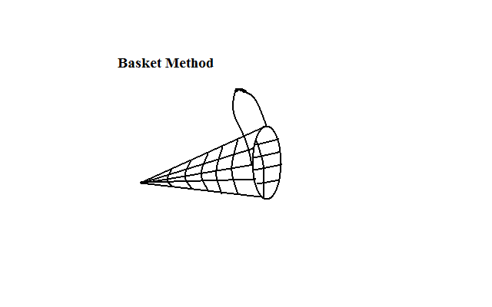

* A basket with a cone opening with bait inside is used.
* It is placed at the shallow end of the water.
* The fish are attracted by the bait.
* Fish run to hide in the basket get inside and are trapped.
* The catch is relatively small.

**Harpooning**

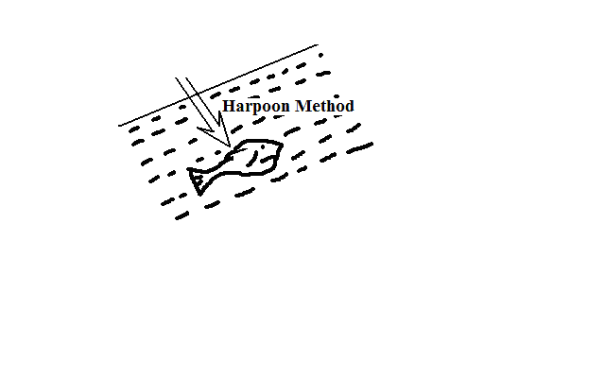

* Using a sharpened arrow or stick to strike Fish.
* One fish is caught at a time.
* Dangerous in waters infested with crocodiles and hippopotamuses.

**Barrier Method**

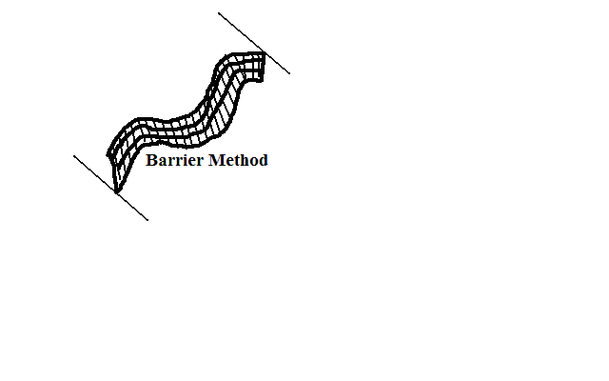

* Using Barriers made of reeds or sticks to catch fish in flood waters.
* Are placed on the downstream side of a flooded region and when water levels drop the fishermen scoop the fish.

**Herbs**

* Sprinkling crushed herbs in waters making fish to become unconscious then the fishermen collect fish from the river using hands.

**Use of Lamp and Net**

* Placing a lit lamp on the edge of the boat to attract fish.
* Fish swim towards the light and are caught using net.

**Hook and Line**

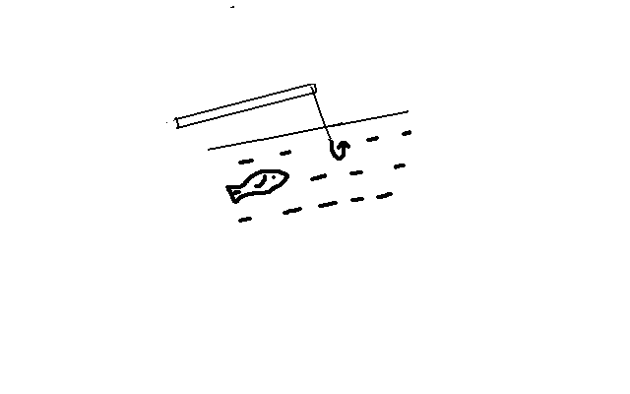

* Throwing a line with a baited hook into the water.
* The fish are attracted by the bait which they swallow together with the hook.
* The line is pooled from the water together with the fish.

**Gill Nets**

-Nets with mesh which lets only the head of a fish through and then traps it by the gills.

-They can be swerved across or round the river on the path of fish.

**Modern Fishing Methods**

**Seining**

* Method is used to catch pelagic and anadromous/migratory fish which swim in shoals.
* A Bag like nets with small meshes (seine) attached to two boats on each end is cast into the sea.
* It’s kept open and held in position by floats on top and weights at the bottom.
* Fish move towards the net and get trapped.
* The net is hauled over and fish emptied onto the ship or the net is hauled to the shore (haul seining).
* Leads to overfishing because it doesn’t discriminate the ages of fish caught.

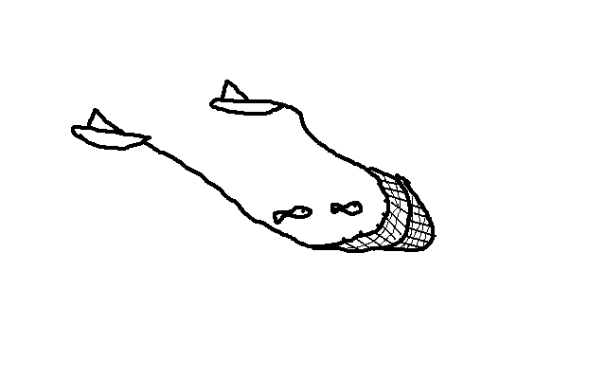

**Trawling**

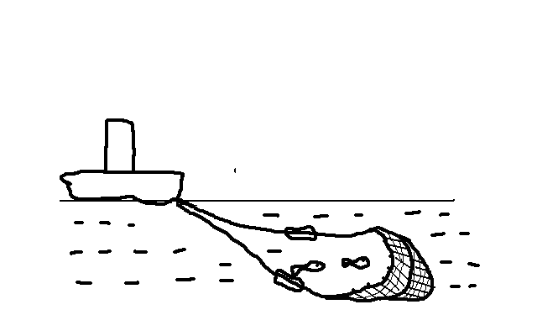

* Mainly used to catch demersal fish.
* A bag shaped net is attached to a trawler (ship) is is cast into deep waters
* The upper part is kept open by floats and lower part kept down by weights.
* The net is dragged by the trawler along the sea bed.
* The trawl net sweeps in the fish.
* The net is hauled into the trawler and the fish is emptied onboard.
* Also catches immature fish.

**Line Fishing**

-The method is used to catch demersal fish.

* Fishing boats spread out long line with several baited hooks on them.
* Floats keep the lines suspended and also show the fishermen where the lines are.
* Baited hooks catch the fish as they compete to feed.
* Hooks are drawn and fish unhooked and put in refrigerated containers.

**Distribution of Major Fishing Grounds in the World**

**The Atlantic Fishing Grounds**

**N.W. Atlantic Fishing Grounds**

* Located along the E. coast of N. America.
* Fishing grounds are Grand bank, Sable bank, George bank and Nova Scotia.
* Fish caught are cod, herring, mackerel, lobsters, etc.

**Factors That Have Led To High Development of Fishing**

1. Large continental shelf providing an extensive area over which plankton can grow.
2. Convergence of warm Gulf Stream current and cold Labrador Current resulting in cool temperatures favourable for the thriving of plankton and which also makes the area to be ice free most of the year.
3. Adjacent lands have a cold climate and a rugged landscape unfavourable for agriculture making the alternative to be exploitation of fishing grounds.
4. There is a dense population in the surrounding areas which provide a ready market for fish e.g. Massachusetts and Connecticut.
5. There is a highly developed technology which allows fishing to go on throughout the year e.g. large and self contained ship with radar to forecast storms, wireless communication and processing and storage facilities

**N.E. Atlantic Fishing Grounds**

* + Location in W. coast of Europe.
  + Major fishing grounds are coasts of France, Germany, Denmark, Britain and Norway.
  + Fish caught are herring, mackerel and cod.

**Factors That Have Led To High Development of Fishing**

1. Numerous sea inlets which provide shelter for the spawning of fish and anchoring of fish boats e.g. fiords of Norway.
2. Ruggedness of landscape by glaciated features which is unfavourable for agriculture making fishing another economic activity.
3. Warm Atlantic Drift Current which raises the temperature making conditions to be favourable for plankton growth and making fishing possible throughout the year.
4. Large continental shelf providing an extensive area for plankton growth.
5. Land derived minerals brought by the icebergs from the land which provides plenty of food for plankton which fish eat.
6. Dense and affluent population of W. Europe which provides ready market for fish.
7. There is a highly developed technology which allows fishing to go on throughout the year

**S. Atlantic Fishing Grounds**

**1. N.W Africa**

* Located along the Coastland of Mauritania

**Factors**

* + - 1. Presence of cold canary current that cools the warm ocean waters.
      2. Wide and fairly shallow continental shelf providing an extensive area for the growth of plankton.

**2. S.W. Africa**

* + - * + Located in and Cape Province of S. Africa.

Namibia **Factors**

1. Washed by cold Benguela current which cools the warm tropical waters hence favouring the growth of plankton**.**

**3. West Coast of S. America**

* + Location is the coast of Peru.

**Factors**

1. Presence of a continental shelf.
2. Prevailing Peruvian current which favours plankton growth.

**Pacific Fishing**

**N.E. Pacific Fishing Grounds**

* + Located along the W. Coast of N. America.
  + Fishing grounds are from Alaska, British Columbia, Oregon states to California.
  + The main fish caught is salmon.

**Factors**

1. The coast is washed by N. Pacific current which makes water favourable for plankton growth and ice free enabling fishing to be done throughout the yea.
2. Many inlets which form favourable shelter for breeding of fish and good sites for fish ports e.g. fiords and river estuaries.
3. Presence of several rivers and lakes which form suitable breeding grounds for species such as salmon.
4. Rugged mountainous landscape and dense forest cover which has made the area unconducive for agriculture and forced people to carry out fishing as an alternative economic activity e.g. British Columbia.
5. Ready market because of sound economies of the industrialised USA and Canada enabling people to have economic power to purchase fish and capital for the development of fishing industry.

**N.E. Pacific Fishing Grounds**

* + Located along the coast of N.E. Asia.
  + The world’s largest fishing ground.
  + Stretchesfrom Beijing southwards to China Sea in Japan, Malaysia and Indonesia.
  + Fish caught are salmon, mackerel, cod, sardines, eels, trout etc.

**Factors**

1. Broad continental shelf which favours plankton growth leading to more fish.
2. Convergence of cold Oya Siwo and warm Kuro Siwo currents which result in cool well oxygenated and ice free waters ideal for fishing throughout the year.
3. Numerous islands, bays and sheltered inlets which favour fish breeding and provide good fishing ports.
4. Mountainous landscape especially in Japan which hinders development of agriculture making fish an alternative source of food and income.
5. Large and ready market due to high population in the Asian countries.
6. Advanced technology e.g. Japan has large modern vessels with refrigeration facilities, Processing equipment, electronic communication making fishing to be very efficient.

**Fresh Water and Marine Fisheries in East Africa**

**Marine Fishing**

* Fishing grounds found in oceans and seas.
* Carried off the coast of Kenya and Tanzania in the Indian Ocean.
* Uganda doesn’t have marine fisheries because she is landlocked.

**Kenya and Tanzania**

* Contributes only about 10% in Kenya and 13% of the total catch in Tanzania.
* Relatively warm waters of the tropics don’t favour breeding of a large number of fish.
* Indian Ocean is warmer and hence has little plankton.
* Continental shelf is narrow with little fish resources.
* Warm Mozambique current and deep continental shelf discourages the flourishing of fish.
* They use simple tools.
* Fish caught include pelagic fish such as tuna, kingfish, mullet, bonito and sardines.
* Fishing is done in small scale for both subsistence and commercial purposes.
* In Kenya small boats and a few of them motorised without refrigerators are used while in Tanzania, fishermen use small rarely motorised dhows which are guided by trade winds which travel into deep sea.
* In Tanzania most of the coastal communities take part in fishing industry particularly in the islands of Mafia, Pemba and Zanzibar and along the coast around Tanga, Mtwara, and Dar-es-Salaam.
* Dense coastal population provides a ready market for fish.
* Fish is more popular than beef in Pemba and Zanzibar.

**Problems Facing Marine Fishing**

* + 1. Inadequate market due to low purchasing power of the surrounding community, Poor transport network to the interior of the country and availability of agricultural products in some coastal areas which reduces the rate of fish consumption.

1. Inadequate capital which causes fishermen unable to afford expensive equipment used in deep sea fishing which restricts them to fish near the shore hence the low catch.
   * 1. Stiff competition from industrialised countries mainly Japan and Korea which have modern fishing equipment and are able to tap fish in the deep sea.
     2. Lack of refrigeration facilities to enable them transport fish to distant markets.
     3. Unpopularity of fishing as an economic due to fish prices being high which discourages people from eating it regularly.
     4. Strong sea tides which are a great menace to local fishermen who use small boats which are not motorised which forces them to go fishing when the sea is calm making them to catch only a limited stock.

**Fresh Water Fisheries**

* Found in inland in lakes, rivers and ponds.

**Kenya**

* Lakes are the main suppliers of fish and their resources are more exploited than those of the Indian Ocean because they are calm than seas enabling fishermen to reach deep areas where there is a large catch.
* The fresh water lakes containing fish are Lakes Victoria, Naivasha, Baringo, Jipe, Chala, Balisa and Shakababo in lower Tana and Kanyaboli and Sare in Yala Delta.
* The only alkaline lake containing fish is L. Turkana,
* Most fishermen use simple equipment but around L. Victoria trawlers are used.
* Many fishermen don’t belong to a co-operative hence they sell their catch to the middlemen at minimal prices.
* The middlemen with refrigerated lorries transport the fish to urban centres where they make a huge profit while the rest of the fish is smoked, salted or sun dried and transported to local markets.
* L. Victoria forms the main centre for inland fishing contributing the largest fresh water catch.
* The main species of fish is tilapia and others are herring*,* Nile perch and omena.

**Factors Which Have Favoured Fishing in L.Victoria**

1. Shallow waters which allow plankton to thrive in abundance.
2. Several beaches and highlands within the lake which provide good landing sites for fish boats e.g. Asembo and Mbita.
3. Large and ready market within major towns because of dense population e.g. Kampala, Kisumu and Mwanza.
4. Presence of a variety of species which are of economic value.
5. Presence of fish eating culture as it is a traditional diet of the people around.
6. Fishermen have formed co-operatives which help them in marketing of fish.

**Problems Facing Inland Fishing**

1. Overexploitation due to accessibility of L. Victoria. Tilapia from L. Turkana is cheap and thus in high demand.
2. Indiscriminate fishing leading to catching even immature fish.
3. Boundary conflict over L. Victoria especially with Uganda e.g. recently over Migingo
4. Water hyacinth in L. Victoria.
5. Lack of capital leading to lack of modern fishing equipment which restricts the catch per day.
6. In L. Victoria Nile perch preys on the other fish such as tilapia lowering their stock.
7. Communities neighbouring L. Turkana such as Turkana, El Molo, and Rendile are pastoralists and sparsely populated so they can’t provide reliable market for fish.
8. The damming of river Omo in Ethiopia has reduced the amount of water flowing into L. Turkana drying of Ferguson bay which is the main fishing area.

**Fish Farming in Kenya**

* + Rearing of fish in ponds where the farmer provides an environment conducive for the survival of fish.
  + Fish farms are mainly found in Nyanza, Western, Central, Coast and parts of Rift Valley.
  + Fish ponds are built in areas with heavy clay or loamy soils which are usually impervious.
  + The ponds must be located near a river to ensure a steady supply of water to ensure the water remains fresh providing natural environment for fish.
  + After establishing a pod the farmer gets fingerings from hatcheries set up at Sagana, Kabaru, Kibos, and Aruba and put them in the pond.
  + The main types of fish kept are tilapias which are more popular because they breed fast, are resistant to diseases and can survive in different environments, trout suited to cool areas such as the slopes of Mt. Kenya and mudfish.
  + Fish are fed regularly on grass, vegetables, grains, compost manure and remains of processed fish.
  + Some plants are grown in the pod to provide oxygen.

**Fishing in Tanzania**

* More intensive than in Kenya and Uganda.
* Inland fishing grounds include lakes Victoria, Tanganyika and Rukwa which form substantial fishing grounds, Lakes Rukwa and Malawi and rivers Mara, Malagasi, Ruvu, Pangani, Ruaha, Rufiji, Kagera and Wami.

**L.Victoria**

* About 49% of L.Victoria is in Tanzania.
* There are many fishermen who use modern techniques and equipment.
* Fishing boats are large and carry large stocks of fish which enables fishermen to travel deep into the lake where there is more fish.
* The neighbourhood of the lake is densely populated with large towns as Bukoba, Mwanza and Musoma which provide a ready market and processing facilities for the fish.
* Lack of well developed transport limits the marketing of fish to the interior towns.
* L.Tanganyika deep and is the richest in the region in fish.
* Fishing has been an old tradition of the people living around the lake.
* The main type of fish caught is dagaa usually caught at night when attracted by light using special nets with small meshes.
* The factory at Kigoma preserves and processes fish for sale to other parts of the country while some of the fish is smoked or dried and exported to Zambia.
* Fishing is concentrated along the shore because rough storms discourage fishermen from going far into the lake.
* Sparse population around the lake doest offer a ready market for fish but the large surplus is transported by rail to other parts of the country.
* Rukwa’s biggest problem is fluctuation of water levels which affect survival of fish.
* A section of L. Malawi is in Tanzania enabling Tanzanian fishermen to catch a lot of fish which is dried and sold in the southern districts of Mbeya and Songea.

**Fishing in Uganda**

* Inland fishing grounds include lakes Victoria, Kyoga, Albert, George, Edward, Katwe and in rivers Nile, Kagera, Kafu, Semliki and Katonga.
* Fishing industry has been interrupted by a long civil strife in the country reducing it to a subsistence economy.
* L.Victoria is the main fishing ground.
* 46 % is in Uganda.
* Many fishermen own motorised boats enabling them to travel deep into the lake and catch a lot of fish.
* Numerous highlands provide anchoring and resting places for fishermen.
* The fishermen sell their fish to co-operatives which organise processing and marketing.
* The dense population around such as in major towns of Entebbe, Kampala and Njinja provide a ready market for fish.
* Fish is also dried and sold in other parts of Uganda.
* Fish is popular as a diet of majority of Ugandans.
* There are fish processing factories in Njinja where fish is filleted.

**Significance of the Fishing Industry in Kenya**

1. A source of income to fishermen and traders when they sell their catch to co-operatives and customers at a profit.
2. A source of employment such as for those employed to catch fish, in fishing related industries such as making and repairing of boats and officers and clerks of co-operatives.
3. It is a tourist attraction as it is a sporting activity done for enjoyment which is a source of foreign exchange and revenue to the government.
4. A source of protein and food because it’s a major dish to some communities such as around L.Victoria and along the coastal strip.
5. Has led to development of industries such as those depending on fish as a raw material e.g. fertilizer plants, for making cod liver oil, etc.
6. A source of medicine whereby cod liver oil is used in alleviation of chest problems a
7. Fish oil is used directly or indirectly as a source of cooking fat.
8. For biological control of mosquitoes by introducing it in water so as to feed on mosquito larvae thereby reducing mosquitoes and hence incidents of malaria transmission.
9. Has led to development of transport system by e.g. an all weather road from Kitale to Kalokol has made it easier for the fish from L.Turkana to get to the market.

**Problems Facing Fishing Industry in Kenya and Their Possible Solutions**

1. Overfishing resulting from use of small meshed nets and unlicensed fishermen resulting in extinction of such species.

* Restrictions should be made on the type of net that should be used.
* Licensing a selected number of fishermen and limiting their catch per day.
* Fish farming to ease pressure on natural fishing grounds.

1. Pollution of water bodies by oil spillage and seepage of industrial and agricultural chemicals into water which kills marine organisms and prohibits introduction of fish into such waters.
   * Agricultural activities should be prohibited close to fishing grounds.
   * Legislation should be put in place to check disposal of wastes from industries.
2. Transport problem as key fisheries being far from centres of population which causes many places to rarely receive fresh fish e.g. L.Turkana.

* Roads should be tarmacked for efficient transportation of fish.

1. Lack of adequate market due to many communities having not developed fish eating culture, availability of agricultural products such as beef and pork, many fishing grounds being found in sparsely populated areas, many fishing grounds being found far away from potential markets and inability by many people to afford fish due to being expensive due to transport costs being passed on to consumers.

* Roads to the potential markets should be improved.
* People should be educated on the importance of fish in the diet so as to develop fish eating culture,

1. Inadequate capital making fishermen unable to afford fishing equipment with speed and greater capacity making them unable to venture into deep waters where there is more fish and modern preservation facilities limiting their catch per day.

* Fishermen should form co-operatives so as to get financial assistance.

1. Location of marine waters within tropical latitudes where there is warm water limiting the growth of plankton.
2. Narrow continental shelf hence less fish.

* Modern fishing methods and equipment can enable fishermen to go into deep waters where there is abundant fish.

1. Fluctuation of volume of water in rivers and lakes due to seasonal variation of rainfall and prolonged droughts which causes fish death or migration e.g. Turkana after damming of R. Omo in Ethiopia.

* Conserving water catchment areas to ensure regular supply of water.

1. Growth of weeds e.g. water hyacinth in L.Victoria which prohibits movement of vessels thereby lowering the catch.

* Mechanical or biological removal of weeds.

1. Human activities near fishing grounds which cause soil erosion which causes siltation which lowers the depth of water affecting fish breeding.

* Discouraging agricultural activities near fishing grounds and planting of cover crops around fishing grounds to reduce siltation.

1. Boundary conflict between Kenya and Uganda over Migingo.

* Survey the boundaries to establish the rightful owner of the island.

**Fishing in Japan**

* The leading fishing nation producing 1/6 of the world’s fish output.

**Factors Making It to Be the Leading Nation**

**Physical Factors**

1. Rugged mountainous landscape which doesn’t offer favourable conditions for agriculture making fishing to be an alternative economic activity.
2. Extensive shallow continental shelf that hosts a lot of fish.
3. Convergence of warm Kuroshiwo and cold Oyashiwo currents providing a suitable habitat for plankton on which fish feed.
4. Natural indented coasts that provide good breeding ground as well as excellent natural fishing ports e.g. Yokohama and Nagasaki.

**Human Factors**

1. High technology such as large ships with refrigeration and processing facilities which carry large stocks and enable fishermen to carry out fishing in deep seas and over long periods and equipment to detect where there are abundant fish.
2. Large market for fish due to fish being a popular meal, population being large and with a high purchasing power.
3. Fish farming is carried out in the fresh waters and dams which are intensively managed allowing maximum returns.
4. Fish marketing is done through co-operatives which advance loans to fishermen to improve and expand their fishing.

**Problems Facing Fishing in Japan**

1. High pollution of Japanese waters by industrial effluent sand oil spillage which has interfered with aquatic life.
2. Overfishing along coastal waters as a result of increase in the fishing fleet which has resulted into depletion of some fish species.
3. Restriction of Japanese fleet from other nations territories e.g. to the west where they are kept away by the Korean government.

**Comparison between Fishing in Kenya and Japan**

**Similarities**

* Both countries carry out inland and marine fishing activities.
* There is overexploitation of fish resources in both countries.
* There is fish farming in both countries to supplement natural fisheries.
* Both countries experience the problem of pollution whereby in Kenya it’s by industrial effluents and agricultural chemicals and in Japan by industries dumping mercury into the sea.
* Modern methods of preserving and processing fish such as refrigerated vessels and fish filleting are used in both countries.
* Fish is consumed locally and exported in both countries.
* In both countries fishermen have organised themselves into co-operatives.
* In both countries fishing faces the problem of restriction e.g. in japan by Korean Government while in Kenya they are restricted from Ugandan and Tanzanian waters.

**Differences**

* In Kenya fishing is mostly concentrated in inland waters while in japan fishing is mostly concentrated in the N.W. Pacific fishing grounds.
* In Kenya fishing is carried a few kilometres off the shore but in japan it is done in deep seas even far beyond their territorial waters.
* Less fish is found in Kenya due to warm waters and narrow continental shelf while in japan there plenty of fish in marine waters due to broad continental shelf and convergence of warm and cold current.
* In Kenya there is low demand for fish than in Japan.
* In japan the fish species caught are cod, Mackerel, Alaska Pollack while in Kenya it is Tilapia, Nile Perch Dagaa and black bass.
* In Japan marketing of fish is done mainly by co-operatives while in Kenya it’s mainly done by individual fishermen although there are few co-operatives.
* Marine fishing in Kenya faces competition from other countries such as Japan and Korea while in japan it doesn’t.
* Japan has more advanced technology than Kenya that ensures heavy catch while Kenya has limited technology leading to low catch.

**Management and Conservation of Fisheries**

* Management of fisheries refers to effective planning and control of fish resources and their habitats while conservation of fisheries is careful use and protection of fish resources from overexploitation by people.

**Management Measures**

1. Establishment of research stations to come up with fish species which can do well in various conditions and know fish predators and separate them from fish.
2. Educating people on the importance of fishing grounds and fish resources such as by advising farmers not to cultivate near fishing grounds to prevent siltation and industrialists to treat wastes before disposing them.
3. Government inspecting inland water resources to ensure people don’t interfere with regular flow of water through activities such as damming which lead to fluctuation of water which affects migratory fish and which may also cause their death.

**Conservation Measures**

1. Enact law banning of small meshed nets to prevent catching of immature fish which leads to depletion of fish stocks in water bodies.
2. Improve transport infrastructure to enable exploitation of fishing grounds in remote areas in order to reduce overexploitation of the few accessible fishing grounds such as L.Victoria.
3. Fish farming to ensure fish caught in natural waters aren’t overexploited and depleted.
4. Restocking overfished waters using fingerings from hatcheries or from overpopulated fishing grounds.
5. Banning fishing temporarily whenever over fishing is detected to let fish to mature and breed.
6. Licensing fishermen to regulate the rate at which fish are exploited to prevent their depletion.
7. Regular patrols to ensure that foreign fishermen don’t trespass Kenya’s marine waters to reduce competition for fish.

**WILD LIFE AND TOURISM**

* + Plants (flora) and animals (fauna) in their natural habitats.

**Factors that Influence Distribution of Wildlife in E. Africa**

**Climate**

* + Heavy rainfall results in big forests which favour animals such as elephants and buffaloes e.g. Mt. Kenya forest.
  + Arid and semi-arid climate supports hardy animals which can stand scarcity of water e.g. hart beast and gerenuk which can stand scarcity of water.

**Relief**

**(a) Aspect**

* Windward sides which receive heavy rainfall support big forests which favour animals such as elephants while leeward sides of mountains which experience low rainfall favour grasslands which favour carnivores which in turn attract herbivores e.g. Amboseli.

**(b) Terrain**

* Hunting animals like cheetah are found in plains and plateaus which are relatively level where they are able to run for long distances chasing their prey.

**Soils**

* Infertile and shallow soils favour grasslands which suit many herbivores and carnivores.

**Vegetation**

* Birds live where there are trees so as to have shelter.
* Savannah woodlands with more acacia trees favour giraffes which feed on foliage from the trees.
* Desert and semi-desert vegetation supports hardy animals such as grants gazelle.

**Availability of water**

* Fish are found in rivers, lakes and oceans e.g. Lakes Victoria Kyoga and Indian Ocean.
* Some animals such as hippos and crocodiles live mainly in fresh water in rivers and lakes e.g. R. Nile and L. Naivasha.

**Human activities**

* Man hunts animals illegally threatening some species with extinction.
* Man has displaced animals from their natural habitat by clearing vegetation for agriculture and settlement.
* Man has taken measures to conserve endangered species of wildlife through establishing national parks, game reserves and sanctuaries.

**National Parks**

* Area set aside for preservation of scenery, wildlife and historical sites e.g. Tsavo, Mombasa marine, Amboseli, Samburu in Kenya, Kilimanjaro, Arusha and Serengeti in Tanzania and Kipendo valley and Ruwenzori in Uganda.

**Characteristics**

* 1. Established by an act of parliament
  2. Managed by the government
  3. No other form of land is permitted.
  4. May be fenced off to keep off people and prevent animals from going out.

**Game Reserve**

* An area set aside for preservation of wildlife e.g. Maasai Mara in Kenya, Selous game reserve in Tanzania and Kigezi wildlife reserve in Uganda.

**Characteristics**

1. Managed by local authorities.
2. Accommodates both wildlife and livestock.
3. May be or not fenced off.

**Game Sanctuary**

An area set aside for protection of birds or other kinds of animals which are endangerede.g. Kisumu Impala Sanctuary, Rhino Sanctuary at L. Nakuru National park and Mwaluganje Elephant sanctuary.

**Characteristics**

1. Hunting isn’t permitted.
2. Predators are controlled.
3. Breeding and keeping young ones until they are fit for release.

**Significance of Wildlife**

1. Tourist attraction which brings foreign exchange and revenue for the government by paying entry fee to the national parks and reserves.
2. Wildlife conservation has led to proper utilisation of marginal areas of marginal areas where crop growing is difficult due to unreliable rainfall.
3. Creates employment for people raising their standards of living e.g. game rangers, tourist guides and drivers and workers in tourist hotels.
4. Wildlife preservation helps to preserve and protect water catchment areas and soil and also modifies the climate resulting in increased rainfall.
5. A source of food e.g. animals meet and honey from bees.
6. Wild plants such as *Muarobaini* are used as a source of medicine.
7. It has led to development of industries by providing raw materials e.g. trees provide timber used in the building and construction industry.
8. It has led to development of infrastructure when good roads are built to make Game Parks more accessible to tourists.
9. It has diversified the economic base of East African countries instead of relying on agriculture as a major source of revenue.

**Problems Facing Wildlife in East Africa**

* 1. Poaching which is likely to bring rare species of animals to extinction e.g. rhinos and elephants.
  2. Adverse climatic conditions which causes death of some animals due to shortage of water and pasture.
  3. Floods which drown animals and destroy plants depriving animals of pasture.
  4. Bush fires which destroy large tracts of land and kill animals which may cause extinction of rare species and expose land to agents of erosion.
  5. Overgrazing by high population of herbivores resulting in destruction of vegetation which exposes land to agents of erosion destroying habitats of animals causing them to migrate to areas with adequate pasture.
  6. Wildlife-human conflict where by pastoralists kills carnivores which kill their livestock.
  7. Pests and diseases such as Feline Immunodeficiency Virus which threatens to reduce the lion population in many parts of Africa.
  8. Human activities e.g.

1. Overgrazing by livestock where grazing is allowed leading to destruction of the natural habitat for wildlife.
2. Destruction of vegetation by tourists’ vehicles which reduces the amount of food for browsing animals.
3. Encroachment of land which was formerly reserved for wildlife by clearing land for settlement and agriculture which has led to killing of animals.
4. Overfishing which threatens the survival of certain species of fish and other marine life.
5. Environmental pollution such as release of sewage from lodges which pollutes the water leading to the poisoning of animals which drink it e.g. at L. Nakuru where it has led to the death of flamingos and noise pollution from vehicles and people which disturbs animals making them unable to feed well.

**Management and Conservation of Wildlife**

Wild life management is effective planning and control of wildlife while wildlife conservation is protection of wildlife against interference and destruction by people.

**Management Measures**

1. Educating people through print and electronic media on the need to preserve wildlife.
2. Establishing wildlife clubs in schools to create awareness on the importance of wildlife conservation.
3. Formation of wildlife conservation bodies e.g. Kenya Wildlife Service charged with management and conservation of wildlife.
4. Initiating game ranching or wildlife farms to control overexploitation of wildlife resources from the natural habitats.
5. Culling of old animals to give room for the younger ones and to control the animal numbers.
6. Translocation of animals whose population increases beyond the capacity of park to other parks where their number is small to prevent the problem of overgrazing.
7. Encouraging of domestic tourism by lowering entry fee into parks to help people to appreciate the value of wildlife and thus accept conserving it.

**Conservation Measures**

1. Banning hunting in order to prevent extinction of endangered species.
2. Banning trade in wild game and trophies to prevent endangered animals from becoming extinct.
3. Setting up of game parks to protect wildlife against destruction by people.
4. Setting up of wildlife sanctuaries to protect the endangered species of wildlife.
5. Employment of paramilitary personnel by the government to combat poaching.

**Tourism**

* + Process of travelling to other places for pleasure, business or education.

**Types**

**Eco-tourism**

* + Environmentally friendly tourism or tourism emphasizing environmental conservation where tourists and local communities are involved in enjoying nature as well as conserving it or.

**Aspects/Characteristics of Ecotourism**

1. Tourists are guided along marked trails instead of driving to the areas where there are animals.
2. Telescopic viewing of animals to avoid disturbing animals.
3. Use of camping sites rather than big tourist hotels so as not to put pressure on resources which animals depend on.
4. Prohibiting off road driving and travelling by foot.
5. Allowing particular types of vehicles.
6. Warning people against throwing cigarette remains on dry vegetation.

Its encouraged by:

* + Creating awareness among the local communities to understand and appreciate nature by visiting Game parks.
  + The local community directly benefits from income from tourism which provides them with incentive to conserve wildlife.

There are two types of tourism namely:

**Domestic tourism** involves local people visiting tourists’ attractions which are within their own country.

**Why Domestic tourism is Encouraged**

* To understand features available in the country so as to appreciate them.
* Understand and appreciate the need to conserve wildlife.
* To compensate for the low turn outs of international tourists in April and October this helps to run the hotels without relying on tourists from outside.

Its encouraged by:

* Lowering entry fee to game parks.
* Lowering charges in tourists’ hotels for Kenyans who want to stay in them.

**Mass tourism** is where large institutional groups of students of staff visit tourists’ attractions.

**Green Tourism** is where people travel seeking to protect and restore the damaged environment e.g. by planting trees.

**International tourism** involves movement of persons from one country to another for leisure.

**Factors Influencing Tourism in Kenya**

**Physical factors**

* 1. Tropical location which causes tourists from temperate countries to come to Kenya to escape the harsh winter cold.
  2. Attractive scenery such as snow capped Mt. Kenya, unpolluted sandy beaches, Great Rift Valley, hot springs and geysers, great rivers with falls etc which attract tourists.
  3. Richness in wildlife e.g. many plants because of warm climate e.g. rain forests and acacias of savannah and tropical animals and birds which are conserved in their natural habitat. Its home to the famous wildebeest in the Mara.

**Human Factors**

1. There are different ethnic groups with unique way and dancing, handicrafts, and dressing which attracts tourists.
2. Presence of historical sites which feature artefacts of iron age e.g. Kariandusi in Nakuru and Orgesailie near Magadi which attract tourists.
3. Political stability which assures tourists of their safety.
4. Accessibility of many tourist sites by road, air and water and also there are communication facilities throughout the country.
5. There are comfortable tourist accommodation facilities e.g. high-class hotels and lodges in major towns and game parks.

**Tourist Attractions in Kenya**

-Grouped into two:

**Main Attractions at the Coast**

1. Beautiful natural uncrowded and unpolluted sandy beaches which are ideal for sun-bathing (sitting or lying in strong sunlight in order to make the body brown).
2. Warm and sunny climate due to tropical location which attracts tourists from temperate regions who escape from the harsh winter cold and come for health purposes.
3. Water sports like yatching, surfing and sport fishing which are carried out in the Indian Ocean.
4. Historical sites such as Fort Jesus, Gedi ruins, Vasco Dagama and slave caves in Malindi and Shimoni.
5. Traditional culture of the coastal people e.g. they have a unique way of dancing, songs, clothing and handicrafts and shrines e.g. Kaya of the Mijikenda which attracts tourists.
6. Mangrove swamps which have unique plants and different species of fish, snails, snakes, birds etc.

**Main Attractions Inland**

1. Wild life conserved in National Parks and Game Reserves. Wildlife is conserved in their natural habitats.
2. The Famous wildebeest migration in the Mara.
3. The sunny warm climate which attracts tourists from temperate countries.
4. Attractive scenery such as the snow capped Mt. Kenya, the Great Rift Valley and its lakes and hot springs and geysers and great rivers with waterfalls.
5. Diverse culture of inland people e.g. the Maasai way of dressing, dancing, housing.
6. Historical attractions such as Kariandusi near Gilgil and Orgesailie near Magadi featuring artefacts of Iron Age.
7. National museums of Kenya in Nairobi.

**Significance of Tourism**

* 1. Tourism earns the country foreign exchange by paying for their services in foreign currency which is used to trade with other countries.
  2. It employs many people enabling them to earn an income and hence raise their standard of living e.g. tourists guides, drivers, in tourist hotels etc.
  3. Source of revenue for the government from licenses from tour operators, entry charges to game parks rental fee paid by game lodges etc.
  4. Has led to improvement of infrastructure resulting when new roads are constructed and existing ones improved and also airstrips constructed which benefits people living along the routes which in turn stimulate development.
  5. Promotes international understanding resulting in peace between countries by bringing together people from different countries of the world..
  6. Promotes conservation of wildlife and historical sites sine they are tourist attractions.
  7. Promotes agriculture as tourist hotels rely on farmers for the supply of food e.g. fruits and vegetables.
  8. Promotes development of industries e.g. craft industries when tourists buy curios e.g. wood and stone carvings and *ciondos.*

**Problems facing Tourism in Kenya**

1. Insecurity whereby tourists are robbed of their belongings which discourages potential tourists from visiting the country. The government is increasing security patrols in the areas frequented by tourists.
2. Ethnic classes in tourist attraction areas which make tourists to stay away than put their lives at risk e.g. ethnic clashes in Molo. The solution is preaching peace among the tribes since the clashes are fuelled by ethnic hatred.
3. Illegal hunting of animals which reduces some rare wildlife species which attract tourists which reduces the number of tourists visiting the country. Some tourists encourage poaching by buying trophies and involvement in smuggling skins, ivory and other articles out of the country. The solution using game rangers to patrol game parks to hunt for illegal hunters and banning trade in game trophies and inspecting tourists at departure.
4. Terrorism attacks such as the bombing of tourist resort at Kikambala which causes foreign countries to issue travel advisories to their citizens which reduces the number of tourists. Security personnel are being trained on ways of detecting and countering terrorism.
5. Pollution of aquatic systems such as L. Nakuru which has caused the death of flamingos reducing the number of tourists since some are specifically attracted by flamingos. The solution is regular inspection of factories to ensure treatment of effluents before they are released to water bodies.
6. International media giving negative publicity of Kenya by portraying it as an insecure country. There should be established tourism promotion bodies in foreign countries to report positively to counter lies.
7. Air fares from and to many parts of the world is high due to high fuel prices which discourages tourists from coming to Kenya.

**Problems Associated With Tourism**

1. Local people borrowing from tourists some social cultural values with negative consequences e.g. homosexuality and lesbianism which could lead to breakage of marriage life and spread of S.T.Ds.
2. Government neglecting other sectors of the economy such as agriculture and development projects like health and education by using a lot of money on tourist infrastructure such as construction of roads and airstrips in tourist areas some of which are rarely used.
3. Some tourists encourage poaching by buying and smuggling souvenirs in form of game trophies which make poachers to kill animals so as to meet demand for these products.
4. Destruction of vegetation by tourist’s vehicles as they move over it which reduces the amount of pasture available for browsing animals.
5. Tourists chasing animals while trying to get close-up photographs which destructs the animals feeding and bleeding habits. Noise from vehicles and people also disturb animals.
6. Some tourists come with the purpose of trafficking drugs and some introduce youths to drugs leading to drug abuse and its related consequences.
7. It may cause some male and female children to drop out of school to be showing the tourists around and obtain money by befriending tourists e.g. beach boys.

**Tourism in Switzerland**

**-**A country in C. Europe which is landlocked.

-60% of the country is mountainous.

-Its one the leading world destination for international tourism.

-Tourism is highly developed and is the leading foreign exchange earner for the country.

**Factors Influencing Tourism in Switzerland/Why it gets more tourists than Kenya.**

1. Beautiful scenery produced by Alps which is the main tourist attraction in summer. There are features formed by glacial erosion. There are features such as snow capped mountain peaks, clear blue lakes, waterfalls etc.
2. Climate whereby tourists like visiting there during warm summers and especially the southern region of Ticino which receives more tourists as it experiences a warmer summer due to proximity to Mediterranean Sea.

The country also experiences winter in which the mountain peaks and slopes provide excellent ground for skiing and skating.

1. It has Excellent infrastructural facilities with a well developed network of roads, railways, electrified rail cars and cable cars which enable tourists to travel easily to centres of attraction.
2. The policy of neutrality which makes people from all the parts of the world to feel at home while there.
3. Several major languages of Europe are spoken which makes it possible for tourists to get excellent services in the country.
4. Accessibility due to its location in C. Europe for tourists from countries from France, Italy, Spain, Germany and Belgium.
5. It has excellent accommodation facilities which are fairly priced and offer discounts to mass tourists.
6. It’s highly industrialised and many people are employed and earn a good income enabling people to save for holidays.
7. It’s a centre for international meetings since the UN headquarters are in Geneva and the people who go for meetings take time to tour various parts of the country.
8. Tourists organise themselves into groups in order to negotiate for air travel and hotel accommodation making tourism possible for a cross section of the society.
9. The country has favourable banking laws so people visit that country as they go to bank their money.
10. It has one of the lowest crime rates in the world which make many tourists to tour it because their security is guaranteed.

**Significance of tourism to Switzerland**

1. Earns the country foreign exchange which is used to finance development.
2. The country earns revenue through taxation and direct fee collection.
3. Creates employment in both Switzerland.
4. It has encouraged development of other industries e.g. banking, insurance and transport.
5. Has opened up unproductive areas for development e.g. glaciated landscapes.
6. Switzerland has gained good international reputation and fame through tourism.

**Comparison between Tourism in Kenya and Switzerland**

**Similarities**

* + Both counties have similar tourist attractions e.g. snow capped mountains, waterfalls and rich culture.
  + Both countries have well established hotel industry offering excellent accommodation to tourists.
  + Both countries have health spas with mineral water which people consider to cure certain ailments. In Switzerland they are at Mt. Moritz and in Kenya at L. Bogoria.
  + In both countries tourists visit all year round.
  + In both counties tourism sector earns a significant fraction of foreign exchange.
  + Both countries enjoy a peaceful political environment suitable for tourism.
  + Tourists in both countries are attracted by waterfalls. In Switzerland they are associated with hanging valleys while Kenya’s are along her rivers.
  + Both countries have national parks e.g. Swiss National Park in Switzerland and Amboseli National Park in Kenya.

**Differences/ What Tourists Go To See In Kenya Which They Cant See In Switzerland and Vice Versa**

* + Kenya has more physical features which attract tourists than Switzerland e.g. Rift valley, lakes, mountains.
  + Kenya’s climate is warm throughout the year while Switzerland experiences warm summers and cold winters.
  + Kenya has tropical wildlife such as the elephant, cheetah, lion etc. which Switzerland lacks.
  + Kenya is richer in traditional culture than Switzerland due to its many ethnic groups.
  + Switzerland receives more visitors than Kenya and revenue from the industry is far much higher compared to Kenya’s.
  + Kenya has marine attraction which Switzerland lacks because it’s a landlocked country.
  + In Kenya animals are kept in game parks while in Switzerland they are kept in zoos.
  + Switzerland has winter sports such as skiing and ice-skating which Kenya lacks.
  + In Switzerland domestic tourism is more pronounced than in Kenya due to high levels of income.

**Reasons Why Many Kenyans Don’t Visit Other Places as Tourists**

1. Shortage of accommodation especially during the tourist peak season making accommodation expensive and hence unaffordable.
2. Unemployment which makes many people unable to afford to travel let alone pay for food and hotel accommodation.
3. Low income from employment making many people unable to afford holidays in tourist attraction areas.
4. Some employees are unable to get leave so as to be able to visit tourists’ attractions.
5. Many people haven’t developed the habit of going to visit areas with tourists’ attractions during holidays.

**The Future of Tourism in Kenya/Ways in which Kenya is Planning to Expand her Tourism**

Tourism in Kenya has good prospects and may expand in future if the following factors are implemented:

1. Improvement of infrastructure in semi-arid areas which have tourist attractions e.g. N. Eastern Province.
2. Aggressive promotion and marketing of Kenya as a tourist destination in other countries which is done by (KTDC) Kenya Tourist Development Corporation and (KTB) Kenya Tourism Board.
3. Encouragement of domestic tourism by showing documentaries through the electronic media on Kenya’s tourist sites e.g. ‘Out and About’
4. Offering domestic tourists favourable rates of accommodation in the hotels during the off peak tourist season.
5. Beefing up security to ensure tourists don’t gain access to the country in order to make tourists to choose Kenya as their destination since their safety will be guaranteed.
6. Lowering tariffs levied particularly on food and accommodation in tourists hotels to encourage tourists to come and spend more days.

**ENERGY**

-The power required to carry out an activity e.g. diesel, electricity, etc.

**Sources of Energy**

-Classified into 2 types: renewable and non-renewable sources of energy.

**Renewable Sources of Energy**

-Which can be regenerated and used over and over again.

**Types of Renewable sources of Energy**

1. Sun
2. Wind
3. Water (geothermal, hydro power, tides and waves).
4. Biomass (wood, biogas)
5. Animals.

**Sun**

-Energy from the sun is called solar energy.

-The sun is the primary source of all types of energy.

-Solar radiation can be converted into 2 types of energy.

**Heat**

-Solar panels are used to tap solar energy which is then used to heat water in coiled pipes which are inside which are painted black.

-Mirrors are used to converge rays of the sun on one spot which are then used to heat water or cook food in a pot.

-Sun’s rays are reflected and focused on crops to dry them.

**Electricity**

Photo- voltaic cells are used which when sunlight shines on them they generate electricity which is then stored in batteries.

**Advantages of Solar Energy**

1. Cheap because it’s obtained from sunlight which isn’t paid for.
2. Requires minimal maintenance once tapping equipment has been installed.
3. It doesn’t pollute the environment like fossil fuels (environmentally friendly)
4. Can be stored in batteries and used when there is no sunlight.
5. It’s inexhaustible i.e. available as long as the sun continues to shine.
6. Available in all parts of the world.

**Disadvantages**

1. Can’t be used to run heavy machinery.
2. Tapping equipment e.g. solar panels are expensive to buy.
3. The batteries which it’s stored in are cumbersome to carry around.
4. It fluctuates in various seasons throughout the year.
5. Large numbers of solar panels are required to produce useful amounts of energy.

**Wind**

Wind energy is mainly used in arid and semi-arid areas where wind flow isn’t obstructed by vegetation.

* + Wind is harvested using wind mills and converted into mechanical energy which is used for pumping water, grinding grain and generating electricity.
  + Wind energy is also used to propel ocean going vessels e.g. dhows.

**Advantages**

* + 1. It is an inexhaustible source of energy.
    2. It doesn’t pollute the environment.
    3. Land between the windmills can be used for other purposes.
    4. Can be produced on small scale basis for local consumers.

**Disadvantages/ Problems.**

-Wind mills for harvesting it are expensive to buy and install.

-The equipment for harvesting is relatively expensive to maintain.

-Many windmills are required to provide a significant amount of electrical energy.

-It fluctuates when the strength and direction of wind changes.

-The large tracts of land it requires (wind farms) alter the environment beauty.

-It’s not available in many areas except in open areas.

**Water**

**Geothermal Power**

-Steam from underground is heated when in contact with hot rocks.

-The steam finds its way to the surface through fissures or cracks.

-The steam is tapped and used to turn turbines and thus generate electricity e.g. at Olkaria in Kenya.

**Advantages**

-Cheaper as no fuel is required to turn turbines.

-It is Continuous.

-It’s inexhaustible unlike hydro-power which depends on water levels.

-The cost of operating geothermal power station is low compared to hydro-power station.

-A good supplement for other sources of energy.

**Disadvantages**

1. Causes noise pollution from generation plant.
2. Not available in many areas where there aren’t hot springs and geysers.
3. Gases released with steam may pollute the environment e.g. sulphur dioxide, hydrogen sulphide, methane, ammonia, etc.
4. Its exploration is expensive because it requires expensive technology.

**Hydro/Water-power**

-Power obtained from falling water.

-Most widely used renewable source of energy.

-Used to generate electricity (HEP) when falling water is directed to turn turbines connected to generators to produce electricity.

**Advantages**

1. It doesn’t pollute the environment.
2. It’s inexhaustible.
3. Hydroelectric power can be transmitted over long distances using cables.
4. Dams for HEP generation create lakes which can be used for recreation, irrigation and fishing.
5. HEP can be used for many purposes e.g. transport, cooking, etc.
6. It’s reliable because significant levels of energy are produced.

**Disadvantages**

1. Affected by fluctuation of water levels in reservoirs.
2. Construction of HEP generation dams displaces many people.
3. It causes inconvenience to migratory species of fish.
4. The cost of constructing and running hydro-power plants is high.
5. Dams may break and destroy a lot of property and lives downstream.
6. Not available throughout the world.

**Tides and Waves**

-Dams are built across an estuary.

-Incoming and outgoing tides rotate turbines and electricity is generated in similar way as hydro-power.

**Biomass**

-All forms of energy released by plants and animal wastes.

**Wood** **fuel**

Firewood, charcoal and saw dust which are used for cooking and heating.

It can be exhausted if its cut at a higher rate than they are being replaced. So it requires management if it has to be sustained.

**Advantages of Wood**

1. It’s a cheap source of energy.
2. Available almost throughout the world.
3. No maintenance cost is needed.
4. Ashes from burned firewood can be used for plastering houses and as a fertilizer.

Disadvantages

1. Dirty because when burning it gives off smoke and soot.
2. Pollutes environment through the gases it emits.
3. Requires a big storage area.
4. Its overexploitation leads to deforestation leading to problems of soil erosion, global warming and shortage of water.

**Power Alcohol**

Agricultural wastes e.g. straw, molasses and cassava are fermented to produce power alcohol which is directly used to heat or blended with gasoline to run machines.

**Biogas**

Human and animal wastes are used to produce methane (biogas) through fermentation which is used for cooking and lighting.

**Advantages of Biomass**

1. An inexhaustible source of energy.
2. Fuels are efficient and relatively clean.
3. Cheap because it makes use of waste products.
4. Production of biogas is cheap as it doesn’t require advanced technology.
5. Biogas gives twice as much heat as natural gas.
6. Slurry left behind when biogas is being made can be used as fertilizer.
7. Available throughout the world.

**Disadvantages**

1. Biogas digesters require a lot of space and can’t be set in congested areas.
2. Can’t be transported to distant places.
3. Contributes to pollution which causes global warming.

**Animals**

**Examples of Animals and Their Uses**

1. Oxen for ploughing and pulling carts.
2. Horses for transporting by riding on their backs.
3. Donkey for transporting of goods on their backs or by pulling carts.
4. Camel for transporting goods and people on their backs.
5. Elephant in Burma and India for transporting logs from forests

**Advantages**

1. Inexhaustible because animals keep multiplying as a result of production.
2. Available in all parts of the world.
3. Cheep to maintain as they only require food and water.
4. Animals are flexible because they are able go through forests and narrow paths unlike motor vehicles.
5. Some are slaughtered for meat when they outlive their usefulness e.g. oxen, camels etc.

**Disadvantages**

1. They are prone to diseases and fatigue.
2. They can die as a result of too much work.
3. Their use is restricted only to rural areas.
4. They can only transport small loads.
5. They can only do limited work because they tire easily.

**Non-renewable Sources of Energy**

-Sources of energy which are exhaustible if they aren’t well managed.

-They include petroleum, coal and uranium.

**Coal**

-A black or brown rock made of carbon.

* Mud, sand and other materials are deposited over vegetative matter such as tree trunks and branches.
* Deposited material prevents decomposition and also exerts pressure on it causing great heat.
* Peat layers are formed which gradually change into coal.

Usage of coal has declined due to:

1. Discovery of other forms of energy such as petroleum.
2. Exhaustion of old accessible mines.
3. High cost of mining coal.

**Advantages of Coal**

1. More efficient in thermal generation of electricity than oil.
2. Most suitable in the smelting of iron.

**Disadvantages**

It leaves a lot of dirt on any surface it touches.

It leads to formation of smog and smoke which is a health hazard.

Its mining leads to environmental degradation.

**Petroleum**

**-**Consists of gaseous and liquid hydrocarbons from animal and vegetation matter laid on sedimentary rocks.

Natural gas and petroleum are extracted from the same oil wells.

Petroleum is refined to get by-products such as motor oil, diesel, kerosene, gasoline, jet fuel, lubricants, liquid and petroleum gas.

Natural gas occurs alone or is found on the upper layers of crude oil.

It’s a mixture of hydrocarbons with methane making about 90% and other gases such as propane, ethane and butane.

It’s used for domestic purposes, generation of thermal electricity and for industrial activities.

**Advantages**

1. A clean source of energy to use.
2. Cheap to transport by pipes to distant areas.
3. Transport and maintenance costs are low.
4. Easy to use as one needs only switches and burners.
5. Free of the effects of weather changes.

**Disadvantages**

1. An exhaustible source of energy.
2. Accidental fires can occur incase the gas leaks or the pipe is damaged.
3. It can greatly pollute the environment incase of accidental fires occurrence.
4. Expensive for low income groups.

**Uranium**

-A naturally occurring radioactive material used to produce nuclear energy in fusion and fission in reactors.

A lot of heat is produced and the water used to cool the heat producing core is heated and turns into steam used to generate electricity.

**Advantages**

1. It’s a long lasting supply of raw material.
2. It produces large amounts of energy.
3. It doesn’t produce green house gases.

**Disadvantages**

1. It’s expensive to construct a nuclear reactor.
2. Wastes from a nuclear power station are difficult to dispose because they are radioactive for 100 years.
3. It is an exhaustible source of energy.

**HEP Projects in Kenya**

**Factors Favouring Development of HEP**

**Physical Factors**

1. A large and constant volume of water such as R. Tana and its tributaries.
2. Can be located on areas with falling water such as on rapids, water falls, and Knick points.
3. Deep and narrow valley. Deep to ensure a large capacity for the reservoir and narrow to minimize the cost of constructing the dam.
4. Hard basement rocks to reduce the amount of infiltration and also to provide a strong foundation for the dam.

**Human Factors**

Area for dam and reservoir construction should be sparsely populated to minimize the cost of relocating people.

There should be presence of industries and urban areas to provide market for electricity to make the project economically viable or bring a profit.

Construction of an HEP station requires adequate capital because it’s expensive to construct a dam, to maintain it, to transmit power and to compensate the displaced people. Kenya is financed from external source e.g. Sondu Miriu which is financed by Japanese government.

When referring to Kenya you should say: ‘There is presence of …’

**Development of HEP in Kenya**

By the dawn of independence there was few industries and hence low demand for electricity.

Few HEP stations available were set up to supply power for agricultural processing.

The earliest stations were **Mesco** on R. Maragua, **Ndula** on R. Thika and **Sagana** on R. Sagana.

The rest of power supply came from diesel plants in Kipevu.

There was power which was being imported from Uganda which was connected in 1955.

Demand for electricity increased as more industries were established.

The country opted to use her water resources to provide electricity and reduce her reliance on power from Uganda.

R. Tana was identified as the one with the largest potential.

Seven sites appearing as a cascade were identified along the river where the **Seven Forks Scheme** was launched.

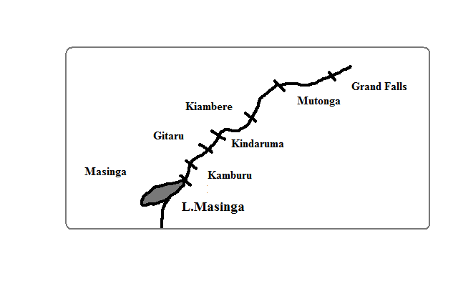

* Kindaruma was the first project to be established which was completed in 1968.
* Kamburu followed which was completed in 1974.
* Gitaru was next which got completed in 1978.
* Masinga which is a multipurpose project was completed in 1981. It has the largest lake. It’s a reservoir for the rest of the dams downstream and the water is also used to provide water for irrigation.
* Kiambere was the last station downstream completed in 1988.
* The other proposed power stations to complete the Seven Forks project are Mutonga and Grand Falls.
* The other HEP stations are Turkwel Gorge on R. Turkwel which was completed in 1991 and Sondu- Miriu which was expected to be completed in 2008.

It’s the main source of electricity accounting for 72% of power production.

The stations are maintained by Ken Gen which sells power to KPLC which distributes it to consumers at a fee.

**Benefits of Tana River Projects**

1. The reservoirs provide power for irrigation and domestic use.
2. The dams promote transport by serving as bridges across the rivers.
3. The dams are a tourist attraction e.g. Masinga tourist lodge provides recreational facilities.
4. The dams provide fresh water fisheries.
5. The projects have generated employment to people thus raising their standard of living.

**Problems Facing the Tana River Projects**

1. Shortage of capital to purchase spare parts which has interfered with maintenance of machinery in the power house.
2. Fluctuation of the water levels of R. Tana due to drought in the catchment areas and evaporation due to flowing through the dry Nyika region which affects power generation.
3. Siltation of dams which occasionally blocks the tail race tunnels leading to a low volume of water and dredging is required which is expensive.
4. Inadequate skills and technology which causes failure to maximise on power production.

**HEP Projects in Uganda**

It has the largest renewable fresh water resources in E. Africa.

It is endowed with numerous rivers and lakes with high potential of electricity generation.

The country receives an average of 1000mm of rain throughout the year.

R. Nile which flows out of L. Victoria has the highest potential.

Where it flows out it has provided a natural water fall.

Owen Falls Dam was built on the site in 1954.

It’s the Africa’s largest storage dam.

It supplies most of Uganda’s electricity (162MW) and exports 30MW to Kenya.

The presence of power was a catalyst to industrial development e.g. Njinja town a few metres from the dam became a scene of several industries to use the cheap electricity nearby.

The country is developing another power station below the Owen Falls.

Kikagat River to the south provides power around Mutukula and Kabale areas in S.W Uganda.

Mobuku River supplies most of the power used in the copper mines at Kilembe.

**HEP Projects in Africa**

Africa has the largest concentration and potential areas of HEP generation. The potential hasn’t been utilised due to:

1. Inadequate financial resources. Where the projects are to be established the countries seek external borrowing of money which is paid for many years overburdening the concerned countries.
2. Some of the potential areas being in remote areas far away from densely populated areas and industrial areas.
3. Some of the countries are lowly industrialised which means there isn’t adequate market for HEP making the venture economically unviable.
4. Some of the rivers with potential for HEP generation don’t have constant volume of water throughout the year due to seasonal fall of rain which affects power generation.

Some of the major projects are:

* Aswan on R. Nile
* Kariba (shared among Zambia and Zimbabwe) and Cabora Bassa on R. Zambezi.
* Kainji on R. Niger
* Akosombo in R. Volta (Ghana)
* Owen Falls (Uganda) and Sennar on R. Nile
* Vanderkloof on R. Orange
* Inga and R. Le Marinel on R. Congo.

**HEP Projects in Tanzania**

* Nyumba ya Mungu dam and Hale dam on R. Pangani.
* Kagera
* Malagasi

**Geothermal Power Projects in Kenya**

Geothermal electricity is generated in areas which experience Vulcanicity where:

* Magma or hot rocks come into contact with percolating water.
* The water is heated beyond its boiling point (superheated).
* The steam escapes through cracks and holes to the surface
* The steam is harnessed using pipes and used to turn turbines that drive electric generators.

In Kenya areas with the greatest potential for geothermal power are found within the Rift Valley from L. Magadi to L. Turkana on Kenya-Ethiopia border.

Geothermal power generation is carried out at Olkaria to the south of Naivasha.

It accounts for 10% of the country’s power needs.

Other potential areas are:

* L. Bogoria which has the highest potential with numerous hot springs and geysers by it shores.
* Eburu to the north of L. Naivasha
* Menengai crater region
* Areas around L. Baringo
* Magadi
* South of L.Turkana.
* Between mountains Longonot and Suswa

**Problems of Energy Development in Kenya**

The aim is to reduce overdependence on imported oil.

1. Inadequate capital which causes the country to seek external borrowing of money which is paid for many years overburdening the country.
2. Small market for power because of the high cost of connection which prevents its horizontal spread.
3. Seasonal fluctuation of water levels in dams due to low rainfall on catchment areas and some rivers flowing through dry areas where much of water is lost through evaporation which leads to inconvenience to consumers because of power rationing.
4. Regular siltation of dams due to deposition of soil which requires regular dredging which is quite expensive.
5. Location of some power generation plants in remote areas making it expensive to transport power for long distances.
6. There is limited spread of solar power in rural areas because the equipment is expensive to install and lack of acceptance because it fluctuates with seasons.
7. There is lack of acceptance of wind power and many people use diesel to pump water instead of it.
8. There is problem of overexploitation of wood fuel as a result of population increasing at a faster rate which has led to deforestation leading to soil erosion and reduced amounts of rainfall as a result of the effect on water cycle.

**Significance of Energy**

1. For domestic use e.g. wood and charcoal for cooking and heating, etc.
2. For use in industries e.g. electricity, petroleum, etc.
3. Used in transportation e.g. electric cars, diesel and petrol used in motor vehicles, etc.
4. Used in agriculture e.g. diesel for tractors which draw ploughs, electricity for milking machines, etc.
5. Used in water supply where diesel engines wind mills and solar power is used to pump water.
6. Used for medical purposes where electricity is used to run equipment for diagnosis e.g. X-Ray and scanning machines and in refrigeration to preserve specimens on medicine research.

**The Energy/Oil Crisis**

Situation whereby the demand for oil is higher than the amount that is being supplied leading to high oil prices.

**Causes**

1. Over-reliance on petroleum and its products.
2. High oil prices due to sharp rise in oil demand.
3. Economic and political sanctions
4. Uncertainties in oil supplies to consumers.
5. Rapid depletion of oil reserves.
6. Conflict in the Middle East especially between Israel and Palestine.
7. Exhaustion of wood fuel
8. Mismanagement of energy
9. Oil production limits set by OPEC
10. Artificial shortages by countries like Russia and USA relying on oil from other countries and conserving their own.

**Examples of Energy Crisis in the Past**

* + 1973 and 1974 when there was war between Israel and Arab countries. The Arab countries which are OPEC members withheld oil supply to Israeli supporting countries e.g. USA and the result was sharp increase in oil prices.
  + 1991 first Persian Gulf war caused by triggered by Iraq invasion of Kuwait caused by:

1. Iraq’s claim that Kuwait was its territory.
2. Kuwait was taking oil from Iraq’s oil from Rumaila fields which lay beneath both countries.
3. Kuwait was exceeding the oil production limits set by OPEC.

Many Kuwait’s oil fields were set on fire and Iraq dumped about 465 m gallons of Kuwait’s crude oil to the Persian Gulf.

There resulted a major oil crisis which was worsened by the trade embargo.

* 2003 second Persian Gulf War. Iraq had failed to destroy weapons of mass destruction which she had agreed to do for the 1991 war to end. The war led to a rapid increase in oil prices from US$35 at the start of war to US $50 by 2004. It forced OPEC members to increaser daily crude oil outputs by 8% to stabilise prices.

**Impact of Energy Crisis**

1. Increase in the prices of many commodities as a result of increase in the cost of production and transportation where oil is used to provide power and as a raw material in some industries.
2. Increase in the prices of imports due to high crude oil prices which affect the balance of trade by causing earnings from exports to be lower than the cost of imports.
3. High rates of inflation or devaluation of currency as a result of commodity prices rising high due to the cost of imports being passed to the consumers.
4. Industries are forced to lay off workers because of the high cost of production which can cause losses.
5. It causes the price of other forms of energy e.g. charcoal and gas also to become expensive.
6. Developing countries running into heavy dept as a result of borrowing heavily to pay for oil loans which are paid at high interest rates making the country unable to invest in development projects.
7. Decrease in agricultural production as a result of decrease in the use of agricultural inputs such as fertilizers due to their high cost brought about by increase in oil prices.
8. Decline in the number of tourists as a result of escalation of oil fares making it very expensive to travel.
9. Environmental degradation as a result of environmental degradation brought about by the high demand for charcoal and firewood which leads to soil erosion and low rainfall amounts.

**Solutions**

1. Developing alternative sources of energy e.g. solar, biomass, Geothermal and HEP.
2. Management and conservation of energy.
3. Developing nuclear energy to enhance self sufficiency in energy provision.
4. Encouraging industries to use coal which is slightly cheaper than petroleum.

**Management and Conservation of Energy**

Management of energy is effective planning and control of energy resources.

**Management Measures**

1. Control of importation of vehicles with large engine capacity which consumes a lot of fuel.
2. Encouraging many people to use public transport in order to reduce the number of vehicles on roads and thus fuel consumption.
3. Educating people through mass media to create awareness on the importance of conserving energy.
4. Improvement and proper planning of road network to reduce traffic jams in which a lot of fuel is wasted.
5. Agroforestry, afforestation and reafforestation programmes to reduce overexploitation of natural forests.
6. Banning logging, selective felling of trees and resettling people who have settled into forests.

**Conservation of Energy**

Conservation of energy is using available energy resources in the most effective manner to ensure there isn’t wastage.

**Conservation Measures**

1. Putting off electricity gadgets when they are not in use.
2. Proper motor vehicle maintenance in order for them to use fuel efficiently.
3. Encouraging use of public transport which carries many people at a go e.g. buses.
4. Encouraging use of renewable sources of energy e.g. solar, wind and biogas to save on oil and wood.
5. Encouraging use of energy saving stoves which use little charcoal and produce a lot of energy.

**INDUSTRY**

**Industry**-any form of economic activity through which people produce goods and services for their consumption.

**Industrialisation**-process through which a country establishes manufacturing industries.

A country is referred to as **industrialised** when production of manufactured goods is the main economic activity in that country. Less industrialised countries mainly produce agricultural raw materials.

**Factors Influencing Location and Development of Industries**

**Raw Materials**

* Industries are located near sources of raw materials to reduce transportation costs e.g. sugar milling factories in sugar growing areas, mostly in urban areas near airports and oil refineries at the coast since oil is bulky and expensive to transport inland.
* They are also established where there is a steady source of raw materials in order for them to be economically viable e.g. oil refineries at the coast

**Power**

* They are located near main power supply pints to reduce the cost of transmitting power e.g. those in Jinja town near Owen falls dam.

**Transport and Communication**

* Theyare located where transportation system is well established to ensure efficient and quick transportation of raw materials to industries and finished goods to the market e.g. in urban centres.
* They are located where there is efficient communication so as to stay in touch with their suppliers and their consumers.
* Well developed communication systems also lower the transport cost.

**Market**

* They are located where buyers of products are available or in areas with dense population to make their operation to be economically viable since they are established for commercial purpose to make a profit e.g. in urban areas, Kenya highlands, lake region and coastal strip.
* Location near markets is also due to the nature of goods e.g. perishable goods have to be consumed before they go bad e.g. bread and daily products. Industries making fragile goods are located near markets to prevent the high risk of breakage during transportation e.g. glass, bricks and roofing tiles.

**Labour**

* Labour intensive industries are located in densely populated areas where there is adequate and cheap labour to reduce production costs.
* Also so as to reduce the cost of transporting and housing workers.
* A country with skilled manpower has faster industrial growth than that without which are forced to depend on expatriates who are costly to hire and maintain which lowers the profits of such industries.
* Industries also require skilled manpower and management skills to ensure maximum output and low production costs.

**Water Supply**

* Some are located near sources of water such as large permanent rivers and lakes to provide water for processing raw materials e.g. coffee pulping, sugar milling e.g. Mumias near R. Nzoia, Sony near R. Migori and Chemilil near R. Nyando.

**Government Policies**

* Decentralisation of industries or encouraging by providing incentives location of industries from urban to rural areas.

**Incentives**

1. Tax exemptions
2. Protection from foreign competition.

**Aims**

* 1. Develop all parts.
  2. Create jobs in rural areas to minimize rural-urban migration.
  3. Take industries where labour is found.
  4. Open remote or underdeveloped areas for development.
  5. To reduce congestion in the capital city.
  6. Environmental reasons whereby industries are located away from residential areas because they produce harmful fumes and a lot of noise.
  7. Security reasons to prevent industries from being attacked by terrorists because if they were all together there would be a great loss.

E.g. EPZ industries located at Athi River to reduce congestion in Nairobi industrial area and Mariakani and Kikuyu Steel Rolling Mills established in their respective areas to open up the region for development

**Industrial Inertia**

**-**Tendency of an industry to remain in a particular place even when the factors for its location no longer exist e.g. industries in the Ruhr Region of Germany have remained at the same place despite closure of coal fields and decline in coal as an energy source.

**Causes**

* Itmay be expensive to move to a new place because new factory buildings would have to be constructed, buying new machinery and equipment.
* Due to availability of experienced workers.
* To avoid the problem of transportation and other basic infrastructural facilities.

**Capital**

* A lot of capital is required in establishing and developing industry e.g. for purchasing land, putting up buildings and purchasing machinery and equipment.
* Countries with plenty of capital industrialise with greater ease than those with little capital which often rely on foreign aid and multinational corporations to set up domestic industries which reduces benefits accruing from such industries.

**Personal Decisions**

* Security to allow secure operations.
* Where they can get maximum benefits.
* To set industries in their home areas to offer jobs to their local people.

**The Cost of Land**

* A place where land is expensive discourages industrial development e.g. industries are now being established in the neighbouring towns of Kitengela, Ruiru and Athi River because land is expensive in Nairobi.

**Types/Classification of Industries**

**According To Raw Materials Used, Products and Level Of Production**

**Primary /Processing Industries**

Industries involved in the exploitation of natural resources (e.g. mining, fishing, forestry and agriculture) or processing raw materials into more useful and valuable form which are used in making final products e.g. coffee pulp factories, cotton ginneries, milk dairies, sugar factories, saw mills, abattoirs, leather tanneries, posho mills and sisal factories.

**Secondary /Manufacturing industries**

-Ones which rely on processed goods to make final products or which make final products directly from raw materials e.g. sweet industries, bread, cement factories, oil refineries, cigarette making, pulp and paper industries, etc.

**Tertiary /service industries**

-Industries involved in providing services and don’t produce tangible goods e.g. transport and communication, trade, banking, tourism, administration, education, medical, etc.

**According To the State of Finished Goods**

**Heavy Industries**

* Manufacture heavy and bulky products.
* Use heavy raw materials.
* Involve heavy investment in their production.
* Production is in large scale e.g. ship building, car manufacturing and assembling, oil refineries, steel rolling mills, fertiliser making plants, glass industries etc.

**Light Industries**

Ones involved in making goods with little volume and weight e.g. textile, cosmetics, plastic, printing, electronics, cigarette, etc.

**Distribution of Industries in Kenya**

**Agricultural Industries**

* 1. **Agricultural Food Processing Industries**

-located where raw materials are produced because they require immediate processing e.g. tea factories, sugar factories, milk Processing plants in the leading dairy farming regions e.g. Eldoret, Nakuru and Kiganjo, coffee factories in coffee growing areas e.g. Kiambu, Nyeri, Embu, fruit canning e.g. Del Monte in Thika and Kenya Orchards Company in Mua Hills in Machakos, Maize milling e.g. Unga Ltd in Eldoret Kisumu and Nairobi, Brewing industries e.g. East African Breweries at Ruaraka, KMC plants at Athi River, etc.

* 1. **Agricultural Non-Food Processing Industries**

-Cotton ginneries, sisal factories, Bata Shoe Company in Limuru, cigarette making e.g. mastermind and BAT, Lumbering industries e.g. Pan African Paper Mills in Webuye near extensive pine plantations in Turbo And Webuye, textile industry e.g. Kisumu Cotton Mills in growing areas of W. Kenya.

**Non-Agricultural Manufacturing Industries**

**-**many are located in urban areas where there is a large ready market, reliable power supply and adequate labour force e.g. cement factories at Athi River and Bamburi, Oil refining at Changamwe in Mombasa, steel rolling mills in the industrial area of Nairobi where scrap metal is available, Central glass company at Kasarani, clay products industries near Ruiru and Githunguri near sources of clay, Vehicle Assembling industries which import car components and join them to make cars e.g. General Motors in Nairobi and Associated vehicle Assemblers in Mombasa, pharmaceutical industries which manufacture medical products e.g. Glaxo Smithkline and Beta Health Care in Nairobi.

**Cottage Industries**

-Industries involved in making products particularly in homes using hands and simple tools.

**Characteristics**

1. Locally available materials are used.
2. Capital infested is small.
3. Most of the products are sold to the local market but few are exported.
4. Skills are acquired informally.
5. Use of hands and simple and sometimes advanced tools.
6. Usually involve an art or skill possessed by a person to produce items that are in demand in the neighbourhood.
7. it’s labour intensive.
8. Very few items are made because the market for items is usually small.

**Examples of Cottage Industries**

**Pottery**

-Cottage industry in which pots and flower vases are made using clay.

Its practised mainly in eastern and central provinces and by women.

Examples of areas are Kwale and Muranga.

**Wood and Stone Carving**

**-**Involves curving of wood and stone into various shapes of animals, humans, etc.

Wood carving is practised in Kitui and Machakos while soapstone (soft metamorphic rock) carving is done in Kisii.

Some products are sold locally while the rest are exported with some being bought by tourists as souvenirs (reminder).

**Weaving**

**-**Involves using sisal, dry palm leaves dry papyrus, nylon fibres etc to make products such as baskets, mats, and fish traps etc.

Baskets mainly known as *Ciondos* are mainly done by Agikuyu women and are sold locally and to tourists.

Weaving is also practised along the coastal region where dry palm leaves are used to make baskets, mats, etc.

Other cottage industries are such as those making use of scrap metal to make metal boxes, wheel barrows, energy saving jikos, rain harvesting gutters, poultry harvesting equipment, swords, knives, spears, jembes, iron bells and jingles and boat making common among communities living around L. Victoria and along the coast.

**Jua Kali Industries**

**-**The most common and popular cottage industry.

Jua kali practitioners include those who are employed in all informal sectors of the economy such as shoe repairers, tailors, carpenters, watch repairers, barbers, mechanics, and tyre-menders,

Jua kali industries are found in all urban centres.

The most common activity is reprocessing old scrap metal to produce useful products listed above.

The government has realised the importance of the industry and is encouraging its development in the following ways:

1. The ministry of Trade and Industry has set up a department to promote this industry.
2. KIE provides loans to Jua Kali industry for the purchase of materials.
3. KIE has put permanent structures/sheds where the artisans can operate at low costs.
4. The local authorities have set aside land for use by Jua Kali artisans
5. Jua Kali artisans have been encouraged to form cooperatives to assist in the marketing of their products.

**Importance of the Jua Kali Sector**

* 1. Has created employment opportunities to many people who would otherwise be jobless offering them a means of livelihood, alleviating poverty.
  2. It has helped to raise the standard of living of many Kenyans who rely on it for income.
  3. it utilises materials that would otherwise be thrown away to make items.
  4. Jua Kali products earn the country substantial foreign exchange when they are exported to COMESA countries.
  5. The industry produces cheaper goods than those produced in the formal industries.

**Significance of Industrialisation to Kenya**

1. Kenya earns foreign exchange after exporting her manufactured goods which is used to develop other sectors of the economy such as education, health care and transport.
2. Industries employ people providing them with income which helps to raise their standard of living.
3. Industrialisation has led to development of transport and communication and social amenities such as power, water, schools and medical facilities where industries have been established.
4. Agricultural based industries have led to increased agricultural production in the process of meeting the rising demand for raw materials.
5. Establishment of industries has led to diversification of the economy thereby helping the country to earn revenue throughout even when agriculture which is the backbone of the economy fails as a result of adverse weather conditions.
   * Workers in industries have joined together and formed co-operatives in which they save money and are then given loans which they use to start projects or generally enhance their living standards.
   * The government also gets revenue through taxation of the dividends got at the end of the year from the profits of SACCOs.
6. Industrial exports help in maintaining a balance of trade between Kenya and her trading partners by reducing over reliance on imports.
7. Industrial exports to other countries create a trading co-operation which in turn helps to foster good relationships among countries of the world.
8. Industries based on locally available materials encourage utilisation of resources which would be otherwise be idle.
9. Establishment of industries promote development of urban centres because it encourages people to move to the area in search of jobs and accommodation and other services are provided.
10. Industrialised countries are likely to produce adequate goods making them to be self-sufficient in industrial goods.

**Problems of Industrialisation and Their Possible Solutions**

1. Kenya lacks adequate capital for industrial establishment forcing her to get loans from financial institutions such as I.M.F and World Bank whose interest rates are very high and sometimes come with strings attached.
   * The solution is government to give incentives such as tax exemptions to investors in order to establish industries.
   * Local financial institutions should assist by giving long term loans at affordable loans.
2. Industries suffer from the problem of raw materials e.g. agricultural industries when agriculture fails due to adverse weather conditions. Timber industry suffers due to trees taking long time to mature and those depending on imported raw materials suffer when strict exchange controls are put in place.

* The solution is supplementing local raw materials with imported raw materials.
* Planting more trees to increase raw materials required for timber related industries.

1. Local market for industrial goods isn’t sufficient to sustain production due to low purchasing power, the cost of manufactured goods being too high due to the high cost of raw materials and the preference of some people to buy imported products thinking they are of better quality.

* Government should explore market within regional trading like COMESA, EAC, etc.
* It should also provide technical assistance to local manufacturers so that produce goods of high quality in order to be able to compete favourably in the world market.
* Government to lower tax on raw materials in order to reduce the prices of manufactured goods.

1. Lack of skilled labour due to brain drain forcing the government to employ expatriates whose salary package is very high thus lowering the profits. It may also lead to poor management leading to losses and eventual close down of some industries.

* More people should be trained in respective fields to make up for shortage.
* Improvement of salaries and working conditions to check the brain drain.

1. Locally produced goods compete with imported goods which are in most cases cheaper leading to the decline or death of local industries. There for instance is importation of 2nd hand clothes which has led to the decline of textile industry.

* Imposing heavy duties on imported products which are also produced locally.
* Improving the quality of locally manufactured goods so that they can compete favourably.
* Eliminating corruption in the importation sector to ensure goods aren’t imported illegally.

1. There is the problem of the high cost of energy due to importation of petroleum at very high cost causing the industrial costs to tremendously increase thus affecting the marketability of the products as they become affordable.
2. Industries cause environmental degradation e.g. pollution from the emissions they release into the air and effluents they release into water bodies. Atmospheric has led to global warming and water pollution to death of fish. Industries such as cement manufacturing make land derelict by depositing rock wastes on the ground.

* The problem can be reduced through strict legislation against dumping of industrial wastes and inspection of industrial activities to ensure wastes aren’t released to the environment before treatment.

1. Has led to the neglecting of agriculture when able bodied people move to urban areas to look for jobs in industries, when people neglect food crops and take up cash crop production.

* The problem can be solved by offering better prices for agricultural produce to make agriculture more attractive.
* Farmers should be encouraged to diversify their activities.

1. it has led to unemployment as it has led to technological innovations such as computers and robots and other automatic gadgets which have replaced physical manpower.

* People are being encouraged to become self employed.
* Industries are also discouraged from laying down their staff.

1. Has led to displacement of people by forcing people to vacate the area where manufacturing industries are being established e.g. the preparation for titanium mining at Kwale District.

* The solution is compensating and resettling the displaced residents.
* Efforts should be made to locate industries in sparsely populated areas.

1. Causes rural to urban migration as a result of establishment of industries in urban areas where rural dwellers go to seek for jobs. This has caused shortage of labour in rural farms, congestion in urban areas leading to pressure on existing social amenities, inadequate job opportunities leading to crime and other social evils, etc.

* The government should ensure equitable distribution of industries throughout the country.
* It should encourage industries to be put up in rural areas through tax exemptions.
* Provision of amenities such as electricity, clean water and entertainment facilities in rural areas.

**Cottage Industry in India**

The major areas in which it’s highly developed include Mumbai, Jabalpur, Magpur, Bhopal, Bhutan, Madras, Calcuta, Bangalore, Lucknow and Moradabad.

The industry involves weaving, making clothes, brass, Copper and silver ware ornamental ivory, jewellery, carpets, safety matches, etc.

**Characteristics of Cottage Industry in India (Comparison)**

1. The cottage industries are rural based while in Kenya they are rural and urban based.
2. The craftsmen are highly skilled while in Kenya not all are highly skilled.
3. Labour in the industry is provided by individuals or members of the family while in Kenya its individuals or members of groups.
4. Industry is owned by the family in India while in Kenya it’s owned by individuals.
5. In India cottage industries are found almost everywhere (ubiquitous) while in Kenya they are mostly in urban areas and some few homes.
6. There are middlemen who supply raw materials to the industry while in Kenya they obtain raw materials directly from their sources.
7. Other characteristics are typical of cottage industries.

**Factors for the Development of Cottage Industry in India**

1. The industry requires little capital outlay to establish.
2. Majority of Indians are very skilled weavers and ornamental ware makers.
3. The high demand for products in the populous sub continent has led to the development of the industry.
4. India has a huge population which ensures a steady supply of cheap labour.
5. The industries don’t require big space so they can be established anywhere e.g. in homes and small rented rooms.
6. Abundant supply of locally available raw materials which are used in the cottage industry.
7. Availability of hydroelectric power which is well distributed within the rural towns.
8. The urge of people to earn an income in order to uplift their living standards.
9. Availability of simple and affordable tools and machines.

**Problems Faced By Cottage Industries in India**

1. Difficulty in obtaining raw materials at affordable prices.
2. Shortages of capital as most of the people are poor and have little access to modern banking facilities.
   * Artisans could form co-operatives through which they could get raw materials and loans.
3. Competition from other industries making similar products.
4. Difficulties in making the products.
5. Exploitation of the artisans by the middlemen when they sell raw materials to them at high prices.
   * Government of India to introduce policy to stop the interference of the middlemen.

**Iron and Steel Industry in the Ruhr region of Germany**

Ruhr Region derives its name from R. Ruhr a tributary of R. Rhine.

Its one of the most industrialised regions of the world. Other areas of the world which are highly industrialised are:

1. Pittsburgh industrial region of U.S.A.
2. Moscow area of former Soviet Union.
3. Tokyo-Yokohama region of Japan.
4. S.E England in Britain and
5. Rotterdam area in the Netherlands.

One of the leading industries deals in iron and steel which is one of the most important industries in the present advanced technological world as it provides raw materials to many other industries.

The basic raw materials are iron ore, coal and limestone mixed in the blast furnace to get iron.

**Factors Which Have Led To the Development of Iron and Steel Industry in the Ruhr Region of Germany**

1. Thereis availability of raw materials because the region has coal, iron ore and limestone making it economical to set up iron and steel industry there.
2. There is availability of cheap water transport for transportation of raw materials and finished products because the region is served by navigable rivers and canals e.g. R. Ruhr, Lippe, Dortmurd-Ems Canal, etc.
3. There is availability of ready market for iron and steel from the dense and affluent population in C. and W. Europe.
4. There are abundant sources of power such as coal, oil and H.E.P. necessary in iron and steel industries.
5. There is availability of capital for development of iron and steel industry due to presence of rich companies, companies and capital accrued from other industries like coal.
6. The region is centrally located in Europe which offers easy access to all parts of Europe.

**Significance of Iron and Steel Industry in the Ruhr Industrial Region**

1. Led to the improvement of transport network due to the need to transport raw materials and finished products related to iron and steel industry.
2. Led to growth and expansion of towns e.g. Essen, Dortmund and Duisburg.
3. Many people have been employed in the iron and steel industry as loaders, clerks, drivers and operators.
4. Has led to promotion of agriculture due to the need to feed the huge population in the industrial towns in the Ruhr region.
5. Led to provision of social amenities to cater for the workers in the industrial region e.g. schools, health centres, housing and recreational facilities.

**Problems Facing the Ruhr Industrial Region**

1. There is environmental pollution from smoke and fumes from coal which is the major fuel and solid wastes which are discharged into the rivers.
2. There is congestion and overcrowding in housing and social amenities due to the large influx of people to the Ruhr region in search of employment.
3. Depletion of coal mines due to coal being a non-renewable resource and continued mining. Coal mining has become expensive as it has to be brought to the surface from great depths.

**Car Manufacturing and Electronics Industry in Japan**

Japan is a country to the east of Asiatic continent made of numerous major/large and minor/small islands.

**Major Islands**

* Hokkaido
* Honshu
* Kyushu
* Shikoku

**Minor Islands**

* Okinawa
* Nancei
* Zu
* Kagoshima and
* Chisima

80% of the land consists of the rugged mountainous landscape which doesn’t favour agriculture making the Japanese to concentrate on the development of manufacturing industries such as chemical, textile, iron and steel and automobiles (car manufacturing) and electronics which become very important.

Examples of automobile companies include the Mitsubishi and Toyota Motor Corporations while examples of electronics companies include Sony and Toshiba.

**Factors Favouring Electronics and Car Manufacturing In Japan**

1. Advanced technology e.g. all the plants dealing with electronics and automobiles are automated (robots controlled by computers) which increases efficiency leading to production of large number of units, lowers production costs and leads to production of high quality goods which are competitive in the world market.
2. Cars and electronics manufactured in Japan aren’t expensive compared with those from European countries which make them to be in high demand all over the world.
3. 80% of the land consists of the rugged mountainous landscape which doesn’t favour agriculture making the Japanese to concentrate on the development of manufacturing industries of which automobiles (car manufacturing) and electronics have become very important.
4. Japan produces cars which are fuel efficient which creates a high demand for them in the world market encouraging the country to produce more.
5. There is availability of a ready market due to Japanese high population with high purchasing power and high demand for Japanese cars and electronics due to their high quality, affordability and fuel efficiency of their automobiles in Africa, S. America, Asia and Europe.
6. There is availability of capital from the profits accrued from other industries like ship building, machinery, textiles, fishing and tourism which are invested in the development of other industries including automobiles and electronics.
7. There is availability of skilled, dedicated and hardworking manpower is available in Japan which has led to production of quantitative and qualitative automobiles and electronics products which reduces production costs and makes goods to be of high demand which in turn stimulated more production.
8. Japan is located in a strategic position making it accessible from all directions via the sea enabling the raw materials and manufactured goods to be transported to or from any part of the world through the modern ports of Tokyo, Nagoya and Osaka.
9. There is abundant water from the lakes, many rivers within the highlands and the Pacific Ocean surrounding Japan which is a prerequisite in a manufacturing plant. It is used in the iron and steel industry whose products are in turn used in the automobile and electronics industry.

**Major Car Manufacturing Zones in Japan**

**Tokyo-Yokohama Industrial Zone**

**-**The most important and the leading motor vehicle manufacturing region.

Manufacturing cities in this region include Tokyo, Yokohama, Chiba and Hitachi (electronics products).

**Osaka-Kobe Industrial Zone**

-2nd most important car manufacturing zone.

It’s located on Honshu Island.

Manufacturing cities in the region are Kobe, Osaka, Kyoto, Otsu, Wakayama and Akashi.

**Nagoya Industrial Zone**

-3rd largest car manufacturing zone.

It’s also on Honshu Island.

Manufacturing zones include Nagoya, Honda, Toyota and Okazaki.

Toyota Motor Corporation has its headquarters at the City of Chiru 20km east of Nagoya.

**Electronics**

Major car manufacturing cities include Tokyo, Kobe and Osaka and others are towns of Hitachi and City of Chiru (Fuji machine).

**TRANSPORT AND COMMUNICATION**

Transport is the act of moving items and people from one place to another while communication is the process of transferring information between individuals, groups and places.

**Factors influencing Transport and Communication**

1. Existence of sets of corresponding places with surplus (supply) and deficits (demand) for goods, services and information.
2. Alternative sources may hinder transport and communication e.g. a nearby source of market of a required commodity or source of information or means of communication.
3. Infrastructure depending on how it is can lead to establishment of efficient or inefficient transport and communication network.
4. Politics where by the government may ban use of certain means of communication e.g. as was the case with Google in China or where the government may decide to be the leading provider of transport and communication facilities.

**Modes of Transport**

There are 3 common modes of transport namely land, water and air transport.

**Land Transport**

-The type that involves movement of people and goods on land.

**Types of Land Transport**

1. **Human Porterage**

**-**Movement of people from one place to another carrying light goods on their back, hands or shoulders or by using hand carts, trolleys, bicycles or motorcycles.

1. **Use of animals**

**-**Use of domesticated animals to carry goods and people on their back or pull loaded carts (drought animals).

**Advantages of Human and Animal Transport**

* 1. It’s the cheapest and can be used by all classes of people since no fuel is used. Animals require very low maintenance costs as they feed on vegetation.
  2. Relatively safe because few accidents occur during transportation.
  3. Doesn’t pollute the environment as it doesn’t use fossil fuels.
  4. They are flexible in that they can be used to transport goods in areas without good road network.
  5. It’s convenient in that it’s readily available whenever required.

**Disadvantages**

1. Goods can be stolen or destroyed by wild animals and extreme weather conditions because they are exposed.
2. They are a very slow means of transport hence time consuming, tedious and boring.
3. They can’t transport large quantities of goods because human and animal energy get exhausted with time.
4. They can cause congestion on busy urban roads which may delay other forms of transport.
5. **Road Transport**

**-**Means of transportation of people and goods by motor vehicles on roads.

**Types of Roads**

* 1. All weather roads- which are used all year round i.e. tarmac and murrum roads.
  2. Dry weather roads- which are used reliably during dry seasons.
  3. Motorable trucks- which are used by people on foot and by vehicles on dry season. A truck is a path or rough road made by people, vehicles or animals.

**Principal Trans-Continental Highways in Africa**

* Great North Road connecting Cape Town and Cairo through Tanzania, Kenya, Sudan and Ethiopia.
* Trans-Africa Highway from the Port of Mombasa to Dakar in Senegal through east and Central Africa.
* Dakar-Djamena Highway through Core De Ivoire , Nigeria and Chad.
* Trans-Sahara Highway from Lagos to Tripoli through Algeria.

**Advantages of Road Transport**

1. It’s a faster means of transport compared to human and animal transport.
2. It’s cheaper compared to railway transport because construction of roads is cheaper than that of railways.
3. It’s available at ones convenient time.
4. Roads can be constructed in stages improved and even repaired while they are being used.
5. It’s flexible in that road connections are available all over the country.

**Disadvantages**

1. Traffic congestion and jams when there are many vehicles on roads which leads to delays and fuel wastage.
2. Its expensive over long distances and when transporting bulky goods.
3. Vehicles can carry a limited number of people and amount of goods at a time making them expensive and uneconomical.
4. It’s adversely affected by weather e.g. during heavy rains, roads become impassable and foggy conditions hinder visibility making it easier for accidents to occur.
5. Vehicles pollute the environment by their exhaust fumes and noise which they produce.
6. **Railway Transport**

-Means of transporting people and goods using trains or rails.

**Advantages of Railway Transport**

1. Less expensive compared to road transport because it can carry a large number of people and heavy and bulky goods in one trip.
2. There is no congestion or jam because there is only one train on a given truck at any particular time.
3. Passenger trains are comfortable for passengers travelling over long distances in that they have facilities such as accommodation, dining and toilets accommodation.
4. Safer than motor vehicles because they are less prone to accidents.
5. Have less maintenance costs because they don’t require frequent repairs like roads.

**Disadvantages**

1. Very slow means of movement especially of perishable and urgently required goods.
2. Expensive to construct as much iron and steel is used to construct railway lines and trains.
3. Inflexible in that railway lines aren’t available all over the country and their direction cannot be changed.
4. Are affected adversely by terrain as where there are steep gradients, tunnels and winding tracks have to be used which adds to the cost of setting up railway system.
5. Specific gauge of railway line can only be used by a specific design of train unlike roads which can be used by many varieties of vehicles.
6. Trains can’t use rails while they are being constructed unlike roads which can be used while they are being constructed, improved or even repaired.

**Examples of Railway Links in Africa**

* Tazara railway- connects Zambia Copper Belt with the sea port of Dar-es-salaam.
* Benguela Railway- runs from Zambia Copper Belt to Angola.
* Kenya Uganda Railway- runs from Mombasa to Kisumu. It has an extension from Nakuru through Eldoret to Malaba then through Tororo to Kampala.
* Kenya’s other railway branches are Voi to Taveta, Konza to Magadi, Nairobi to Nanyuki, Gilgil to Nyahururu, Nakuru to Eldoret and Kisumu to Butere.

**Why There Are Few Railway Links among African Countries**

* Administration by different colonial governments who constructed railway links only within areas of their jurisdiction.
* Political differences which led to mistrust and hostility which works against effort to construct railway jointly.
* Countries have railways of different gauges making connection to be difficult.
* Little interstate trade which doesn’t warrant construction of railways to transport bulky goods.
* Countries lack sufficient capital to establish railways.
* Mountainous landscape and swampy terrain which hinder the development of rails to link the countries.

**Problems Which Kenya Experiences In the Rail Transport**

* Competition from other modes of transport which are cheaper and flexible.
* Frequent accidents from derailments due to inadequate servicing which has led to high maintenance costs and losses when goods are looted.
* High maintenance and expansion costs causing little expansion of rail lines.
* Mismanagement of rail services leading to deterioration at lower income.
* Vandalism during political unrests and by people dealing in scrap metal.

1. **Pipelines**

**-**Means of movement of fluid or gas products such as water, gas and oil through pipes from one place to another. Pumping stations are constructed along the pipelines to keep the product flowing steadily.

In Kenya the main oil pipeline extends from Mombasa through Nairobi to Kisumu and Eldoret where there are main oil depots. The pipeline is managed by Kenya Pipeline Corporation.

**Advantages of Pipelines**

1. No delay as there is a constant supply of commodity.
2. Convenient in that amounts of commodity can be transported within a short period.
3. There are low operating costs in that minimal labour is required in operating pipelines and also the cost of maintenance of pipelines is lower than for other means.
4. They aren’t affected by bad weather like other means of transport.
5. It doesn’t pollute the environment like other means of transport except in cases of leakages which are rare.

**Disadvantages**

* 1. Selective in that they can be used to transport fluids and gasses and can transport only one type of commodity at a time.
  2. Insecure in that they may be sabotaged if they run across a number of countries when there are political differences or when one country decide to withhold the product.
  3. Pipelines may cause pollution if they burst spilling oil, gas or sewage and the problem would be grave if it occurred under water.
  4. Inflexible in that they remain permanently in one position and rerouting becomes impossible and further distribution of the substance from depots has to be done by roads and railways.

**6. Water Transport**

It involves movement of goods and people over waterways/ water bodies.

Water transport is classified into two: Sea Waterways/ marine water transport and inland water ways.

**Sea Waterways/ Marine Water Transport**

**-**Involves movement of goods and people overseas. There are the following types of vessels used in sea transport:

**1. Liners**

They are ship with the following characteristics:

* Operate along fixed routes and time schedules.
* They transport both people and goods.
* Fixed rate of freight charges.

There are two types of liners:

**Passenger Liners**

* Carry people and small valuable items.
* Have luxurious facilities e.g. cinemas, shops, banks, hotels, etc.

**Cargo Liners**

* For carrying both goods and people.
* Have loading and unloading facilities.
* Slower in speed
* Less prestigious
* Smaller in size compared to passenger liners.
* Some carry different products while other carry specialised goods e.g. petroleum.

**2. Tramps**

- They are ships meant for transporting cargo.

* No fixed routes or schedules.
* Are slower in speed
* Have lower freight charges compared to liners

**Improvements in Ocean Transport**

1. Refrigeration facilities to enable transportation of perishable goods.
2. Containerisation (parking of goods in standard sealed metal containers which are unsealed at the destination).

**Advantages of Containerisation**

1. Safety and security because containers are sealed which protects goods from destruction by bad weather and from being stolen.
2. Easy to handle because containers are fitted with special devices like hooks and rings which makes loading and unloading easy.
3. Time saving because goods are put in one container than being carried in several boxes which makes loading and unloading easy.
4. It’s economical in terms of space because containers have a standard shape which reduces wastage of space by allowing tight packaging of goods.

**Ocean/ sea Routes/ Ocean Trade routes**

Are well marked routes through which Ocean traffic passes. They are also called ocean trading routes because they have come about as a result of trading activities among various regions.

Major ocean routes are concentrated in the northern hemisphere due to the following:

* High degree of industrialisation
* Intensive trading activities
* High population
* Availability of ocean terminals in developed countries of Europe, N. America and parts of Asia.

**World major Sea Routes**

1. **Panama Canal Sea Route-** connects Pacific and Atlantic oceans.
2. **Cape of Good Hope Sea Route-** serves eastern and western coasts of Asia, New Zealand and Australia.
3. **North Pacific Sea Route-** serves industrialised countries of Asia e.g. Japan, Singapore, Hong Kong, S. Korea and W.N. America.
4. **N. Atlantic Sea Route-** connects W. Europe to E.N. America.
5. **Mediterranean Asiatic Sea Route**- connects Europe to Africa and the Far East countries.
6. **Trans-Atlantic sea Route**- connects Europe to E.S. America.

**Inland Water Ways**

-Movement of goods and people over rivers, lakes and canals.

**Examples of Navigable Rivers of Africa**

* Section of R. Congo
* R. Nile from Uganda to Khartoum
* R. Ogowe in Gabon.
* Sections of R. Niger
* Tana
* Zambezi

**Examples of Navigable Rivers in Other Parts of the World**

* R. Rhine and its tributaries main, Meuse and Ruhr.
* Mississippi and its tributaries Ohio, Missouri, Arkansas and Tennessee.
* Mackenzie, Yukon, Nelson and Albany in N. America.
* Most important water way in N. America is the St. Lawrence Sea Way Examples of Lakes which are inland water ways are such as Victoria (largest inland waterway in E. Africa, Tanganyika, Malawi, Albert and also man-made lakes such as Kariba, Nasser, Volta and Kainji.

**Factors Which Have Hindered Development of River Transport in Africa**

1. Inadequate capital to develop waterways, ports and for the purchase of vessels.
2. Fluctuation of water levels which makes sailing difficult as a result of rivers passing through dry areas.
3. Presence of rapids and waterfalls which hinders the vessels’ movement.
4. Siltation of rivers which makes their channels shallow hence hindering movement of vessels.
5. Presence of floating vegetation which makes it difficult for vessels to sail due to narrowing of the river channel.
6. Most rivers pass through unproductive zones hence it’s uneconomical to develop river transport.
7. Rivers flow across political boundaries which may require negotiation in order for the countries involved to use them for transport.
8. Inadequate technology.

**Canal Transport**

A canal is a water channel that is cut through land for boats or ships to travel along. Some canals join large water bodies like seas and oceans.

**Examples of Canals**

* **Suez Canal** which joins Mediterranean and Red Sea.
* **Panama Canal** which connects Caribbean Sea with Pacific Ocean.
* **Dortmund-Ems Canal** which joins R. Rhine to the N. Sea.
* **Soo canals** which connects connecting L. Superior to L. Huron.

**The Great Lakes and the St. Lawrence Sea Way**

* It’s the most important sea way in N. America shared by U.S.A. and Canada.
* It’s located along the boundary between the two countries.
* It stretches over 3680km from Atlantic Ocean to the interior of N. America up to L. Superior.
* It comprises of St. Lawrence River and the Great Lakes Superior, Michigan, Huron, Erie and Ontario.

**Shortcomings of the seaway before development**

1. It had obstacles of rock outcrops, rapids, waterfalls and small islands.
2. Shallow sections due to silting
3. Narrow sections (bottle necks).
4. Freezing of water in winter.
5. Presence of fog and mist at the mouth of St. Lawrence River.

* St. Lawrence Sea Way Project was started by U.S.A. and Canadian governments in 1954 to construct and improve navigability of St. Lawrence River.

**Objectives of the Project**

1. Promote trade and industrialisation between the two countries.
2. Remove silt between L. Erie and Huron.
3. Regulate the flow of St. Lawrence River through dam construction.
4. Smoothen river channel by removing rapids, small islands, rock outcrops etc.
5. Regulate different water levels along the sea way through dredging to widen and deepen shallow sections within the lakes and the river.

**What the Seaway Project Was Involved In**

* 1. Dredging of the shallow sections to deepen to accommodate large shipping vessels.
  2. Formation of water reservoirs behind dams to drown rapids allowing ocean vessels to move along the routes.
  3. Installation of radar and light on ships to improve the navigation of ships in order to avoid accidents.
  4. Blasting to remove the rocky islands and narrow sections along the sea route.
  5. Construction of canals to join the lakes and bypass obstacles e.g.
     + Soo Canals to join L.Superior and Huron.
     + Welland Canal joining L. Erie and Ontario to bypass Niagara Falls.
     + New York State Barge Canal to connect L. Erie to Hudson River.

**Benefits/Role of St. Lawrence Seaway to the Economies of U.S.A. and Canada**

1. Source of foreign exchange for the two countries because many tourists are attracted hereby the scenery e.g. Niagara Falls.
2. Dams along the seaway are used to produce H.E.P. which stimulated growth of industries.
3. Fishing is undertaken in dams and lakes along the water way.
4. Development of agricultural activities along the seaway e.g. villages which practice horticultural farming.
5. It’s a source of employment e.g. tour guides, security, transport, etc.
6. Source of revenue to U.S.A. and Canada from toll charges paid by ships which go there.
7. Lakes and the seaway are sources of fresh water for domestic and industrial purposes.
8. Increased trade between the two countries and other countries of the world.
9. Reduction of transport costs to and from the interior of the continent.

**Advantages of Water Transport**

1. Offers less friction to the movement of vessels as it’s the case with roads.
2. Are natural and free transport routes requiring less artificial infrastructures
3. Less expensive because large loads can be carried at minimal costs and water routes require minimal maintenance.
4. It’s a reliable mode of transport since there is very little traffic congestion on waterways because the waterway is large.
5. Goods are protected because they are transported in containers or tankers.
6. It’s a safe mode of transport for delicate goods.

**Disadvantages**

1. Many water ways are affected by water fluctuation like low volumes and high volumes which make them to flow swiftly which make them unnavigable.
2. Water transport is the slowest and unsuitable for perishables, casualties and medicines.
3. Great loses are incurred during accidents such as fire outbreaks, typhoons, tsunamis and mechanical breakdown due to the large carrying capacity of the vessel.
4. High capital is required in the purchasing of modern shipping vessels and maintenance of parts.
5. Ocean transport is available only to people who live near water ways unlike roads which are flexible.
6. Insecurity in the oceans where pirates steal from and attack sailing ships.
7. Sea vessels greatly contribute to water pollution as most of the wastes are thrown into the sea.

**Types of Communication**

* 1. Verbal communication-communication by word of mouth e.g. telephone, face to face and radio.
  2. Written communication-communication by writing e.g. letters. Magazines, newspapers and journals.
  3. Audio-visual communication-communication by using a combination of sounds, signs and pictures e.g. gestures, beating drums, smoke, shouting in a special way, television, etc.

**Telecommunication Services**

**-**Communication over a distance using cables or wireless communication e.g.

1. Telephone-converts sound into electronic signals and back to sound waves at the receiving end.
2. Facsimile (fax)- send information through telephone lines by converting written information into electronic signals and back to written at the receiving end.
3. Internet-global network of computers linked via telephone and enables individuals to send e-mail. It is the fastest, cheapest and connected all over the world.

**Role of Transport and Communication in the Economic Development of Africa**

1. development of trade because buyers are able to move to markets, traders are able to move to market centres where products are in high demand and order goods for sale without necessarily going to the suppliers which reduces transport costs and hence increases profits.
2. Development of infrastructure by making tourist attractions accessible.
3. Promotion of industrial development/establishment of more industries since areas with good transport and communication networks are likely to attract investors to set up industries and finished goods are able to reach consumers easily. Communication enables industrialists to know where raw materials are available without having to move a lot.
4. Promotes international understanding because it enables citizens of different countries to be in close contact enabling them to learn about and appreciate each others culture resulting in good relationship.
5. Many people are employed in the transport and communication sectors e.g. drivers, mechanics, engineers, journalists, broadcasters, computer programmers etc.
6. Settlements develop where transport routes converge e.g. Khartoum at the confluence of blue and white Nile and Mombasa.
7. Transport opens up remote areas for exploitation of natural resources such as minerals, fish, tourists’ attractions because labour can be easily ferried to such areas and resources can be taken easily to processing sites.
8. transport and communication are sources of revenue to the government e.g. tax levied on air time, license fees charged when one wants to start T.V. or radio station, etc.

**Problems Facing transport and Communication in Africa and their Possible Solutions**

1. Some countries are landlocked i.e. located far inland away from oceans e.g. Uganda, Rwanda, Burundi, etc. the solution is to develop good relations among the nations in the continent so that countries which have access to the sea permit their landlocked neighbours to have direct access to the sea routes.
2. Regions having rugged relief due to presence of features like mountains e.g. mountains Kenya and Kilimanjaro which makes construction of roads and railways difficult and expensive. Presence of rapids and waterfalls which causes swift movement of water makes development of river transport difficult. The solution is constructing passes and tunnels through ridges and slopes and building of bridges across rivers and valleys to allow construction of roads and railways.
3. Shortage of navigable rivers because rivers have navigable stretches, presence of obstacles and fluctuations of water volumes, narrowness and shallowness all of which makes navigation difficult. Solution is widening and deepening of river channels through dredging and construction of dams across rivers to improve navigation.
4. Vandalism of communication facilities such as telephones and their cables which hinders communication. The solution would be prosecution of people caught in possession of communication materials.
5. Lack of adequate capital for establishment and maintenance of transport and communication infrastructure e.g. vehicles, locomotives, aircraft, satellites, computers, etc. The solution is joint partnership between African countries with donors in order to finance establishment of communication infrastructure and also.
6. Political instability in countries such as Somalia which have affected transport and communication. The solution would be to set peace mission in the affected countries in order to restore stability.
7. Communication experiences language barriers due to many ethnic groups with majority who only communicates through vernacular making international communication difficult. Solution is adoption of major international languages like French and English to help Africa engage in international communication.
8. High cost of travelling due to high cost of fuel causing the low and middle class persons to travel less which reduces profits realised in the transport sector. The solution is management and conservation of energy to save on the available resources and alternative sources of energy.
9. Deep rooted colonial heritage where colonialists constructed railways of different gauges which makes extension of railways into neighbouring countries difficult. Efforts are being made by several African countries to change the pattern of roads and railways and joint construction of roads and railways.

**TRADE**

-Buying and selling or exchange of goods and services.

**Types of Trade**

**A. Domestic/Internal/Home/Local trade**

-Buying and selling of goods within a country’s borders.

It’s classified into:

1. Wholesale Trade-purchasing of goods in bulk from producers and selling them to retailers.
2. Retail Trade-buying goods from wholesalers and selling them to individual consumers.

**B. Regional Trade**

-Trade between countries found in the same geographical region.

**C. International Trade**

-Exchange of goods and services at the global level.

It’s classified into:

1. Export Trade-selling of goods and services to foreign countries. Examples of major exports from Kenya are coffee, tea, cut flowers, tourism, fluorspar, miraa, vegetables, etc.
2. Import Trade-buying of goods and services from other countries. Examples of imports to Kenya are crude oil, vehicles, electronics, sugar, skilled labour, fertilisers, rice, vehicle parts etc.
3. Bilateral Trade-exchange of goods and services between two countries.
4. Multilateral Trade-exchange of goods and services between many countries.
5. Visible Trade-trading in tangible goods.
6. Invisible trade-trading in services.

**Balance of Trade**

-Difference in value of countries visible exports and imports.

It’s of 2 types:

1. **Adverse Balance of Payments**-in which value of visible imports exceeds that of visible exports.
2. **Favourable Balance of Trade**-in which value of visible exports exceeds that of visible imports.

**Balance of Payment**

-Difference in value between visible and invisible exports and imports.

**Factors Influencing Trade**

1. Differencein natural resources which makes it necessary to trade with other countries or areas in order to obtain goods and resources which are not found in their area.
2. population whereby large population or one with high purchasing power provides a large and ready market for goods and services encouraging trade.
3. Trade occurs when there is demand and supply of goods and services.
   * 1. If the supply is low and the demand is high, prices go up stimulating trade.
     2. When the supply is more and the demand is low, prices go down discouraging trade.
4. Adequate and efficient means of transport and communication encourage trade because bulky goods can be transported quickly and overlong distances from producers to consumers. Poor transport discourages trade due to the difficulty in getting goods to the market in time. Goods can be supplied faster when traders communicate with suppliers without having to travel a lot which reduces travelling cost and hence increasing profits.
5. Trade restrictions can encourage or discourage trade. They are of two types:

* Tariffs- taxes or duties levied by a country on a particular type of commodity imported in order to protect its domestic industries.
* Quotas-specified quantities of goods which must not be exceeded during importation or exportation.
* Trade Agreements-agreements made between countries regarding which commodities are exported or imported from specific countries.
* Total Ban-complete restriction of importation of a particular commodity in order for a country to protect its domestic industries or due to political hostility.

1. Trading Blocks or economic Unions/Associations among countries aimed at promoting regional trade among members states can encourage trade between members and discourage trade with non members.

* Free Trade Associations-liberalise trade among member countries by lowering and abolishing tariffs.
* Common Market Associations-liberalise trade among members and raise tariffs for non members.

1. Trade can only take place between countries only when they are in good terms. Hostility leads to total ban as was the case with s. Africa during apartheid and Iraq when it attacked Kuwait and failed to destroy weapons of mass destruction.
2. Existence of aids to trade e.g.

* Banking facilitates storage and transfer of money used in trade transactions
* Insurance protects businesses against theft and destruction from fire which instils confidence among investors.
* Warehouses are essential for storage of large quantities of goods for sale.

**Significance of Trade to Kenya**

1. Many Kenyans are employed in domestic trade such as in wholesale and retail shops and in sectors dealing with foreign trade such as customs and clearing and forwarding firms.
2. It’s a source of revenue for the government by charging sales tax such as V.A.T. on manufactured goods sold locally and tariffs at the point of entry into the country.
3. Foreign trade enables a country to earn foreign exchange which is used to import goods that a country needs, setting up of industries, developing transport and communication, providing social services etc.
4. Leads to development of settlements e.g. many towns started as a small market and more people moved there when trading activities increased.
5. International trade ensures availability of a wide range of goods for consumers to select from in order to satisfy their needs.
6. It leads to development and improvement of transport infrastructure such as roads and railways in order to enhance transportation of goods and people.
7. Leads to development of industries because as the goods are bought demand for goods increases hence more industries are set or existing ones increase their activities in order to satisfy the increased demand.

**Problems Facing Trade in Kenya**

1. Kenya largely depends on agricultural exports which are sometimes affected by climatic variations and diseases and pests leading to low production, and hence low foreign currency.
2. Kenya’s exports are of low value as they consist of raw materials or semi processed commodities which fetch low prices because they have to be processed further and also due to being bulky a lot of money is required for their exportation making returns accruing from exportation to be low.
3. Local manufactures suffer unfair competition from foreign firms e.g. from COMESA some of which don’t attract tariffs, diversion of goods intended for neighbouring countries to the local market and counterfeit goods which compete with genuine ones.
4. There is ignorance about Kenyan goods where by some Kenyans believe that goods from overseas are of superior quality so they prefer imported goods instead of local ones.
5. Unexpected trade restrictions are sometimes imposed on Kenyan exports e.g. in 2000 E.U. banned fish importation from Kenya.
6. Inadequate transport and communication as most roads are poor and impassable during rainy season meaning goods can’t reach the market and hence increased costs for such goods.

**The Future of International Trade in Kenya**

The future of it is bright because of the following:

1. Kenya has signed trade agreements with various countries of Europe, asia, America and Africa.
2. It’s a member of COMESA which has increased the volume of regional trade.
3. There is revival of E.A.C. which has also increased the volume of regional trade.
4. Peace agreement between Sudanese government and S.P.L.A. has also led to increase in regional trade.
5. Kenya is exploring markets in the Far East countries.
6. Kenya has trade attaches abroad who help promote Kenyan goods there.
7. She has trade organisations such as Kenya External Trade Authority (K.E.T.A.) which carries research on factors which have limited access to top markets in U.S.A. and japan and Kenya Bureau of standards which ensures quality of goods is maintained by the manufacturers.

**The Role of Regional Trading Blocks**

**The Common Market for Eastern and Southern Africa (COMESA)**

* It was established in 1994 to replace Preferential Trade Area (P.T.A.).
* It has 22 member states e.g. Kenya, Uganda, Ethiopia, Zambia, Zimbabwe, Namibia, etc.

**Objectives of COMESA**

1. To reduce and eliminate trade barriers on selected commodities to be traded with member states.
2. Abolish restrictions in administration of trade among member countries.
3. Fostering relations, peace and political stability for member states.
4. Raise the standard of living within member states.
5. Promote goods being produced in the member states.
6. Establish and foster co-operation in all fields of economic activity.

**Achievements**

1. Increased volume of trade.
2. Increased accessibility to markets in member countries.
3. Free movement of goods among member countries due to elimination of trade barriers.
4. Increased efficiency in production as each member is allowed to specialise in what she produces.
5. Improvement of transport and communication facilities.
6. Increased political and economic cooperation among member states.

**The Southern African Development Community (SADC)**

* It started as Southern African Development coordination in 1980 in Lusaka Zambia and transformed into SADC after collapse of apartheid.
* It has 14 member states e.g. Tanzania, DRC, S. Africa, Zambia, Zimbabwe, Mozambique, etc.

**Objectives**

1. Encourage self reliance among member states in the face of instability posed by apartheid regime of S. Africa.
2. Promote and defend peace and security.
3. Promote regional integration.
4. Eradicate poverty.
5. Facilitate trade and economic liberalisation.
6. Promote self sustaining development on the basis of interdependence on member states.
7. Promote and maximise utilisation of natural resources and effective protection of environment.

**Achievements**

1. Promotion of regional industries based on domestic and regional raw materials.
2. Reliability and development of regional transport and communication infrastructure.

**The Economic Community of West African States (ECOWAS)**

* + Was established in 1976 by the treaty of Lagos.
  + It has headquarters in Lagos Nigeria.
  + It has 15 member states e.g. Nigeria, Liberia, Ghana, Benin, Guinea, Sierra Leone, etc.

**Objectives**

1. Promote mutual trade by eliminating trade restrictions among members.
2. Create a monetary union.
3. Impose uniform tariffs for imports from non-member countries.
4. Give special treatment to goods imported from member states.
5. Promote free movement of people to and from member countries by eliminating visas.

**Achievements**

* 1. Brought peace to troubled countries like Liberia and Sierra Leone.
  2. Promotion of trade in the region through the peace achieved.
  3. Development of schools to train people on peace keeping e.g. The National War College.
  4. Free movement of goods among member states.

**The European Union (EU)**

* + - An organisation of European countries dedicated to increasing economic integration and cooperation among members.
    - It was formerly inaugurated in 1993 and has headquarters in Brussels in Belgium.

**Objectives**

1. Promote cooperation in economic, trade, social, security and judicial matters.
2. Implementation of economic and monetary union.

**Achievements**

1. Signing of many trade agreements between EC and other countries.
2. Free trade among members as a result of abolishing trade barriers.
3. High agricultural production as farmers receive guaranteed prices which have enabled them to increase efficiency.
4. Free movement of factors of production which include capital and labour.

**Problems Facing Regional Trading Blocks**

1. Civil wars taking place in some countries which has caused insecurity in turn affecting trade between countries.
2. Political differences among leaders of member states may affect cooperation among member states.
3. Some countries produce similar goods making the volume of trade to be low and less rewarding.
4. Free trade affects local industries as the imported goods without taxes are usually cheaper than locally produced goods.
5. Free trade denies countries revenue they would have earned from taxing imported goods.
6. Poor transport and communication limits inflow of goods and services.
7. Some member states don’t remit their annual subscriptions which affects the operations of the organisations.

**POPULATION**

* **Population**-total number of people occupying a given area.
* **Population distribution**-the way people are spread out on the land.
* **Population density**-number of persons per unit area= number of people in a given area/total area of the place=XP/km2.
* **Demography**-study of statistical data on human populations.

**Sources of Population Data**

* **Primary sources**- registration of births and deaths and censuses.
* **Secondary sources**-census reports, textbooks, periodicals, etc.

**Population Distribution in E. Africa**

* In 2005 was estimated to be 90m people spread out thus:
  1. Kenya-33m
  2. Tanzania-36m
  3. Uganda-21m
* It’s spread out over an area of 1,768,267km2 resulting to a population density of 51 persons per km2.
* The population is unevenly distributed whereby some places are densely populated e.g. large towns of Nairobi, Dar-es-Salaam and Kampala while others are sparsely populated e.g. N. and E Kenya, N.E. Uganda etc.

**Factors Influencing Population Distribution in East Africa**

Distribution of population on the earth’s surface isn’t uniform due to the following factors:

**Climate**

* Areas with moderate temperatures and high rainfall have high population per unit area than those with extremely high or low temperatures and low unreliable rainfall because moderate temperatures give comfort to people and abundant rainfall favours growth of crops.

**Relief**

* High altitude areas have low population because of extremely low temperatures which doesn’t support growth of crops to ensure food sufficiency.
* Plains and gently sloping areas have higher population than steep areas due to fertile soils, ease to erect buildings and construction of transport infrastructure.

**Vegetation**

* Dense forests are sparsely populated because they are habitat to wild animals and it’s difficult to develop transport and communication infrastructure and some are tsetse fly infested e.g. Miombo Woodland in Tanzania.
* Grasslands have high population if rainfall is favourable because they are easy to clear and relatively level or gently sloping.

**Soils**

* + Areas with fertile soils and reliable rainfall have high population because they are agriculturally productive while those with poor soils e.g. savannah with leached soils have low population since they are agriculturally unproductive.

**Drainage**

* + Well drained areas have high population than swampy areas because they support settlement and farming.
  + Areas which are swampy have less population because it’s difficult to construct buildings, carry out agriculture and also mosquito infested.

**Pests and Diseases**

* Areas infested with mosquito and tsetse flies have low population because those pests transmit malaria and sleeping sickness and Nagana to livestock.
* Disease epidemics cause low population in areas affected as was the case in S.W. Uganda as a result of HIV and Aids which left the area almost deserted.

**Historical Factors**

* Slave trade left some parts of W. Africa with low population as people were captured and sold as slaves in America, W. Indies and Arab world. While others run away to avoid being captured.
* Colonisation caused people to be driven from their homes in to reserves to create room for white farmers e.g. in parts of Kenyan Highlands which caused low population in indigenous people’s farms while the population in reserves kept on increasing.

**Tribal Conflicts**

* Areas with tribal conflicts are sparsely populated because people move away from there to seek safety e.g. Molo.

**Economic Factors**

* Towns and areas with mining activities have high population as people go to seek for jobs e.g. Nairobi, L. Magadi due to trona mining.

**Political Factors**

* Political unrest may cause people to move from their home area leaving it sparsely populated e.g. Uganda during the reign of Iddi Amin and S. Sudan.

**Government Policy**

* Government programmes such as construction of dams and mining may require removal of people from certain areas causing them to be sparsely populated while the population in areas of destination increases.

**Factors Influencing Population Growth**

* Population growth is the change that occurs in the number of people in a population over a given period of time.
* Population may grow positively by number of people increasing in a population or negatively by having a decrease in the number of people.
* The main factors influencing population growth are **fertility**, **mortality** and **migration**.

**Fertility**

* **Fertility-**number of live births a woman has during her reproductive period.
* **Fecundity-**ability of a woman to conceive and give birth to a child regardless whether alive or still born.
* **Infecundity/Sterility**-inability of a woman to conceive and give birth to a child regardless whether alive or still born.
* **Primary Infertility-**involuntary childlessness.
* **Involuntary Secondary Infertility-**involuntary childlessness caused by a second factor e.g. when a woman has had a child/children and is unable to have more due to health factors.
* **Voluntary Secondary Infertility-**voluntary childlessness where a woman who has had a child/children decides not to have any more e.g. by using contraception methods.
* **Fertility Rate-** average number of children that a woman of child bearing age (15-49 years) will have in her lifetime.
* High fertility rate leads to high population growth while low fertility rates lead to slow or negative population growth.
* **Population** **Growth**-increase or decrease in the number of people.
  1. **Natural Population Growth**

Natural increase or decrease in population.

It’s calculated using Crude Birth Rate/estimated rate of births in a population (CBR) and Crude Death Rate/estimated rate of deaths in a population (CDR).

CBR=total number of births in a year ×1000/total population estimated at mid year=X births/1000population.

CDR=total number of deaths in a year×1000/total population estimated at mid-year=X deaths/1000population.

N.P.G=CBR-CDR×100/1000=X%.

For instance, in 1999 the CBR in Kenya was 41.3 while CDR was 11.7. Therefore the population growth was (41.3-11.7) ×100/1000=29.6%.

* 1. **Numerical population Growth**

Actual or absolute increase in the number of people in an area within a given period of time.

=inter-censal increase×100/total population in the former census

For instance pop in 1989 was 2000 and in 1999 was 2500. Inter-censal increase was 500

=500×100/2000=25%.

**Causes of High Fertility Rate in Kenya**

**Cultural Beliefs**

1. Early marriage of women which lengthens their fertile duration.
2. Belief in large families as a source of prestige e.g. children are a source of labour and girls are a source of dowry.
3. Polygamy which causes competition between wives leading to large number of births per woman.
4. Sex preference when there is a high regard for a birth of a son/heir to ensure continuity of the family status which causes couples who are bearing girls to continue bearing girls until they get a boy.
5. Naming of relatives whereby couples will continue to get children until they finish naming relatives of both sides e.g. fathers, mothers, uncles, aunts, etc.

**Other Factors**

1. modernisation which leads to decline in social values leading to free interaction of young girls and men causing girls to become mothers at tender age.
2. Availability of enough and better food ensuring people are healthy and live longer and are able to bear more children as they are able to feed them.
3. Availability of health services for both mother and child which provide prenatal and post natal care.

**Factors Which Have Caused Low Fertility Rates in Kenya/Slow population Growth**

1. Economic considerations where modern families prefer fewer children because it has become expensive to bring up a child.
2. Increased use of birth control measures.
3. More girls are attending school so they don’t get married early.
4. Education making women to opt to remain single as they get employed and no longer look to marriage as a source of financial security.
5. Modern career opportunities which have a limiting influence on the women’s fertility rate as most employees don’t want women who keep on going on maternity leave.

**Mortality**

Mortality refers to deaths among members of a population.

* It reduces the population in a given area
* It also affects its structure or composition of the population in terms of age and sex whereby if there is consistent death of a particular age or sex there will be marked change in the population because the other ages or sex will be more than the affected ones.

**Causes of Mortality/ More Factors Which Cause Slow Population Growth**

1. Low nutritional standards which cause deficiency diseases reducing body’s ability to fight diseases which may kill many children below 5 years.
2. Low hygiene standards which may cause diarrhoeal diseases such as cholera which kill young and old members of the population.
3. Prevalence of natural calamities e.g. droughts, floods and earthquakes which also leads to deaths of many.
4. Epidemics and disease outbreaks such as HIV/AIDS which has eliminated large numbers of people in communities where wife inheritance is practised and as was the case in S.W. Uganda.
5. Human made calamities such as outbreaks of war and high crime rates which reduce population.
6. Emigration i.e. movement of people from their country especially the youth to settle else where which reduces population at the area of origin.

**Causes of Decline in Death Rates in Countries**

1. Immunisation of infants which has reduced infant mortality rate.
2. High nutritional standards which have reduced incidents of deficiency diseases which kill children aged between 1-5 years.
3. Improved hygienic standards which have reduced incidents of diarrhoeal diseases which used to kill many people.
4. Advanced medical facilities which have ensured availability of drugs for some diseases which had no drugs which enables people to live longer.

**Migration**

-Movement of people from one place of residence to another.

It causes reduction of population in the place of origin and increase of population in the area of destination.

**Emigrants**-people who move out of a place.

**Immigrants**-people who move out of a place.

**Causes of Migration**

**Push Factors**

-Problems or circumstances which force out a person from his/her area of residence.

1. Pressure on land due to increase in population which cause people to move to other areas where land is available e.g. from C. Kenya to R. Valley.
2. Land becoming too poor to support crops which cause people to move to other areas where fertile land is available.
3. Unemployment and underemployment which cause people to move to other areas to seek jobs or better paying ones.
4. Insecurity such as tribal clashes and terror gangs which cause people to other safer places.
5. Persecution of specific religious groups due to their faith which causes them to move to areas where they can practise their faith freely e.g. Jews from Europe to Israel.
6. Political persecution e.g. many Ugandans moved to neighbouring countries during the reign of Iddi Amin.
7. Occurrence of natural calamities such as diseases, floods and severe droughts forcing people out of their place of residence e.g. in monsoon Asia.
8. Government policy where people are moved from one area to give room for development e.g. H.E.P. projects and mining such as of titanium at Kwale.

**Pull Factors**

-Positive conditions which attract a person to a new place.

1. Attraction of urban life where there is electricity, piped water, entertainment and social amenities.
2. Availability of employment such as in urban areas where there are many industries and businesses or in rural areas with estates and plantations.
3. Opportunities for better education e.g. in urban areas with many education institutions.
4. Security
5. Plenty of land
6. fertile land
7. Higher standard of living e.g. in urban areas

**Types of Migration**

2 basic types namely:

**Internal migration**

**-**Migration within a country.

**Types of Internal Migration**

**Rural to urban Migration**

-Movement of people from rural areas to urban areas.

It involves:

1. Youth who have completed various levels of education moving to urban areas to seek employment in while collar jobs.
2. People moving to urban areas in search of alternative ways of earning a living due to shortage of land in rural areas, unemployment and low prices for agricultural produce.
3. Traders relocating to urban areas where there is a larger market as the people in rural areas have low purchasing power.
4. People moving to urban areas where there is adequate social amenities such as hospitals, entertainment, electricity and generally exciting life.
5. Youth seeking for further education who join universities and colleges many of which are located in urban areas.
6. Transfer of people employed in rural areas to urban areas.

**Rural to Rural Migration**

-Movement of people from one rural area to another.

It involves:

1. People moving to plantations and other large farms seeking employment e.g. tea pickers in Kericho from Kisii rural parts.
2. Movement of nomadic pastoralists from one place to another in search of water and pasture.
3. People moving to other parts of the country to buy land and settle there.
4. Movement of people into settlement schemes e.g. Mwea, Nyandarua etc. to ease pressure on land.
5. Movement of public and private employees on transfer from one rural area to another.

**Urban to Rural Migration**

-Movement of people from urban areas to rural areas.

It involves:

1. Transfer of people employed in urban areas to rural areas.
2. Movement of people from urban areas to search for jobs in rural areas.
3. People moving from urban areas to rural areas to settle permanently after retirement.
4. People moving away from stressful urban life to suburbs to be commuting daily to work.

**Urban to Urban Migration**

-Movement of people from one urban area to another or from one part of urban area to another.

It involves:

1. Employed persons who are transferred from one town to another.
2. people moving from one part of town to another due to:
   * transfer
   * in search of affordable housing
   * in search of better employment
   * in search of better business opportunity

**External Migration**

-Movement of people from one country to another.

It involves:

1. People who seek employment abroad for a short period who end up settling permanently.
2. Refugees who are forced out of their country by factors such as war.
3. People seeking political asylum due to political persecution in their country.
4. Government employees such as ambassadors who are in assignment abroad.

**Effects of Migration**

**At the Place of Origin**

**Positive Effects**

1. Improved agricultural production in rural areas when people move out creating more room for cultivation.
2. Increase in purchasing power in rural areas when migrants remit money back home.
3. Relief to a country which is faced with unemployment when people get employed outside the country.

**Negative Effects**

1. Lowering agricultural production when able bodied people go to town leaving the women, elderly and children who are unable to manage farms effectively.
2. Underemployment in rural areas due to lowered agricultural productivity.
3. Break up of families and lowering of social morals since majority of migrants are men which causes imbalance of female-male ratio.
4. Lowering of population density in the area of origin.
5. Lowering or fertility due to long separation between a man and wife.
6. Lower rate of industrialisation due to transfer of skilled man power to other countries (brain drain).

**Place of Destination**

**Positive Effects**

1. There is a gain in population.
2. Development if the migrants are involved in gainful employment which results into increased production.
3. Contributes to national peace when people from different parts of the country settle together.

**Negative Effects**

1. Social evils such as crime, prostitution and drug peddling when people fail to secure employment.
2. Shortage of housing and high house rents leading to growth and expansion of slums.
3. Shortage of social amenities such as schools, hospitals, water and transport.

**On the Individual**

**Positive Effects**

1. Improved living standard of the worker resulting from savings made from income gained after employment.
2. Acquisition of skills and change in attitude due to exposure which may cause some town dwellers to change their way of life and become more sophisticated.

**Negative Effects**

1. Lower fertility rates when some people who have migrated to towns take long time before marrying as they try to achieve various goals in their lives.
2. Immorality may arise may arise when urban migrants lose touch with their cultural values.
3. Marriage breakages may occur when spouses are separated for long periods of time.

**Demographic/Population Trends**

* Various positive or negative changes (transition) which take place in the population of a given society, country or the world and their impact on social economic environment.
* Demographic transition refers to the historical change in birth and death rates from high to low which causes population increase.

**Demographic Transition Theory**

-A theory compounded to explain this phenomenon.

There are 4 demographic transition phases namely:

**Stage/phase 1**

* High birth rate and high death rate due to inadequate food supply, wars, diseases and insufficient medical facilities.
* Little or no increase in population
* Was experienced in Europe before 19th Century.

**Stage 2**

* High birth rate and a decline in death rate due to improved food supplies and medical facilities.
* High population growth rate
* Was experienced by European countries in the 19th Century during industrial revolution.
* Kenya is in this stage.

**Stage 3**

-Relatively low death rates and declining birth rate due family realisation of the need to have small families due to pressure exerted on economic resour-ces and social facilities, level of education attainment leading to use of birth control measures.

-Moderate population growth rate.

**Stage 4**

* Low birth and death rates.
* Low population growth rate.
* The population becomes static and can only reproduce to replace the dying ones (population replacement level).
* It’s experienced in industrialised countries like Germany and Sweden where death rate is falling below death rate.

**Population Structure**

**-**Composition of a given population in terms of age and sex.

The information on population structure is obtained in a census and presented using an age sex pyramid.

**Characteristics of an Age Sex Pyramid**

* Vertical axis represents age ranges
* Horizontal axis represents percentage of total population
* Right hand side represents females proportion
* Left hand side represents males proportion

**Population Structure of a Developed Country**

* It’s broad at the base due to factors contributing to high fertility rates already discussed.
* Hollows for ages 5-9 due to high mortality rate.
* Thins towards the top due to the low life expectancy (average number of years a person is expected to live) as few people survive to 70 years.
* Tapers towards the top due to relatively high death rates throughout age groups.

**Population Structure of a Developed Country**

* Narrow at the base due to low birth rates causing low population of children and young people.
* Broadens towards the top due to high life expectancy leading to a high population of old people (ageing population).
* Broadens towards the top which is an indication of low mortality rate throughout age groups.

**Significance of Population Structure**

1. For planning by enabling the government to know the percentage of available funds to allocate for various sectors e.g. if most of the people in the population are youth it will allocate more funds for education and health services and if most are elderly more funds will be allocated for health and social welfare.
2. For calculation of dependency ratio (proportion of population which isn’t involved in production activities to the one that is.

DR=children <15+old people/working population (15-64)

* + High dependency ratio means the population is strained since population will devote most of its resources to consumption instead of investment.

1. For calculation of sex ratio (number of males per 100 females.
   * If greater than 100 it means there are a greater number of males than females which is typical in urban areas.
   * Small sex ratio results in male deficiency which affects fertility which is typical in urban areas.

**Consequence of Population Structure**

1. Strain on budget due to developing countries having a large population of young people whose health and education cost is high and developing countries having a large proportion of old people whose cost of health and social welfare is high.
2. Low quality of education and health care in developing countries due high population leading to the high cost of those services.
3. Better quality of health and education in developing countries due low population.
4. Strain on working population in developing countries since most of the money is consumed leaving less for investment. Large population of old people does the same in developing countries.
5. Boost in food production when there is a large proportion of males due to the availability of a large labour force.
6. Heavy taxation of the working population when the dependency of young and old is high in order to avail funds for provision of social amenities.
7. Large number of females than males leads to low birth rates and consequently slow growth of population.
8. Increase in promiscuity when there are a large number of females than males.

**Consequences of Population Growth**

**Overpopulation (Positive Population Increase)**

**Positive Effects**

1. A large population provides cheap labour due to a large number of people competing for jobs.
2. Increased exploitation of natural resources and industrial development due to increased demand for goods and services causing those activities to be increased to meet the demand.
3. Technological innovation due to pressing needs associated with a high population (necessity is the mother of invention).

**Negative Effects**

1. Pressure on land leading to land fragmentation.
2. Environmental degradation when people clear forests to make room for settlement and agriculture.
3. Low investment and slow growth of industry as the government spends a lot of money on education and medical facilities leaving less for investment.
4. Lowering GDP (aggregate value of goods and services that a country can produce) due to inability to save any money for investment.
5. High rate of unemployment due to employment sector growing at a slower rate than population growth.
6. Towns face problems of water shortage, pressure on social amenities and high cost of housing leading to development of informal settlements such as slums which expand covering agricultural land surrounding the towns.

**Under population (Negative/Slow Population Growth)**

-This is the case in developed countries.

1. High government spending on health and social welfare as the population consists of a high proportion of old people due top low birth rates and low death rates.
2. High cost of production since there is a small work force consisting of skilled people whose wages are high.
3. Underutilisation of resources such as agriculture and mineral resources since there is shortage of labour due to sparse population and most of it being concentrated in urban areas.
4. Inadequate market for goods and services due to a small population.
5. Underdevelopment and low living standards in rural areas since a large percentage of people live in urban areas.
6. Traffic congestion and atmospheric and noise pollution in urban areas due to continuous expansion of towns.
7. Reduced food production as towns expand and engulf surrounding agricultural land.

**Related Studies on Population in Kenya and Denmark**

**Sweden**

* One of the Scandinavian countries which also include Norway, Finland and Denmark.
* It’s located in the N. Europe.
* It’s in the 4th stage of the population transition trend. The birth and death rates are equal i.e. replacement level.
* Natural and numerical population growth is 0.5%.

**Factors Which Have Contributed To Slow Population Growth in Sweden**

1. Improvement of medical facilities.
2. People have become more affluent and urbanised causing a tendency to have fewer children so as to maintain a high standard of living.
3. Population has embraced birth control measures and as a result contraceptives are widely used.
4. Move towards small families in response to economic realities.
5. High rate of separation leading to low fertility rate and consequently low birth rates.
6. Population is highly literate and understands the need for controlling population growth.
7. Low death rates reducing the need to bear more children.

**Factors Influencing Population Distribution in Sweden**

1. A large proportion of the country is mountainous whose cultivation isn’t easy due to steepness, stony soils and permafrost causing 60% of population to be found in the southern part (Skane) where there is fertile soils and warmth which favours cultivation.
2. Chilly climate with cold winters especially in the northern lands (Norrland) which are not inhabited at all once again causing population to be concentrated in the south.
3. Sweden is a forested country and areas under forests are more settles because they are more ideal for cultivation unlike plains which are permafrost.
4. Lakes and rivers cover almost ½ of the country and the area with water bodies aren’t settled which causes the population to be scattered.
5. Mining centres such as Grangesbery and Fennimore form islands of high population while the immediate neighbourhoods have high population.
6. The largest number of people lives in urban areas the major one being Stockholm and villages forming nucleated and clustered type of settlement.

**Comparison between Population Trends in Kenya and Sweden**

**Similarities**

Both countries have uneven distribution of population dictated by factors such as relief, climate and presence of economic activities.

Both countries have low mortality due to improved medical care.

In both countries population density in urban areas is high.

In both countries there is use of family planning methods in effort to control population growth.

Both countries have parts which aren’t inhabited at all e.g. in the north of Sweden and Chalbi desert in Kenya.

In both countries there is high population in areas with mining activities e.g. Grangesbery in Sweden and Magadi in Kenya.

In both countries population distribution is influenced by drainage where areas with water bodies aren’t settled.

**Differences**

* Kenya has a birth rate of 3.2% leading to high population growth while Sweden has 0.5%leading to slow growth rate.
* Kenya has a population density of 36 persons per square km while Sweden has a population density of 19 P/km2.
* Kenya has a larger population than Sweden.
* Kenya has a large population of young people and a small proportion of old people while Sweden has a large population of old people and a small proportion of young people.
* Kenya has relatively high death rates throughout age groups while Sweden has low.
* Population distribution in Sweden is very uneven compared to Kenya’s.
* In Sweden most of the population is found in urban areas while in Kenya most of it is found in rural areas.
* Kenya has a high dependency ratio compared to Kenya.
* Kenya has a low life expectancy (50 years) than Sweden (70 years).
* The main factor contributing to population growth in Kenya is high birth rate while in Sweden it is Migration.
* Kenya has high population density while Sweden has low.

**URBANISATION**

**-**Development of towns.

**-**Process in which a population is transformed from a rural based agricultural lifestyle to an urban based non-agricultural lifestyle

**Distribution of Major Urban Centres in E. Africa**

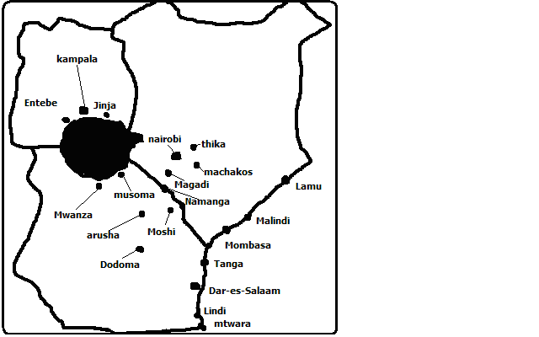

**Main categories of Urban Centres**

1. **Capital** **towns**-towns which are the main seat of the government or administrative centres of each country. These are Nairobi, Dodoma and Kampala.
2. **Cities-**largest towns in E. Africa with city council status i.e. Nairobi, Dar and Kampala.
3. **Sea ports**- are located in the Indian Ocean Coast and are Mombasa, Malindi, Dar, Tanga, Mtwara and Lindi.
4. **Lake Ports**- are located on lake shores e.g. Kisumu, Mwanza, Kigoma, Bukoba, Jinja, etc.
5. **Mining towns**-evolved due to mining activities e.g. Magadi, Kakamega, Shinyanga, Kilembe, etc.
6. **Industrial towns**-whose main functions are industrial activities e.g. Thika, Athi River, Jinja, Tanga, etc.
7. **Collecting towns**- whose functions are to collect agricultural produce for being located in rich agricultural areas e.g. Karatina, Nakuru, Eldoret, Mbalala and Kabale in Uganda and Mbeya and Songea in Tanzania.
8. **Gap towns-** (Makutano towns) located at points of convergence of transport routes e.g. Voi, Moshi and Tabora in Tanzania and Hoima in Uganda.
9. **Administrative towns-**whose main function is administration e.g. all provincial and district headquarters in Kenya, Dodoma and Morogoro in Tanzania and Gulu and Fort Portal in Uganda.

**Factors influencing the Growth of Major urban Centres in E. Africa**

1. Rural to urban migration when young people complete formal schooling and migrate to major towns to look foe employment causing population to expand in those towns.
2. Natural growth of urban population through births because most of migrants are young couples who are at their height of their reproductive years.
3. advantages of well develop[ed transport and communication network since most of them are accessible by good roads, railway, air and some by waterways enabling goods to be imported easily and accelerates migration.
4. Industrialisation which attracts people because industries attracts people because they offer employment opportunities.
5. Some have emerged due to mining as it attracts workers who move and settle in the mining area.
6. Tourism whereby influx of tourists to a town can cause demand for high class hotels, curio shops, entertainment etc which make the town to grow e.g. Malindi and Mombasa.
7. Agriculture can make a town to grow by providing market for industrial products from urban centres and by providing raw materials foe industries established in urban areas.
8. administration when there is set district or provincial headquarters and government employees are posted there to provide services to the people and houses, shops and service industries such as banking are established there to serve people.

**Growth and Functions of Selected Towns in Kenya**

**Thika (An Industrial Town)**

* its one of the most industrialised towns in Kenya with industries such as flour milling, bread baking, vehicle assembly, fruit canning, etc.
* Located at the edge of Kenyan Highlands.
* Started as a small African village where the Akamba and Agikuyu traders met and exchanged goods.
* A market developed and Asian traders set up shops to cater for the small African and European farmers from the surrounding areas.

**Factors Which Have Contributed To Its Development as an Industrial Town**

1. It’s surrounded by districts which are agriculturally productive e.g. Kiambu, Thika, Maragua and Muranga.
2. It’s situated near rivers Chania and Thika which supply water for domestic and industrial use.
3. It’s located on Nairobi-Nanyuki railway and tarmac road which makes transport of raw materials to the town and that of finished products to the market easy.
4. It’s near Nairobi which is a source of raw materials making many investors to prefer to establish industries there.
5. High population from the surrounding districts which supply labour to the industries as well as market for some manufactured goods.
6. Availability of expansive flat land for industrial growth.
7. Congestion of Nairobi’s industrial area which made many investors to prefer Thika as it’s outside and at the same time near Nairobi.
8. Availability of power from 7 Forks Power Project on R. Tana which provides electricity for industrial and domestic use.

**Kisumu (A Lake Port)**

* It’s the largest port of E. Africa.
* Located on the E. shores of L. Victoria on the Winam Gulf.
* Third largest city after Nairobi and Mombasa.
* Started as a small fishing settlement called Ugowe Bay.
* Later, the settlement developed into a port called Port Florence after the completion of the railway from Kilindini to Mombasa.
* Port Florence later came to be known as Kisumu

**Factors Which Contributed To Its Development into a Leading Lake Port**

1. Settlement of Asians after the railway reached there who later built shops to cater for Africans needs (Bombay of Kenya).
2. Location on the shores of L. Victoria which ensures adequate supply of water for domestic and industrial use.
3. Availability of H.E.P. from Uganda which has enabled industries to grow and expand.
4. Being a lake port which handles regional trade across the lake.
5. Development of industries and trade which has attracted many job seekers thus increasing the population.
6. Surrounding areas are highly populated thus acting as a pool of labour for industries and market for products.
7. Fishing activities and processing of fish has contributed to its growth.
8. Being surrounded by areas which are agriculturally productive e.g. Western Kenya which provide a base for potential development in industries in sugar and cotton in Kisumu.

**Eldoret (An Agricultural Collecting Centre)**

* Located in the highlands on the western part of the R. Valley.
* It started as a small post office from which the town grew.
* It was started as an agricultural collecting and marketing centre for White farmers who were commercial wheat farmers and practised dairy farming.
* It has acted as a collecting centre for agricultural produce from Uasin Gishu District.

**Factors Which Made It to Be a Leading Agricultural Collecting Centre**

1. It’s easily accessible by the railway line from Mombasa to Kampala and the highway from Mombasa to Kampala.
2. Location at the heart of one of the richest agricultural hinterlands for which it has acted as a collecting, processing and marketing centre.
3. Availability of social amenities which has led to rapid increase from the surrounding areas.
4. Availability of H.E.P. which has led to establishment of industries such as plywood making, manufacture of soft drinks, textile, milk processing, etc.
5. High population in the surrounding regions which provides labour for industries and a ready market for manufactured products.
6. Plenty of land for expansion of the town and industries.
7. Establishment of service industries such as banking and insurance which has contributed significantly to its growth.

**Related Studies on Selected Cities in the World**

**Nairobi and New York**

**Nairobi**

* Came into existence when Uganda Railway reached it in 1899.
* It started as a railway camp before embarking on the rugged highlands and the steep descent into the R. Valley.
* It’s located on Athi-Kapiti Plains.
* The plains were unoccupied due to the tribal clashes between Kikuyu and Maasai.
* The camp was temporarily relocated to Kiambu due to mosquitoes and wild animals which posed a danger.
* Settlers later moved back to the present city centre.
* Nairobi became the provincial headquarters of Ukamba Province.
* It was in 1907 elevated to the administrative capital of British East Africa Protectorate.

**New York**

* Located on the E. coast of U.S.A. at the mouth of R. Hudson.
* A section of the city is situated on the mainland while part of it is made up of a group of islands-Long Island, Staten Island, Manhattan and Jersey.
* Established after the Dutch bought the Manhattan Island from the Red Indians and renamed it New York.
* Its growth is associated with the construction of New York State Barge Canal which links Hudson to L. Erie one of the great lakes of N. America which passes through regions which are highly industrialised and agriculturally productive.

**Functions of Nairobi and New York/Similarities**

1. **Both are industrial centres** with Nairobi being the leading industrial town in E. Africa with industries such as brewing, steel rolling, motor vehicle assembly, etc. and New York has ship building, chemical industries, pharmaceutical industries and the largest industry being clothing followed by printing.
2. **Both are international centres** with Nairobi having KICC and high class hotels where international meetings are held and New York is the Headquarters of U.N. World Bank, I.M.F. and other international organisations.
3. **Both are residential centres** with Nairobi providing shelter to over 2m people in estates and slum areas and New York is also a residential centre for people of various races of European origin, West Indians, Jews, Chinese, Indians and Jews and the famous ghetto for blacks known as Harlem.
4. **Both are educational centres** with Nairobi having educational institutions such as Kenyatta and Nairobi Universities and Kenya Polytechnic and various other colleges and New York has several junior schools, high schools, colleges and universities for people of all races.
5. **Both are transport and communication centres** with Nairobi having JKIA and Wilson Airports and several highways leading to other major urban centres and Telcom Kenya and Mobile phone services which have headquarters there and New York is the largest sea port in the world, has J.F. Kennedy, New York and La Guardia airports and The New York State Barge Canal.
6. **Both are religious centres** with religious centres including cathedrals, temples, mosques and Jewish synagogues.
7. **Both are financial and trade centres** with C.B.K., commercial banks and N.S.E. and shops and New York is the world’s financial centre and the headquarters for I.M.F. and also has shops.
8. **Both are recreational and cultural centres** with Nairobi having Kasarani and Nyayo stadiums, Gong Race Course etc. and N. York has Night clubs, cinema halls, Central Park, Madison Square Garden and it’s also the fashion and art centre.

**Differences**

1. New York developed as a sea port while Nairobi developed as a town following construction of Uganda Railway.
2. New York is a coastal city while Nairobi is an inland city.
3. New York comprises of mainland and several islands while Nairobi is in the mainland.
4. New York has an approximately 12 times larger population than Nairobi.
5. New York is located in a developed country while Nairobi is located in a developing country.
6. New York is an international city while Nairobi is a national city.
7. New York is a sea port while Nairobi has an inland dry port at Embakasi.
8. New York is the capital of the state of New York while Nairobi is a national capital.
9. New York experiences the problem of racism while Nairobi experiences the problem of tribalism.

**Mombasa and Rotterdam**

**Mombasa**

* It’s located at the coast of east Africa in a Ria at the mouth of R. Mwachi.
* Started as a resting and calling port during the era of slave trade.
* It was once a Portuguese town who built Fort Jesus in 1593.
* Originally the town was located on the island surrounded by the creeks namely Tudor and Port Reitz.
* Later the town expanded farther north, south and west to the mainland.

**Factors Which Influenced Its Location**

1. Was a strategic calling port for early traders to and from the Far East.
2. Provided a good defensive site against external aggression (Fort Jesus).
3. Has flat land which is ideal for construction of buildings (coastal plains).
4. Coral limestone rocks found in the sea were used as building stones for houses.
5. River Mwachi and Kimbeni provided early settlers with fresh water for domestic use later Mzima Springs in Tsavo W. N. Park became the main source of water.
6. The deep waters of Kilindini creek provide a good well sheltered natural harbour.
7. Has a large and rich agricultural hinterland i.e. the whole of Kenya, N. Tanzania, Uganda, S. Sudan, Rwanda and DRC.

**Rotterdam**

* Located in the province of s. Holland in Netherlands.
* Located at the mouths of rivers Rhine and Meuse on the N. Sea.
* Originated as a small port sandwiched between 2 other ports Antwerp in Belgium and Amsterdam.
* Silting of the N. Sea led to the dwindling of the development of Rotterdam.
* After the harbour was deepened it witnessed rapid growth at the 1st half of 19th Century.
* The growth was halted by the devastations during the 2nd World War.
* It has since grown into the leading world port in terms of tonnage.
* It’s the enterport to Europe.

**Factors Which Have Led To Its Development as an Enterport**

1. Deepening of the harbour creating a new port known as Europoort which is deep enough to handle large vessels.
2. Has an extensive hinterland for which it handles transit goods through the navigable R. Rhine comprising of Belgium, Netherlands, Germany, Austria, etc.
3. Located at a strategic central point in Europe where sea routes converge from America, Africa and other parts of Europe giving it an advantage over the other ports of Europe.
4. The port doesn’t freeze due to the warm Atlantic Drift Current which raises the temperature enabling it to operate throughout the year.
5. Provision of modern port facilities.
6. Its industrial function of its being the major industrial area in the Netherlands with industries such as engineering, food processing, oil refining etc.

**Functions of Mombasa and Rotterdam/Similarities**

1. **Both are sea ports** with Mombasa being the gateway to E and C Africa and Rotterdam being the enterport to Europe.
2. **Both are transport and communication centres** with Mombasa being well served by transportation routes such as Nairobi-Mombasa Highway, has Moi International Airport etc and Rotterdam is linked to other urban centres by modern roads, railway lines and waterways.
3. **Both are industrial centres** with Mombasa having Changamwe oil refinery, Bamburi cement Factory, motor vehicle assembly, etc. and Rotterdam having being the major industrial centre in Netherlands having industries such as ship building, engineering, petrol chemical ,etc.
4. **Both are commercial centres** with both having shops and businesses selling goods to citizens.
5. Both are located at the mouths of rivers, Mombasa on the mouth of R. Mwachi and Rotterdam on the mouths of rivers Rhine and Meuse on the N. Sea.
6. Both are in the coastal region.
7. Both are open for use throughout the year due to favourable weather conditions.
8. Both are the second largest towns in their respective countries.

**Differences**

1. Mombasa handles much less volume of trade.
2. Mombasa is frost free throughout the year while Rotterdam is sometimes affected by frost.
3. Netherlands has more sophisticated port facilities than those of Mombasa.
4. Mombasa is in a developing country while Rotterdam is in a developed country.
5. Mombasa depends on roads, railways, air and pipeline transport while Netherlands has canal transport in addition to those means of transport.
6. Mombasa mainly exports agricultural raw materials while Rotterdam exports manufactured goods.

**Effects of Urbanisation**

**Positive effects**

1. Urbanisation encourages national unity as people of different ethnic backgrounds come together and interact.
2. It creates employment opportunities through establishment of commercial and industrial activities through which peoples living standards are raised.
3. Leads to development of infrastructure within urban centres and the surrounding areas.
4. Provides a market for agricultural goods produced in the country.
5. Encourages development of industrial and agricultural sector by providing market for manufactured goods and produce.

**Negative Effects (Problems)**

1. Environmental degradation e.g. air pollution when the industries and motor vehicles emit smoke and other gases to the atmosphere which accelerates global warming, pollution of rivers through discharge of harmful effluents from industries into them and people throwing all types of wastes there and noise pollution from industrial machines, aircrafts and motor vehicles which causes loss of sleep and permanent loss of hearing.
2. Unemployment because of the population growing at a higher rate than the employment sector.
3. Crime and other social evils like prostitution which people engage into to earn a living due to high levels of unemployment.
4. Strain on social amenities i.e. there is shortage of housing, health centres, sanitation, schools, transport etc due to increase in population.
5. Traffic congestion especially in developing countries due to poorly planned roads which are unable to accommodate the ever increasing motor vehicles which causes wastage of time and fuel.
6. Breakdown of family units as many men leave members of the extended family, their wives, children and get concubines leading to marriage breakages.
7. Causes mental disorder to people due to stress and depression resulting from the high cost of living causing some people to abuse drugs in the process of stress management causing them to end up getting mad.
8. Juvenile delinquency or tendency by the youth to break the law due to idleness resulting from lack of activities to keep them busy.
9. Urban sprawl or expansion of towns into the surrounding agricultural land which lowers agricultural production.

**MANAGEMENT AND CONSERVATION OF THE ENVIRONMENT**

Environmental conservation is protection and preservation of natural resources from destruction, wastage or loss while environmental management is effective planning and control of the processes and activities that could cause deterioration of environment.

**Need For Environmental Conservation and Management/Why its Essential**

1. To sustain human life because it depends or resources from the environment e.g. soil, water, air, forests, wildlife, etc.
2. So as to protect endangered species of plants and animals from becoming extinct e.g. Meru oak, white rhino and Sokoke Scops owl.
3. So that the natural resources in the environment can continue sustaining the present and future generations.
4. Because a lot of natural resources in the environment are of economic value by being consumed directly or by giving us an income.
5. Because the features in the environment e.g. plants and animals are of aesthetic value i.e. they are beautiful to look at.
6. For posterity i.e. to ensure a better life for future generations.
7. To curb global warming by reducing the green house effect which is causing a lot of heat to be trapped in the earth’s atmosphere.

**Environmental Hazards**

**-**Dangers or disasters within the environment due to natural causes or human activities.

1. **Floods**

-An overflow of a large amount of water over dry land.

**Causes**

* 1. Spilling of excess water of a river over its banks into the surrounding areas.
  2. Rising of the level of the sea or lake due to increased rainfall.
  3. Exceptionally heavy rainfall like El Nino resulting in excess water on land collecting in shallow basins and flat areas causing flooding.
  4. Breaking of a dam making the water in the reservoir to drown the land on the downstream side of the valley.
  5. When an earthquake occurs in the ocean causing huge sea waves called Tsunami which travels to the land flooding it.

**Control of Floods**

1. Construction of dams to reduce the speed and amount of water flowing down stream by excess water flowing into the reservoir.
2. Construction of dykes or high walls some distance from the river bank, lake shoe or sea shore to protect low lying land from being flooded by water from the water body.
3. Making piles of earth along the riverbanks to form a raised platform to keep flood waters within the river channel.
4. Reforestation of land to reduce to increase infiltration by vegetation giving rain water ample time to percolate and thus reduce runoff meaning there will be less water in rivers and hence less incidents of flooding.
5. Dredging of shallow river channels to increase their depth and hence the channels capacity.
6. Straitening of rivers with meanders to enable the water to flow more swiftly.
7. Diverting of some river tributaries to reduce the volume of water getting into the main river.
8. **Lightning**

-Flash of brilliant light in the sky produced by natural electricity passing between clouds or from the clouds to ground.

-Common where convectional rainfall occurs.

-Associated with cumulonimbus clouds.

-Common Kakamega, Kisii and Nyamira and around L. Victoria which experiences in the highest frequency.

-It starts forest fires e.g. in U.S.A and damages houses and electrical installations leading to loss of life and property.

**Control**

1. Installing lightning arresters on buildings which are copper rod conductors which direct lightning electrical current into the ground.
2. Educating the people on the dangers of lightning and precautions to take.
3. Not taking shelters under trees or on verandas when it’s raining.
4. Avoiding walking on open fields during thunderstorms.
5. If possible people should remain indoors when it’s raining.
6. **Windstorms**

-Very strong winds that develop as a result of great differences in atmospheric pressure on the ground e.g. hurricanes, tornadoes and typhoons. Kenya experiences thermals.

**Effects**

* In the deserts they transport sand which may burry houses and oasis.
* Rip off roofs of buildings
* Uproot trees and
* Cause flooding and
* Felling of crops e.g. cocoa pods.
* Spreading bush fires

**Control Measures**

* 1. Predicting and monitoring windstorms using satellites to know their development and advancement speed.
  2. Warning people through electronic media of advancing windstorms so that they can move away.
  3. Taking shelter in bankers.
  4. Planting of trees in open ground to break the speed of wind thus reduce its destructive effects.

1. **Earthquakes**
2. **Droughts**

-Condition whereby an area experiences a rainfall deficient season followe4d by a long dry period.

**Causes**

1. Insufficient rainfall
2. Global warming leading to high rates of evaporation which exceed precipitation.
3. Encroachment of desert like conditions due to destruction of vegetation by deforestation and overgrazing.

**Effects**

1. Crop failure leading to famines
2. Deaths due to famines
3. Shortage of water
4. Closing of HEP stations
5. Death of livestock and other herbivores due to shortage of water and pasture
6. Migration of people to unaffected areas which may lead to conflict due to competition for resources (environmental refugees.
7. Destruction of vegetation and animal life causes loss of biodiversity.
8. Poverty as those who depend on agriculture lose their livelihoods.
9. **Fires**

**Causes**

1. Kerosene stoves
2. Candles electric faults
3. Explosion of oil pipelines
4. Explosion of oil tankers when people drawing fuel set the on fire accidentally e.g. when attempting to smoke e.g. Sachangwan.
5. Lightning
6. **Volcanic Eruptions**

**Effects**

1. Lava flows spread to nearby settlements burying and burning people.
2. Set vegetation on fire.
3. Heated water cause death of aquatic life.
4. Emit poisonous gases which kill people when they inhale them.
5. Damage and disrupt infrastructure.
6. **Pests and Diseases**

Pests- animals, insects and birds which are harmful to other animals and plants.

**Effects**

* Locusts and army warms destroy vegetation resulting in shortage of pasture for herbivores.
* Ticks, river flukes, tapeworms and fleas affect animals by transmitting their diseases and weakening them.
* Jiggers cause woods in human feet through which infections may enter the body.
* Parasitic plants feed on the host plant leading to its eventual death.
* Cause problems in the provision of food and maintenance of human health.

Most diseases which affect plants and animals are viral, bacterial or fungal.

**Control**

1. Use of chemicals e.g. fungicides, herbicides and pesticides.
2. Developing plant species which are resistant to pests and diseases.
3. Biological control e.g. control of tsetse flies by breeding sterile males which are released to mate with females which occurs once in a lifetime thus reducing their population.
4. Educate people on the proper use of chemicals to prevent resistance and environmental degradation.
5. **Pollution**

**-**Contamination of environment with harmful or poisonous substances.

**Types**

1. **Water Pollution**

- Addition of harmful substances in water causing deterioration in the quality of water so that it no longer serves the purpose for which it is intended.

1. Addition of materials like dust and salts to water through erosion and wind deposition.
2. Disposal of wastes from houses e.g. sewage into rivers or lakes.
3. Effluents from industries and factories.
4. Oil spills from e.g. off shore oil drilling, tankers and burst oil pipes.
5. Testing of nuclear weapons under the sea.
6. Agricultural fertilisers and chemicals washed in to the river by rain water.

**Effects**

1. Causes diseases such as cholera when drinking water is contaminated.
2. Causes poisoning e.g. when mercury from industries is consumed by fish and is eventually consumed by human beings.
3. Causes death of aquatic life like fish due to poisoning and suffocation.
4. Makes introduction of fish into aquatic systems difficult.

**Soil/Land pollution**

-Addition of harmful substances in the soil land leading to deterioration of their state.

1. Chemical fertilisers added to improve fertility.
2. Pesticides, fungicides and herbicides to control pests and diseases.
3. Chemicals and explosives which are used during mining.
4. Nuclear testing and careless testing of nuclear wastes.
5. Presence of garbage heaps which stinks, become breeding ground for disease vectors and make the land to look ugly.
6. Open cast mining and quarrying of rocks which leaves open pets which people may fall into, water may collect in to them and become breeding ground for mosquitoes which transmit malaria.
7. Heaping of the overburden on the land during mining.

**Effects**

1. Causes poisoning and cancers when toxic chemicals are absorbed by crops then people consume them.
2. Contaminates ground water as rain water aids the toxic chemicals to seep underground.
3. Kills soil organisms.
4. Affects the growth of crops by altering soil PH.
5. Makes land derelict i.e. useless for other activities like agriculture.

**Air pollution**

-Addition of toxic and harmful substances in to the air which destroy its purity.

**Causes**

1. Eruption of volcanoes which releases poisonous gases, dust and ash particles to the atmosphere.
2. Natural fires started by lava flows and lightning which add a lot of smoke into the air.
3. Industrial emissions e.g. sulphur dioxide, carbon dioxide, hydrocarbons etc.
4. Dust and carbon particles added by quarrying and factories,
5. Tanneries which release large quantities of hydrogen sulphide and ammonia into the atmosphere.
6. Smoke and poisonous gases from motor vehicle emissions.

**Effects**

1. Sulphur dioxide and nitrogen dioxide combine with water vapour forming acidic water which corrodes buildings.
2. Sulphur dioxide also combines with oxygen forming a dilute mixture of sulphuric acid which damages forests, ancient buildings and sculptures.
3. Lead released into the air from leaded fuels is absorbed by vegetables which are eaten by human beings and animals causing sickness resulting from poisoning.
4. Large quantities of smoke contribute to formation of smog in industrial cities such as Beijing.
5. Hydrocarbons cause depletion of ozone layer leading to excess UVR reaching the surface which accelerates global warming and causes problems such as skin cancers, deterioration of plastics etc.
6. Air pollution also causes respiratory problems and also aggravates respiratory diseases such as asthma. respiratory

**Noise Pollution**

-Discordant sound which is excessive, unwanted and of a disturbing nature.

**Causes**

1. Booming music in night clubs, shops or motor vehicles.
2. Repeated hooting of motor vehicles.
3. Revving of motor vehicles’ engines continuously.
4. Defective exhausts of vehicles or without silencers.
5. Sound from large aeroplanes and military aircraft.
6. Loud noises from machines in factories.

**Effects**

1. Headaches
2. Stress leading to physical or mental illnesses such as neurosis.
3. Cause people to become irritable.
4. Raising blood pressure.
5. Damaging of eardrums leading to impaired hearing or total deafness

**Measures undertaken to Curb Pollution**

1. Not to cultivate on river banks to prevent silting of rivers, lakes and reservoirs.
2. Sewage treatment before releasing it to the environment.
3. Regular inspection of factories to ensure they don’t release toxic fumes to the atmosphere.
4. Using unleaded fuels.
5. Sorting garbage before disposing it into vegetative and non-biodegradable e.g. plastics and glass.
6. Recycling wastes such as plastics, paper, glass and polythene bags and turning vegetative wastes into manure.
7. Banning use of chemicals with residual effects in the soil e.g. DDT.
8. Use of ear guards.
9. Use of efficient energy saving stoves.
10. Prohibiting playing of loud music in public service vehicles, clubs and etc.
11. Use of pit latrines
12. Use of alternative environmentally friendly sources of energy such as solar energy, hydropower, etc.

**Environments Management and Conservation Measures**

* 1. Setting organisations and institutions to coordinate matters related to environmental conservation and management e.g. UNEP. Green Belt Movement, Environmental and wildlife clubs.
  2. The government has made laws governing environment conservation and management e.g. Wildlife Conservation and Management Act, The Water Act, Forest Act etc.
  3. Setting up of ministries to deal with various aspects of environment e.g. Ministry of Tourism and Wildlife, Ministry of Water, Ministry of Environment and Natural Resources, etc.
  4. Presidential decrees and directives e.g. declaration of “Kayas”, Protecting the aloe plant, etc.
  5. Educating people to create awareness on environmental issues through the mass media and seminars.
  6. Participating in environmental activities such as tree planting and construction of gabions during the environmental day.
  7. Research on development of crops that are resistant to certain pests and diseases and environmentally friendly methods of controlling pests (ICIPE).
  8. Setting up recycling factories to recycle scrub metal, paper, glass, plastics and make manure out of vegetative wastes.
  9. Rehabilitating land rendered derelict by mining by filling pits with waste rock and soil and planting vegetation.

**Global efforts towards environmental Conservation and Management**

1. Signing of Kyoto Accord where countries agreed to reduce the amount of green house gases they emit.
2. International law which binds the countries to protect the sea against pollution and overexploitation of its resources.
3. Guidelines on the use of hazardous chemicals have been issued.
4. Countries have agreed to notify others when they restrict the use of a chemical.
5. FAO collaborates on matters involving food additives and pesticide residue.
6. Governments are required to notify others of chemical accidents.
7. Governments are required to provide assistance when hazardous chemicals cross national frontiers by accident.